Integrated Management Plan of
Zarivar Wetland Basin
Provided through the cooperation of the following parties:
Governmental authorities representatives, local communities, non-governmental organizations and other stakeholders and in charges of Zarivar Wetland





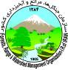




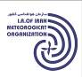



1395
Department of Environment Protection | Kurdistan provincial Governorship | Conservation of Iranian Wetlands Project | Marivan Gubernatorial
Kurdistan Agricultural Jihad organization | Kurdistan Department of Natural Resources | Kurdistan province Department of Environment | Kurdistan Regional Water Authority
Kurdistan province water and wastewater co. | Kurdistan province rural water and wastewater co. | Kurdistan Meteorogical organization | Kurdistan province Cultural Heritage, Handicrafts and Tourism organization
Kurdistan Industry, Mine and Trade organization | Chia Green Forum | Marivan County justice | Rural municipality of Zarivar surrounding villages

25-year Vision:
A dynamic beautiful wetland with adequate and fresh water amount and significant biodiversity and wise use of every potential of it in accordance with the sustainable development of the basin

Goal:
Establishment and continuity of ecological management in order to revive the natural situation of the wetland to let the current and future generations profit and engage

1-1-1- | Inception workshop: identifying the values and functions, threats and issues, and stakeholders and in charges analysis | …………………………………………………….2
1-1-2- | The second workshop: categorizing and illustrating the tree of problems, policy and target developments | ……………………………………………………..2
1-1-3- | The third workshop: designing the organizational structure and contributing the management plan monitoring system | ……………………………………………………..2
1-1-4- | The forth workshop: Zoning………………………………………………. | ……………………………………………………...3
2-1- | Conclusion…………………………………………………………………………. | ………………………………………………………3
3-1- | Specifications and physical characteristics of the wetland | ………………………………………………………3
4-1- | 25-Year Vision and general Goal …………..………………………….. | ………………………………………………………6
5-1- | Policies, strategies and Priority actions……………………………… | ………………………………………………………7
6-1- | Organizational structures…………………………………………………… | …………………………………………………….12
7-1- | Zoning………………………………………………………..……………………… | ….…………………………………………………14
8-1-1- | Classification of the wetland sensibility activities …….………. | …………………………………………………….14
8-1-2- | Proposing allocation land uses according to their compatibility | …………………………………………………….16
Table of Contents

The summary of integrated management plan
of Zarivar Wetland Basin

The methods of development the plan

There have been efforts to debate the different aspects of various required topics to develop the plan regarding the aspect and processes of ecological management through the attendance of all stakeholders and in charges in participatory workshops to eventually develop the integrated management plan. The summary of the outcomes of the 4 mentioned workshops are as follows:
    - Inception workshop: identifying the values and functions, threats and issues, and stakeholders and in charges analysis.

The first workshop of Zarivar ecological management plan development was held on 12 and 13th of Isfand in 1392 (solar calendar) hosting the majority of stakeholders and in charges such as: in charge representatives from DEO, province authorities, NGOs and local people. The goal of the first step of the integrated management plan development was to identify “values and functions of the wetland”,” threats and issues”, and stakeholders and in charges analysis” besides defining the 25-year milestones to manage the place.
    - The second workshop: Categorizing and illustrating the tree of problems, policy and target developments
The second workshop of integrated management plan for Zarivar Wetland was held on 18 and 19th of Khordad, 1393 (solar calendar) for categorization and classification of the threats and issues, analysis and identification of their cause and effect relationship and their policy development. The proceedings and management proposes have been declared in the 5 following groups:
- Reaching the satisfying water and soil resources. 2- wise use of the wetland and its capacities, 3- significant biodiversity and its protection, 4- principle studies, budget specification and integrated management, 5- raising awareness and cooperation
    - The third workshop: Designing the organizational structure and contributing the management plan monitoring system
The third workshop of ecological integrated management plan development of Zarivar Wetland was held on 6 and 7th of Bahman, 1393 (solar calendar). The purpose of the workshop was introducing the management plan process, extraction and designing organizational structure in various scales of province, town and indigenous communities. Also designing the wetland monitoring plan has been done in 3 categories of “water and soil resources”, “social- economic issues” and “biodiversity”.

The fourth workshop: Zoning
The fourth workshop of ecosystem management of Zarivar Wetland has been held on 3rd of Azar, 1394 (solar calendar) with the purpose of “introducing the suitable zones for conservation and sustainable exploitation, on the map” and “determination of executive instructions of each activity in its zone” in order to detect the appropriate zone for executive proceedings in stakeholder organizations.

2-1 Conclusion
After receiving and wrapping up the advices and ideas of stakeholders in various meetings, and with the supplementary cooperation of technical-consulting team during numerous meetings, the workshop reports have turned to integrated management plan and this book the total outcome of it. Among the abovementioned workshops there have been various other meetings to plan and hold workshops the results of which lead to development of Zarivar wetland integrated management plan.

  - Specifications and physical characteristics of the wetland
Freshwater Lake of Zarivar (Zirêwar,Zirêbar) is located 130 kilometers to the north-west of Sanandaj which is the center of Kurdestan Province, and also 3kilometers to West of Marivan. This is one of the unique lakes worldwide and also one of the most important sites for overwintering and breeding places for migratory birds.
Zarivars Drainage Basin has an area of 15827 hectares with the eastern latitude from "51 '04 ˚46 to "30 '15 ˚46 and the northern longitude from "23 '28 ˚35 to "30 '36 ˚35 . It contains 2 sideway urban drainage basins with the area of 5000 hectares. Marivan’s area is 10827 hectares. The maximum height of the basin is 2120 meters and the minimum one which is located at the lake’s outlet is 1283 meters above the sea level. The average slope of the basin is 18.2% and the focal point of surface water runoffs is 11 score in hydrological scale in Zarivar Basin. The main part and the bowl of the wetland are extracted about 4.5 kilometers in length and the width of approximately 2 kilometers. The area of the bowl accordingly comes to 8.3 km^2 which makes an area of over 20 km^2 taking into account the surrounding reedy margins.

Zarivar region as per "clause A of Article 3 of the Law on Environment Improvement Act of 1353 and Act No. 304 dated 05.07.1388 of the fundamental affairs Commission for Industry, Mine and Trade" was introduced as "Zarivar Wildlife Shelter" and is a part of the areas under the shelter management of the Kurdistan province Environment department. The area of the shelter zone, the wetland, and the water range are as follows in the same order: 3293, 2403, 855 hectares and their locations are as mentioned in the same order: latitude of 599550 to 605050 and longitude of 3929857 to 3939779 for the shelter zone, the latitude of 600324.6 to 604890.4 and longitude of 3930071.6 to 3938911.69 for the wetland and the latitude of 600759 to 603545.87 and the longitude of 3931084.8 to 3935665.5 for the water range in UTM coordinate system.

There are 3 resources of water to feed Lake Zarivare. The first one is rainwater and atmospheric fallout as rain or snow directly into the lake, while the second one is the springs of the wetland bed linked to underground aquifers and the third one is surface water from the wetland drainage basin and the Qzalche su/Deh veran Inter-basing canal is seasonally belonged to the wetland in case of necessities of ecological balance. It flows to the wetland after receiving snow or rainfall by the current trickles on the western and eastern domains in addition to drainage basin of the wetland. The majority of Zarivar area is owned by the government expect of a few minor parts which are private properties. The region has different introduced land uses such as wetland water, reedy area (a place for cow grazing) and greed harvesting by the local people, water lily (lotus) in very limited part of the wetland, and rangeland for sheep herds grazing. All over the surface of the wetland is fishing area and its surrounding is used as gardens and agricultural farms. Regarding to its ecological functions as the water diet regulator, Lake Zarivar is counted as a habitat to support plants and animals especially water birds which have vast variety of species. The species such as Phragmetes australis, Thypha latifolia, Cyprus, Juncos latifolia, Butomus umbellatus, Cyprus longus, Scirpus maritimes, Carex nigera, Myriophyllum spicatum, Utricularia neglecta, Potamogeton lucens, Polygonum amphibiu, Nymphaea alba, Capoeta trotta, Leuciscus cephalus, Alburnus mossulensis,
Mastacemblus mastacemblus, Aythya nyroca, Strena repressa, Fulica atra, Tachybaptus ruficollis, Podiceps cristatus, Ardea purpurea, Egretta garzetta, Bubulcus ibis, Ciconia ciconia Tadorma ferruginea, Anas platyrhynchos, Porphyria porphyria, Vanellus, Larus ridibundus, Larus genei, Motacilla alba, Lutra lutra exist there and also it ecologically hosts various phytoplanktones and zeoplanktones,growth place for different aquatic and waterfront plants, habitat for different kinds of fish and migratory and native birds.
The major production of this aquatic ecosystem consists of fish, forage (Carex and Phragmetes), medicinal plants, and a water resource to farms and gardens. The water system of Lake Zarivar has various values and functions such as: providing wildlife habitat, biodiversity, landscape and climatic balance, in addition to being a reeds and Lutus harvesting area, providing the raw material for arti-crafts, fishing, sight-seeing, tourism, study and research area, and cultural, historical, traditional and athletic services. We can explain major ecological changes by taking into account the effect of soil dyke in 1374 (solar calendar) in natural overflow of the lake which prevents some native species prevents from spawning in flowing waters and made Mastacemblus, Leuciscus cephalus, and Capoeta Trotta extinct.
Furthermore, the invasion of Grass carps, common carps (Silver carps), and phytofacs in early 70s (solar calendar) eliminated the indigenous species through food competition and made them disappear from the ecosystem of the area. Also other threats such as deliberate and inadvertent firing in reedy areas in some cases leads to endanger the biodiversity of the wetland. Water transfer from Gazalche Sou/Deh to Zarivar has been effective in providing the water necessities acquisitions. Though in flood cases it lead the sediments from the canal into the ecosystem. Change of land use besides farming in the wetland area caused fertilizers and pesticides enter the wetland. Seasonal harvesting of Lutus for medicinal usage also has threatened the population of water birds and waterfront birds such as Akai, Tern and many others due to destruction of their nests and eggs teams the invasion of new non-native species brought by local people to change and threat the ecosystem.

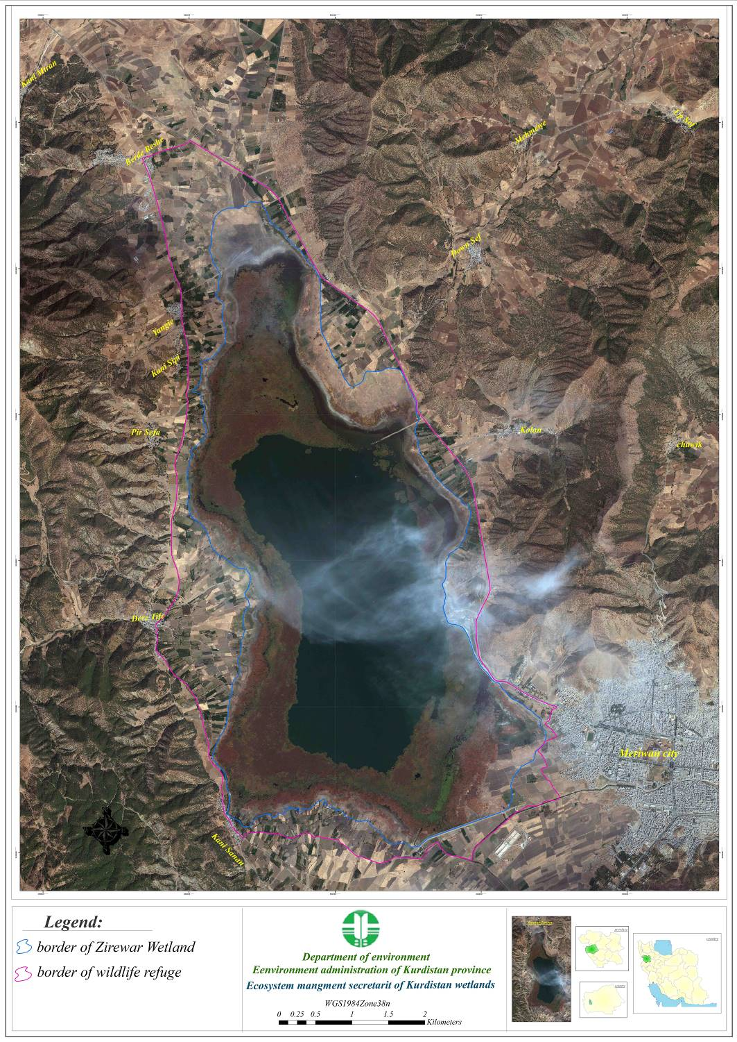

Image 1-2: Satellite image of geographical location of Lake Zarivar in adjacent to Marivan Town

4-1- Vision and Goal
According to the framework of an integrated management planning, the protection of the environment is not just the responsibility of one organization. It is a participatory process which takes place through cooperation of other in charge organizations, institutions, NGOs and local people supervised by a central organization. It is obvious that the ongoing interaction between human being and nature, and also the synergy of willingness and power of human communities and (none)/governmental authorities can predispose us to provide a suitable landscape, present Strategic and macro politics to protect the environment and implement sustainable development. Through the approach of Eco systematic development of integrated management for Lake Zarivar, 4 workshops had been held to cooperate, collaborate and participate. 2 principles of development, declaring long-term milestones which demonstrates the expected situation for the future of the lake and general purpose which leads to strategies and reaching the milestones, were identified. The strategies and implementing plans to profit the facilities and opportunities to vanish and solve the threats and issues were planned is follows:

Long-term Vision:
A dynamic beautiful wetland with adequate and fresh water amount and significant biodiversity and wise use of every potential of it in accordance with the sustainable development of the drainage basin

Goal:
Establishment and continuity of ecological management in order to revive the natural situation of the wetland to let the current and future generations profit and engage

  - Policies, strategies and Priority Actions
The program for prioritized proceedings to reach the general purpose and the long-term milestone is been declared within 4 principle strategy through cooperation and collaboration of groups in charged.
Table (3-1). First Strategic Objective: To get to desirable situation of soil and water resources
Partner Agent | Responsible  Agent | Priority Actions | Objectives | Priority Issues
NGOs  Provincial Government, provincial Department of Environment, municipality, rural municipality, | Provincial Urban and rural water and waste water co. | Completion of drainage network in Marivan  and surrounding villages  main collector of transmission line execution | 3-year target: 30% rural and urban waste water entry elimination into the wetland  10 -years target: full elimination of waste water entering the wetland | Improving water quality
Rural municipalities, provincial Department of Environment, municipality,  NGOs | Provincial Urban and Rural water and waste water co. | Construction sites collect animal  waste in the village |  | Improving water quality
provincial Department of Environment | Agricultural Jihad organization | Education and promotion for correct usage of biologic  fertilizers and pesticides, and organic farming | 3-year target: 30% replacement of chemical fertilizer and pesticides with compost fertilizer and biologic pesticides at agricultural lands and gardens surrounding wetland  10- year target: 70% replacement of chemical fertilizer and pesticides with compost fertilizer and biologic pesticides | Improving water quality
provincial Department of Environment | Agricultural Jihad organization | Production and distribution of compost fertilizer and  biologic pesticides among wetland surrounding farmers |  | Improving water quality
Provincial Government, Regional Water Authority, Department of Natural Resources | provincial Department of Environment | Accomplishment of modeling and simulation studies for wetland water quality. | 3-year target: accomplishment of studies and finding solutions for reduction wetland pollution load and their implementation  10- year target: up to 70% ecosystem standards of wetland polution load elimination | Improving water quality
Regional Water Authority | provincial Department of Environment | Construction of stations for measuring water qualitative parameters in different parts of the wetland |  | Improving water quality
provincial Department of Environment, Provincial Government | Cultural Heritage and Tourism | Organizing tourism projects with the aim of reducing pollutants entering the to the wetland |  | Improving water quality
NGOs،  Ministry of Education & Universities | provincial Department of Environment | Public education of local people and tourists with the aim of reduction in pollutant entering the wetland water |  | Improving water quality
provincial Department of Environment, Provincial Government, Ministry of Justice | Regional water authority | Delamination and implementation of wetland qualitative border |  | Improving water quality
NGOs,  provincial Department of Environment | Agricultural Jihad organization | Establishing incentives and limitations for compost and usage development, usage of compost fertilizer and biologic pesticides instead of chemical materials |  | Improving water quality
provincial Department of Environment | Regional Water Authority | Accomplishment of qazlche su transmission canal operation of sediment fixation | 3-year target: 30% reduction in sediment entry load to wetland  10-year target: 50% reduction in sediment entry load to wetland | Soil protection  Soil protection
provincial Department of Environment, Provincial Government,  The gubernatorial | Department of Natural Resources | Prevent destruction of surrounding forests and accomplishment of watershed operation |  | Soil protection  Soil protection
provincial Department of Environment, research centers and universities | Agricultural Jihad organization | Execution of executory techniques for soil conservation by school in farm method to farmers and gardeners in wetland surrounding | 3-year target: settlement of stable farming system in 20% of farming lands in wetland margin | Soil protection  Soil protection
Department of Environment, Research centers and universities | Agricultural Jihad organization | Support from soil conservation techniques execution in wetland basin and its continuous execution. | 10-year target: settlement of stable farming system in 50% of lands in wetland margin | Soil protection  Soil protection
Universities | Provincial Government | Accomplishment of studies about adapting with climate change | 3-year: preparation and approval of program adaptable with climate change for users who have high consumption of water  10- year target: 70% execution of continuously compatible program with climate change | Protection of water resources of the basin and supply sufficient water for the wetland
provincial Department of Environment, Meteorogical, Provincial Government, Regional Water Authority, Agricultural Jihad organization, The Gubernatorial | Provincial Government | Execution of results from studies of adapting with climate change with goal of reducing the water consumption in basin
Provincial Government, provincial Department of Environment, Government | Regional Water Authority | Preventing other wetland usages from consuming the water resources of the wetland basin
Regional Water Authority, Provincial Government | Agricultural Jihad organization | Implementation of modern methods of irrigation (tape) reducing water consumption | 3-years program for agriculture and gardens to reduce water consumption up to 10%  10-year: program for agriculture and gardens to reduce  water consumption up to 40%
Agricultural Jihad organization, provincial Department of Environment, Provincial Government, Government | Regional Water Authority | Indicating exploitation limits for legal wells and monitor the exploitation of water
Agricultural Jihad organization, Provincial Government, Government, Justice | Regional Water Authority | Determination for the water share of registered farmers and monitoring the water exploitation
provincial Department of Environment, Provincial Government | Regional Water Authority | Studying and preparation of approved adopted programs for the right of the wetland and its water share | 3-years target: study and determine the need to maintain water balance in the normal condition and to determine the border of wetland  10-year target: will need to provide 100% water for wetland
provincial Department of Environment | Regional Water Authority | Determination for the qualitative and quantitative frontage of the wetlands and its signing
Regional Water Authority | Provincial Department of Environment | studying and determining the ecologic frontage of the wetland and its signing
Provincial Government, Regional Water Authority | provincial Department of Environment | Studying the environmental impacts of soil dam on wetland ecosystems | 3-year: analysis and determination of defects and define new studies to complete them  10-year target: synthesis and compilation accomplished studies | Completion and integration of studies related to wetlands soil and water resources
، NGOs  Provincial Government, | Provincial Department of Environment | Studying the expansion and burning effects of marshes on the ecosystem and region
Provincial Government | Regional Water Authority | Studying the springs feeding the wetland and their role in providing the required water for the wetland
Provincial Government, Urban and rural Abfa | provincial Department of Environment | Conducting and completing studies about water quality
Provincial Government | Provincial Department of Environment | Combining studies and extract the feasible solutions

Table (3-2). Strategic Objective Two: wise use of wetland and its capacity
Partner Agent | Responsible Agent | Priority Actions | Objectives | Priority Isuues
provincial Department of Environment, Municipalities, Provincial Government, NGOs | Tourism Organization | Studying, planning and identifying priorities for tourism development and partly implementation of the prioritized proceedings | 3-year target: To plan and implement sustainable tourism and implement it up to 20%  10-year target: To implement the other 80% of approved program of sustainable wetland tourism | Sustainable Tourism
 | Tourism Organization | Implementing principle proceedings to promote sustainable tourism in accordance with the approved plans |  | Sustainable Tourism
Tourism Organization | The Gubernatorial | Implementation of sustainable tourism in the catchment area of wetland |  | Sustainable Tourism
Agriculture, Government, Tourism Organization | Municipality | Organizing jobs and prohibiting employments in contrast to the wetland ecosystem |  | Sustainable Tourism
provincial Department of Environment, Provincial Government, Government | Agricultural Jihad organization (Fisheries) | Sustainable use of aquatic resources wetland program | 3-year target: Develop and implement sustainable use of aquatic resources of the wetland | The operation fits the aquatic resources of wetland
 | Agricultural Jihad organization (Fisheries) | Forming Licensed fishing cooperation of wetland |  | The operation fits the aquatic resources of wetland
NGOs  Provincial Government, NGOs | provincial Department of Environment, Fishery | Local fishermen training and awareness raising and brain storming workshops in order to reduce illegal fishing |  | The operation fits the aquatic resources of wetland
provincial Department of Environment | Agricultural Jihad organization (Fisheries) | Studies to determine the capacity of fishing in the pond and regulating the guidelines and appropriate ways of fishing in the pond |  | The operation fits the aquatic resources of wetland
Real Estate Registration, Ministry of Justice, Regional Water Authority, Provincial Government, provincial Department of Environment | Department of Natural Resources (Agricultural Jihad organization) | To provide a plan to determine the ownership of the lands and documentation of them | 3-year target: Determining land ownership status in the area of wildlife shelter and plan to restore the degraded lands  10-year target: resolving 90% of conflicts about degraded lands | Avoid land use change and the restoration of degraded land
 |  | Having the approval and rule clause in the comprehensive management of all lands, wetlands, and watersheds and documenting their registrations |  | Avoid land use change and the restoration of degraded land
provincial Department of Environment, Provincial Government | Department of Natural Resources | Identification of destroyed land uses, develop and implement restoration plan |  | Avoid land use change and the restoration of degraded land
provincial Department of Environment, Provincial Government | Department of Natural Resources | Identify and investigate disputes and provide guidelines to resolve them |  | Avoid land use change and the restoration of degraded land
provincial Department of Environment | Roads and Urban Development, Provincial Government | Optimizing Road program,  Optimizing and protecting the road from possible pollutions to wetland using the results of optimization studies for road program | 3-year target: 100% removal of threats to wetland boundary road | Immunization of border road
Provincial Government | Provincial Department of Environment | Do the basic research and provide executive solutions to prevent the spread of marshes | 3-year target: Develop the program for preventing the reeds expansion  10-year target: To minimize fire hazards marshes | Marshes Management
NGOs  Department of Natural Resources | provincial Department of Environment | Training local communities to reduce hazards of marches fire |  | Marshes Management

Table (3-3). Strategic Objective III: Preserving the richness of biodiversity
Priority Issues | Objectives | Priority Actions | Responsible Agent | Partner Agent
Elimination the Threats from Animal Biodiversity | 3-year target: To develop and implement a plan to remove the fish from endangered snake species list  10-year target: the formulation and implementation of the project to preserve species from getting extinct, species such as : eel brushed, black mackerel, beaver, duck, chestnut | Studying and tunneling a fish way in soil dyke  Feasibility study to create ponds for certain fish species to reproduce in order to enhance the wetland fishery resources | Regional Water Authority  Fishery | Regional Water Authority
Elimination the Threats from Animal Biodiversity |  | Study and plan to remove non-native or/and invasive species | Fishery | provincial Department of Environment
Protect the stability of plant species | 3-year target: To study and provide a plan to restore the typical plant species of the wetland  10-year target: To implement the restoration of wetland plant species project. such as Symya Vlgars Chia, epinephrine Pars Palvty | to prevent the harvest of lotus in order to protect Tern | Provincial Department of Environment | NGOs
Protect the stability of plant species |  | Preparing and equipping the facilities for quick fire suppression in case of vegetation firing in the wetland and its basin | Department of Natural Resources | Provincial Government, Government, provincial Department of Environment
Protect the stability of plant species |  | Settle and buy land ownerships surrounding the wetland in order to prevent trespassing and destruction of wetland ecology and its vegetation | Provincial Department of Environment, Regional Water Authority | Police, Real Estate Registration, Ministry of Justice, Government
Conservation and restoration | 3-year target: To provide plans for restoration of degraded wetland ecosystems  10-year target: To implement the plans for restoration of degraded wetland ecosystems | Get the legal Approval for a special budget amount to save Zarivar Wetland in the provincial scale | Provincial Government | provincial Department of Environment, Department of Natural Resources, Regional Water Authority, Agricultural Jihad organization, Government
Conservation and restoration |  | Studying and providing a plan for restoration of degraded ecosystems of the wetland | Provincial Department of Environment | Provincial Government, Department of Natural Resources, Regional Water Authority, Agricultural Jihad organization, Government

Table (3-4). Four strategic objectives: to increase the awareness and participation
Priority Issues | Objectives | Priority Actions | Responsible Agent | Partner Agent
environmental issues training | 3-year target: promoting awareness of at least 30% of local people in the following areas:  - Damage caused by soil erosion and sediment discharge into the wetlands  - Damage caused by firing marshes  - The importance of preserving biodiversity  - Damage caused by the emission of pollutants to wetland  - The necessity of parsimony in agricultural water usage  10-year target: raising awareness of at least 75 per cent of the local population in the above-mentioned area | Training the ranchers to reduce the damage caused by overgrazing of pastures | Department of Natural Resources Organization | NGOs
environmental issues training |  | Raising awareness of locals communities and tourists to prevent unwanted fires | Provincial Department of Environment | Provincial Government, Department of Natural Resources, Police and military
environmental issues training |  | Establishing wildlife museum, Visitor Center and the Center for awareness raising in wetland margins | provincial Department of Environment | Provincial Government
environmental issues training |  | Informing the fishermen about the damage of overfishing and the need to control fishing, spear fishing practices and the importance of species diversity | provincial Department of Environment | NGOs  Agriculture Jihad,
environmental issues training |  | Training local people in relation to controlling the entry of pathogens into the wetlands | provincial Department of Environment | Medical Sciences, Provincial Government
environmental issues training |  | Educating and encouraging farmers and gardeners to use compost and biological fertilizers. | Agricultural Jihad organization | Provincial Government, provincial Department of Environment
environmental issues training |  | Public and tourists education in order to reduce polluting sources of the environment | Provincial Department of Environment | NGOs  Education & Training, Universities, tourism Organization,
environmental issues training |  | Informing the local communities about the consequences of the spread of wetland marshes due to eutrophication caused by the discharge of pollutants into wetland | Provincial Department of Environment | NGOs  Provincial Government,
environmental issues training |  | Encourage farmers and gardeners to grow crops with low water requirements | Agricultural Jihad organization | NGOs  provincial Department of Environment
environmental issues training |  | Educating and engaging the students in eco-friendly process;  Educating and public participation of local communities;  The use of the mass media, posters, documentation etc. to teach concepts related to wetlands | provincial Department of Environment | NGOs  Agricultural Jihad organization, Natural Resource Organizations, TV and radio, Education & Training, NGOs

  - Organizational structures
Secretariat ecological management structures of Zarivar Wetland are formed to “plan to implement and supervise the integrated plan”, “optimized and coordinated principal resource management and human activity in the watershed”,” coordination between different executive sections”, “ reinforcing the intersectional collaboration”, “ executive leadership of management plan”, and “ verification of the anticipated goals”. On this basis therefore, the comprehensive management structures in order to integrate with the core objectives of it, are declared as follows.
The organizational structures for integrated management of Lake Zarivar is drafted and suggested as followed. The above-mentioned structures are functioning in integrated management plan based on commitments, responsibilities, team work and members in three levels of provincial, town and native-locals. The key responsibility of native- local group is to assist and consult the wetland provincial and town management working groups and to support the implementation of wetland integrated management plan.

Figure (4-1). Provinces, cities and local organizational structures of Zarivar wetland integrated management
Zarivar Local indigenous wetland Working Group
Tasks
Members
Kurdistan Environmental Network:
Village Administrations and Councils, Chia Green Community, Zarivar Mashdaran Community, Theater Association, Kurdistan Nature Scavengers Community, Earth Women's Association, Population Association of Green Kurdistan, Ashti Cycling Association, Friday prayer leaders and local dignitaries, Fishing cooperatives, Cooperative dock owners, Certified Farmers' Association, trade Community of agricultural work, County Cooperative tractor owners, Documentary makers and film-makers
Working Group chairman: governor
Secretary of the Working Group: Environment Organization
Members:
Agricultural Jihad Organization; Natural Resources Organization
Rural Water and Wastewater (Abfar)
Cultural Heritage and Tourism, The City Council prosecutor, The Real Estate Registration Organization, Department of Environment, county water department, urban water and sewage (Abfa), sheriff Dom, Foundation for Preservation of Sacred Defense Works and Buildings, Police, Electricity Company; fishing cooperatives, Education & Training, Local dignitaries of wetland margins, geography group,
Environment and Agriculture Center of Marivan Payam Noor University, Azad University, the City Council "Barda Rasha"Friday prayer leader, the representative of Islamic great center
Intersectional Synergy and coordination
Annual Pathology of wetland instability and report preparation to the wetland Secretary
To suggest obtaining the necessary funds by the executive program
To supervise the implementation of the tasks of the responsible agencies
Track records of the destruction and occupations of wetlands basin
Monthly evaluation of the effectiveness of proceedings taken on the wetlands and presenting their annual wrapped up report to the secretary of the provincial wetlands
Supporting the implementation of a comprehensive management plan for the wetland
Implementation of Marivan wetland ecosystem management program
6-month and annual executive report
To schedule the implementation of projects
Inquiry and licenses the wetland projects in the basin of the Working Group
County
Local
Approval of research affairs
Monitoring and supervision of construction projects in progress
Public awareness and sensitizing local communities to attract participation
Determine the executive plans of the town
Integrated management and intersectional coordination between executive organization
Monitoring the existing activities and amenities of the wetland
Implementation of environmental monitoring programs
Funding all research and executive projects related to wetlands
Sentences and develop job descriptions for all members
Settling specialized committees and implementation supervision
Keeping track the mechanisms of a comprehensive management plan adaptation
Preparation and approval of annual work programs concerned authorities
Coordination of required finance in various sectors
Provide regular reports based on the management plan
Monitoring and evaluation reports based on integrated management plan
Assessment of short-term, medium-term and long-term implementation of a comprehensive program defined in the program
Follow-up meetings holding
Secretariat functions of Kurdistan wetlands (in place)
Collecting and organizing garbage, waste and …
Arm field of research, training and clear regions of the wetland area
Theater programs and public education and sensitivity basin on its management
Education and Research
Sponsoring the occasional conferences on Training and Information
Providing information on sensitivity and value of the wetland
Coordination between the State - nation and increase public awareness on management and supervision of Hadi and construction plans
Preparing cultural context of the Integrated Management
Contribute to the implementation of priority measures of program management activities in the field of education and awareness, assessment and monitoring;
Help to protect the biodiversity of the wetland
Contribute to the sustainable use of the wetland;
Identifying the Farmers and issuing the exploit license, monitoring product type and area of land, type of construction
Conservation tillage in agriculture
Provincial Working Group on Wetlands زریوار
Committee chairman: Provincial governor
Secretary of the Committee: Provincial Chief Director of Environment
Members:
Governorship Assistant Department of Development and Planning
Department of Environment, Department of Natural Resources, Ministry of Justice
Department of Urban and rural water supply and sewerage
Cultural Heritage and Tourism
State universities and higher education institutions
Agricultural Jihad Organization, regional water organization
Marivan Gubernatorial, Municipality and City Council
Organization of Industry, Mine and Trade, Ministry of Labor and Social Affairs
Roads and Urban Development, Police, NGOs
Provincial
County Working Group

Zoning
The approach of zoning or zoning by the aim of multi-profiting has on one hand prepared high protection levels in certain areas and the other hand has created an opportunity for wise and rational use in other zones. Zoning in order to achieve the wise use of wetlands, is able to separate incompatible land uses and determine the suitability of different activities. Zoning refers to curbing the spatial and temporal implementation or non-implementation of specific activities, in different parts of protected areas depending on the circumstances of the area.

This includes requirements and methods of natural resources management, biodiversity richness protection, resource management and cultural practices, the interests of human society, resource utilization management methods, utilization practices of visitors and tourists, access rate to different parts of the region, and existing facilities, their maintenance and utilization.

8-1-1- Classification of the wetland sensitivity activities
Sensitivity zoning of the habitats is implemented in order to satisfy the protection of habitats, species and rare species ecological process, separate the conflicting human activities, prepare the facilities for human activities depending on wetlands healthfulness, and also to persist the social and economic benefits, and allowing isolation and exclusion of affected areas to get restored and reconstructed. Also zoning is a practical tool to provide the necessary conditions for rational utilization and sustainable development in wetland ecosystems and to facilitate management decisions regarding the implementation approach of management programs and development projects in the wetland zone in such a way that leads to cause the minimum amount of damage and environmental degradation. After detecting the zones, their type and methods of land use will be defined. These criteria and instructions could simply be illustrated in a chart containing allowed activities in each zone or written instructions with integrated details of each activity or a combination of two methods. For instance the touristic boating is a sample to show the instructions for land use, places and time periods allowed for activities and …

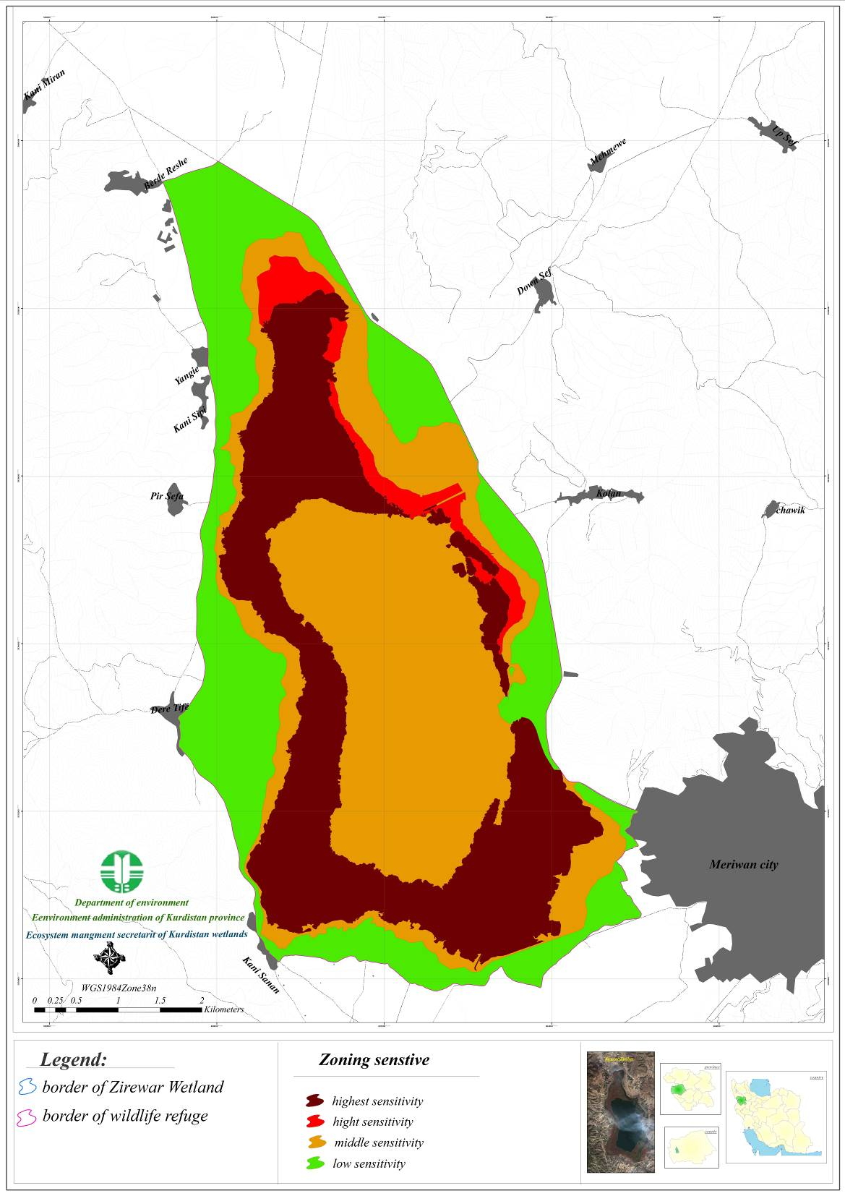
Image 2: Sensitivity Zoning of the Wetland

8-1-2- Proposing allocation land uses according to their compatibility
Zone | Authorized activities | Other activities
Very high | Conservation and restoration, research and investigation | unauthorized
high | Bird watching, research and investigation | unauthorized
Medium | Boating and recreational fishing, livestock grazing and forage cutting (forest) | Ecotourism in certain seasons
low | Sustainable ecotourism, allowed livestock grazing | limited Agriculture by determining the cropping pattern

