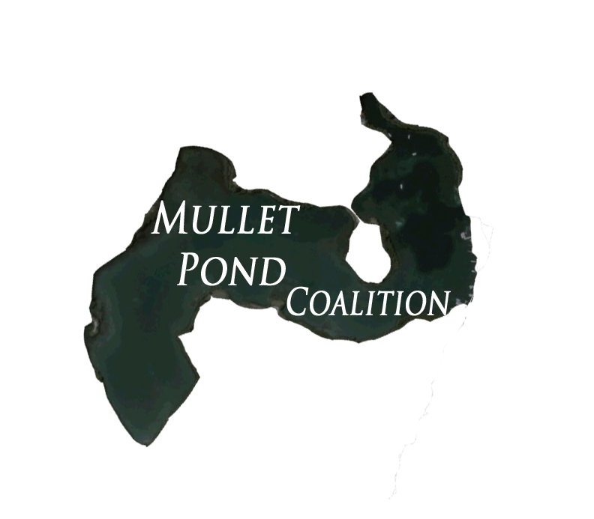
MULLET POND COALITION

Mullet Pond, Simpson Lagoon, St. Maarten:
A Preliminary Survey

9 March 2007

Natalia Collier, Environmental Protection In the Caribbean, ncollier@epicislands.org
Rikke Speetjens, Ocean Care
Jesus Ruiz Lopez , OceanCare
Tadzio Bervoets , OceanCare
Rueben Thompson, St. Maarten Pride Foundation

INTRODUCTION

Simpson Lagoon: Importance and Threats

As one of the largest lagoons in the Caribbean, the Simpson Lagoon of St. Maarten provides essential habitat for wildlife and plants; it forms the center of a food web which extends all the way to our ocean reefs. This unique body of water gives the island a backdrop unmatched by other islands, a place of beauty appreciated by countless visitors and residents. The lagoon also drives a significant portion of the economy by providing safe harbor, goods, and services to the maritime sector.

Tragically, the lagoon continues to be polluted and destroyed. Each year, more mangrove trees are ripped from the coastline and more seagrass beds are smothered with fill dirt or removed. The frenetic pace of development, primarily in support of the tourism sector, has left little behind in its devastating wake. Only approximately ¼ of the coastline of St. Maarten’s lagoon is still populated by aquatic Red Mangrove trees. The remainder is bare soil, rock, or concrete.

The majority (65%) of these mangroves survive in Mullet Pond (unpublished data, EPIC). Mullet Pond is currently under threat due to the redevelopment of the hurricane damaged Mullet Bay Resort. Development plans posted online by an architectural firm include a megayacht marina, waterfront homes, and private docks. This type of development would require the destruction of large areas of mangrove trees and the dredging and siltation of extensive seagrass beds.

While the Mullet Pond Coalition supports the redevelopment of Mullet Resort, we also support the protection of the coastal zone. The Coalition advocates the zoning of Mullet Pond, located between Point Pirouette and Mullet Beach, as a protected area in which it is prohibited to remove and/or cut existing vegetation, including mangroves and seagrass, within 15 meters of the lagoon shoreline. A complete Environmental Impact Assessment should be completed for Mullet Pond. In addition, the public should have sufficient time to comment on any proposed building plans prior to issuance of permits.

Significance of Mangroves to the Caribbean Ecosystem

Recent research has valued coral reefs at up to US$600,000 per square kilometer per year, and mangroves forests at more than $900,000 per square kilometer per year (United Nations Environment Program). They serve as storm buffers, supply our fisheries, support birdlife, and provide aesthetic enjoyment.

Red Mangroves are the only tree in our region which can grow in salt water. Their extensive prop roots stabilize the coastal soil, especially important during hurricanes, and can actually collect sediment and increase the storm barrier area. Perhaps one of their most astounding attributes, mangroves are able to clean the water. Through a process called rhizofiltration, these remarkable trees remove pollutants from the water.

Our marine ecosystem relies on mangroves, whose complex root structure protects juvenile sealife from predators and storms. Many of our reef dependent fish rely on mangrove forests as a nursery until they are able to survive in the open ocean. Countless organisms cling to theses roots, serving dual roles as a food source and as filter feeders which remove pollutants from the water. Mangroves naturally deposit leaves and bark in the water, which is broken down by bacteria and fungi. The nutrients are then recycled through the ecosystem as small invertebrates capitalize on the available food. This then supports slightly larger organisms such as small fish, conch, crab, and shrimp and so on up the food chain. Ultimately, the fish we eat and the fisherfolk whose livelihoods depend on fisheries, rely upon the mangroves.

PRELIMINARY SURVEY OF MULLET POND

Methods

The survey took place on 7 March 2007 and was conducted by members of the Mullet Pond Coalition. The team was led by the St. Maarten non-profit organization Ocean Care, which is the Reef Check coordinator for the island and experienced in underwater survey methods.

A 100 meter transect line was surveyed, with unlimited time to locate and photograph specimens. Two photographers, one videographer, and one observer surveyed the area for 45 minutes. Photographs were later used to identify specimens to species, primarily sessile organisms. Mobile specimens were more difficult to identify. Although research has shown that fish trapping can identify 60% more species within mangroves, traps were not used in order to avoid negative impacts on the area (Acosta 1997).

Results

Twenty-three species from ten phyla were identified from survey photographs (Table 1). Some specimens could not be identified to species, such as the white sponge.

Algae
Caulerpa sp. | Caulerpa sp. (C. toxifolia?)
Green feather algae | Caulerpa sertlarioides
Three-loped leaf algae | Halimeda incrassata
Mermaid’s wineglass | Acetabularia calyculus
Seapearls | Valonia sp.
Mulusca
Flat mangrove oyster | Isognomon alatus
Echinodermata
Sea cucumber
Thorny starfish | Echinaster spinulosus
Platyhelminthes - Flatworms
Lined flatworm/ Tiger flatworm | Pseudoceros crozeri
Annelida
Medusa worm | Loimia medusa
Polychaete worm
Feather duster worm | Sabella sp. or Bispira sp.
Cnidaria
Upside-down jelly | Casseopia xamachanna
Ringed anemone | Bartholomea anulata
Pale anemone | Aiptasia pallida
Porifera
Fire sponge | Tedania ignis
Pink mangrove sponge | Haliclona implexiformis
Green sponge | Haliclona viridis
White sponge
Chordata
Mangrove tunicates | Ecteinascidia turbinata
Black tunicate | Ascidea nigra
Fish
Mojarra | Gerres cinereus
Juvenile schoolmaster | Lutjannus apodus
Juvenile barracuda | Sphyraena barracuda
Mangrove/grey snapper | Lutjanus griseus
Arthropoda
Barnacles

DISCUSSION

This survey provides important preliminary data on Mullet Pond. The presence of organisms representing multiple trophic layers indicates that Mullet Pond is a relatively intact marine system. In addition, the high density of juvenile barracuda recorded could signify a plentiful prey base.

We are confident that further surveys, especially those using trapping methods, would reveal an even greater diversity within Mullet Pond. It would also be of great interest to determine the relationships between Mullet Pond and other coastal systems, such as reefs. This could be accomplished through the use of tags or transmitters to track fish migrations between habitats.

In addition, this data forms the first biological survey in all of Simpson Lagoon and can be used as a baseline in determining the health of other habitats within the lagoon in relation to Mullet Pond.

The economy of St. Maarten is dependent upon tourists who want to visit a beautiful tropical island. It is the beaches, the coastal cliffs, the lagoon, and the mountains that visitors enjoy. Development will continue, but it must be managed responsibly. Areas as unique, important, and rare as the mangroves of Mullet Pond should be provided protected status.

LITERATURE CITED

Acosta, Alejandro. 1997. Use of Multi-mesh Gillnets and Trammel Nets to Estimate Fish Species Composition in Coral Reef and Mangroves in the Southwest Coast of Puerto Rico. Caribbean Journal of Science Vol. 33, No.1-2. pp 45-57.

United Nations, World Conservation Monitoring Center. 2006. In the front lines: shoreline protection and other ecosystem services from mangroves and coral reefs.

