**Aboriginal Land Council of Tasmania (ALCT)**

|  |
| --- |
|  |

***Management Plan for the***

***truwana Lagoons Ramsar Site***

(formerly known as East Coast Cape Barren Island Lagoons Ramsar Site)

Written by:

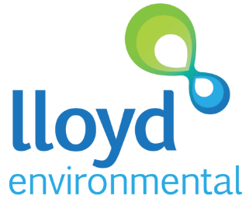

in Association with



***Project Ref: LE1544***

**Novemeber 2017**

**Table of Contents**

Acknowledgements 3

Acronyms and Abbreviations 3

1 Introduction 4

1.1 Vision for the truwana Lagoons Ramsar Site 4

1.2 Purpose and Requirements of this Plan 4

1.2.1 Objectives of management plan 5

1.3 Ramsar documentation 5

1.4 Relevant Treaties, Legislation and Government Policy 5

1.4.1 International Treaties 5

1.4.2 Australian Government Legislation and Policy 7

1.4.3 State Legislation and Strategies 7

1.4.4 Local plans 9

1.5 Wise Use 11

1.6 Planning Context 11

1.7 Plan Development 12

2 THE truwana lagoons RAMSAR SITE 13

2.1 Site Details 13

2.2 Location and Site Description 13

2.3 Ramsar listing criteria 16

2.4 Ecological Character 20

2.4.1 Critical components, processes and services 20

2.4.2 Ecosystem benefits and services 20

2.4.3 Limits of Acceptable Change and Ecological Character status 21

2.5 Land tenure and land use 24

2.6 Current management plans 24

3 PHYSICAL CHARACTERISTICS 26

3.1 Geology 26

3.2 Geomorphology and Soils 26

3.3 Climate 27

3.4 Hydrology 28

3.5 Changes in ecological character since listing 29

4 BIOTA OF THE SITE 30

4.1 Flora 30

4.2 Fauna 32

4.2.1 Avian Fauna 32

4.2.1 Microfauna and Estuarine invertebrates 32

5 CULTURAL VALUES 34

5.1 Aboriginal Cultural Heritage 34

5.2 European Cultural Heritage 34

6 WISE USE 35

6.1 Economic 35

6.1.1 Tourism 35

6.1.2 Farming 35

6.2 Recreation 36

6.2.1 Current - passive 36

6.2.2 Potential/Future 36

6.3 Environmental and Cultural Education 36

6.4 Scientific Research 36

7 THREATS and knowledge gaps 37

7.1 Fire 37

7.2 Introduced fauna and flora 37

7.2.1 Fauna 37

7.2.2 Flora 38

7.3 Pathogens 39

7.4 Climate change / prolonged drought and increased rates of evaporation 39

7.5 Vehicle use/misuse and general visitor use 39

7.6 Grazing pressures 40

7.7 Insufficient knowledge of Aboriginal cultural heritage sites 40

8 MANAGEMENT 41

8.1 Management principles and objectives 41

8.2 Monitoring site health 43

8.3 Managing for limits of acceptable change 44

8.4 Managing risks 44

8.4.1 Fire Management 44

8.4.2 Pest animal control 46

8.4.3 Weed control 46

8.4.4 Biosecurity management 47

8.4.5 Climate Change adaptation and management 47

8.4.6 Vehicular access and visitor management 47

8.4.7 Grazing and stock management 48

8.5 Managing cultural sites and activities 48

8.6 Priority actions, roles and responsibilities 50

9 MONITORING 55

9.1 Condition 55

9.2 Threats and knowledge gaps 55

9.3 Developing a monitoring plan 57

10 EVALUATION, REPORTING AND REVIEW 61

10.1 Performance and Evaluation 61

10.2 Reporting and Review 61

11 REFERENCES 63

12 Appendix 65

12.1 Field sheet for interim sampling program 67

## Acknowledgements

The authors of this report, Peter Newall (Independent Ecological Consulting) and Lance Lloyd (Lloyd Environmental Pty Ltd) would like to thank Inputs from the community on truwana and their welcome during our time on the island. Graeme Gardner and Sarah O’Reilly from ALCT provided project management, guidance and information for the report and the truwana Rangers provided expert local knowledge and field support as well as field data on the dynamics of wetlands of the Site.

List Rangers names

Fiona

Terry

Bill

Colin

Bourbon

Scott Livingston provided information of the current IPA planning project underway as at June 2017 for truwana and providing information on how this planning information will assist the Ramsar Site Management Plan.

This report can be referred to as:

Newall, P.R. and Lloyd, L.N. 2017. Management Plan for the truwana Lagoons Ramsar Site (formerly known as East Coast Cape Barren Island Lagoons Ramsar Site). Lloyd Environmental Report (LE1544) for the Aboriginal Land Council of Tasmania (ALCT). Novemeber 2017, Somers, Victoria.

# Introduction

The East Coast Cape Barren Island (truwana) Lagoons Ramsar Site was listed as a Wetland of International Importance in 1982 under the Ramsar Convention. This management plan subsequently uses a proposed new name of the Ramsar Site, “truwana Lagoons Ramsar Site”, to reflect the wishes of the local island people and the indigenous name of the island.

As signatory to the Ramsar Convention, Australia has an obligation to maintain the ecological character of its Wetlands of International Importance. To achieve this, the Environmental Protection and Biodiversity Conservation Act (1999) (EPBC Act) requires site-based management plans be prepared for these wetlands. The management plan for the truwana Lagoons Ramsar Site is expected to provide a framework for the conservation and maintenance of the site’s ecological character and wise use of the area.

## Vision for the truwana Lagoons Ramsar Site

“The truwana Lagoons Ramsar Site will remain unimpacted by humans, providing an environment where natural wetland processes and undisturbed shorelines protect and maintain habitat for a wide range of vegetation communities, floral species and native fauna.”

This vision will maintain:

* Healthy wetland ecosystems
* Ramsar listing criteria
* Ecological Character of the Site
* Aboriginal sites and uses

The management plan will result in

* Greater community knowledge & understanding
* Threat reduction/management

The truwana people will be actively involved in the management of the Site and the final plan should be owned by the community and consistent with the wider Island Plan.

## Purpose and Requirements of this Plan

The primary purpose of this management plan is to establish, and put into effect, planning to enable conservation and wise use of the site so as to maintain its Ramsar ecological values.

The management plan has two critical compliance requirements:

1. The plan must comply with relevant legal, technical and management needs; and
2. The plan must be developed in union with the truwana managers and community to promote interest and ownership, while providing information and using local knowledge.

Compliance with relevant legal, technical and management needs: The management plan must:

* Comply with Schedule 6 of the EPBC Act and the Australian Ramsar management principles checklist;
* Incorporate recommendations from the Ecological Character Description of the site; and
* Use, and be consistent with, other documents focused on resource management of the Ramsar Site and truwana in general. These documents include:
  + truwana (Cape Barren Island) Management Plan;
  + truwana Weed Management Plan; and
  + Furneaux Fire Management Plan.

Working with the truwana community: This plan is part of a larger project that is focused on increasing Aboriginal participation in natural and cultural resource management and increasing land and cultural heritage management skills for individuals residing on truwana. This must be reflected in the development of the management plan. The approach must therefore include:

* Working with the truwana Aboriginal Rangers on the Island and other key stakeholders in the development of the management plan;
* Informing the truwana community of the significance of the Ramsar wetland;
* Fostering ownership of the management plan and its recommended actions by incorporating the community’s voice into the plan; and
* Working with the Rangers and community to identify appropriate mechanisms for stakeholders to continue to work together for the future management of the site.

The involvement of people who have a special interest in the wetland and who may be affected by the management of the wetland is also a requirement of Schedule 6 of the EPBC Act.

### Objectives of management plan

Specific objectives of the management plan are to:

* document the legislation, policy and any related management instruments which direct or otherwise influence management both within and adjacent to the site;
* provide a comprehensive site description;
* identify the values for which the site is recognised as a Ramsar Site;
* assess threats to these values through systematic analysis of both current and potential risks;
* clarify the roles and responsibilities of management agencies; and
* give priority to Site Management Strategies that minimise and, where possible, eliminate identified risks to values.

## Ramsar documentation

The Ramsar documentation for this site consists of an Ecological Character Description (Dunn et al. 2010) and a Ramsar Information Sheet (DPIPWE 2012). This management plan is the first Ramsar Site Management Plan for the truwana Lagoons Ramsar Site.

## Relevant Treaties, Legislation and Government Policy

The following section outlines the treaties, legislation and regulations that are relevant to the truwana Lagoons Ramsar Site. For further information regarding international, national or state legislation or policies, refer to http://www.austlii.edu.au/.

### International Treaties

**Ramsar Convention**

The Convention on Wetlands of International Importance (Ramsar, Iran, 1971), known as the Ramsar Convention, is an inter-governmental treaty dedicated to the conservation and sustainable use of wetlands (Environment Australia 2001). Australia was one of the first 18 countries to sign the Convention in 1971, and its obligations to protect and maintain the ecological character of its Ramsar Sites are recognised in the Commonwealth EPBC Act, described in Section 1.4.2.

The Ramsar Secretariat maintains a List of Wetlands of International Importance that includes 65 Australian sites (c. 8.3 million hectares). Criteria to determine international importance are set out by the Ramsar Secretariat at <http://www.ramsar.org/key_guide_list2006_e.htm#V>. They include considerations of representative, rare or unique wetland type, the presence of vulnerable, rare or threatened species or ecological communities, diversity of particular biogeographic regions, supporting critical life stages of plant or animal species, the support of large waterbird populations, significance to native fish populations and support for 1% or more of wetland dependent organisms.

**Ramsar wetlands and the EPBC Act**

Under the EPBC Act, a person is required to obtain an approval for any action that has, is likely to, or will have a significant impact on a matter of National Environmental Significance, which includes the ecological character of Ramsar wetlands of international importance. Actions that affect the ecological character of wetlands include:

* areas of wetland being destroyed or substantially modified;
* a substantial and measurable change in the hydrological regime (for example, a change to ground-water, or to the volume, timing, duration and frequency of surface-water flows);
* any change that might affect the habitat or life cycle of native species dependent on the wetland;
* a substantial and measurable change in the physico-chemical status of the wetland (for example, a change in salinity, pollutants, nutrients or water temperature which may affect biodiversity, ecological integrity, social amenity or human health); and,
* an invasive species potentially harmful to the wetland community.

The EPBC Act also sets standards for managing Ramsar wetlands through the *Australian Ramsar Management Principles*, established as regulations under the Act (Environment Australia 2001).

**International conventions on migratory species**

Australia is a signatory to three international conventions on migratory species:

* The Japan-Australia Migratory Birds Agreement (JAMBA);
* The China-Australia Migratory Birds Agreement (CAMBA);
* The Republic of Korea-Australia Migratory Birds Agreement (ROKAMBA); and,
* The Bonn Convention on Migratory Species (CMS).

JAMBA and CAMBA are bilateral agreements between the governments of Japan and Australia and China and Australia, seeking to protect migratory birds in the East Asian – Australasian Flyway. The two agreements list terrestrial, water and shorebird species (most are shorebirds) that migrate between Australia and the respective countries. They require parties to protect migratory birds from ‘take or trade’, except under limited circumstances, to protect and conserve habitats, exchange information and build cooperative relationships. The JAMBA agreement also includes specific provisions for conservation of threatened birds (DEH 2005).

ROKAMBA, signed in Feb 2006, is a bilateral agreement similar to JAMBA and CAMBA. The agreement obliges its Parties to protect bird species which regularly migrate between Australia and the Republic of Korea, and their environment. An annex to ROKAMBA contains a list of species or subspecies of birds for which there is reliable evidence of migration between the two countries.

The Bonn CMS adopts a framework in which countries with jurisdiction over any part of the range of a particular species co-operate to prevent migratory species becoming endangered. For Australian purposes, many of the migratory species are birds.

### Australian Government Legislation and Policy

The principal Commonwealth environmental legislation that relates to wetland conservation is the EPBC Act. Under the Act, any actions that have, or are likely to have, a significant impact on a matter of National Environmental Significance requires approval from the Commonwealth Environment Minister.

Seven matters of national environmental significance are identified in the Act:

* World heritage properties;
* National heritage places;
* Wetlands of international importance (Ramsar wetlands);
* Threatened species and ecological communities;
* Migratory species;
* Commonwealth marine areas; and,
* Nuclear actions (including uranium mining).

The matters relevant to the truwana Lagoons Ramsar Site under the EPBC are Ramsar listing and six migratory bird species listed under one or more international treaties (Dunn et al. 2010).

**EPBC Act and protection of species listed under international conventions**

The species that are the subject of the agreements or conventions are listed as ‘migratory species’, a matter of National Environmental Significance under the EPBC Act. Any action that may affect these species requires the Commonwealth Minister for the Environment to decide whether the action will, or is likely to, have a significant impact on the listed species, and whether the action will require approval under the EPBC Act. If this approval is required, an environmental assessment is carried out. The Minister decides then whether to approve the action, and what conditions (if any) to impose.

### State Legislation and Strategies

Tasmanian legislation of most relevance to the site includes the:

* *Threatened Species Protection Act* 1995;
* *Nature Conservation Act* 2002;
* *Forest Practices Act* 1985;
* *Inland Fisheries Act* 1995;
* *Crown Lands Act* 1976;
* *Weed Management Act* 1999; and
* *National Parks and Reserves Management Act* 2002.

The *Threatened Species Protection Act* establishes a Scientific Advisory Committee and enables the development of threatened species lists, strategies, threat abatement and recovery plans. The *Act* also enables the imposition of interim protection orders and facilitates the development of land-management plans.

Threatened vegetation communities at the site and elsewhere in Tasmania are protected through amendments to the *Nature Conservation Act* and the *Forest Practices Act*:

* [*Nature Conservation Amendment (Threatened Native Vegetation Communities) Act 2006*](http://www.thelaw.tas.gov.au/tocview/index.w3p;cond=;doc_id=36%2B%2B2006%2BGS1%2FEN%2B20080208000000;histon=;prompt=;rec=0;term=); and
* [*Forest Practices Amendment (Threatened Native Vegetation Communities) Act 2006*](http://www.thelaw.tas.gov.au/tocview/index.w3p;cond=;doc_id=35%2B%2B2006%2BGS1%2FEN%2B20080208000000;histon=;prompt=;rec=0;term=)*.*

The newer legislation establishes a list of threatened communities under the *Nature Conservation Act*, and provides measures to protect these communities from clearance and conversion under the *Forest Practices Act*.

The *Inland Fisheries Act* details fishing regulations and licence requirements, as well as prohibited actions in relation to impacts on fish in waterways, which are relevant to the site.

The *Crown Lands Act* controls use of crown land within the site. Schedule 1 of the *National Parks and Reserves Management Act 2002* lists the management objectives for Conservation Areas as:

* to conserve natural biological diversity;
* to conserve geological diversity;
* to preserve the quality of water and protect catchments;
* to conserve sites or areas of cultural significance;
* to provide for the controlled use of natural resources;
* to provide for exploration activities and utilisation of mineral resources subject to appropriate controls;
* to provide for the taking, on an ecologically sustainable basis, of designated game species for commercial or private purposes, or both;
* to provide, in special circumstances, for other small-scale commercial or industrial uses;
* to encourage education based on the purposes of reservation and the natural or cultural values of the conservation area, or both;
* to encourage research, particularly that which furthers the purposes of reservation;
* to protect the conservation area against, and rehabilitate the conservation area following, adverse impacts such as those of fire, introduced species, diseases and soil erosion on the conservation area's natural and cultural values and on assets within and adjacent to the conservation area;
* to encourage appropriate tourism, recreational use and enjoyment consistent with the conservation of the conservation area's natural and cultural values; and,
* to encourage cooperative management programs with Aboriginal people in areas of significance to them in a manner consistent with the purposes of reservation and the other management objectives.

The State legislation relevant to the truwana site are the site’s fourteen rare and two vulnerable plant species listed under the *Threatened Species Protection Act* (with eleven of the rare species being wetland-dependent) and ‘Wetlands’, which are listed as threatened vegetation communities, (Dunn et al. 2010).

### Local plans

**Cape Barren Island Draft Management Plan (2008)**

The aim of the plan was to assist management to maintain and improve the island’s cultural and natural values in line with what are currently considered the most effective planning models. The plan intended to present information to generate discussion over the many options available for the management of the whole island. As such, the plan was more a presentation of issues for consideration, rather than a presentation of management objectives or planning. Parts of the plan directly relevant to the Ramsar Site include:

* Heritage
  + There is a lack of knowledge of the locations of aboriginal heritage sites and therefore surveys are required to locate them.
  + Relevant locations could be zone as Cultural Protection.
* Vegetation
  + More comprehensive vegetation surveys and mapping is required to identify rare species and areas of highest conservation significance.
  + Long-term monitoring of vegetation should be used to assess vegetation change.
  + Changes in fire frequency since 1982, and possibly earlier, are contributing to vegetation change.
  + The introduction of *Phytophthora cinnamomi*; is having significant impacts across truwana and it needs to be mapped and controlled, including quarantining of areas of highest conservation significance.
  + Weed infestations are a threat to truwana’s biodiversity and need to be mapped, managed and eradicated.
  + Inappropriate use of vehicles and stock access threatens native vegetation through trampling, erosion, and the spread of weeds and *Phytophthora cinnamomi*.
* Fauna
  + Detailed faunal surveys are required as there is a lack of information.
  + Feral cats pose serious threats to native fauna on the island.
  + All issues associated with vegetation on truwana also have the potential to harm fauna through habitat impacts or loss.
* Fire Management
  + At the time of the Draft Management Plan for the island there was no fire management plan (subsequently produced in 2015). Fire management issues for truwana and the Ramsar Site in particular are discussed under the Fire Management Plan, below.
* Coastal values
  + The major impact on coastal values that is directly relevant to the Ramsar Site is the potential degradation of coastal vegetation, as summarised above. In particular, fires, stock trampling and vehicles are threats to be evaluated and managed.

**Furneaux Fire Management Area Fire Protection Plan 2014 – 2019 (2015)**

The Furneaux Fire Protection Plan was prepared to manage bushfire-related risk to people, assets and community values (including the environment and social setting). The focus was on identification and treatment of bushfire-related risk within the Furneaux Fire Management Area. The plan emphasises the collective responsibility of the whole community in managing fire risk and recognises the importance of review and renewal of the plan as new information becomes available.

The plan covers the whole of the Furneaux Island Group and with its strongest focus on protecting human lives and structural assets, there is little discussion of truwana apart from The Corner. The Ramsar Site is not mentioned in the plan, however the area covered by the Ramsar Site was assessed as part of a fire risk assessment across the islands. The majority of the Ramsar Site is classified as either low or moderate bushfire risk, reflecting the rating for the majority of the island, particularly its eastern half. That said, a large part of the site was burnt in the fires of December 2017.

Map 7: Bushfire Risk and Map 8: Likelihood of Ignition (Appendix 4 of the plan), show that the areas with a moderate risk rating on the eastern half of the island are the areas rated as ‘likely’ to ignite (once per ten years); and the areas rated as low risk are the areas rated as ‘unlikely’ to ignite (once per thousand years). These risk ratings show that the environmental impact of fire in the Ramsar Site and most of the eastern half of truwana are considered to be of minor or insignificant consequence.

**truwana Weed Management Plan (undated)**

The truwana Weed Management Plan presents a ‘rough weed map’, including priority areas, that identifies significant weed locations within truwana and nearby islands. The plan also identifies short-term goals (priorities for the first two years of implementation) and long-term goals (to achieve after 2 years). Priority weeds identified by the community are included in the plan, with descriptions, control/dispersal issues and eradication methods. The three highest priority weeds were identified as gorse (*Ules europaeus*), African boxthorn (*Lycium ferocissimum*) and sea spurge (*Euphorbia paralias*). Other significant weeds on the island include: horehound (*Marubium vulgare*), tobacco weed (*Elephantopus mollis*), common/scotch thistle (*Onopordum acanthium*) and Parramatta grass (*Sporobolus africanus*).

The truwana Weed Management Plan identifies the risk of weeds on the island to include infestation of the Ramsar Site, potentially undermining its Ramsar status.

**Badger and Hummocky: Draft Badger and Chappell Islands Management Plan, 2011 – 2016 (undated)**

This draft management plan is for two island approximately 10 km north-west of truwana: Badger and Hummocky (Chappell) Islands. Badger and Hummocky are owned by the Tasmanian Aboriginal community, similar to most of truwana. The management plan for these two islands was based on goals determined by the Aboriginal community and prepared by the Tasmanian Aboriginal Land Centre. It therefore presents a highly relevant potential approach and structure that could be adapted for the truwana Lagoons Ramsar Site Management Plan.

The Draft Badger and Chappell Islands Management Plan presents three clear visions:

* The Aboriginal community’s connection with the land is strengthened;
* The land and its ecosystems are health;
* Weeds and pests have been eradicated.

A set of tangible goals are presented which, alone or in combination contribute to the achievement of one or more of the visions. Similarly, a set of strategies have been developed to achieve the goals and a set of actions, designed to implement the strategies, have been produced.

## Wise Use

The wise use of wetlands is defined as: “the maintenance of their ecological character, achieved through the implementation of ecosystem approaches, within the context of sustainable development.” (Ramsar Convention Secretariat 2010). The phrase “within the context of sustainable development” is intended to recognise that although some wetland development is inevitable and that many developments may have important benefits to society, developments can be facilitated in sustainable ways by approaches elaborated under the Convention. It is not intended, nor appropriate, to imply that ‘development’ is an objective for every wetland (Ramsar Convention Secretariat 2010).

Proposed application of the ‘wise use’ principle for truwana is described in Section 6 of this plan.

## Planning Context

The development of this management plan is part of an overall project for which the Aboriginal Land Council of Tasmania (ALCT) has received funding from the Australian Government to undertake an Aboriginal Cultural and Natural Resource Management Activity on truwana. The larger project is focused on increasing Aboriginal participation in natural and cultural resource management and increasing land and cultural heritage management skills for individuals residing on truwana. The focus of the larger project therefore aligns with Schedule 6 (Part 1) of the EPBC Act, making special provision for the involvement of people who have a special interest in the wetland and who may be affected by the management of the wetland. This is reflected in the management plan, by:

* Working with the truwana Aboriginal Rangers on the Island and other key stakeholders in the development of the Ramsar Site management plan;
* Informing the truwana community of the significance of the Ramsar wetland;
* Fostering ownership of the management plan and its recommended actions by incorporating the community’s voice into the plan; and
* Working with the Rangers and community to identify appropriate mechanisms for stakeholders to continue to work together for the future management of the site.

Federal, State and Local planning instruments for implementation are discussed in Section 1.4, above.

The Aboriginal Land Council of Tasmania has engaged Scott Livingston of AK Consultants, to facilitate the revision of the Draft Cape Barren Island Management Plan (2008). The new plan will be written in “Healthy Country/ Open Standards” format and will rely heavily of the input of the community and in particular the truwana rangers, to set visions, goals and objectives and identify the priorities for targets to protect and reduction of threats to those values. This will set the over aching framework for the management of the 44,500 ha of aboriginal land on truwana, including protection of environmental and cultural values, sustainable use of some resources, reductions in threats. The plan will include the zoning of lands to guide management decision based on differing priorities for different sections of the island. The authors of both plans are working closer to ensure any recommendations take into account the management requirements for the truwana Lagoons Ramsar Site.

## Plan Development

The project comprised six major tasks:

1. Project inception meeting;
2. Desktop review of existing documents;
3. Draft content of Management Plan;
4. Development of Draft Management Plan;
5. Review of the Draft Management Plan (yet to be completed); and
6. Finalise Draft Management Plan and sign-off by the ALCT (yet to be completed).

The preparation of the Management Plan focused on two critical needs:

1. Compliance with relevant legal, technical and management needs; and
2. Working with the truwana community through engagement to promote interest and ownership, while providing information and using local knowledge.

Both of these components were considered vital for the completion of the project and the team was committed to ensure these were fulfilled. Working with the truwana community included:

* Working with the truwana Aboriginal Rangers on the Island and other key stakeholders in the development of the management plan;
* Informing the truwana community of the significance of the Ramsar wetland;
* Fostering ownership of the management plan and its recommended actions by incorporating the community’s voice into the plan; and
* Working with the Rangers and community to identify appropriate mechanisms for stakeholders to continue to work together for the future management of the site.

The key deliverables for the project were:

* Full **engagement** by key stakeholders during the preparation of management plan and **community ownership** of its recommendations.
* Production of a **management plan** for the truwana Lagoons Ramsar site which meets the required standard and when implemented, will **protect and enhance the Ramsar site**.
* Identification of **critical gaps in information**, along with any recommendations of how best to address them, through full and thorough use of existing information and local knowledge.
* Development of a clear list of **priority on-ground works** to be undertaken to address issues of the truwana Lagoons Ramsar site.

# THE truwana lagoons RAMSAR SITE

The site is listed as the ‘East Coast Cape Barren Island Lagoons’; however, the indigenous name for Cape Barren Island is ‘truwana’. At the time of preparing this document a request has been lodged for a name change to ‘truwana Lagoons’. Hereafter in this document the site will be referred to as truwana Lagoons.

The truwana Lagoons Ramsar Site contains numerous shallow, saline lagoons within a sand dune system on the east coast of truwana. The remoteness of the site contributes to it being largely free from anthropogenic disturbance and impacts of exotic species. The site supports several flora species and vegetation communities threatened on a bioregional level. Due to its remoteness, information on the components, processes and services of the site, at the time of listing and more recently, is limited (RIS 2012).

## Site Details

Introductory site details are presented in Table 2.1.

The Ramsar Site was designated in in November 1982 and in May 2012 (RIS 2012) and listed under the following criteria:

* Criterion 1: A wetland should be considered internationally important if it contains a representative, rare, or unique example of a natural or near-natural wetland type found within the appropriate biogeographic region; and
* Criterion 3: A wetland should be considered internationally important if it supports populations of plant and/or animal species important for maintaining the biological diversity of a particular biogeographic region.

## Location and Site Description

The truwana Lagoons Ramsar Site occupies 4473 hectares (approximately 10% of truwana) running in a north-west to south-east direction. The site is approximately 15 kilometres long and typically ranges between 1 and 2 kilometres wide, covering almost the entire east coast of the island (Figure 2.1). The whole site is less than 20 metres ASL.

With the majority of the site being formed on a prograding, low relief coastal plain, a diversity of wetlands and lagoons have formed in close proximity to each other, bound on the eastern side by the wave-dominated coastline. The western edge of the site grades into coastal scrub and heathland with a variety of native vegetation communities including coastal scrub, heathland, *Callitris* woodland and *Allocasuarina* forest forming the greater part of its area, interspersed by numerous wetland associations (Dunn et al. 2010). West of the site are granite ranges that run north-south, their eastern slopes delivering runoff that provides the site’s freshwater.

The site is largely undisturbed and mostly inaccessible by road.

Further information on the site’s physical and biodiversity characteristics are presented in sections 3 and 4, respectively.

**Table 2.1: Introduction to the truwana Lagoons Ramsar Site (adapted from Dunn et al. 2010)**

|  |  |
| --- | --- |
| **Site Name** | East Coast Cape Barren Island Lagoons (current);  **truwana Lagoons** (proposed) |
| Location in coordinates | 40°18' 00" to 40°26' 00"S, 148°20' 00" to 148°26' 00"E. |
| General location of site | truwana Lagoons Ramsar Site lies along the eastern edge of Cape Barren Island. Cape Barren Island lies within the Furneaux group of islands in eastern Bass Strait, in the municipality of Flinders, Tasmania. The site is located 20 kilometres from Lady Barron, on Flinders Island, the second largest settlement in the Furneaux group. The Corner is the largest settlement on Cape Barren, located in the north-west, and is approximately 30 kilometres from the site.  The site occupies most of the eastern lowland and lagoon complex, from just north of Tar Point down to Jamieson’s Bay and extends westwards from the coast for a distance varying from 1 to 4 kilometres. |
| Area of site | 4473 hectares |
| Date of Ramsar designation | 1982 |
| Ramsar criteria met by the wetland | 1, 3 |
| Management Authority | Title is vested with Aboriginal Land Council of Tasmania. The local community via the Aboriginal Land Council of Tasmania is the land manager. |
| Date the ecological character description applies | 1982 |
| Date the ecological character description was compiled | July 2010 |
| Names of Compilers | Dr Helen Dunn, Dr Frances Mowling and Entura |
| Reference for Ramsar Information Sheet | Ramsar Information Sheet prepared by DPIPWE 2012  http://www.environment.gov.au/water/topics/wetlands/database/pubs/8-ris.pdf |
| Reference to the Management Plan | This document.  Newall, P.R. and Lloyd, L.N. 2017. Management Plan for the truwana Lagoons Ramsar Site (formerly known as East Coast Cape Barren Island Lagoons Ramsar Site). Lloyd Environmental Report (LE1544) for the Aboriginal Land Council of Tasmania (ALCT). Sept 2017, Somers, Victoria. |

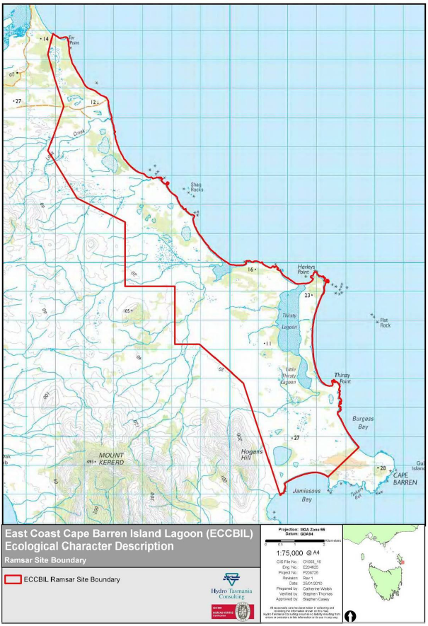

**Figure 2.1: Map of the truwana Lagoons Ramsar Site (from Dunn et al. 2010).**

## Ramsar listing criteria

The truwana Lagoons Ramsar Site is listed under criteria 1 and 3.

*Criterion 1: A wetland should be considered internationally important if it contains a representative, rare, or unique example of a natural or near-natural wetland type found within the appropriate bioregion.*

truwana Lagoons Ramsar Site provides high quality representative examples of eight Ramsar wetland types in almost completely natural condition (Table 2.2).

**Table 2.2: Ramsar wetland types found in truwana Lagoons Ramsar Site (adapted from Dunn et al. 2010)**

|  |  |  |
| --- | --- | --- |
| **Ramsar Wetland Type** | **Ramsar Wetland Code** | **Approximate Area/Size** |
| Rocky shores | D | 20 ha |
| Sand shingle or pebble shores | E | 80 ha |
| Estuarine waters | F | 200 ha |
| Intertidal mud sand or salt flats | G | 55 ha |
| Intertidal marshes | H | 44 ha |
| Coastal brackish/saline lagoons | J | 375 ha |
| Coastal freshwater lagoons | K |
| Seasonal/intermittent/irregular rivers/streams/creeks | N | 38 km |

*Criterion 3: A wetland should be considered internationally important if it supports populations of plant and/or animal species important for maintaining the biological diversity of a particular biogeographic region.*

truwana Lagoons Ramsar Site supports a large range of wetland vegetation types, including six TASVEG vegetation types covering 13 wetland floristic communities identified by Kirkpatrick and Harwood (1981) (Table 2.3). These communities are present within the site at different successional stages, contributing to a high diversity of habitats and species present at the site (Dunn et al. 2010).

*Other listing criteria*: There are other listing criteria based on supporting internationally, nationally and regionally rare or threatened species and also on supporting migrating waterbirds.

truwana Lagoons Ramsar Site is likely to meet more criteria but there is very little information on waterbirds and other species at the site. Without evidence, these criteria could not be listed a being met.

**Table 2.3: Wetland floristic communities in the truwana Lagoons Ramsar Site and their corresponding TASVEG mapping unit and conservation status (adapted from Dunn et al. 2010)**

|  |  |  |  |
| --- | --- | --- | --- |
| TASVEG description | **TASVEG code** | **Conservation status (***Nature Conservation Act***)** | **Floristic community description Kirkpatrick and Harwood (1981)** |
| Lacustrine herbland | AHL | Threatened | ***1****. Mimulus repens* (creeping monkey flower) herbfield  ***2****. Selliera radicans* (shiny swampmat) herbfield  ***3****. Wilsonia rotundifolia* (roundleaf wilsonia) herbfield |
| Freshwater aquatic sedgeland and rushland | ASF | Threatened | ***4****. Baumea arthrophylla* (fine twigsedge) sedgeland  ***5****. Eleocharis sphacelata* (tall spikesedge) sedgeland  ***6****. Lepidosperma longitudinale* (spreading swordsedge) sedgeland |
| Freshwater aquatic herbland | AHF | Threatened | ***7****. Triglochin procerum* (greater waterribbons) aquatic herbland  ***8****. Myriophyllum elatinoides*\*aquatic herbland  ***9****. Myriophyllum propinqua*βaquatic herbland |
| Saline aquatic herbland | AHS | Threatened | ***10****. Lamprothamnium* spp. (charophyte) aquatic herbland  ***11****. Lepilaena cylindrocarpa* (longfruit watermat) aquatic herbland |
| Saline sedgeland/rushland | ARS | N/A | ***12****. Juncus kraussii* (sea rush) rushland |
| Succulent Saline herbland | ASS | N/A | ***13****. Sarcocornia quinqueflora* (beaded glasswort) herbfield |

*Now known as *Myriophyllum salsugineum* (lake watermilfoil), (Buchanan 2009, in Dunn et al. 2010)

βThis taxon has been split into *Myriophyllum simulans* (amphibious watermilfoil) and *M. variifolium* (variable milfoil), (Buchanan 2009, in Dunn et al. 2010)

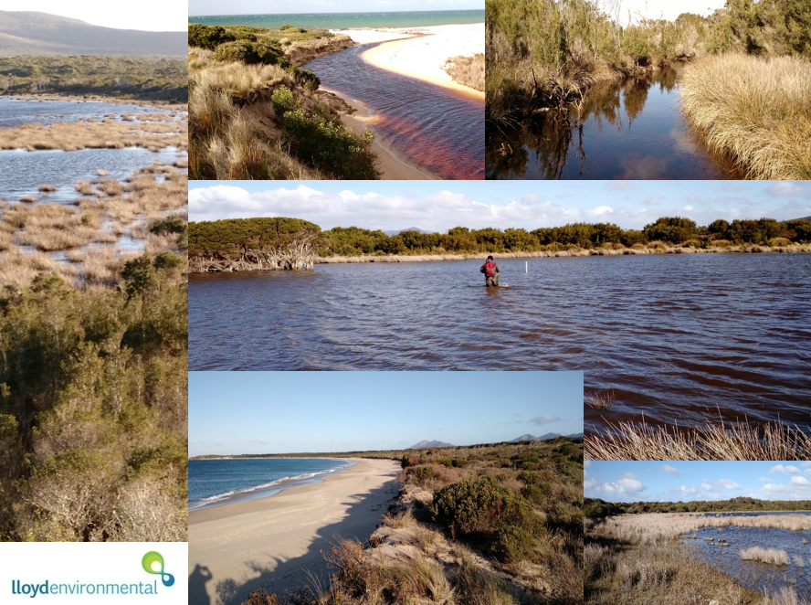

Plate 1: Montage of habitat types within the truwana Lagoons Ramsar Site

|  |
| --- |
|  |

Plate 2: Fauna and habitat of the truwana Lagoons Ramsar Site (Photos by Graeme Gardner)

## Ecological Character

### Critical components, processes and services

The critical components for the truwana Lagoons Ramsar Site were determined based on their importance in influencing or determining the ecological character (Dunn et al. 2010). The selection criteria were:

* they are important determinants of the sites unique character;
* they are important for supporting the Ramsar criteria under which the site was listed;
* change is reasonably likely to occur over the short or medium term (<100 years); or
* if change occurs to them they will cause significant negative consequences (DEWHA 2008).

Using these criteria, the critical components and processes for the truwana Lagoons Ramsar Site at the time of listing in 1982 were determined to be:

* Geomorphology;
* Hydrology; and
* Vegetation types.

The site may have additional critical components and processes, particularly those supporting shorebirds However, there are insufficient data to evaluate whether they are a critical component. Further investigation and monitoring of the site is required (refer to section 9 of this report).

### Ecosystem benefits and services

Using the Millennium Ecosystem Assessment Ecosystem (2005) list of recognised services, four important services were identified as being provided by the truwana Lagoons Ramsar Site, falling within three service categories: Regulating services, Cultural services and Supporting services (Table 4). The services are presented in Table 4 with descriptions of their function and the components and processes they service.

**Table 2.4: Ecosystem services, and related components and processes in the truwana Lagoons Ramsar Site (source: Dunn et al. 2010)**

|  |  |  |
| --- | --- | --- |
| **Ecosystem benefit or service** | **Description** | **Related component or process** |
| **Regulating service** | | |
| Coastal shoreline stabilisation | Vegetation associated with the wetlands plays an important role in stabilising the highly dynamic coastal system. | * Flora * Geomorphology, including sediment deposition and retention of soils * Hydrology * Water quality, including groundwater recharge and discharge |
| **Cultural service** | | |
| Spiritual and inspirational | The site has significant cultural value in recent history of the Tasmanian Aboriginal Community and is a place of spiritual and religious significance | * Geomorphology * Hydrology * Flora * Fauna |
| **Supporting service** | | |
| Natural or near-natural wetland ecosystems | The site is a good example of an almost natural coastal wetland system in near pristine condition. | * Flora * Fauna * Geomorphology * Hydrology * Water Quality |
| Threatened wetland species, habitats and ecosystems | The site supports rare or uncommon plant species and communities at the limit of their ranges. | * Flora * Fauna * Geomorphology * Hydrology * Water Quality |

Using the same selection criteria for identifying critical ecosystem services as those applied to components and processes (DEWHA 2008), the critical ecosystem service for the truwana Lagoons Ramsar Site was determined to be ‘Natural or near-natural wetland ecosystem’. The dynamics and diversity of the site’s vegetation are maintained because of the absence of human induced disturbance, which makes them unique within the Tasmanian Drainage Division. All six TASVEG freshwater and saline wetland types (mapping units) are found within the site and they are comprised of 13 separate floristic wetland communities (Dunn et al 2010).

### Limits of Acceptable Change and Ecological Character status

Dunn et al (2010) established the limits of acceptable change for the truwana Lagoons Ramsar Site (Table 2.5). Table 2.5 outlines the current (baseline) condition, range and extent of the site’s critical ecological components, processes and services and how much these could change before indicating a potential change in the Site’s ecological character.

Table 2.5: Limits of Acceptable Change and Status of the Ecological Character of the Site (Source: Dunn et al. 2010)

|  |  |  |  |  |
| --- | --- | --- | --- | --- |
| **Critical ecological components, processes and services** | **Baseline condition and range of natural variation where known** | **Limits of acceptable change (based on baseline and natural variability)** | **Basis of LAC** | **Level of confidence** |
| Critical component and process: **Geomorphology** **and** **hydrology** Critical service: **Natural or near-natural wetland ecosystem** | There is a diversity and range of Ramsar wetland types which are defined by their geomorphology and hydrology.  There is an absence of information relating to the variability in extent and types of wetland around the time of listing | The areal extent of Ramsar wetland types1 does not change by ±20%, i.e.:   * estuarine waters (F) ± 20% from 200 hectares * intertidal marshes (H) ± 20% from 44 hectares * coastal brackish/saline lagoons (J and K) ± 20% from 375 hectares * intertidal mud sand or salt flats (G) ± 20% from 55 hectares. | Based on aerial photograph interpretation and geomorphological mapping by Frances Mowling | Low:  Limited confidence in estimates of areal extent.  Limited data on changes to geomorphology, hydrology and vegetation types since time of listing (refer to Chapter 7 of Dunn et al. 2010). |
| Critical component and process: **Hydrology** Critical service: **Natural or near-natural wetland ecosystem** | Hydrology as a critical component and service is linked to the geomorphology of the wetland. | As above, this LAC is linked to the geomorphology of the wetland. | As above | As above |

1 Does not include the Ramsar wetland types − rocky shores (D), sand shingle or pebble shores (E), or seasonal/intermittent/irregular/rivers/streams/creeks (N) because the coastal land forms (D) and waterways (N) are natural formations which will not change significantly without human intervention whereas coastal shorelines (E) are likely to have a high natural variability depending on weather conditions (e.g. storm events).

Table 2.5 (cont.): Limits of Acceptable Change and Status of the Ecological Character of the Site (Source: Dunn et al. 2010)

|  |  |  |  |  |
| --- | --- | --- | --- | --- |
| **Critical ecological components, processes and services** | **Baseline condition and range of natural variation where known** | **Limits of acceptable change (based on baseline and natural variability)** | **Basis of LAC** | **Level of confidence** |
| Critical component **Vegetation types**  Critical service: **Natural or near-natural wetland ecosystem** | Thirteen different Tasmanian wetland vegetation communities were identified within the site which corresponds to six TASVEG communities.  Sixteen flora species have been recorded on site that are threatened in Tasmania.  Vegetation succession is an integral component of the site’s wetlands such that some changes in vegetation communities are normal. | Maintenance of the extant TASVEG vegetation communities on site at time of listing i.e.   * lacustrine herbland (AHL) * freshwater aquatic sedgeland and rushland (ASF) * freshwater aquatic herbland (AHF) * saline aquatic herbland (AHS) * saline sedgeland/rushland (ARS) * succulent saline herbland (ASS). | Based on the limited available vegetation data i.e. TASVEG mapping, the Kirkpatrick and Harwood (1981) survey and expert opinion. | Low:  Not confident in the data and not confident that this will represent a change in ecological character.  Limited information about the variability in extent and condition of the vegetation types since the time of listing is available.  Difficult to describe baseline condition and variability (refer to Chapter 7 of Dunn et al. 2010). |

## Land tenure and land use

At the time of listing, the truwana Lagoons Ramsar Site was unallocated Crown Land under the Crown Lands Act 1976 and was managed by the Tasmanian National Parks and Wildlife Service. Freehold title to part of Cape Barren Island was vested in the Aboriginal Land Council of Tasmania, on behalf of the Tasmanian Aboriginal community, under the Aboriginal Lands Act 1995 (Tasmania). A second land transfer of 45 000 hectares in 2005 placed most of the island under Aboriginal ownership. This includes the truwana Lagoons Ramsar Site.

Previously, the local Aboriginal community organisation, the Cape Barren Island Aboriginal Association (CBIAA) was the land manager for the Ramsar Site but management is now under the direction of the Aboriginal Land Council of Tasmania.

The previously leased northern area of the Site for cattle grazing has been fenced and cattle are largely excluded from the Site. Previously, cattle roamed freely across the site, trampling around wetlands. Natural Heritage Trust funding was provided to the lessee in 2002 to fence the areas used for grazing and prevent livestock from straying into the wetland areas (Department of Premier and Cabinet 2004). In addition, part of the lease area has been revoked but the effectiveness of these measures is variable.

## Current management plans

Management plans that are currently relevant to the site are presented in Table 2.6. Each plan and its relevance to the Ramsar site has been described more fully in Section 1.4.4 of this document.

Tale 2.6: Management plans relevant to the truwana Lagoons Ramsar Site

|  |  |  |
| --- | --- | --- |
| **Title** | **Focus of plan & relevance to truwana** | **Author and year** |
| Badger and Hummocky: Draft Badger and Chappell Islands Management Plan 2011 – 2016. | Provides direction for the Land Management Program to achieve goals on Badger and Hummocky, as determined by the Aboriginal community. Substantial overlap with truwana in terms of environmental setting, Aboriginal community input to management, and alignment with international management principles [Ramsar for truwana; Indigenous Protected Areas (IUCN Category V) for Badger and Hummocky]. | Tasmanian Aboriginal Centre Land Management Program (2011). |
| Cape Barren Island Draft Management Plan: An investigation of the issues concerning the use and environmental management of the island. | Presents issues for consideration that are directly relevant to management of truwana. | Tony Weaver (2008), for the Aboriginal Land Council of Tasmania. |
| Furneaux Fire Management Area Fire protection Plan 2014 – 2019. | Designed to manage bushfire-related risk to people, assets and community values (including the environment) within the Furneaux Fire Management Area. | Steve Summers (2015) for the Furneaux Fire management Area Committee. |
| truwana Weed Management Plan | Presents a ‘rough weed map’, priority areas, and significant weed locations within truwana and nearby islands. The Plan also notes weed infestations of the Ramsar Site, potentially undermining its Ramsar status. | Tasmanian Aboriginal Centre Inc. (undated) |

# PHYSICAL CHARACTERISTICS

## Geology

The oldest rocks on truwana are a thick sedimentary sequence (the Mathinna Beds) formed from sand, silt and muds, which have been intruded by granite that is exposed over almost half of the island (Weaver, 2008). Undifferentiated Quaternary sediments cover almost as much of the island’s surface as the Mathinna Beds and are the prevalent surface within the Ramsar site.

The Quaternary sediments consist of wind-blown, marine and alluvial (river-borne) deposits and are generally sandy over most of the coastal areas, including the Ramsar Site (Perrin 1988). These areas are susceptible to wind erosion if vegetation cover and dune or soil structure are disturbed.

## Geomorphology and Soils

There are two identified mountain ranges on truwana, the Mount Munro range in the northwest and the Mount Kerford range in the southeast. The Ramsar Site lies to the north and east of the Mount Kerford range, on a low-lying, generally sandy, coastal plain.

Within the Ramsar site, there are a number of coastal lagoons that have formed along the eastern coastline due to parallel sand dunes blocking drainage to the coast. There are also lunettes bordering lagoons and parabolic dunes, with both landforms formed by the predominantly westerly winds. Wetlands within the site have generally formed in response to a number of historic and ongoing geomorphic processes (Dunn et al. 2010), including:

* deflation, caused by loose sediment being blown by wind to bed rock, or to water table;
* physical obstructions such as sand barriers impeding water flow (e.g. parallel dunes, bars, spits, or sediment accumulation);
* tidal and wave driven coastal processes operating within and at the mouths of tidal lagoons
* water scour of drainage channels
* a combination of these processes potentially varying over time.

Overall, truwana’s soils are poorly developed, severely constraining agricultural development. The eastern part of the island has soils that are deep with ridges of pale yellow sand often with an iron organic layer at depth.

Specific features identified in the Ramsar Site as key geomorphic components that influence the diversity of wetland types and conditions (Dunn et al. 2010) are:

Small low energy estuarine systems. These barrier-impounded systems are flushed by intermittent fresh water inputs from shallow, frequently dendritic stream channels and are represented by Thirsty Lagoon, Little Thirsty Lagoon, Little Creek and two unnamed systems. Spits and bars have formed at the entrances to these estuarine systems, suggesting intermittent flushing by marine waters and some isolation from marine influence for long periods.

Impounded lagoons. In the Ramsar site these are generally located inland of shore parallel dunes or beach ridges. A string of these lagoons occurs in the north of the site. These lagoons may be the result of deflation basins originally formed during colder climatic stages, subsequently becoming impounded. There is marked variation in depth of basin and duration of inundation between the lagoons. Some lagoons contain fresh water, others are brackish to hypersaline.

Deflation basins. There are several lagoons, mainly in the southern part of the site, formed predominantly in response to deflation by wind at the site, including lagoons 3338, 2338, 329, 341 and 335 (Dunn et al. 2010)). Lagoon 341, covering 33 hectares in the south end of the Ramsar Site near Jamiesons Bay, is the most obvious example of a deflation basin and is possibly of Pleistocene origin. This lagoon has a lunette and is of at least regional significance as a representative example of this landform, and possibly outstanding given its condition (Ian Houshold, in ECD)

Deflated plains. These features are formed by wind reducing the dune surface to either ground water level or to bedrock, forming low lying areas that are subject to inundation for variable periods. The distribution of wetted areas and degree of inundation is not documented for the Ramsar site. The deflated plains have a network of dendritic drainage channels that originate in the Mount Kerford range and are particularly evident in the northern portion of the site. The drainage channels disperse water across the deflated plains after effective rainfall. The moist conditions of the plains may be enhanced by groundwater flow lying on impermeable bedrock or subsoils.

Drainage channels. These originate in the ranges external to the Ramsar Site and become low energy stream capture channels on the low gradient plain. The channels that run through the sandy sediments are typically deeply scoured whereas the channels in the deflated plains typically form only shallow indentations. The channels are more numerous in the northern portion of the Ramsar site, dispersing fresh water flow across the wetlands of the plain, then subsequently reforming into single channels and draining into impounded lagoons or estuaries. Some channels are lined with vegetation. Some channels may be barred by sediment dams with resulting formation of organic soils.

Polygenetic wetlands. These wetlands are a mixture of dune (or beach-ridge) barred lagoons and deflation basins. Examples of these wetlands mostly occur in the northern half of the site and all are good representative examples because of their good condition, including the two Flyover Lagoons (wetlands 330 and 331).

In addition to these features, the ‘Cape Barren Dunes’ within the truwana Lagoons Ramsar Site is a geoconservation site in Tasmania (RIS 2012).

## Climate

The climate of truwana is maritime and temperate (Perrin 1988) with warm summers, cool winters and no real dry season. The average annual rainfall is 710 mm (Perrin 1988). There is no Bureau of Meteorology weather station on truwana, although there are weather stations on nearby Flinders Island and Swan Island with both displaying similar rainfall data. A climograph, showing monthly rainfall and temperature measures from Swan Island is presented in Figure 2.a. At Swan Island, daily maximum temperatures average around 20°C in summer and around 13°C in winter (Figure 2.a), although Perrin (1988) notes a peak of around 23°C at truwana in February.

Rainfall has a small but sustained peak from late autumn to early spring, with mean monthly rainfall of 50mm or greater from April to October (Figure 3.1).

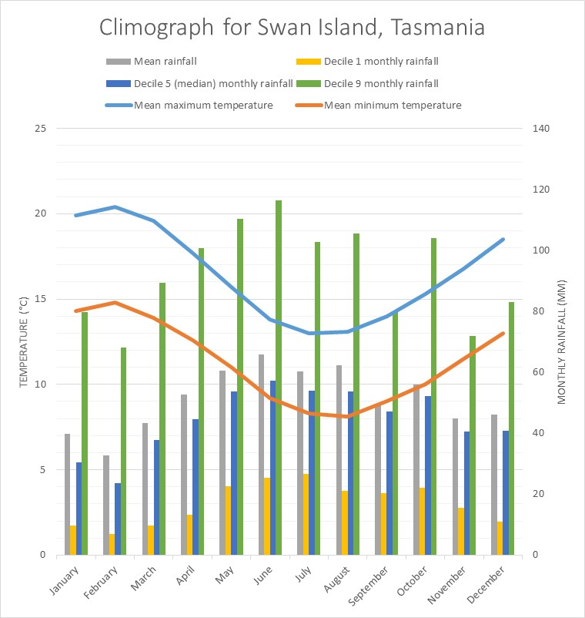

**Figure 3.1. Climograph for Swan Island, near truwana. Data source from BoM website.**

## Hydrology

For much of truwana, drainage is mainly via short creeks arising in the high inland areas (Perrin 1988) and within the Ramsar Site a number of coastal lagoons exist along the coastline due to the presence of sand dunes blocking drainage on the low-lying coastal plain which stretches from Puncheon Point in the north to Cape Barren Point in the south (Weaver 2008). Elsewhere in the site the large areas of sediments overlying impermeable bedrock leads to streams and surface flows from catchments reaching the dune sands and quickly sinking below the surface then following subsurface flow paths as groundwater (Dunn et al. 2010). This groundwater is discharged as beach springs and estuaries, and is exposed as lagoons where wind has deflated the sand to the water table. The only waterway to cross the dune field is Little Creek in the north of the Ramsar site, and this creek is ephemeral (Dunn et al. 2010).

Elsewhere in the northern areas of the site, the comparatively extensive catchment area supports freshwater drainage channels that flow into a series of deflation plains that are subject to inundation. These areas subsequently drain into Little Creek and two unnamed estuarine systems (Dunn et al. 2010). In contrast, the southern area of the site has fewer drainage channels with large areas of sand-sized particles several metres deep. The southern half of the site contains Thirsty Lagoon, Little Thirsty Lagoon, deflation basins, chains of impounded lagoons behind parallel dune ridges and a mosaic of drainage channels and hummocky ‘islands’ (Dunn et al. 2010).

Within the site there are some small lagoons, independent of the groundwater. These are perched lagoons, sealed by a low permeability peat layer. The existence of these lagoons is dependent on the peat layer, and any puncturing of this layer in any of the lagoons could limit its capacity to hold water (Dunn et al. 2010). The use of off-road vehicles therefore has the potential to seriously impact these lagoons.

## Changes in ecological character since listing

The truwana ecological character description notes that there is limited information available for the site, making it difficult to assess changes in ecological character since listing in 1982. Bases on the remoteness and relatively undisturbed nature of the site, the site was assumed to be relatively unchanged since listing (Dunn et al. 2010).

Two threats that were noted to have either arrived or increased since listing, without yet impacting on the site’s ecological character, were introduced weeds and the pathogen ‘roor-rot fungus’ (*Phytophthera cinnamomi*). The area of the site was noted to be free of weeds prior to listing (Kirkpatrick and Harwood 1981, in Dunn et al. 2010) but since then thistle (*Cirsium arvense*) (Blackhall 1986), marram grass (*Ammophila arenaria*), gorse (*Ulex europaeus*) and sea spurge (*Euphorbia paralias*) (Harris and Magnus 2004) have been reported at the site.

It is not known when *Phytophthera cinnamomi* was introduced to truwana or its Ramsar site. There is some thought that it may have reached the site after listing (Dunn et al. 2010) although this may be due to its impacts becoming more apparent in recent years.

Changes in the fire regime of the site has been listed as both a threat and a knowledge gap for the site. Two significant fires are known to have burnt a large percentage of the site. Large wildfires occurred on truwana in 2006 and 2017. There is little information about the 2006 fire except for a map of fire extent, but it appears that many of the wetlands of the site were not directly impacted by the 2017 fire. Further field work will be required to determine long-term effect of these fires on ecological condition of the site.

# BIOTA OF THE SITE

## Flora

The truwana Lagoons Ramsar Site supports all freshwater and saltmarsh TASVEG mapping units and a significant proportion of the wetland floristic vegetation communities found in Tasmania (Dunn et al. 2010). Three groups of saline wetland vegetation communities occur at the site (Dunn et al. 2010):

* *Wilsonia rotundifolia* (round-leafed Wilsonia) and *Sarcocornia quinqueflora* (beaded samphire, beaded glasswort) herbfields occur in highly saline situations with prolonged exposure above water level (the most saline locations in the site);
* *Juncus kraussii* (sea rush) rushland and *Selliera radicans* (shiny swamp mat) herbfield occur in brackish to saline sites with prolonged exposure; and
* *Lepilaena cylindrocarpa* (watermat) and *Lamprothamnium* (stonewort) communities are saline but with longer periods of inundation

The physical characteristics of the site, particularly the geomorphic and hydrologic diversity have contributed to the corresponding diversity in the site’s vegetation communities including spatial and temporal (successional) mosaics. As identified in Section 2.3 of this report, the range of wetland vegetation types at the site includes eight Ramsar wetland types, six TASVEG vegetation types and 13 of the wetland floristic communities identified by Kirkpatrick and Harwood (Tables 2.2 and 2.3). The different successional stages further contribute to a high diversity of habitats and species present at the site (Dunn et al. 2010).

The thirteen Tasmanian wetland vegetation community types identified by Kirkpatrick and Harwood (1981) represents the only systematic floristic data collected for the wetlands of within the Ramsar site and although it provided a finer classification of wetlands vegetation than was mapped by the TASVEG statewide mapping project, there is no definitive map of the vegetation communities as described by Kirkpatrick and Harwood (1981) (Dunn et al. 2010). Current TASVEG mapping identified 17 different native vegetation mapping units within the site (Figure 4.1). Sixteen species of flora listed on the Tasmanian Threatened Species Protection Act 1995 have been recorded at the site.



**Figure 4.1: TASVEG vegetation communities of the truwana Lagoons Ramsar Site (source: Dunn et al.** **2010)**

## Fauna

### Avian Fauna

A bird survey of the truwana Lagoons Ramsar site was conducted in 1996, recording 13 wetland dependent species and nine migratory species (Dunn et al. 2010) (Table 4.1). Although no systematic surveys of migratory birds have been conducted at the site, Thirsty and Little Thirsty Lagoons have been identified as providing suitable habitat for migratory species (Hirst et al. 2006 in Dunn et al. 2010). Similarly, parts of the site have also been characterised as offering a range of habitats for waterbirds, shorebirds and migratory waters, including feeding and nesting sites (Dunn et al. 2010).

### Microfauna and Estuarine invertebrates

Surveys of aquatic microfauna have been undertaken at Flyover Lagoon and a deflation basin near Jamiesons Bay, with the former recording 28 species and ranking among the highest of any lagoons in the Bass Strait Islands (Walsh et al. 2001 in Dunn et al. 2010). In contrast, the lagoon in the deflation basin near Jamiesons Bay only recorded five species. Water chemistry and variability of salinities may play a significant role in the composition and diversity of the microfauna (Dunn et al. 2010).

A survey of invertebrates was undertaken in the Thirsty Lagoon system and an unnamed estuary north-west of the mouth of Thirsty Lagoon. A total of twenty taxa were identified across the estuaries, with changes in the fauna noted to be a function of variability and extremes in salinities, as well as continuity of connection with the ocean and variability of size and depth of the water bodies.

**Table 4.1: Wetland dependent and migratory species recorded at the truwana Lagoons Ramsar Site (Data source: Dunn et al. 2010; SPRAT Database Sept 2017).**

|  |  |  |  |  |
| --- | --- | --- | --- | --- |
| Species name | Wetland dependent | Migratory | EPBC Status | Tasmanian Conservation Status |
| Red-capped plover *(Charadrius ruficapillus)* | ✓ |  | Marine | - |
| Double-banded plover *(Charadrius bicinctus)* | ✓ | ✓ | Marine | - |
| Hooded plover *(Thinornis rubricollis)* | ✓ |  | Marine  Vulnerable | - |
| Red-necked stint *(Calidris ruficollis)* | ✓ | ✓ | Marine | - |
| Ruddy turnstone *(Arenaria interpres)* | ✓ | ✓ | Marine | - |
| Curlew sandpiper *(Calidris ferruginea)* | ✓ | ✓ | Critically Endangered  Marine | - |
| Knot (unspecified) *(Calidris sp.)* | ✓ |  | Marine (some species are Endangered or Critically Endangered) | - |
| Crested tern *(Thalasseus bergii)* |  | ✓ | Marine | - |
| Caspian tern *(Hydroprogne caspia)* |  | ✓ | Marine | - |
| Short-tailed shearwater *(Ardenna tenuirostris)* |  | ✓ | Marine | - |
| White-bellied sea eagle *(Haliaeetus leucogaster)* | ✓ | ✓ | Marine | Vulnerable |
| Great egret *(Ardea modesta)* |  | ✓ | Marine | - |
| Large black cormorant *(Phalacrocorax sp.)* | ✓ | - | Marine | - |
| Australian pelican *(Pelecanus conspicillatus)* | ✓ | - | Marine | - |
| Black swan *(Cygnus atratus)* | ✓ | - | - | - |
| Chestnut teal *(Anas castanea)* | ✓ | - | - | - |
| Pacific Black duck *(Anas superciliosa)* | ✓ | - | - | - |

# CULTURAL VALUES

## Aboriginal Cultural Heritage

Although there is evidence aboriginal occupation of the Furneaux Islands until approximately 4,500 years ago and eleven sites on truwana are recorded on the Tasmanian Aboriginal Island Index (Weaver 2008), none have been recorded in the Ramsar site. However, this is likely due to there being no formal assessment of these values within the site. Crystal Lagoon, approximately 8 km from the Ramsar Site boundary on the south of truwana, contains two listed sites. One of these is, in terms of prehistoric artefact numbers, one of the richest surface sites recorded in the Furneaux region (Department of Premier & Cabinet 1999 in Weaver 2008). The density of artefacts probably relates to an advantageous combination of freshwater availability, stone sources and localised topography and vegetation.

The island is significant in recent history of the Tasmanian Aboriginal community. The transfer of ownership to the Aboriginal community in 2005 acknowledged the long association and significant meaning of the area for Indigenous people.

The Tasmanian Aboriginal people have a long history of traditional activities associated with lagoon environments, including gathering plant and animal resources. Information about the cultural values of the Ramsar Site for the local community was not available for the production of the site’s Ecological Character Description (Dunn et al. 2010) ECD, although the CBIAA have stated that they do not use four-wheel drives (4WD) or motor-bikes around the Ramsar Site (Dunn et al. 2010).

## European Cultural Heritage

No European cultural heritage sites are recorded within the truwana Ramsar site.

# WISE USE

As a Contracting Party to the Ramsar Convention, Australia has committed to work towards the wise use of all the wetlands and water resources in its territory, through national plans, policies and legislation, management actions and public education. The Ramsar Convention defines wise use of wetlands as “the maintenance of their ecological character, achieved through the implementation of ecosystem approaches, within the context of sustainable development”. More simply, ‘wise use’ can be described as the conservation and sustainable use of wetlands and all the services they provide, for the benefit of people and nature (Ramsar Convention Secretariat 2017).

In many situations, ‘sustainable use’ incorporates existing human uses of wetlands, ranging from fishing and hunting by indigenous peoples, through to water extraction for major irrigation developments. The existing use of truwana has been minimal and undocumented. Therefore, wise use of the truwana Lagoons Ramsar Site could include little or no change to current to management, perhaps with the exception of stopping unauthorised tourism at the site. In this context, any discussion of potential uses of the site represents an increase in use rather than a reduction or amelioration of impacts.

## Economic

### Tourism

Currently there is no authorised tourism of the site, although unauthorised use in known to occur with evidence including numerous shotgun cartridges and ‘off-track’ tyre tracks. There is potential for some form of ecotourism at the site with the following issues needing to be considered:

* Provision of off-site accommodation and provisions;
* Determining whether overnight camping will be allowed on-site;
* Provision of transport options to and from the site;
* Positive and negative potential impacts on the community;
* Identifying a maximum number of tourists over several time periods (e.g. per day, per season and per year);
* Visitor management and facilities (e.g. board walks, fences, toilets)
* Determination and enforcement of fire bans or restrictions;
* Ways to stop unauthorised tourism;
* Provision of interpretations material, including on-site signs, brochures and booklets; and
* Provision of guided tours by rangers (with the consequent need to empower the rangers with presentation skills and range of knowledge of the site).

The above dotpoints are not exhaustive and need to be discussed by the ALCT and the truwana community, preferably with technical input from relevant government departments (in particular, DPIPWE).

### Farming

There is no authorised farming on the site and discussions with the truwana community and ALCT indicated no intention to start farming. Fresh cattle spoor and manure well within the site boundaries demonstrated that unauthorised grazing occurs on the site. There is only a single farm where the cattle could have come from. The documented impacts of cattle on wetlands suggests that discussions with the farm owners would be important.

## Recreation

### Current - passive

Currently there is very little recreation at the site, with only the occasional visitor from the truwana community or from the Tasmanian mainland known to visit the site.

### Potential/Future

Passive recreation is likely to increase with growing interest in the site from the truwana community. During community input and information exchange sessions held as part of the development of this management plan, several community members began planning a site excursion with the truwana rangers. Some of the community mentioned areas of interest within the site that they had heard about or had seen and would like to visit. Although this form of recreation is likely to be the most minimal impact on the site, there are still management actions to be considered for its wise use, including fire safety and management, keeping on tracks, minimising disturbances, and implementing *Phytophthora* quarantine measures, such as foot baths at strategic locations.

Any form of recreation by visitors to truwana should be considered under tourism.

## Environmental and Cultural Education

There is no formal education being undertaken at the site. Potential types and forms of education could include:

* Training or the truwana rangers, in:
* Flora, fauna and other environmental knowledge, by other Tasmanian aboriginal rangers, field naturalists club members, and/or relevant DPIPWE staff;
* Cultural site training by suitable elders, and/or other Tasmanian aboriginal rangers;
* Information sessions for the truwana community run by the truwana rangers, possibly assisted by other rangers and/or field naturalist club members;
* University undergraduate field trips examining cultural or natural history

Some of these education options could be run in conjunction with recommended monitoring programs for the site’s management.

## Scientific Research

There have been scientific descriptions of the site’s landforms (e.g. Cocker 1980; Perrin 1988) as well as some surveys of biota, forming parts of larger survey programs (e.g. Kirkpatrick and Harwood 1981). However; there are no known detailed scientific studies of the site. Possible future studies could include post-graduate theses of the site’s vegetation communities, bird populations, cultural sites, water regimes, and/or palaeoecology.

Similar to the educational opportunities, these research opportunities could be designed to align with baseline surveys and monitoring programs to maximise the information for both. See Sections 8 and 9 (management and Monitoring, respectively).

# THREATS and knowledge gaps

This section lists the key threats and knowledge gaps associated with the site and identifies priority issues. Management approaches, roles and responsibilities are presented in subsequent sections.

Six major threats to the Ramsar Site have been identified (Dunn et al. 2010). Four were identified as already occurring: fire (increase in intensity and frequency); exotic species (plants and animals); pathogens (root-rot fungus and possibly chytrid fungus); and climate change (changes in sea level, temperature and rainfall). Vehicle access (particularly four wheel drives) was identified as almost certainly occurring and grazing as possibly occurring.

Since the preparation of the ECD, reconnaissance trips to the site have identified recent vehicle tracks in the site and recent evidence of cattle access (cattle tracks and droppings). Since the ECD there has also been a major fire in on truwana, covering much of the Ramsar Site, although the full extent is yet to be detailed.

Two key knowledge gaps have been identified: change in fire regime; and presence/extent of Aboriginal cultural heritage sites within the Ramsar Site.

## Fire

The short-term impacts from fire include the loss of vegetation, leading to:

* increased susceptibility of soils and sediment to erosion;
* loss of habitat for flora and fauna species;
* direct loss of flora and fauna species and communities from the site; and

Medium- to long-term impacts from fire include changed floristics, leading to:

* increased coverage of more fire tolerant and/or fire promoting species;
* permanent loss of flora and fauna species and communities;
* permanent changes to geomorphic features of the site through erosion; and
* decreased options for adaptive management (e.g. for climate change)

Although there are no sites of Aboriginal cultural significance listed for the Ramsar Site, this is likely to be due to the lack of a relevant survey. Therefore, there is a possibility that impacts of fire could include the loss of Aboriginal cultural sites.

The recent (2017) fire that covered much of the Ramsar Site and of truwana itself has highlighted the difficulty in stopping fires once they start, particularly in hot and windy conditions. Therefore, the highest priority for managing the threat of fire should be to reduce its occurrence. This should include raising community awareness and installation of information boards within the site.

Review of fire management actions and their success/failure during the fire would also help with fire management, as would the benefits of fire planning beforehand.

Studies into fire impacts on floristics of the types of vegetation communities within the site may also help with management of the site.

## Introduced fauna and flora

### Fauna

Little is known about the presence of feral animal species within the Ramsar Site, although rabbits and feral turkeys are both known to be present on truwana and have the potential to impact the site if present. Rabbits may impact the site’s flora through selective grazing of plants as well as causing serious erosion problems by digging and burrowing. Scratching of the soil/litter surface by feral turkeys can impact the regeneration of flora species as well as impact litter fauna (Weaver 2008).

Given the lack of information on the presence of feral animals at the site, the highest priority would be to determine the presence and extent of any feral species at the site. This task could commence with documenting observations of the site rangers and any community members who have visited the site; and then be supported by monitoring.

### Flora

Thistle, marram grass, gorse and sea spurge have been reported at the site (Dunn et al. 2010). The fact that the ECD noted the arrival of these weeds subsequent to listing of the Ramsar Site identifies them as an increasing threat. This has been supported by reconnaissance trips to the site that have noted these weeds, particularly sea spurge (Figure 7.1). The impact of sea spurge and marram grass on the structure and stability of the site’s sand dunes is a serious concern, as is their ability to displace native plant species destroy faunal habitat.

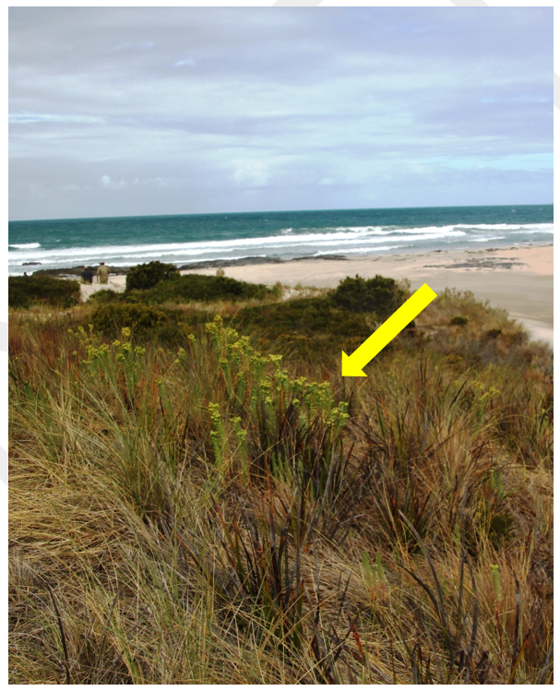

**Figure 7.1: View of northern shoreline of the truwana Lagoons Ramsar Site, with sea spurge in the foreground**

Gorse and African boxthorn (*Lycium ferocissimum*) have also been observed at the Ramsar Site and are noted by Weaver (2008) to be high priority weeds due to their ability to impact negatively on nature conservation values.

The three highest priorities should be:

* Eradication/management of the priority weeds sea spurge, boxthorn and gorse using approaches identified in the truwana Weed Management Plan;
* Identification of a preferred approach to eradication/management of marram grass; and
* An on-ground survey and monitoring program for all weed species at the site.

Prioritisation of management of introduced flora and fauna will need input and feedback from rangers and other relevant community members

## Pathogens

Root-rot fungus is on truwana and it appears that it has infected parts of the Ramsar Site. Currently it is not known whether chytrid fungus is on the island.

The four highest priorities should be:

* Survey the site to identify areas that are already infected with root-rot fungus;
* Implement quarantine measures for people and vehicles entering the site and moving within the site;
* Raise public awareness of root-rot fungus, its impact and control measures; and
* Determine an approach to identify whether chytrid fungus is present within the site and within truwana.

## Climate change / prolonged drought and increased rates of evaporation

Rising sea levels can increased salinisation of wetlands via increased frequency and distance of sea water coverage, as well as forcing a ‘back-up’ of sea water into the groundwater. The impacts of this can be increased by changes in rainfall and increases in air temperature and evaporation. Changes in rainfall can also lead to changes of the vegetation in the catchment and within the wetlands.

Disruptions of weather patterns, including greater variability and more extreme events (droughts, rainfall, and heatwaves) may make the site unsuitable for the flora and fauna that are currently a part of its ecological character. This includes disruptions to breeding cycles, loss of recruitment and complete changes to habitat.

Although there is little that can be done to reduce climate change at a local site level, there are some actions that can be undertaken to help manage the impacts. These include:

* Work to maintain the maximum natural biodiversity of the site. This will help increase management options and adaptation pathways in future scenarios; and
* Liaise with land managers of similar sites to share ideas, lessons and methods for management.

## Vehicle use/misuse and general visitor use

Key issues associated with vehicles and, in particular, driving off tracks, include:

* Disturbance/destruction of vegetation, leaving the soil and sediments more susceptible to wind and water erosion;
* Erosion of soil particle increasing the turbidity of waters running into wetlands (and within wetlands), also increasing the risk of sediment smothering the wetland biota;
* Destruction of native species and their habitat;
* Breaking the seal of perched wetlands, causing potential losses of water from the wetlands;
* Spreading of weeds and pathogens (in particular, root-rot fungus); and
* Potential disruption or death of nesting shorebirds on beaches.

Other issues associated with visitor use include illegal shooting of wildlife. During one of the site reconnaissance visits, four wheel drive tricks were observed on one of the wetlands with numerous shotgun cartridges nearby.

The highest priorities for managing vehicle and visitor use should be:

* Raise public awareness on truwana and Flinders Island about the use of vehicles on the site, including the use of clear signage setting out requirements;
* Raise public awareness of root-rot fungus and the need for vehicles to meet quarantine requirements;
* Consider the running of educational field days, inviting interested community members from truwana and Flinders Island to learn about the site, its ecological status and its threats; and
* Consider developing a visitor management plan, for legal and illegal visitors.

## Grazing pressures

Similar to use of vehicles, grazing can impact through the trampling of flora; pugging of wetland soils/sediments; introduction of weeds and pathogens; erosion; and the runoff of sediment and nutrients into wetlands.

Although there should not be grazing within the site anymore, the presence of cattle tracks and spoor demonstrate that this threat is still occurring.

The most effective approach to the problem is likely to be liaison with the relevant land manager.

## Insufficient knowledge of Aboriginal cultural heritage sites

The lack of any Aboriginal cultural heritage survey within the Ramsar Site presents a clear knowledge gap. The rich density of artefacts at nearby Crystal Lagoon suggests that a cultural heritage survey of the Ramsar Site should be undertaken.

# MANAGEMENT

## Management principles and objectives

The management principles and objectives will be guided by the established community vision for the Ramsar Site. The vision is that the truwana Lagoons Ramsar Site will remain unimpacted by humans, providing an environment where natural wetland processes and undisturbed shorelines protect and maintain habitat for a wide range of vegetation communities, floral species and native fauna.

This vision will maintain the healthy wetland ecosystems present on site, the Ramsar listing criteria and the ecological character of the Site.

The management plan will result in a greater community knowledge & understanding and a reduction and/or management of threats to the site’s values.

The truwana people will be actively involved in the management of the Site and the final plan should be owned by the community and consistent with the wider Island Plan.

Specific objectives of the management plan are to:

* document the legislation, policy and any related management instruments which direct or otherwise influence management both within and adjacent to the site;
* provide a comprehensive site description;
* identify the values for which the site is recognised as a Ramsar Site;
* assess threats to these values through systematic analysis of both current and potential risks;
* clarify the roles and responsibilities of management agencies; and
* give priority to Site Management Strategies that minimise and, where possible, eliminate identified risks to values.

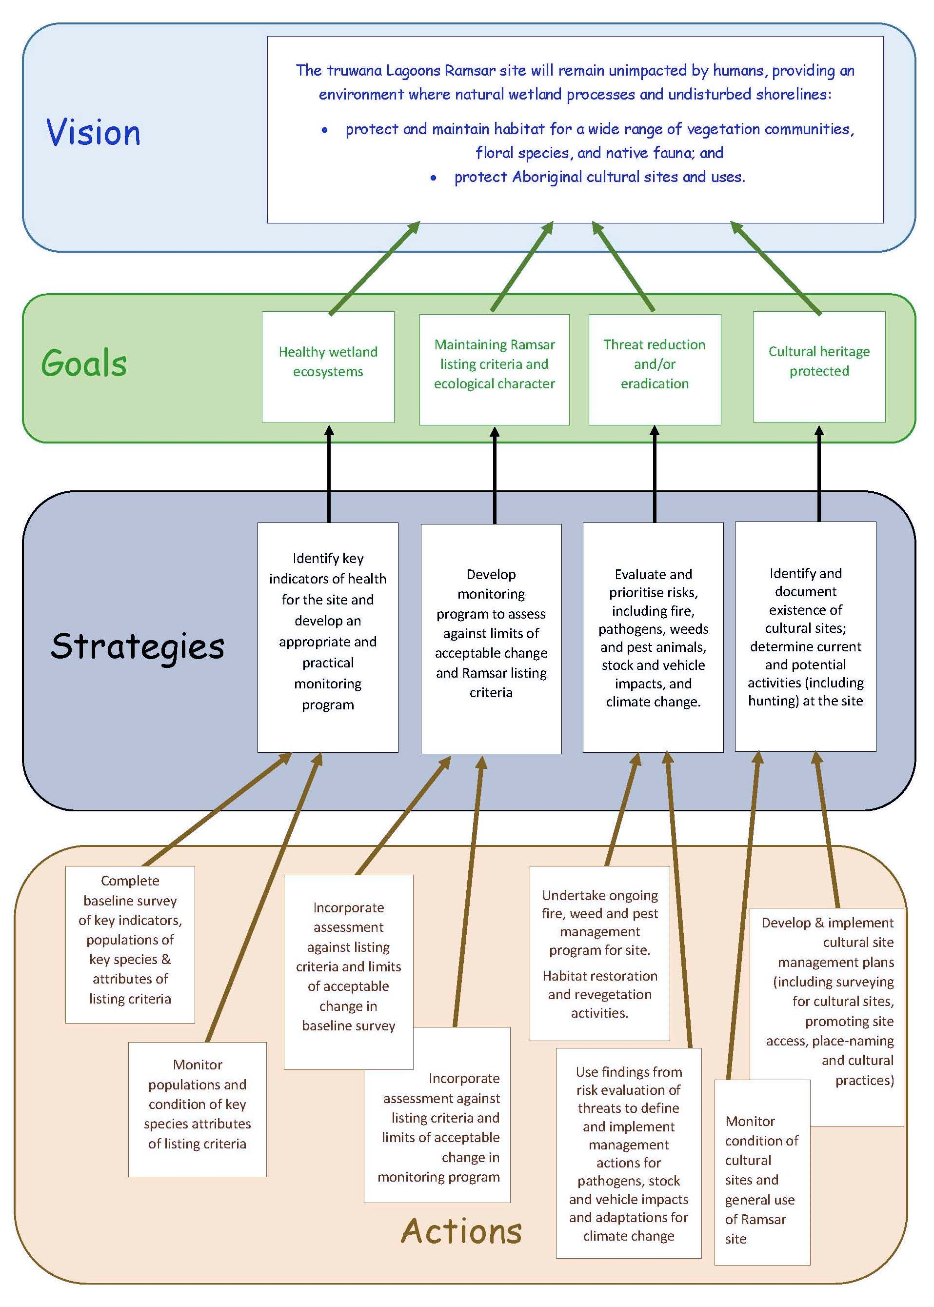

Figure 8.1: Description of how actions within this plan are supported by strategies, which are in turn supporting the goals and vision for the plan.

## Monitoring site health

Identifying key indicators of health for the site and developing an appropriate and practical monitoring program can be separated into two actions:

* Complete a baseline survey of key indicators, populations of key species & attributes of listing criteria; and
* Develop and implement and monitoring program for key indicators, populations of key species & attributes of listing criteria using the results of baseline survey as a foundation.

Baseline survey.

A baseline survey for site health should be developed around the critical components, listing criteria and the limits of acceptable change identified in the ecological character description (Dunn et al. 2010). Critical components and ecosystem services identified in Dunn et al. (2010) were:

* Geomorphology (component), in particular its influence on successional stages of the vegetation communities;
* Hydrology (component), via drainage channels, impounded lagoons, variability of inundation;
* Vegetation types (component), covering a range habitat conditions and a highly diverse mosaic of vegetation communities and rare species that contribute to regional diversity.
* Provision of a near-natural wetland (ecosystem service), with so little disturbance as to make them unique in the Tasmanian Drainage Division.

These components and ecosystem service necessarily align with the listing criteria, through:

* Being a representative, rare, or unique example of a natural or near-natural wetland type found within the appropriate biogeographic region; and
* Supporting populations of plant and/or animal species important for maintaining the biological diversity of a particular biogeographic region.

The baseline survey should also be designed to fill knowledge gaps identified in the ecological character description (Dunn et al. 2010). The knowledge gaps relevant to the ecological health of the site were:

* Mapping of soil types and geomorphic features;
* Hydrological information associated with the wetland types;
* Accurate vegetation mapping;
* Detailed inventory of vascular and non-vascular flora including mapping of threatened species; and
* Detailed inventory of fauna (mammals, reptiles, frogs, fish, birds and invertebrates) including mapping of threatened species.

Monitoring Plan.

A monitoring plan for site health should use the approach, methods and outcomes of the baseline survey to refine the approach and methods to suit the field conditions, the importance/rarity/abundance of the attribute being monitored, and its expected stability. Prior to monitoring, the attributes will need to be assessed in terms of several aspects, including:

* The number of sites and amount of time required for each sampling event;
* The frequency of sampling events for the attribute (for example, geomorphology may need less frequent monitoring than vegetation communities, and vegetation communities may need less frequent monitoring than shorebird nesting);
* The intensity of monitoring (for example, each individual of a rare species may need to be recorded whereas flood waters may simply be noted as present or absent);
* The priority ratings for each attribute should be determined to help determine the percentage of resources that can be allocated to it. Priorities may be based on risks to the attribute, the importance of the attribute; and
* The resources required to obtain meaningful results.

Monitoring methods will also need to be designed with an understanding of how and when changes measured will be evaluated.

## Managing for limits of acceptable change

Limits of acceptable change are set using the critical components of the listing criteria. Therefore, assessing for management of limits of acceptable change requires:

* As part of the baseline survey, obtain quantitative baseline information on the critical components identified for the site’s limits of acceptable change; and
* Incorporate assessment against those limits of acceptable change in the subsequent monitoring program.

These critical components are:

* The areal extent of Ramsar wetland types
  + Estuarine waters
  + Intertidal marshes
  + Coastal brackish/saline lagoons and
  + Intertidal mud, sand or salt flats
* Maintenance of the extant TASVEG vegetation communities on site at the time of listing:
  + Lacustrine herbland
  + Freshwater aquatic sedgeland and rushland
  + Freshwater aquatic herbland
  + Saline aquatic herbland
  + Saline sedgeland/rushland
  + Succulent saline herbland.

## Managing risks

### Fire Management

Raising community awareness and installation of information boards.

This action aims to promote the importance of reducing the occurrence of wild fires. The Fire Protection Plan for the Furneaux fire Management Area notes that management of fire risk is not the sole responsibility of any one element of the community; rather it is a collective responsibility of the whole community.

Raising community awareness could involve tasks such as:

* Documenting a clear approach to fire prevention strategies;
* Holding one or more community meetings;
* Raising the topic through the Cape Barren Island Aboriginal Association;
* Emphasise the topic at relevant fire planning meetings; and
* Working with the Furneaux Fire Management Area Committee in the ongoing updating and development of the Fire Protection Plan for the Furneaux fire Management Area.

Information boards could be installed, setting out any fire restrictions and providing information on safety and management of campfires. These could be installed at priority sites, including:

* The main track leading into the northern end of the site;
* Outside the community centre at The Corner; and
* Any likely camping locations, if visitor use of the site increases.

Review of fire management actions and their success/failure during the 2017 fire and the benefits of fire planning beforehand.

Review of fire management actions during the 2017 fire will include actions undertaken as part of the Fire Protection Plan and also actions undertaken based on active decision-making during the event. Components of the review could include:

* Clear description of each fire management action relevant to the Ramsar Site during the fire event, and categorisation as either from the Fire Protection Plan or ad-hoc decision making;
* Evaluation of the effectiveness of each of the above in the protection of the Ramsar Site; and
* Description and evaluation of preventative/maintenance measures undertaken prior to the fire event (e.g. fire breaks; road maintenance; communications awareness).

Studies into fire impacts on floristics of the types of vegetation communities within the site for management purposes.

Impacts of fires can include short-term and long-term changes to the species make-up of the fire affected areas. An increase in fire frequencies may lead to proliferation of weed species or species that are more fire tolerant or even fire promoting. Being aware of any changes can help with future management decisions. This action could include:

* A baseline survey of the vegetation of the site, including comparisons of sites that were burnt with similar sites that were not burnt; and
* Regular – possibly 5-yearly – monitoring of the baseline survey sites.

Fire management planning

The current Fire Protection Plan is relevant to all of truwana and therefore the Ramsar Site. Therefore it is important to:

* Maintain current Fire Protection Plan for the Furneaux fire Management Area and determine whether any changes should be made in future plans to improve protection of the Ramsar Site
* Incorporate high value (and therefore high consequence) of Ramsar Site and other high value conservation areas (conservation values are mentioned in the Fire Protection Plan but there appears to be a strong focus on buildings/infrastructure)
* Include the importance of using just water in and fire-fighting/fire-bombing; that is, avoid the use of fire retardants and other chemicals that may impact the site.

### Pest animal control

Develop an action plan for pest animal control

Pest animal control is essential to remove the threats post by invasive animal species. Control maintains the levels of animals to a level where impacts are minimised. Further regular patrols will also act as a surveillance program picking up in new pest animals become established.

However, the first action before implementation of specific species control is to develop a clear action plan. It is likely that such a plan will consider:

* Rabbit Control
* Turkey control
* Feral cats control (if present?)

Pest animal (and native animal) surveys

Pest animal (and native animal) surveys will be an important part of any strategy to reduce the impacts of these pests by understanding the levels of pest (and native animals) before management efforts. This will help design the control strategies, locations and methods. Further it will provide a baseline for both pest and native species to measure reductions in pest species and recovery of native species. Thirdly, it will provide additional surveillance for new pests invading before they become established.

### Weed control

Undertake an on-ground survey and monitoring program for all weed species (and native vegetation) at the site

Weed surveying and monitoring should include:

* A site weed survey (potentially as part of an overall vegetation survey) recording species and their locations;
* Regular monitoring (e.g. annual) of sites where weeds have been removed; and
* Regular (e.g. 5 yearly) overall vegetation monitoring.

Eradication/management of the priority weeds sea spurge, boxthorn and gorse using approaches identified in the truwana Weed Management Plan

These three weeds have been identified as present at the site and listed as priority weeds in the truwana weed management plan. Their eradication, following the approaches in the weed management plan, should be a high priority for the Ramsar Site.

Identification of a preferred approach to eradication/management of marram grass

In consultation with DPIPWE, a preferred approach for eradication of marram grass should be identified and implemented at the Ramsar Site.

### Biosecurity management

Biosecurity management is required to control pathogens which can have significant effects on the ecosystem with both cinnamon and Chytrid fungus potential spreading through the Ramsar Site and causing plant and frog deaths.

Survey the site to identify areas that are already infected with root-rot fungus

A survey of the site will allow infected areas to be identified, quarantined, management plan developed and implemented to prevent the pathogens spreading. The survey should follow the determination of an approach to identify whether chytrid fungus is present within the site and within truwana.

Implement quarantine measures for people and vehicles entering the site and moving within the site

Quarantine measures are the frontline actions for pathogens being trekked by people or moved by vehicles. This would involve areas to be fenced off and shoes or vehicles would be treated if people or machinery needs to access the area. Treatment options could also be implemented at the entrance to the Ramsar Site - vehicles should be limited to the main road and walkers should have shoe treatment available with signs installed to ensure compliance.

Raise public awareness of root-rot fungus, its impact and control measures

As well as signage on site, public awareness should be undertaken in The Corner settlement through sings, leaflets in the post office and regular information sessions (as this pathogen needs to be contained where-ever it occurs).

### Climate Change adaptation and management

Work to maintain the maximum natural biodiversity of the site (actions in this plan)

Maintaining the site’s biodiversity will increase management options and adaptation pathways in future scenarios. The first step towards this will be undertaking the actions identified in this management plan. Similarly, maintaining the site within the limits of acceptable change (as presented in the ECD) will also contribute to the maintenance of the site’s natural biodiversity.

Liaise with land managers of similar sites to share ideas, lessons and methods for management.

DPIPWE and the Tasmanian Climate Change Office have undertaken work into preparing for and responding to the impacts of climate change, including studies on coastal vulnerability and natural systems resiliency. Seeking out working groups that have worked or are working on these issues will strengthen the management of the site.

### Vehicular access and visitor management

Vehicles and visitor access mediates many of the potential impacts to the site, so these actions are a high priority amongst the range of possible actions. These actions include:

* Raise public awareness on truwana and Flinders Island about the use of vehicles on the site, including the use of clear signage setting out requirements
* Raise public awareness of root-rot fungus and the need for vehicles to meet quarantine requirements
* Consider the running of educational field days, inviting interested community members from truwana and Flinders Island to learn about the site, its ecological status and its threats
* Consider developing a visitor management plan, for legal and illegal visitors

### Grazing and stock management

Grazing is not permitted in the Ramsar Site.

The most effective approach to the problem is likely to be liaison with the relevant land manager.

## Managing cultural sites and activities

In contrast with the risks, managing the cultural sites and activities would need its own monitoring and management.

As part of its plan to have the aboriginal lands of truwana declared an Indigenous Protected Area, and continued management of natural and cultural values on the island The Aboriginal Land Council of Tasmania has engaged Scott Livingston of AK Consultants, to facilitate the revision of the Draft Cape Barren Island Management Plan (Weaver 2008). The new plan will be written in “Healthy Country/ Open Standards” format and will rely heavily of the input of the community and in particular the truwana rangers, to set visions, goals and objectives and identify the priorities for targets to protect and reduction of threats to those values. This will set the over aching framework for the management of the 44,500 ha of aboriginal land on truwana, including protection of environmental and cultural values, sustainable use of some resources, reductions in threats. The plan will include the zoning of lands to guide management decision based on differing priorities for different sections of the island.

A key to making the plan work will be the interaction with other more site or task specific planning documents such as this document (truwana Lagoons Ramsar Site Management Plan), Weed Management Plan and Sustainable Firewood Management Plan. This interaction must be a two way one, for example the island contains many high value wetland areas outside the Ramsar Site, and the management of these area should be informed by the principals within the more site specific truwana Lagoons Ramsar Site Management Plan.

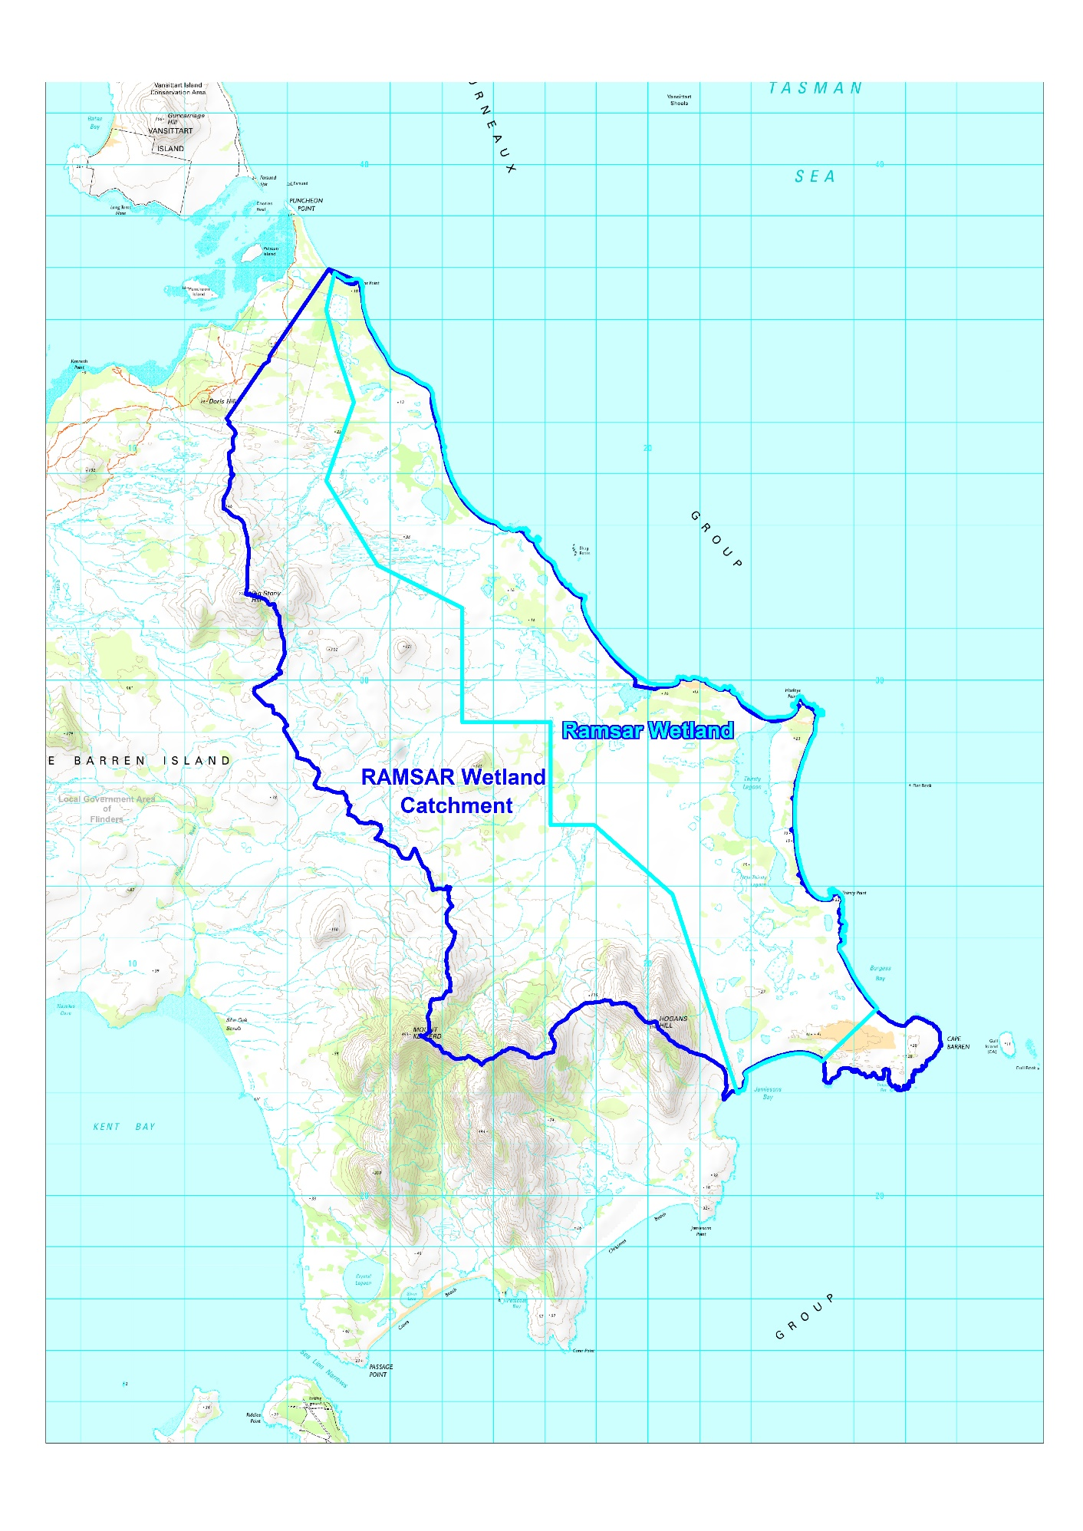Figure 8.2: Map of the truwana Lagoons Ramsar Site and its catchment [source, Livingston (unpublished)].

Planning including creation of special zones for the Ramsar Site is a particularly important suite of actions to provide long term protection of the site, which at moment has few significant impacts, but the biggest threat is unfettered access, development and site uses.

Create a special protection zone to cover the catchments draining to Ramsar Site

Zone the catchments of streams flowing into the Ramsar Site but which are not included in the Ramsar Site as special protection zones to protect the water supplies, water quality of inflows and habitat condition of these upper catchment areas.

Extend the Ramsar Site boundary to cover the catchments draining to Ramsar Site

Consider extending the Ramsar Site to include these areas and any adjacent areas of high value to protect regional values con connectivity aspects.

Ensure the Ramsar values are considered in all management of the island assets.

The natural and cultural values of the Ramsar Site should be considered equal with other values used to determine management of the island assets. In particular, the values of the site should be regarded as important as built assets in fire management (as the natural resources represent the food resources and has high cultural significance to the truwana community) so the appropriate effort is expended in protecting these values.

## Priority actions, roles and responsibilities

The priority actions are listed in Table 8.1.

Table 8.1: List of priority actions

| **Actions** | **Tasks** | **Responsibility** | **Priority** | **Start by** |
| --- | --- | --- | --- | --- |
| 1. Baseline survey of key indicators, species & attributes of listing criteria (incorporating limits of acceptable change) | 1.1. Using the management plan and ECD, identify list of indicators, species & attributes for assessing (e.g. measures of near-naturalness; geomorphic features; cover and frequency of wetland vegetation types/communities; water regime; Ramsar wetland types and rare species). This may include potential critical components that were not included in the listing criteria due to lack of information (e.g. shorebirds). | DPIPWE & ALCT | High | 2018 |
| 1.2 Define method for quantifying measurement of indicators, species & attributes (e.g. how to define and measure near-naturalness, rare species abundance, etc.). | High | 2018 |
| 1.3 Using local knowledge from Rangers and sampling experience from DPIPWE, plan survey sampling method to optimise opportunities of locating and measuring key indicators, species & attributes of listing criteria and limits of acceptable change. | High | 2018 |
| 1.4 Undertake baseline survey; record and report data gathered. | High | 2018 |
| 2. Monitoring of key indicators species & attributes of listing criteria (incorporating limits of acceptable change) | 2.1 Using methods and outcomes of baseline survey, refine sampling approach and methods (may include removing/adding sampling locations) prior to developing monitoring regime. | DPIPWE & ALCT | High | 2018 |
| 2.2 For each of the key indicators, species & attributes, assign preferred sampling frequency (e.g. shorebirds every 2 years; vegetation communities every five years; extent and duration of wetland flooding based on storm events). | High | 2018 |
| 2.3 Compile monitoring plan, with priority ratings for key indicators, species & attributes (based on risks, importance, practicalities). | High | 2018 |
| 2.4 Identify evaluation methods for assessing importance of any changes in each of the attributes to be monitored. | High | 2018 |
| 2.5 Undertake monitoring, reporting and evaluation. | DPIPWE & ALCT | High | 2019 - 2024 |

Table 8.1 (continued): List of priority actions

| **Actions** | **Tasks** | **Responsibility** | **Priority** | **Start by** |
| --- | --- | --- | --- | --- |
| 3. Fire Management | 3.1 Raise community awareness through meetings and installation of information boards within the site. | ALCT; DotEE; CBIAA, | Moderate | 2018 onwards |
| 3.2 Review fire planning and management activities undertaken before fires and their success in reducing/limiting fire outbreaks. | Furneaux Fire Management Area Committee, ALCT, CBIAA, DPIPWE, Community | High | 2018 |
| 3.3 Review fire management actions undertaken during fires and their success/failure to inform fire management. |
| 3.4 Studies into fire impacts on floristics of the types of vegetation communities within the site to help with management of the site. | DPIPWE & ALCT | Moderate | Ongoing |
| 4. Pest animal control | 4.1 Develop an action plan that prioritises species and locations for pest animal control. | DPIPWE & ALCT | High | 2018 |
| 4.2 Design and undertake pest animal control (e.g. rabbits, turkey, cats) | ALCT (with DPIPWE assistance) | Moderate | 2019 onwards |
| 4.3 Pest animal (in conjunction with native animal) surveys. | ALCT (with DPIPWE advice) | Moderate | 2020 |
| 5. Weed control | 5.1 Using approaches identified in the truwana Weed Management Plan, design and undertake a program of eradication/management of the priority weeds sea spurge, boxthorn and gorse. | ALCT (with DPIPWE assistance) | Very High | 2018 - 2019 |
| 5.2 Research, design and undertake a program for eradication/management of marram grass. | ALCT (with DPIPWE advice) | Moderate | 2019 |
| 5.3. Undertake an on-ground survey and monitoring program for all weed species (in conjunction with native vegetation) at the site. | ALCT (with DPIPWE advice) | High | 2018 |

Table 8.1 (continued): List of priority actions

|  |  |  |  |  |
| --- | --- | --- | --- | --- |
| **Actions** | **Tasks** | **Responsibility** | **Priority** | **Start by** |
| 6. Biosecurity management | 6.1 Survey the site to identify areas infected with root-rot fungus. | DPIPWE & ALCT | Very high | 2018 |
| 6.2 Ensure permanent quarantine measures are established for rangers and surveyors and their vehicles entering and moving within the site. | ALCT (with DPIPWE advice) | Very high | 2018 |
| 6.3 Implement quarantine measures for visitors and their vehicles entering the site and moving within the site. | ALCT (with DPIPWE advice) | High | 2019 |
| 6.4 Raise public awareness of root-rot fungus impact and control | ALCT, CBIAA | Moderate | 2020 |
| 6.5 Determine an approach to identify whether chytrid fungus is present within the site and within truwana | DPIPWE & ALCT | Low | 2020 |
| 7. Climate Change adaptation and management | 7.1 Work to maintain the maximum natural biodiversity of the site (actions in this plan). This will help increase management options and adaptation pathways in future scenarios. | ALCT (with DPIPWE advice) | Very high | 2018 ongoing |
| 7.2 Liaise with land managers of similar sites to share ideas, lessons and methods for management. | ALCT (with DPIPWE assistance) | High | 2020 |
| 8. Vehicular access and visitor management | 8.1 Raise public awareness on truwana and Flinders Island about the use of vehicles on the site, including the use of clear signage setting out requirements. | ALCT | High | 2019 |
| 8.2 Raise public awareness of root-rot fungus and the need for vehicles to meet quarantine requirements. | ALCT | High | 2019 |
| 8.3 Consider the running of educational field days, inviting interested community members from truwana and Flinders Island to learn about the site, its ecological status and its threats. | ALCT; Flinders Island Council | Moderate | 2020 |
| 8.4 Consider developing a visitor management plan, for legal and illegal visitors. | ALCT; Flinders Island Council | Low | 2022 |

Table 8.1 (continued): List of priority actions

|  |  |  |  |  |
| --- | --- | --- | --- | --- |
| **Actions** | **Tasks** | **Responsibility** | **Priority** | **Start by** |
| 9. Grazing and stock management | 9.1 Ensure signage indicates that grazing is not permitted in the Ramsar Site. | ALCT | High | 2018 |
| 9.2 Undertake liaison with the relevant land owner to ensure compliance. | ALCT; DPIPWE | High | 2018 |
| 10. Planning and zoning of site and surrounding lands | 10.1 Zone the catchments of streams flowing into the Ramsar Site but which are not included in the Ramsar Site as special protection zones to protect the water supplies, water quality of inflows and habitat condition of these upper catchment areas. | ALCT; DPIPWE; Flinders Island Council; Planning Commission; Dept of PM&C (for IPA) | High | 2018 |
| 10.2 Consider extending the Ramsar Site to include these areas and any adjacent areas of high value to protect regional values and connectivity aspects. | ALCT; DPIPWE; | Moderate | 2022 |
| 10.3 Ensure the Ramsar values are considered in all management of the island assets (e.g. fire management, weed management). | ALCT; DPIPWE | Very high | 2018 |
| 11. Cultural Heritage | 11.1 Design and undertake an on-ground survey of cultural heritage sites within the Ramsar Site. | ALCT, CBIAA, DPIPWE | High | 2019 |

# MONITORING

Monitoring the condition of, and threats to, the site is a key requirement of managing Ramsar sites. Many of the monitoring needs for the site have been identified in Section 8. This section crystallises the key requirements and provides a high-level overview for a monitoring program. Detailed monitoring plans will need to be developed in discussions with the agencies and organisations listed in the ‘Roles and responsibilities’ column of Table 8.1, in Section 8.

Threats and knowledge gaps are addressed in Table 8.1 (Section 8). Given the paucity of information on the ecological character of the site, the first step of any monitoring program will be designing and undertaking a baseline assessment of the site’s condition for future comparisons.

## Condition

The site’s condition and ecological character is defined by its listing criteria, critical components and services and Limits of Acceptable change. The listing criteria were:

* Being a representative, rare, or unique example of a natural or near-natural wetland type found within the appropriate biogeographic region; and
* Supporting populations of plant and/or animal species important for maintaining the biological diversity of a particular biogeographic region.

The critical components and services are those site features that support its listing criteria and therefore its ecological character. These were identified in Dunn et al. (2010) as:

* Geomorphology (component), in particular its influence on successional stages of the vegetation communities;
* Hydrology (component), via drainage channels, impounded lagoons, variability of inundation;
* Vegetation types (component), covering a range habitat conditions and a highly diverse mosaic of vegetation communities and rare species that contribute to regional diversity.
* Provision of near-natural wetlands (ecosystem service), with so little disturbance as to make them unique in the Tasmanian Drainage Division.
* Provision of significant cultural value in the recent history of the Tasmanian Aboriginal Community as a place of spiritual, inspirational and religious significance (cultural service).

Limits of acceptable change are set using the critical components and services that support the listing criteria. Therefore, monitoring for Limits of Acceptable Change requires obtaining quantitative information on those critical components and services.

Combining the critical components and services from the above lists, the components, processes and services for monitoring the Site’s condition are presented in Table 9.1, with the indicators that need to be measured to assess condition.

## Threats and knowledge gaps

The key threats and knowledge gaps identified in Section 7 are presented in Table 9.2, with the indicators that need to be measured to assess threats to the site’s condition and to address significant knowledge gaps of the site.

Table 9.1: Components, processes and services for monitoring the condition of the truwana Lagoons Ramsar Site.

|  |  |
| --- | --- |
| Components, processes and services for monitoring | Indicator measurement requirements |
| Geomorphology | Erosion: coastal fore dunes; drainage lines; wetland banks |
| Wetland types (Ramsar wetland types; TASVEG vegetation communities) | Presence; location, quantification of areal extent |
| Populations of plant species | Species list with measures of frequency/abundance; location and status of rare or threatened species |
| Populations of animal species |
| Biological diversity | Index allowing comparison against similar habitats in the region |
| Hydrology (water regime) | Presence of water; where possible, quantification of areal extent, depth, period of inundation (pools) or flow (creeks) |
| Sites of cultural significance (also a knowledge gap) | Presence, significance, location, measures of disturbance (human, erosion impacts) |

Table 9.2: Threats and knowledge gaps for monitoring in the truwana Lagoons Ramsar Site.

|  |  |
| --- | --- |
| Threats/knowledge gaps | Indicator measurement requirements/approaches |
| Changes in fire regime (threat and knowledge gap) | * Mapping of areal extent of fires (past and future) * Measures of intensity (where possible) * Comparison with expected fire regimes for vegetation categories at the site * Palaeo studies (wetland coring for charcoal and pollen analysis) |
| Exotic animal species (threat) | Species list with measures of frequency/abundance; location and pest status |
| Exotic plant species (threat) |
| Root rot fungus (threat) | Presence of water; where possible, quantification of areal extent, depth, period of inundation (pools) or flow (creeks) |
| Chytrid fungus (threat and knowledge gap) | Assess relevance of Commonwealth Govt. field test to detect the chytrid fungus |
| Climate change (threat and knowledge gap) | Climate change is difficult to monitor, however its impacts (including sea level rise; changes temperature and changes in volumes and variability of rainfall) can be monitored |
| Vehicle access (threat) | Presence, significance, location, measures of disturbance (soil/sediments, vegetation) |
| Grazing (threat) | Presence, significance, location, measures of disturbance (soil/sediments, vegetation) |
| Aboriginal cultural heritage sites (knowledge gap) | Presence, significance, location, measures of disturbance (human, erosion impacts) |

## Developing a monitoring plan

In addition to identifying the components, processes, services, threats and knowledge gaps to monitor, as well as the attributes to measure, a monitoring plan also requires identification of roles, responsibilities, frequency and intensity of sampling, and prioritisation. These planning aspects have been presented in Section 8 of this document and are combined with the information in Tables 9.1 and 9.2 to provide a template for the development of a monitoring plan for the truwana Lagoons Ramsar Site (Table 9.3).

Table 9.3: Template for the development of a monitoring plan for the truwana Lagoons Ramsar Site

| Component, process, service or threat | Purpose of monitoring | Indicator | Frequency | Priority | Responsibility |
| --- | --- | --- | --- | --- | --- |
| Geomorphology | Assess compliance with LAC; Ensure maintenance of: coastal shoreline protection; hydrological processes; physical habitat for wetlands | Rates, types and extent of erosion (coastal and inland) | 5-yearly + after storm events | Medium | ALCT & DPIPWE |
| Wetland types (Ramsar; TASVEG) | Assess compliance with LAC; | Presence; areal cover; changes/trajectories | 3 to 5-yearly + after storm or drought events, fires | High |
| Populations of plant species | Assess maintenance of listing criteria and compliance with LAC | Species lists; abundance/frequencies (focus on rare/threatened species) | 3 to 5-yearly + after storm or drought events, fires | High |
| Populations of animal species | Assess maintenance of listing criteria and potential additions (e.g. rare/threatened bird species) | presence and numbers of faunal species (esp. shorebirds); breeding pairs | 1 to 3-yearly | High |
| Biological diversity | Assess maintenance of listing criteria | Diversity indices based on data from wetland/plant/animal data | 5-yearly | High |
| Hydrology (water regime) | Key contributor to listing criteria and LAC, via impact on vegetation communities and specific flora & fauna species; address important knowledge gap | Presence of water; where possible, quantification of areal extent, depth, period of inundation (pools) or flow (creeks) | 3 to 5-yearly + after storm or during drought events | High | ALCT & DPIPWE |
| Sites of cultural significance | Addressing a knowledge gap; Informing future management | Presence, nature and significance of cultural sites | 5-yearly | High | ALCT &CBIAA |
| Changes in fire regime (threat and knowledge gap) | Addressing a knowledge gap; Informing future management | Vegetation floristics and structure; data from palaeo studies | 5-yearly | High | ALCT & DPIPWE |
| Exotic animal species (threat) | Assess significance of threat; Informing future management | Presence and abundance of exotic species | 1 to 3-yearly | Moderate | ALCT & CBIAA |
| Exotic plant species (threat) | Assess significance of threat; Informing future management | Presence and abundance of exotic species | 3 to 5-yearly | High | ALCT & CBIAA |
| Root rot fungus (threat) | Assess significance of threat; Informing future management | Presence and areal extent | 1 to 3-yearly | High | ALCT & DPIPWE |
| Chytrid fungus (threat and knowledge gap) | Assess significance of threat; Informing future management | Presence and areal extent | 3 to 5-yearly | Moderate | ALCT & DPIPWE |
| Climate change (threat and knowledge gap) | Assess significance of threat; Informing future management | Changes to geomorphology, hydrology and vegetation types | 5-yearly | High | ALCT & DPIPWE |
| Vehicle access (threat) | Assess significance of threat; Informing future management | Presence of tyre tracks (frequency & extent) | Yearly | High | ALCT & CBIAA |
| Grazing (threat) | Assess significance of threat; Informing future management | Presence of cattle tracks and droppings; vegetation changes (abundance & extent) | Yearly | Moderate | ALCT & CBIAA |

# EVALUATION, REPORTING AND REVIEW

Evaluation, reporting and review are essential components of the Ramsar Management Plan (Figure 10.1). This will ensure the actions recommended are implemented, monitoring occurs and values are protected. There are two components: 1. Performance and Evaluation and 2. Reporting and review.

We propose that a MERI (Monitoring, Evaluation, Reporting and Improvement) approach be used for the truwana Lagoons Ramsar Site as this will facilitate evaluation and reporting against the management plan actions and ensure that that an adaptive approach is taken to maintain or improve ecological character of truwana Lagoons. This process will allow site managers to detect trends in threat indicators and changes to ecological character, monitor implementation of management activities and report any actual or likely changes in ecological character. The principles which guide this MERI approach are:

* routine monitoring of critical components, processes and services to inform assessment and reporting on the status of ecological character;
* regular review and updating of the Ramsar Management Plan;
* regular assessment the management activities to assess impact, appropriateness, effectiveness, and efficiency; and
* results used to inform adaptive management of the site.

## Performance and Evaluation

Assessing the performance of the implementation of the plan will be undertaken by recording when actions listed in Table 8.1 are undertaken and comparing this to the recommended timeframe. Performance is assessed through evaluation of how well outcomes link to objectives; assessing the progress of implementation of key actions, the success rates of these actions and the efficiency (value for money/time input) of these actions.

Evaluating the ecological condition (and the limits of acceptable changes) of the site arising from the monitoring recommended will allow a comprehensive record of the condition of the site and, over time, if the ecological character is maintained, diminished or lost. This will be achieved by summarising monitoring results and assessing the results against the limits of acceptable changes outlined in the ECD and documented in Table 2.5.

## Reporting and Review

Reports should be simple outlining methods, results and discussion as well as any conclusions arising out of this assessment. An annual report should just document the monitoring and actions implemented as well as a brief report of the comparison of the monitoring results to the LAC. Every five years a more comprehensive report and assessment of the previous year’s monitoring and annual reports will assess the effectiveness and success of the Ramsar Management Plan.

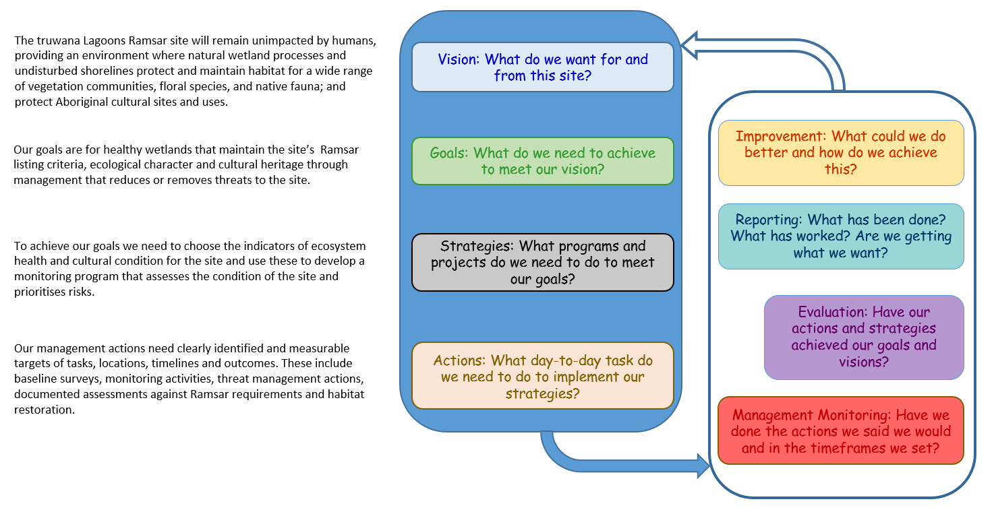

Figure 10.1: MERI Framework for the truwana Lagoons Ramsar Site Management Plan (adapted from TAC 2015).

# REFERENCES

Blackhall, S.A. (1986). A Survey to Determine Waterbird Usage and Conservation Significance of Selected Tasmanian Wetlands. NPWS, Hobart

Buchanan, A. (ed.). (2009). A Census of Vascular Plants of Tasmania. The Tasmanian Herbarium, Hobart. http://www.tmag.tas.gov.au/file.aspx?id=4439 accessed 29 July 2008.

Cocker, J.D. (1980). Regional geology of the Southern Furneaux Group. *Papers and Proceedings of the Royal Society of Tasmania* **114:** 49-68

Department of Environment Water Heritage and the Arts (2008). National Framework and Guidance for Describing the Ecological Character of Australia’s Ramsar Wetlands. Module 2 of Australian National Guidelines for Ramsar Wetlands – Implementing the Ramsar Convention in Australia. DEWHA (Department of Environment, Water, Heritage and the Arts).

Department of Environment and Heritage (2005). Bilateral migratory bird agreements with Japan (JAMBA) and China (CAMBA). Department of the Environment and Heritage, Canberra, ACT.

Department of Premier and Cabinet (2004). Land Management Audit, Crown Land parcels on Cape Barren Island, Clarke Island and Goose Island, Furneaux group Tasmania. Report to the Aboriginal Land Council of Tasmania, Launceston.

Department of Primary Industries, Parks, Water and Environment (2012). Ramsar Information Sheet for East Coast Cape Barren Island Ramsar Site.

DoEE. 2017. SPRAT Database Accessed 15th Sept 2017 at <http://www.environment.gov.au/cgi-bin/sprat/public/sprat.pl>

Dunn, H., Mowling, F. & Entura. 2010. East Coast Cape Barren Island Lagoons Ramsar Site Ecological Character Description. Entura Report to SEWPaC, June 2008 (updated in 2010).

Environment Australia (2001). A Directory of Important Wetlands in Australia. Third Edition, Environment Australia, Canberra.

Harris, S and Magnus, Z. (2004), A rapid biodiversity information audit and gap analysis for three islands in the Furneaux Group, Tasmania. Department of Primary Industries, Water and Environment (Nature Conservation Branch) internal report.

Kirkpatrick, J.B. and Harwood, C.E. (1981). The conservation of Tasmanian wetland macrophytic species and communities. Report to the Australian Heritage Commission. Tasmanian Conservation Trust.

Livingston, S. (unpublished). Draft proposed management units from revision of the Draft 2008 Cape Barren Island Management Plan. AK Consultants.

Millennium Ecosystem Assessment (2005). Ecosystem Services and Human Well-Being: Wetlands & Water: Synthesis. 2005. Millennium Ecosystem Assessment report to the Ramsar Convention: World Resources Institute, Washington D.C.

Perrin, R.A. (1988). Land use on Cape Barren Island, Tasmania. *Papers and Proceedings of the Royal Society of Tasmania* **122:** 73-83

Ramsar Convention Secretariat (2010). Wise use of wetlands: Concepts and approaches for the wise use of wetlands. Ramsar handbooks for the wise use of wetlands, 4th edition, vol. 1. Ramsar Convention Secretariat, Gland, Switzerland.

Ramsar Convention Secretariat (2017).Ramsar website: [www.Ramsar.org](http://www.Ramsar.org)

Summers, S. (2015) Furneaux Fire Management Area Fire Protection Plan 2014 – 2019. Report for the Furneaux Fire management Area Committee

Tasmanian Aboriginal Centre (undated). Truwana Weed Management Plan. Tasmanian Aboriginal Centre Inc.

Tasmanian Aboriginal Centre (2011). Badger and Hummocky:Draft Badger and Chappell Islands Management Plan, 2011 – 2016. Tasmanian Aboriginal Centre Inc.

Tasmanian Aboriginal Centre (2015). trawtha makuminya Healthy Country Plan 2015. Tasmanian Aboriginal Centre Inc.

Walsh, R.G.J., Shiel, R.J. and Tyler, P.A. (2001). Reconnaissance limnology of Tasmania VII. Coastal lagoons of Bass Strait islands, with reference to endemic microflora and microfauna. Archiv fur Hydrobiologie 152 (3):489-510

Weaver, T (2008). Cape Barren Island Draft Management Plan: An investigation of the issues concerning the use and environmental management of the island. Report to the ALCT, July 2008.

# Appendix

**Interim sampling plan for   
East Coast CBI (truwna) Lagoons Ramsar Site**

**1. INTRODUCTION**

This sampling plan for the East Coast Cape Barren Island Lagoons Ramsar Site identifies what data should be gathered, what sites should be sampled and how often the sampling should occur.

The sampling plan is proposed for a trial period of one year. At the end of one year, the sampling program should be reviewed and reported. The review could include consideration of quantitative sampling of flora and/or fauna.

**2. DATA COLLECTION**

2.1 Photopoints. At least one photopoint should be created at each site. This involves the installation of a post at a location that allows a photograph to be taken that will provide a visual summary of the conditions at the site. The top of the post should be at the height to allow the best photograph while still being practical for use. On the top of the post there should be markings or carvings to indicate the positioning of the camera and the direction it should point.

Before each field trip the previous photographs should be reviewed at each site to make sure that the same is used for the photographs for each site on each field trip.

2.2 Description of Water. At each site there should be a note made as to whether there is any surface water visible in the lagoon. If there is surface water at the site, useful description of the water would include colour, depth, the area of the water surface (approximate square meters), the presence of any visible inflows or outflows, and a measure of its electrical conductivity.

When measuring depth, it would be helpful to record the method used (e.g. estimated, measured at a specific location, or measured using a permanent depth marker placed at the site).

When measuring electrical conductivity (EC), meters will often give several options, including salinity (PPT = parts per thousand), EC at ambient temperature, and EC at 25°C. The standard measurement most used in inland water quality assessment is EC at 25°C and this is the measure that should be recorded.

2.3 Observations. A lot of useful information can be gathered by simply observing and recording interesting and important features at each site. This includes the species of plants and animals that are observed during each sampling trip and estimates of the numbers. A simple scale to use could be:

|  |
| --- |
| Estimated numbers |
| 1 |
| 2 – 5 |
| 6 - 20 |
| 21 – 100 |
| > 100 |

The usefulness of this scale will vary between species and should be adjusted to suit. For example, it is more sensible to record the actual number of sea-eagles seen at a site, rather than a range.

Interpreting any observation will be easier if a hand-drawn ‘mud-map’ is drawn at each site. The mud-map should include a rough outline of the wetland shape, a north pointer, approximate scale, and any important observations (e.g. water coverage, locations of species and vegetation communities, where EC was measured, inlets/outlets).

**3. SAMPLING SITES**

The large area within the Ramsar boundary and the large number of potential sampling sites means that it is not sensible to try and sample all sites. Therefore sites have been allocated a priority level as part of the sampling plan. The levels were derived using a practical approach, based on ease of access.

Level 1 Sites

Due to the distance that must be travelled from The Corner to the Ramsar site and the limited number of tracks, high priority (Level 1) was given to five lagoons that are closest to the track at the northern end of the Ramsar site. These are:

* the wetland north of the track into the Ramsar site at its northern end, identified as wetland number 329 in the Ecological Character Description (Dunn, Mowling and Entura 2010);
* the lagoon formed by Little Creek estuary;
* wetland 330; and
* wetland 331.

Although selected primarily on the basis of their accessibility, a reconnaissance of the area indicated that these wetlands represent a variety of salinities and hydrological regimes.

Level 2 Sites

The suggested Level 2 sites are further south of the Level 1 sites and contain a variety of habitat types, including estuaries, estuarine lagoons, sandy beach and fluvial flats. These sites are:

* Thirsty Lagoon; and
* Little Thirsty Lagoon.

**4. SAMPLING FREQUENCY**

Level 1 sites should be sampled monthly and Level 2 sites should be sampled seasonally. Where possible, sampling trip timing should be adjusted to take advantage of significant rainfall events, particularly after long dry periods.

**5. OH&S**

This sampling plan does not include Occupational Health and Safety (OH&S) planning. However, OH&S must be considered and planned for prior to sampling. Issues particularly relevant to this sampling program include: off-road driving; snake/spider bites; dehydration; sampling in or near water; and communications in remote areas.

We recommend that the ALCT develop a field sampling component as part of its overall OH&S plan.

## Field sheet for interim sampling program

(see next 2 pages)

East Coast CBI (truwana) Lagoons Ramsar Site

Wetland Field Sampling Form

|  |  |
| --- | --- |
| **DATE:** | **TIME:** |
| **SITE NAME:** | **SITE NUMBER:** |

Name of person recording:

GPS Reading:

|  |  |
| --- | --- |
| **Photopoint photo taken?: Y / N** | **Photo number:** |

**Water description (if present):**

|  |  |
| --- | --- |
| **Water present?:** | **Y / N** |
| **Colour (e.g. tannin coloured; clear; green)** |  |
| **Depth** | **……… cm**  **How measured?** |
| **Area covered** |  |
| **Flows** |  |
| **Electrical conductivity** | **µS/cm @ 25C°** |
| **Other Notes** |  |

**‘Mud map’ drawn? Y / N**

**Flora & Fauna Observations:**

|  |  |  |
| --- | --- | --- |
| **Type\*** | **Name\*\*** | **Numbers\*\*\*** |
|  |  |  |
|  |  |  |
|  |  |  |
|  |  |  |
|  |  |  |
|  |  |  |
|  |  |  |
|  |  |  |
|  |  |  |
|  |  |  |
|  |  |  |
|  |  |  |
|  |  |  |

*e.g. plant, bird, reptile, mammal

** common name (or scientific name if known)

***1, 2 – 5, 6 – 20; 21 – 100; >100