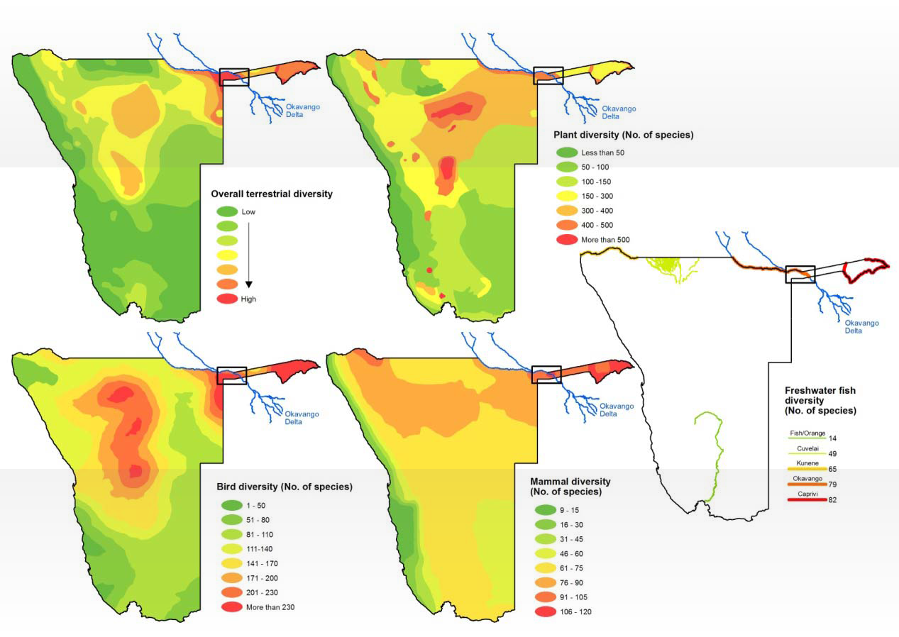

Figure 1. Biodiversity levels for plants, birds, mammals and fish, and overall terrestrial diversity, in Namibia. The area of the proposed Bwabwata-Okavango Ramsar Site is indicated.

