Appendix 3: Map showing bathymetry of Lake Qarun (interval 1 meter)

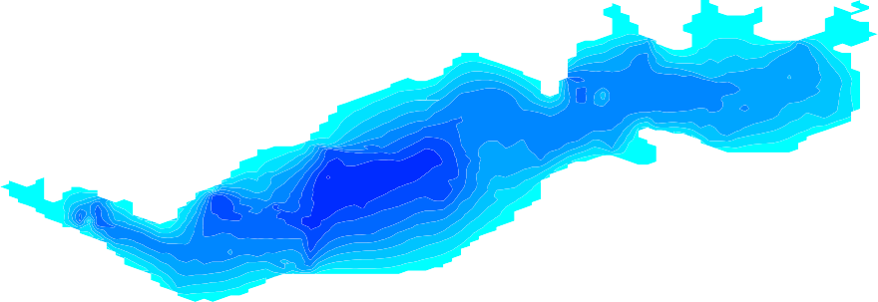29.55

29.5
8.0
7.0
6.0
5.0
4.0
3.0
2.0
1.0
0.0

29.45

29.4

30.4 30.45 30.5 30.55 30.6 30.65 30.7 30.75 30.8 30.85

