Appendix 3: Map showing bathymetry of Wadi El Rayan Lakes (interval 5 meters)

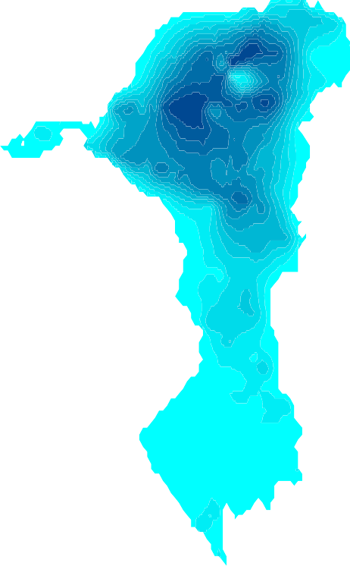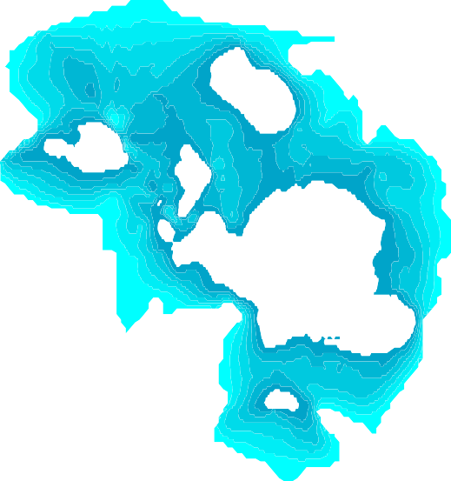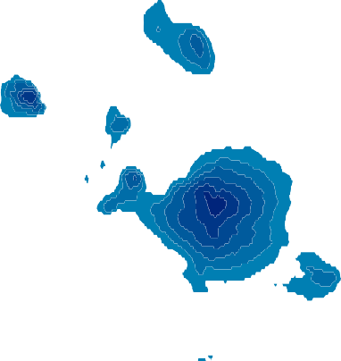29.28
28 m
26 m
24 m
22 m
20 m
18 m
16 m
14 m
12 m
10 m
8 m
6 m
4 m
2 m
0 m

29.26

29.24

29.22

29.2

29.18

29.16

29.14

29.12

29.1

29.08

30.36 30.38 30.4 30.42 30.44 30.46 30.48 30.5 30.52

