Fish Landings Per Species

250,000
2005
2006
2007
2008
Year
Total Landings (Kgs)
200,000
150,000
100,000
50,000
-
1
2
3
4

Tilapia Clarias Protopterus Catfish Marine Other

Figure 3: Fish Landings per Species

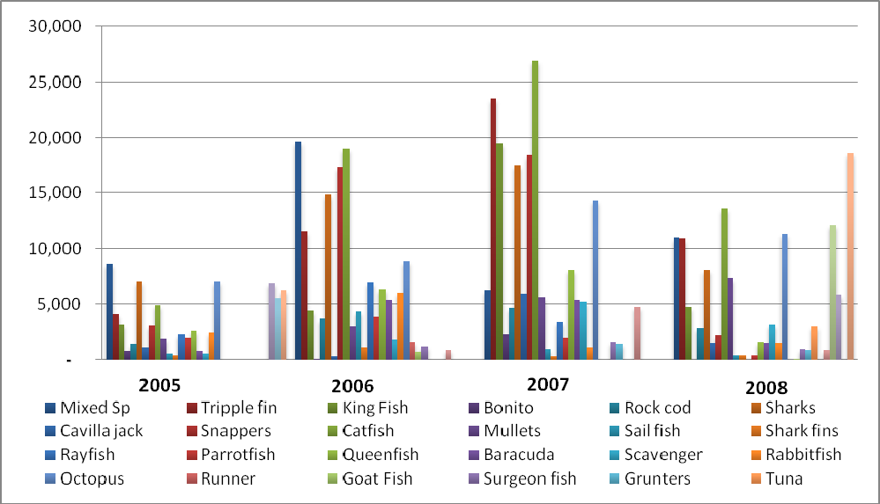
Figure 4: Marine Landings per Species

