FIELD SURVEY REPORT CENTRAL MARSHES JANUARY 2014
Central Marsh
Abu Zirig Marsh
The site was surveyed in 10 Jan 2014.
Administrative Area: Thi-Qar
Central coordinates: N 31° 05' 59.8"; E 46° 38' 17.7"

N | E | S
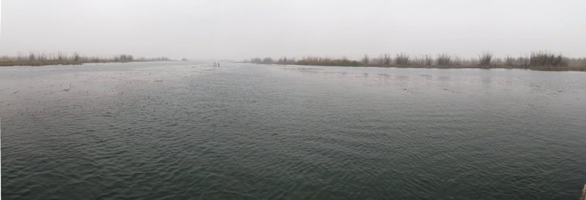
Eastern view of Abu Zirig marsh (180°).

S | W | N
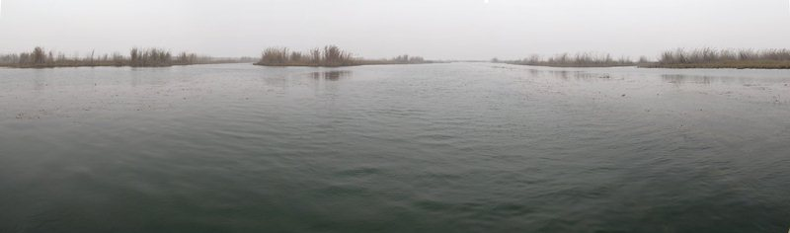
Western view of Abu Zirig marsh (180°).

Threat assessment

Agricultural expansion | Urbanization | Oil & mining | Transport | Over-exploitation | Disturbance | Natural system modification | Pollution

The level of each threat: White: Low, Yellow: Medium, Orange: High, Red = Very high

Site Description:
Abu Zirig is located on the western side of the Central Marshes in southern Islah sub-district at about 30 km northeast Nasiria city.
The water source of the area is the Gharraf river, a branch of the Tigris that provides the marsh with good water flow. The area is generally covered with vegetation reed being the most of it. Reed is about 3-4 m high. The water depth at the site is 1.3 m and most of the area is characterized by common aquatic plants. Activities of hunting, fishing and reed harvesting were observed.

Flora Observations.
# | Plant name
1 | Phragmites australis
2 | Potamogeton lucens
3 | Typha domingensis
4 | Polygonum amphibium
5 | Nymphoides peltata
6 | Ceratophyllum demersum
7 | Hydrilla verticillata
8 | Potamogeton pectinatus
9 | Salvinia natans

Birds observed during the surveys. The numbers in the table represents the counts of the individual birds of each species.
# | Common Name | Scientific Name | Count
1 | Little Grebe | Tachybaptus ruficollis | 13
2 | Eurasian Coot | Fulica atra | 8
3 | Common Moorhen | Gallinula chloropus | 3
4 | Eurasian Teal | Anas crecca | 38
5 | Marbled Duckv | Marmaronetta angustirostris | 7
6 | Purple Heron | Ardea purpurea | 3
7 | Squacco Heron | Ardeola ralloides | 12
8 | Little Egret | Egretta garzetta | 75
9 | Western Marsh Harrier | Circus aeruginosus | 2
10 | Greater Spotted Eaglev | Aquila clanga | 1
11 | Armenian Gull | Larus armenicus | 3
12 | Slender-billed Gull | Chroicocephalus genei | 50
13 | Black-winged Stilt | Himantopus himantopus | 3
14 | Common Sandpiper | Actitis hypoleucos | 1
15 | Great Reed Warbler | Acrocephalus arundinaceus | 2
16 | Mesopotamian Crow | Corvus capellanus | 1
17 | Common Chiffchaff | Phylloscopus collybita | 7
18 | Pied Kingfisher | Ceryle rudis | 17
19 | White-throated Kingfisher | Halcyon smyrnensis | 2
20 | Common Kingfisher | Alcedo atthis | 1
21 | Eurasian Collared Dove | Streptopelia decaocto | 6
22 | Iraq Babbler | Turdoides altirostris | 3
23 | House Sparrow | Passer domesticus | 8
24 | White Wagtail | Motacilla alba | 7
25 | Western Yellow Wagtail | Motacilla flava | 1

Other Fauna species found/reported during the four surveys.
# | Common Name | Scientific Name | Note
1 | Wild Boar | Sus scrofa | Reported by locals
2 | European Otter | Lutra lutra | Reported by locals
3 | Euphrates Softshell Turtle | Rafetus euphraticus | Observed
4 | Caspian Pond Turtle | Mauremys caspica | Observed
5 |  | Aspius vorax | Reported by locals
6 | Bighead carp | Hypophthalmichthys nobilis | Reported by locals
7 |  | Barbus luteus | Observed
8 | Abu Mullet | Liza abu | Observed
9 | Crucian carp | Carassius carassius | Reported by locals
10 |  | Heteropneustes fossilis | Reported by locals
11 |  | Cyprinus carpio | Reported by locals
13 |  | Tilapia zilli | Dominant

Field measurements of Abu Zirig.
Parameters | Station 1 | Station 2 | Station 3
Air Temperature ( C° ) | 9.5 | 10 | 11
Water Temperature ( C° ) | 11 | 10.1 | None
pH | 8.29 | 8.11 | None
Conductivity (ms/cm) | 1.48 | 1.48 | None
Salinity (ppt) | 0.5 | 0.5 | None
Dissolve Oxygen (mg/l) | 8.54 | 7.42 | None
Dissolve Oxygen (%) | 76.5 | 64.1 | None
Turbidity (NTU) | 19.5 | 4 | None
Depth (m) | 3 | 1 | 0

Baghdadiya
The site was surveyed in 10 Jan 2014.
Administrative Area: Thi-Qar
Central coordinates: N 31ᵒ 02ʹ 51.5ʺ; E 47ᵒ 02ʹ 06.3ʺ

N | E | S
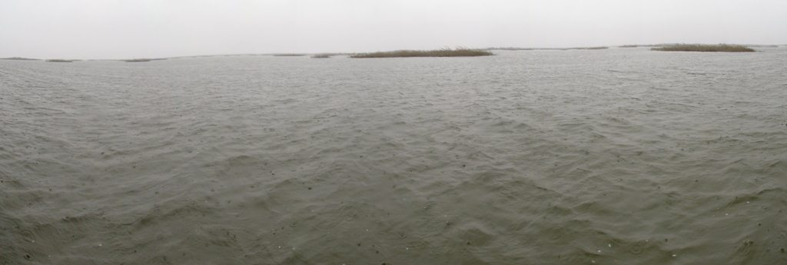
Eastern view of Baghdadiya (180°).
S | W | N
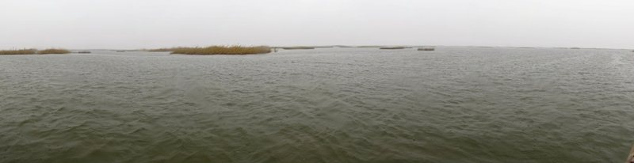
Western view of Baghdadiya (180°).

Threat assessment

Agricultural expansion | Urbanization | Oil & mining | Transport | Over-exploitation | Disturbance | Natural system modification | Pollution

The level of each threat: White: Low, Yellow: Medium, Orange: High, Red = Very high

Site Description:
The site is located in the middle of Al-Baghdadiyah Lake. The depth at the site is 3 m. There are reed beds in the lake. Compared to the previous surveys, the lake now has denser plant-cover and reed is getting to spread more in the middle of the lake. This could be due to the availability of more water in the central marshes area in general. There are activities of hunting fishing and reed harvesting observed at the site.

Flora Observations.
# | Plant name
1 | Phragmites australis
2 | Typha anguststa
3 | Cyprus paperas
4 | Juncus sp
5 | Myriophyllum sp
6 | Ceratophyllum demersum
7 | Schoenoplectus litoralis

Birds observed during the surveys. The numbers in the table represents the counts of the individual birds of each species.
# | Common Name | Scientific Name | Count
1 | Little Grebe | Tachybaptus ruficollis | 33
2 | Eurasian Coot | Fulica atra | 2
3 | Common Moorhen | Gallinula chloropus | 6
4 | Greylag Goose | Anser anser | 4
5 | Eurasian Teal | Anas crecca | 8
6 | Great Cormorant | Phalacrocorax carbo | 1
7 | Pygmy Cormorant | Phalacrocorax pygmeus | 3
8 | Grey Heron | Ardea cinerea | 1
9 | Little Egret | Egretta garzetta | 14
10 | Purple Heron | Ardea purpurea | 3
11 | Western Marsh Harrier | Circus aeruginosus | 4
12 | Whiskered Tern | Chlidonias hybrida | 250
13 | Slender-billed Gull | Chroicocephalus genei | 120
14 | Armenian Gull | Larus armenicus | 3
15 | Black-winged Stilt | Himantopus himantopus | 12
16 | Red-wattled Lapwing | Vanellus indicus | 6
17 | White-tailed Lapwing | Vanellus leucurus | 7
18 | Kentish Plover | Charadrius alexandrinus | 2
19 | Little ring plover | Charadrius dubius | 1
20 | Pied Kingfisher | Ceryle rudis | 90
21 | White-throated Kingfisher | Halcyon smyrnensis | 3
22 | Common Kingfisher | Alcedo atthis | 2
23 | Common Chiffchaff | Phylloscopus collybita | 10
24 | Mesopotamian Crow | Corvus capellanus | 2
25 | European Robin | Erithacus rubecula | 2
26 | Common Starling | Sturnus vulgaris | 3
27 | Eurasian Collared Dove | Streptopelia decaocto | 2
28 | DaurianIsabelline Shrike | Lanius isabellinus | 2
29 | Western Yellow Wagtail | Motacilla flava | 2
30 | White Wagtail | Motacilla alba | 5
31 | Great Reed Warbler | Acrocephalus arundinaceus | 3
32 | Graceful Prinia | Prinia gracilis | 3
33 | House Sparrow | Passer domesticus | 9

Other Fauna species found/reported during the four surveys.
# | Common Name | Scientific Name | Note
1 | Wild Boar | Sus scrofa | Reported by locals
2 | European Otter | Lutra lutra | Reported by locals
3 | Euphrates Softshell Turtle | Rafetuseuphraticus | Reported by locals
4 | Caspian Pond Turtle | Mauremys caspica caspica | Observe
5 | Indian stinging catfish | Heteropneustes fossilis | Observe
6 | Mesopotamian spiny eel | Mastacembelus mastacembelus | Reported by locals
7 | Mesopotamian catfish | Silurus triostegus | Reported by locals
8 |  | Aspius vorax | Reported by locals
9 |  | Hemiculter leucisculus | Reported by locals
10 |  | Carassius auratus | Observe
11 |  | Alburnus mossulensis | Reported by locals
12 |  | Barbus luteus | Reported by locals
13 |  | Cyprinus carpio | Reported by locals
14 |  | Gambusia affinis | Reported by locals
15 |  | Liza abu | Observe
16 |  | Tilapia zilli | Observe

Field measurements of water sample.
Parameters | Station 1 | Station2
Air Temperature ( C° ) | 10.5 | 9.5
Water Temperature ( C° ) | 11 | 11
pH | 8.10 | 8.29
Conductivity (ms/cm) | 5.62 | 1.48
Salinity (ppt) | 2.9 | 0.5
Dissolve Oxygen (mg/l) | 8.16 | 8.54
Dissolve Oxygen (%) | 74.6 | 76.5
Turbidity (NTU) | 4.4 | 19.5
Depth (m) | 4 | 2

Anions, Cations and COD of water sample.
Parameters | Station 1 | Station 2
 | Duplicate 1 | Duplicate 1
Cl (ppm) | 1400 | 1500
HCO3 (ppm) | 220 | 233
NO3 (ppm) | ND | 0.19
SO4 (ppm) | 137 | 111
COD (ppm) | 72 | 96
Ca (ppm) | 176 | 240
Mg (ppm) | 54 | 90
Na (ppm) | 686 | 732
K (ppm) | 68 | 68

Zichri
The site was surveyed in 11 Jan 2014.
Administrative Area: Basrah
Central coordinates: N 31 03' 21.1"; E 47° 13' 18.4"

N | E | S
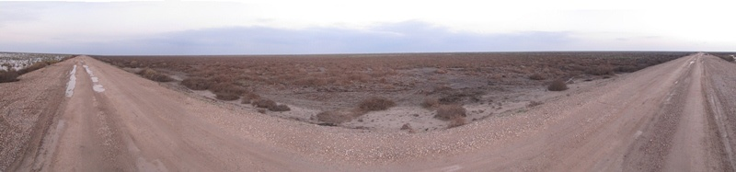
Eastern view of Zichri (180°).

S | W | N
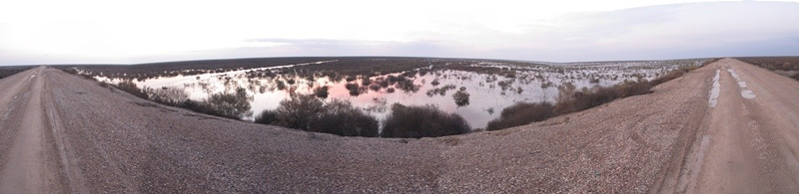
Western view of Zichri (180°).

Threat assessment

Agricultural expansion | Urbanization | Oil & mining | Transport | Over-exploitation | Disturbance | Natural system modification | Pollution

The level of each threat: White: Low, Yellow: Medium, Orange: High, Red = Very high

Site Description:
The site is located on the western side of the main embankment on the eastern site of the Central Marsh. The eastern side of the embankment is completely dry with terrestrial plant-cover, and the western side of the embankment used to be wetland with water depth about 30cm when the area was completely flooded during previous surveys. There were new oil extraction works at the eastern side of the embankment to the east of the site.

Flora Observations.
# | Plant name
1 | Tamarix sp.
2 | Suaeda vermiculata
3 | Suaeda sp.
4 | Salsola imbricata

Birds observed during the surveys. The numbers in the table represents the counts of the individual birds of each species.
# | Common Name | Scientific Name | Count
1 | Common Moorhen | Gallinula chloropus | 2
2 | Great White Pelican | Pelecanus onocrotalus | 35
3 | Little Grebe | Tachybaptus ruficollis | 4
4 | Pygmy Cormorant | Phalacrocorax pygmeus | 11
5 | Great Cormorant | Phalacrocorax carbo | 5
6 | Northern Pintail | Anas acuta | 250
7 | Eurasian Teal | Anas crecca | 300
8 | Purple Heron | Ardea purpurea | 7
9 | Little Egret | Egretta garzetta | 90
10 | Black-crowned Night Heron | Nycticorax nycticorax | 125
11 | Squacco Heron | Ardeola ralloides | 30
12 | Long-legged Buzzard | Buteo rufinus | 1
13 | Western Marsh Harrier | Circus aeruginosus | 4
14 | Little Crake | Porzana parva | 2
15 | Pallid Harrier | Circus macrourus | 1
16 | Marbled Duck | Marmaronetta angustirostris | 16
17 | Slender-billed Gull | Chroicocephalus genei | 70
18 | Whiskered Tern | Chlidonias hybrida | 35
19 | Pied Kingfisher | Ceryle rudis | 20
20 | White-throated Kingfisher | Halcyon smyrnensis | 1
21 | Common Kingfisher | Alcedo atthis | 2
22 | Common Sandpiper | Actitis hypoleucos | 1
23 | White-tailed Lapwing | Vanellus leucurus | 1
24 | Spur-winged Lapwing | Vanellus spinosus | 2
25 | Red-wattled Lapwing | Vanellus indicus | 3
26 | Iraq Babbler | Turdoides altirostris | 4
27 | Crested Lark | Galerida cristata | 3
28 | Graceful Prinia | Prinia gracilis | 3
29 | House Sparrow | Passer domesticus | 12
30 | White Wagtail | Motacilla alba | 80
31 | Western Yellow Wagtail | Motacilla flava | 5

Other Fauna species found/reported during the surveys.
# | Common Name | Scientific Name | Note
1 | Golden Jackal | Canis aureus | Observed
2 | Red Fox | Vulpes vulpes | Observed
3 | Rüppell's Fox | Vulpes rueppelli | Reported by locals
4 | Brown Hare | Lepus capensis | Reported by locals
5 | Wild Boar | Sus scrofa | Reported by locals
6 |  | Liza abu | Reported by locals
7 |  | Tilapia zilli | Reported by locals

Field measurements of water sample.
Parameters | Station 1 | Station2
Air Temperature ( C° ) | 9.2 | 9.1
Water Temperature ( C° ) | 12.3 | 11.8
pH | 8.60 | 7.99
Conductivity (ms/cm) | 5.95 | 5.78
Salinity (ppt) | 3.1 | 3.1
Dissolve Oxygen (mg/l) | 8.20 | 6.80
Dissolve Oxygen (%) | 78.0 | 60.1
Turbidity (NTU) | 30.2 | 31.2
Depth (m) | 0.3 | 0.35

ANNEX 3 – List of Villages represented in the Ramsar site Map

ID | Village | ID | Village | ID | Village
1 | Emarat 2 Village | 126 | Village Akhlyfa | 251 | AL Abu Ewaid
2 | Bager 2 Village | 127 | Village Aljeboot | 252 | AL Sachit
3 | Al hendya Village | 128 | Village Alaly | 253 | Al-mubader
4 | Drhamea Village | 129 | Um Alshweegh | 254 | Al-Toman
5 | Door Betro chemical Village | 130 | Village Alsamayer | 255 | Al Shimamrah
6 | Juebda Village | 131 | Village Altraba | 256 | Kasaibaa
7 | Al Najmea Al Gharbya Village | 132 | village Alshlha | 257 | Karmaat Hassan
8 | South Najmi Zubair | 133 | Village Alsuea | 258 | ALRisaalah
9 | Al Khoissat | 134 | Village Bet Faleh | 259 | Am Shajaa
10 | Najmi 17 | 135 | Village Aldrweza | 260 | AL Thamaar
11 | Door North Rumaila oil | 136 | Village Large Khamysa | 261 | AL Bthij and AL Shami
12 | Wast Kreytat | 137 | Village Alkhas | 262 | AL Esmaaeal
13 | Shaeba SKK | 138 | Village Alhrd | 263 | AL Mizlik
14 | East Khor | 139 | Village Abo Ktaeeb | 264 | AL Abraat
15 | Door Al-Jawad (Iron and Steel) | 140 | Village Almahyat | 265 | AL Ganamaa
16 | Snam Village | 141 | Village Aljry | 266 | Al bo Ziyad
17 | Almuylhat North Village | 142 | Village South Hawash | 267 | ALDawood
18 | Al Karta North Village | 143 | Village Abo Khreeb | 268 | -
19 | Al-Aekalat | 144 | Village Bahla | 269 | Al-Rumthan
20 | Al fayha 3 (Aeraitham) | 145 | Alhusinat | 270 | Al-awad
21 | Al Sadiq | 146 | abdAl- razah | 271 | Al-Naeef
22 | North Najmi (Sparse) | 147 | komaizAl-jushet | 272 | Hajaam AL Atiabaa
23 | Village Al Asmeda | 148 | al-oweja | 273 | Al-Amirat
24 | East Safwan 6 (Sparse) | 149 | Al-jader | 274 | Al-Safafia'a
25 | Door Civil Engineering | 150 | Al-Asriyah | 275 | Al-mowijad
26 | Village/ Al sanajer | 151 | al-boAlwan | 276 | Al-lakiwat
27 | Al Maa'mer | 152 | secondAl-zuhariyah (salem mohamed | 277 | al-shaheed
28 | Door Al mared Village | 153 | al-furaihy (al-alalimain ) | 278 | Abo Ghanam
29 | Door refinry Village | 154 | al-buty | 279 | Hajaam Afndi
30 | Al masharea Naftea Village | 155 | Al-juhar | 280 | Hajaam
31 | Door Noab thubat & KahrbaaVillage | 156 | Abo hawala | 281 | Am Kiazraana
32 | Dawajen Village | 157 | Al boTayot | 282 | Al-homran
33 | Door Al Asmeda Village | 158 | Al-Mahmod | 283 | Bani Saeed
34 | Door Al Jawya Village | 159 | Al-SadaAndAl-shafijat | 284 | AL Dabaat
35 | Alsayrya Village | 160 | Al-Ebidat | 285 | east OmAl-roos (Al-bo Juma'a)
36 | Alheas Village | 161 | Al-mustafawiyah | 286 | south OmAl-roos fromAl-bo Juma'a
37 | AlKorya Village | 162 | Al bo juma'a | 287 | Al-Farha
38 | AlHakeem Village | 163 | Area 22 oil (oil Qu.) | 288 | 2 Abu Hawaan
39 | Village/ Abo sakheer | 164 | Al-Ajel | 289 | AL Kathim
40 | Village/ Al Khoora | 165 | Al-Barhuos | 290 | AL Nakailah
41 | Village Hamryan | 166 | Said Shwuea | 291 | AL Rasol /2
42 | Village Al halaf | 167 | AL Eslah | 292 | Al Bo Hawala
43 | Village Abo Mahmer | 168 | Kather | 293 | Al -Bader
44 | Village Abo meleh | 169 | AL Sair (AL Saair ) | 294 | Al-hazrah
45 | Village Al tuerash | 170 | Said Maanagi | 295 | eastAl-Aritham
46 | Village Al Hassan Al Askary | 171 | Al Ali | 296 | Al-hussam
47 | Village Al Murthatha | 172 | Al Sulaman | 297 | AL Naser (AL Ansaar)
48 | Village Sayed Shuada | 173 | Al-bohan | 298 | Naser HussainAndAl-Hadara Houme
49 | Village Al Entsar | 174 | Dayish | 299 | Hameed Hadib
50 | Village Al Shakhtea | 175 | Al-Zugaiby | 300 | Al-Aia
51 | Village Anakhlat | 176 | Khuwajira | 301 | Al-shaty
52 | Village Bet awafy | 177 | Al-bo Jary | 302 | Mutashar Shatab
53 | Village Alalwa | 178 | Al-AbdAl-Hussain | 303 | AL Bu hafaa
54 | Village Alhadama | 179 | Al-gawalib | 304 | AL BuHamdaan
55 | Village Alkhysat | 180 | Al-bo hamadAl-husinat (Al-hawas ) | 305 | AL Shawaleesh
56 | Village Al Tuba & nakhyla | 181 | AL Jadooeaa | 306 | Hassan Zamil
57 | Village Al Kheet | 182 | AL Awawiah | 307 | AL Mansor
58 | Al-Shahla Al-Mohammdia | 183 | AL Nasir | 308 | AL BuHadraa
59 | Beut Al-Taqa | 184 | Al-Abarat | 309 | Al Muwajed Jenebat
60 | Al Mhela Village | 185 | NorthAl-Haramy | 310 | Kut Mahniaa
61 | Al Amya 1 Village | 186 | Al-UwaeedAl-Mutar | 311 | Kut Jaar Alaa
62 | Kut Alzen Village | 187 | Siad Hussain Naama | 312 | Al Zahra
63 | AL Sybaa 1 Village | 188 | Al-khanjar | 313 | ALSihail
64 | Um meaj 2 | 189 | AL Amyiaa | 314 | AL Salhiia
65 | Um meaj 1 | 190 | Mashargaa | 315 | Mataasher Falih
66 | Village Hleajea 2 | 191 | AL BuJasim | 316 | AL Raasoul (Abud AL Jaleel Kair Ala )
67 | Village Meah Abo Breadya | 192 | AL Araaj and AL Shahlaawiaa | 317 | AboAl-Ruwaish
68 | Village Mzeraa | 193 | AL Nasaar | 318 | AL-Aqarat
69 | Village Silk Atyaa | 194 | AL Sahaalat | 319 | Hischa
70 | Village Door Al Thalet | 195 | Al-Majry | 320 | Al Sihahki
71 | Al-Muardha 2 | 196 | Al-Bank | 321 | Miasaloon
72 | Village Almhamed | 197 | Al-bo HamodyAl-Sahar | 322 | AL Shimoos
73 | Village Alsalam | 198 | FirstAl-Kawaf | 323 | 1 June
74 | Village Almhyat | 199 | secondAl-Kawaf | 324 | Al-bo Hamad
75 | Village Albatat | 200 | dara'an | 325 | AL Mutaajwezeen
76 | Village Bany skeen | 201 | Said Thiyab | 326 | Al-Noman
77 | Village Alnaser | 202 | AL Grafiyaa | 327 | Al-shajan
78 | Village Albo wawi | 203 | Bani Mislim | 328 | Barijah
79 | Village Alshryba | 204 | AL Bu Hamidi | 329 | AL Shweli
80 | Village Almanasyer | 205 | Am AL Wadaa | 330 | AL Bu Hussein
81 | Village Khthabo | 206 | Muwelhiyah | 331 | SakbanAl-Ali
82 | Village Naher Umr | 207 | Al-rumaid | 332 | Al Kulibah
83 | Village Alzawen | 208 | khilaiwe | 333 | Kathim Alwaan /AL Thiyaabat
84 | Village Aljrahy | 209 | AL Bu kaleefa | 334 | AL Sadaaga
85 | Village Alshramkha | 210 | AL Bu Aewiad | 335 | 1-Ansar Alhussain
86 | Village Hay Alamel 1 | 211 | AL Hamamaa | 336 | 1-Om Ishgag
87 | Village Abo Alshlook | 212 | AL Hathra tian | 337 | 1-Almizbaniah
88 | Village Shhaeb Alzrkanya | 213 | AL Ziyaad | 338 | 3-Alzubaidat
89 | Village Alathba & Kahen | 214 | AL Kurdiaa | 339 | 6-Brick factories
90 | Village meeah Alsura | 215 | AL Basharaa | 340 | 2 – Abu Sabee
91 | Village Beat wafi | 216 | AL Kaamsaan | 341 | 4 – Fakir Tahir
92 | Village Alshafi Abo basiry | 217 | Haasn Lami | 342 | 5 – Abdulkareem Kadeem Alsadkan
93 | Village Alshnana | 218 | Al-bo Hajy | 343 | 3 – Aljidaed
94 | Village Tleaa Alzaween | 219 | Mutlak Abud Alaa Bakut /AL Saraafian | 344 | 9-Alimam Alhussein
95 | Village um masjed | 220 | AL Sharamtaa | 345 | 1-Alkurah
96 | Kharkhara | 221 | AL Kamisiaa | 346 | 3-Alaythah (wide side)
97 | Village Bet khzeel | 222 | AL Nwashi (Hassan Mansoor ) | 347 | Abu Garab
98 | Village Alhaymoon | 223 | Hajaam AL Nahi and Katlaat | 348 | 2-Gazah
99 | Village Bet Abad Almkroon | 224 | Sporadic housing | 349 | 3-Altarabah
100 | Village Alshaty | 225 | AbdAl-wahedAbdAl-Hassan | 350 | 4-Bait Hleel
101 | Al-sheganba 1 | 226 | Al-Sumood | 351 | 1-Alqudis
102 | Al-sekhreacha | 227 | Said Kadhim Said Baqer | 352 | 2-Aladarah Almahaliah
103 | village Al Dawra | 228 | AL Abu Kalaf | 353 | 1-Alhashriah
104 | Hawz Sauth Qushla | 229 | AL Zraaj and AL Medaan | 354 | Al Frejat
105 | Village/Kut Alkwam | 230 | AL Rahmaa | 355 | Al Hameed and Diftalah
106 | Village/Kut AlJweaa | 231 | AbdAl-Saheb | 356 | 1-Alwatan
107 | Village /Mzareaa Albean | 232 | Al-bo Ulaian | 357 | 6-Karamli
108 | Jurf Al-Milh | 233 | AL Obaaid | 358 | 6 – Aldunmaat
109 | Al-zirijy | 234 | Al-Muzarea'a | 359 | 3- Alhifirah
110 | Villlage Al Lalya | 235 | AL Bandryaat | 360 | 3-Nahar saad
111 | Village Albo Bsairy | 236 | AL Thamiriaa | 361 | 4-Om Ubaidah
112 | Village Abo Dalfa | 237 | Al Jamamlaa | 362 | 4-Abu Jissanh
113 | Village Almlfaty | 238 | AL Shidood | 363 | 1-Albahathah
114 | Village Abo khrab | 239 | AL Bu Hamdaan | 364 | 13-Maamal Alwaraq (paper factory)
115 | Village Al shahban | 240 | AL Afreat | 365 | Abu Kasaf
116 | Village AlHawafed | 241 | Al-Hesasera | 366 | Almutabag & Almteebig
117 | Village Albo msheah | 242 | Al-kawea'a | 367 | 5-Alikeb
118 | Village Alabarat | 243 | Al-Saliteyah (Al-baejat ) | 368 | 1-Bait Ateah
119 | Village Aljlal | 244 | OmAl-Dehen | 369 | Al Kataa
120 | Village Alhydadya | 245 | westAl-Jazra | 370 | 3-Alkifah
121 | Village Alalwan | 246 | AL BuAli | 371 | 1-Abu Alalaa
122 | Village Alfraj | 247 | AL Abaaid (Hussian Abud ) | 372 | 2-Abd Ali
123 | Village Alswad | 248 | Al-DananiyahAnd OmAl-eash | 373 | 1-Alfaatoos
124 | Village Aljeader | 249 | AL Garianaat
125 | Village Abo khzlan | 250 | AL Rathwaan

