COMMON BIRDS OF LAKE CHIVERO

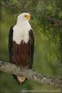
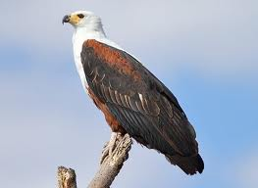
Scientific Name: Haliaeetus vocifer
Common Name: African Fish Eagle
Shona Name : Hungwe
Habitat : Large rivers, lakes, pans and dams usually with large trees
Diet : Mainly Fish
Clutch ; 1-3 Eggs (Usually 2)

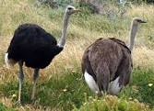

Scientific Name: Struthio camelus
Common Name: Common Ostrich
Shona Name : Mhou
Habitat : Bushveld to desert
Diet : Grass, berries, seeds, succulent plants, small reptiles, insects
Clutch : 16-23 Eggs

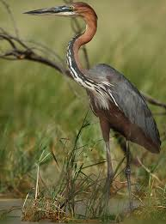
Scientific Name: Ardea goliath
Common Name: Goliath Heron
Shona Name :

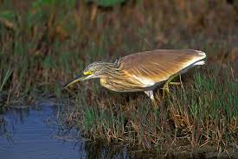
Scientific Name: Ardeola ralloides
Common Name: Squacco Heron
Shona Name :

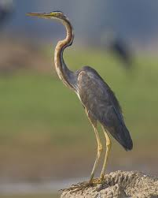
Scientific Name: Ardea purpurea
Common Name: Purple Heron
Shona Name :

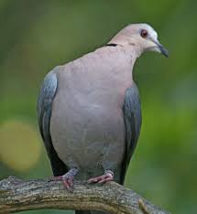
Scientific Name: Streptopelia semitorquata
Common Name: Red-eyed Dove
Shona Name : Njiva

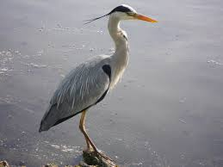
Scientific Name: Ardea cinerea
Common Name:Grey Heron
Shona Name :

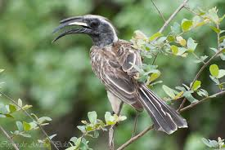
Scientific Name: Tockus nasutus
Common Name: African Grey Hornbill
Shona Name : Hoto

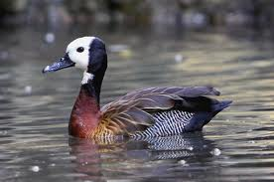
Scientific Name: Dendrocygna viduata
Common Name: White-faced Duck
Shona Name :

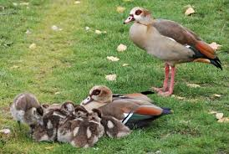
Scientific Name: Alopochen aegyptiaca
Common Name: Egyptian Goose
Shona Name :

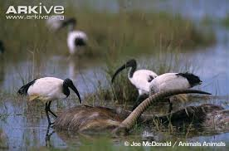
Scientific Name: Threskiornis aethiopicus
Common Name: African Sacred Ibis
Shona Name :

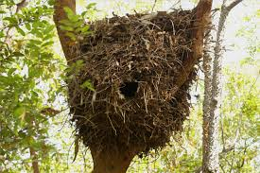
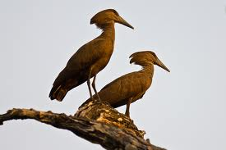
Scientific Name: Scopus umbretta
Common Name: Hamerkop
Shona Name : Kondo

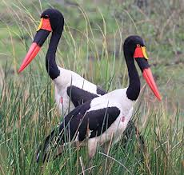
Scientific Name: Ephippiorhynchus senegalensis
Common Name: Saddle-billed Stork
Shona Name : Shuramurove

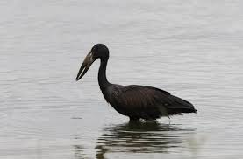
Scientific Name: Anastomus lamelligerus
Common Name: African Openbill Stork
Shona Name : Shuramurove

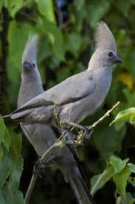
Scientific Name: Corythaixoides concolor
Common Name: Grey Go-Away -Bird
Shona Name : Kuwe

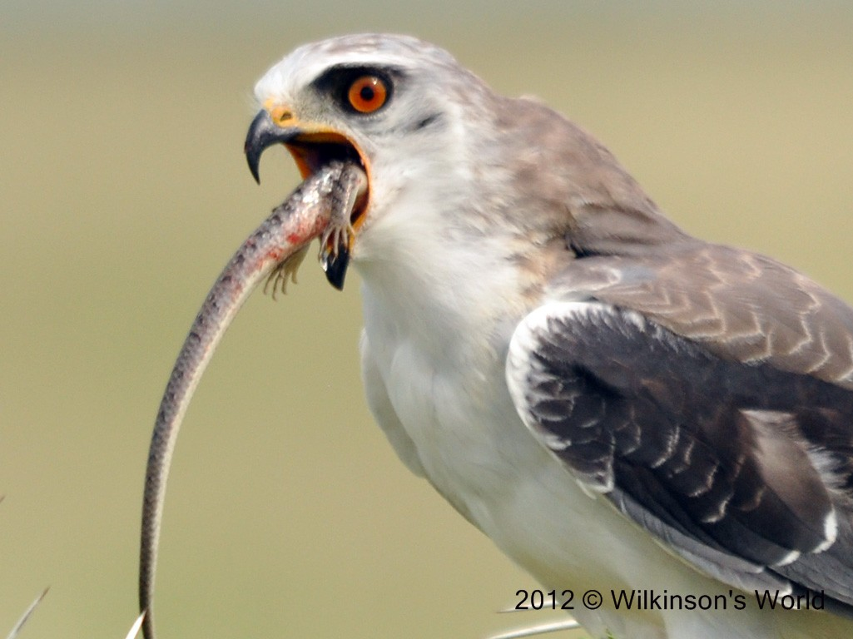
Scientific Name: Elanus caeruleus
Common Name: Black-shouldered kite
Shona Name : Hungwe

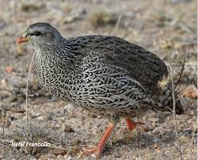
Scientific Name: Pternistes natalensis
Common Name: Natal Francolin
Shona Name : Chikwari

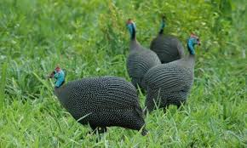
Scientific Name: Numida meleagris
Common Name: Helmeted Guinefowl
Shona Name : Hanga

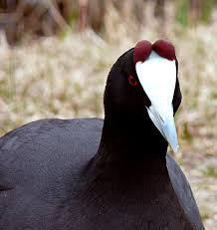
Scientific Name: Fulica cristata
Common Name: Red-knobbed Coot
Shona Name :

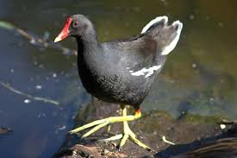
Scientific Name: Gallinula chloropus
Common Name: Common Moorhen
Shona Name :

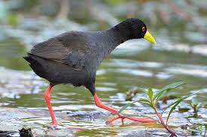
Scientific Name: Amaurornis flavirostris
Common Name: Black Crake
Shona Name :

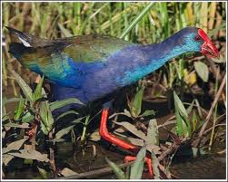
Scientific Name: Porphyrio madagascariensis
Common Name: African Purple Swamphen
Shona Name :

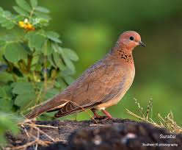
Scientific Name: Streptopelia senegalensis
Common Name: Laughing Dove
Shona Name : Njiva

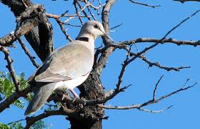
Scientific Name: Streptopelia capicola
Common Name: Cape Turtle Dove
Shona Name : Njiva

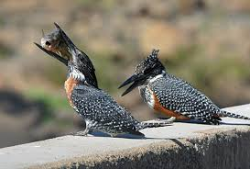
Scientific Name: Megaceryle maximus
Common Name: Giant Kingfisher
Shona Name : Chinyururahove
Habitat :Rivers,estuaries,lakes,wooded strams,sewage ponds,seashore
Diet :Fish,crabs,frogs
Clutch :3-5 Eggs

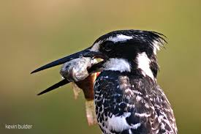
Scientific Name: Ceryle rudis
Common Name: Pied Kingfisher
Shona Name : Chinyururahove
Habitat : Rivers,lakes,dams,estuaries,canals,costal waters
Diet : Mostly fish and insects
Clutch :2-6 Eggs

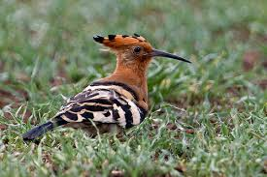
Scientific Name: Upupa africana
Common Name: African Hoopoe
Shona Name :

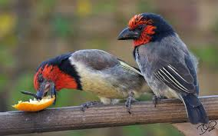
Scientific Name: Lybius torquatus
Common Name: Black-collared Barbet
Shona Name : Chikweguru
Habitat : Coastal bush,woodland,forest edge,riverine forest,parks,gardens
Diet : Fruit especially figs,insects
Clutch : 2-5 Eggs

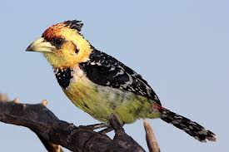
Scientific Name: Trachyphonus vaillantii
Common Name: Crested Barbet
Shona Name : Chizuvaguru
Habitat :Thornveld.thickets in woodland,riverine bhushveld,exotic plantations
Diet ;Insects(especially termites),worms,fruit,snails
Clutch ;3-5 Eggs

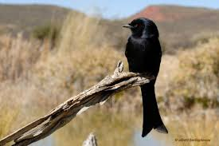
Scientific Name: Dicrurus adsimilis
Common Name: Forktailed Drongo
Shona Name : Nhengure
Habitat :Woodland.savanna,riverine,plantations.open grasslands
Diet :Insects,small birds,nectar,fish

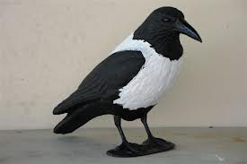
Scientific Name: Corvus albus
Common Name: Pied Crow
Shona Name : Gunguwo
Habitat :Farmland ,urban areas,rubbish dumps, verges of roads and railways
Diet :Primarily plant materials(seeds,fruits,roots) carrion(e.g road kills),frogs,reptiles,fish,birds
Clutch : 2-4 Eggs

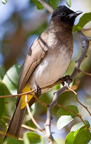
Scientific Name: Pycnonotus tricolor
Common Name: Dark-capped Bulbul
Shona Name : Gwenhure
Habitat :Woodland,forest edge,riverine bush
Diet :Fruit,nectar,insects,small lizards
Clutch: 2-3 Eggs

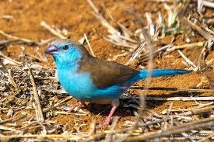
Scientific Name: Uraeginthus angolensi
Common Name: Blue Waxbill
Shona Name : Kasisi
Habitat : Open thornveld with grass and bushes,riverine bush
Diet ; Seeds,insects
Clutch; 3-6 Eggs

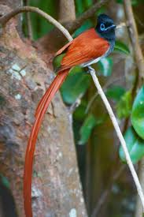
Scientific Name: Haliaeetus vocifer
Common Name: African Fish Eagle
Shona Name : Hungwe

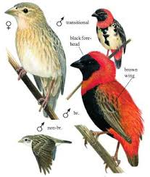
Scientific Name: Haliaeetus vocifer
Common Name: African Fish Eagle
Shona Name : Hungwe

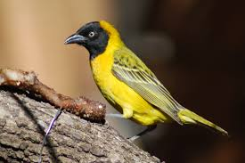
Scientific Name: Haliaeetus vocifer
Common Name: African Fish Eagle
Shona Name : Hungwe

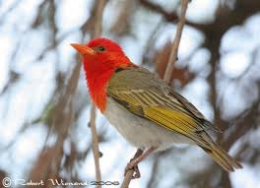
Scientific Name:
Common Name: African Fish Eagle
Shona Name : Hungwe

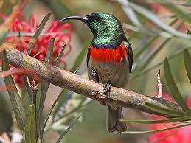
Scientific Name: Cinnyris manoensis
Common Name: Miomb Double-collard sunbird
Shona Name :

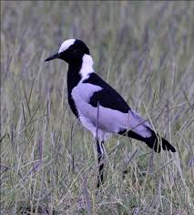
Scientific Name: Vanellus armatus
Common Name: Blacksmith Plover
Shona Name :

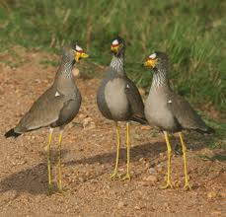
Scientific Name: Haliaeetus vocifer
Common Name: African Fish Eagle
Shona Name : Hungwe

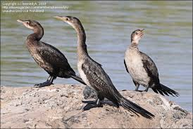
Scientific Name: Haliaeetus vocifer
Common Name: African Fish Eagle
Shona Name : Hungwe

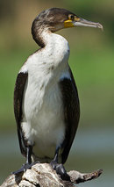
Scientific Name: Haliaeetus vocifer
Common Name: African Fish Eagle
Shona Name : Hungwe

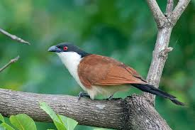
Scientific Name: Haliaeetus vocifer
Common Name: African Fish Eagle
Shona Name : Hungwe

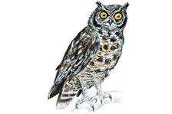
Scientific Name: Haliaeetus vocifer
Common Name: African Fish Eagle
Shona Name : Hungwe

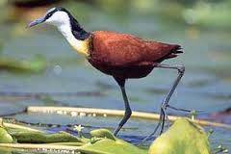
Scientific Name: Haliaeetus vocifer
Common Name: African Fish Eagle
Shona Name : Hungwe

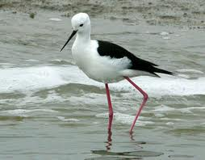
Scientific Name: Haliaeetus vocifer
Common Name: African Fish Eagle
Shona Name : Hungwe

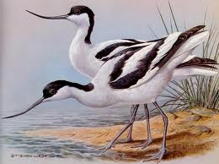
Scientific Name: Haliaeetus vocifer
Common Name: African Fish Eagle
Shona Name : Hungwe

