ANNEXE I : Liste des algues recensées dans 4 stations à l’oued Soummam (S1 : Akbou, S2 : Sidi Aich, S3 : El Kseur, S4 : Embouchure), le lac Mézaia (M) et la lagune de Tamellaht (T).

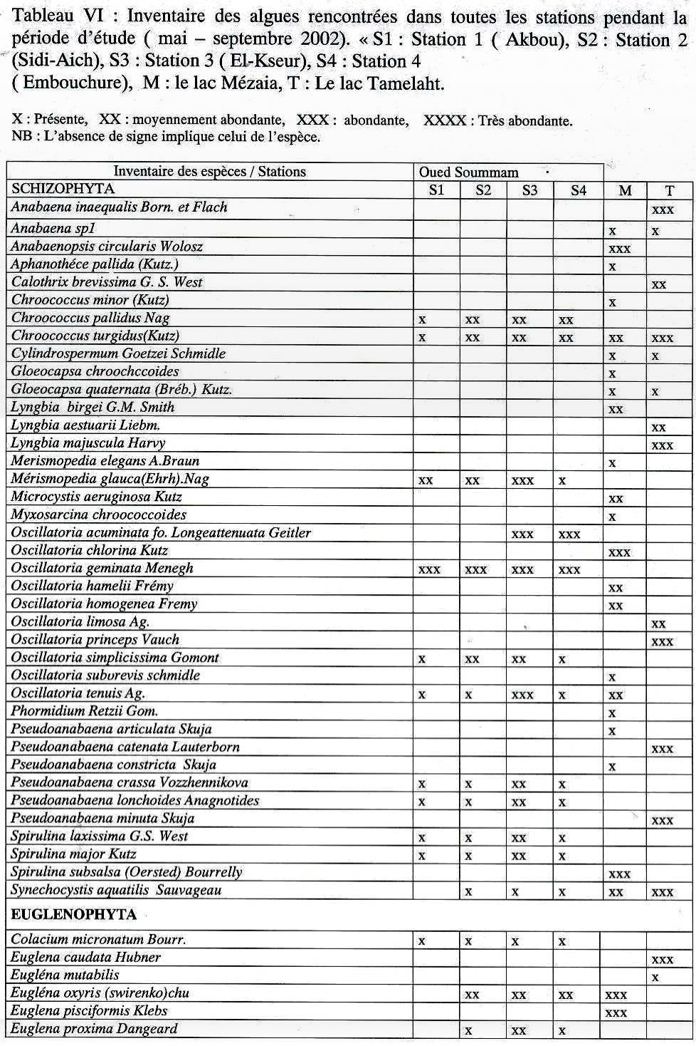

|  |  |  |  |  |  |  |  |
| --- | --- | --- | --- | --- | --- | --- | --- |
| *Eug/ena sociabilis dangeard* | |  | x | xx | x | xx |  |
| *Euglena texta var.salina(Fritsch)* | |  |  |  |  | xx | xxx |
| *L,epocinclis fusifo rmis Lemmermann* | |  |  |  |  | x |  |
| *Lepocinclis gfabra Drezepolski* | . |  |  |  |  | x |  |
| *Lepocinclis ovum var. dimidio-minor Defiandre* | |  |  |  |  | x | x |
| *Lepocindis ovum var.butschlii (Conrad)* | |  |  |  |  | x |  |
| *Lepocinclis ovum var.globula( pertv>lemm* | |  |  |  |  | xx |  |
| *Lepocinclis ovum(Ehrenb .)L emm.* | |  |  |  |  | x |  |
| *Lepocinclis salina Fritsch* | |  |  |  |  | - | xxx |
| *Levocinclis teres* | |  |  |  |  |  | xx |
| *Lepocinclis turbiniformis De/f.* | |  |  |  |  | xx |  |
| *Menoidium pellucidum Perty.* | |  |  |  |  | xx |  |
| *Phacus indicus SKV.* | |  |  |  |  | xxx |  |
| *Phacus OnvxPochm.* | |  |  |  |  | xx |  |
| *Phacus orbicularis Hubner* | |  |  |  |  | xxx |  |
| *Phacus pleuronectes* | |  |  |  |  | xxx |  |
| *Phacus undulatus (Skwortzow)* | |  |  |  |  | xxx |  |
| *Trachelomonas cylindrica Ehrenberg* | |  |  |  |  |  | xx |
| *Trachelomonas hispida var. Punctata Lemmermann* | |  |  |  |  | xx |  |
| *Trachelomonas l:lcustris var.ovalis* | |  | x | x | xx | :xx | x |
| *Trachelomonas ova/is Plavfair var.ovalis* , | |  |  |  |  | xx |  |
| *Trachelomonas sculpta Balech* | |  |  | x | xx |  |  |
| *Trachelomonas volvocinopsis Swirenko* | | x | x | x | x |  |  |
| PYRROPHYTA | | | | | | | |
| *Cryptomonas tetraovrenoidosa Skuja* | |  |  |  |  |  | xx |
| *Peridinium cunningtonii* | |  |  |  |  |  | x |
| *Peridinium spl* | |  |  |  |  |  | xx |
| *Peridinium volzii Lemmermann* | |  |  |  |  | xx | xx |
| CHROMOPHYTA | | | | | | | |
| *Bicoeca petiolata (stein.)PrinKshein* | |  |  |  |  | x |  |
| *Bumilleria spirotaenia Pasch* | |  |  |  |  |  | xx |
| *Characiovsis elegans Ettl.* | |  |  |  |  | x |  |
| *Ophiocytium arbuscula(A. Br.)Rabenh* | | x | xxx | xx.x |  |  |  |
| *Tribonema elegans Pascher* | |  |  |  |  |  | x |
| Diatomees | |  |  |  |  |  |  |
| *Amphiprora paludosa W.Smith* | |  |  |  |  |  | xxx |
| *Amphora communata Grun* | |  |  |  |  |  | xxx |
| *Amphora copu[a{a* | |  |  |  |  |  | xx |
| *Caloneis amphisbaena(Bory)Cleve* | | xxx | xxx | xxx | xxx |  |  |
| *Cocconeis p/acentula* | |  |  |  |  |  | xxx |
| *Cyclotella bodanica* | | xx | xx | xx | xxx |  | xx |
| *Cvclotella menef!hiana Kutz* | | xx | xx | xx | xxx | x | xxx |
| *Cyclotella stelligera Cl. et Grun* | | x | xx | xx | xx |  | xx |
| *Divloneis ovalis (Hilse)Cleve* | |  |  |  |  |  | xxx |
| *Epithemia zebra(Ehrbg)Kutz* | |  |  |  |  | xx |  |
| *Fragilaria crotonensis* | |  |  |  |  |  | xxx |
| *Gomphonema brasiliense Grun* | |  |  |  |  | xxx |  |
| *Gomphonema constrictum Ehrbg.* | |  |  |  |  | xxx |  |
| *Gvrosif!ma acuminatum (Kutz)* | | xxx | xx | x | x |  |  |
| *GyrosyKflla attenuatum (Kutz.)Rabh* | | xxx | xx | xx | x |  | xx |
| *Gyrosyj!ma balticum (Ehrbf!.)* | | xx | xx | x | x |  |  |
| *Gyrosyf{ma pseudokuet zinKii* | | xx | xx | xx |  |  |  |
| *Hantzschia amphioxvs(Ehr.) Grun* | | xx | xx | xx | X' |  |  |
| *Navicula cuspidate(Kutz.)Ku tz* | |  |  |  |  | xx |  |

|  |  |  |  |  |  |  |
| --- | --- | --- | --- | --- | --- | --- |
| *Navicula vvi!maea Kutz* |  |  |  |  |  | xx |
| *Nitzschia aciculvis Var. Closterioides* | x | xxx | xxx | xxx |  |  |
| *Nitzschia acicularis W.Smith* | x | x | x | x | xx | xx |
| *Nitzschia linearis* . |  |  |  |  |  | xxx |
| *Nitzschia longissima (Breb.)Ralf s* | xx | xx | xx | xx |  |  |
| *Nitzschia obtusa W Smith* |  |  |  |  |  | xxx |
| *Nitzschia palea (Kutz.)W.Smith* | xx | xx | xx | xx |  |  |
| *Nitzschia sigmoidea W.Smith* |  |  |  |  | xxx | xxx |
| *Pla1tiotropis lepidopt era(Grex) Reimer* |  |  |  |  | , | xx |
| *Rhopa/odia musculus (Kutz.) 0.Mull* |  |  |  |  | xx |  |
| *Surirella ova/is Breb* | xxx | xxx | xxx | xxx |  |  |
| *Synedra acus* | xxx | xxx | xxx | xxx |  |  |
| CHLOROPHYTA | | | | | | |
| *Bulbochaeta longipes Bourr.* |  |  |  |  | xx |  |
| *Characium acuminatum* |  | x | x | xx |  |  |
| *Chlorella miniata (Na1r.)Oltm.* |  |  |  | xxxx |  |  |
| *Chlorella vulgaris Beiier* |  |  |  | xxxx |  |  |
| *Chlorolobion obtusum Korch* |  |  |  |  | x |  |
| *Closteriopsis lonf!issimum G. M.Smith* | xx | xx | xx | xx |  |  |
| *Closterium acutum* |  |  |  |  | xx |  |
| *Clostriopsis acicularis var.afri cana* | xx. | xx | xx | xx |  |  |
| *Coelastrum astroideum De-Notaris* | x | xx | xx | x |  |  |
| *Coelastrum mic10sporum Nal!eli* |  |  |  |  | xxx |  |
| *Coelastrum reticulatum(Dan1r.J* |  | x | x | x |  |  |
| *Cosmarium botrytis Menegh* | x | x | x | x | x |  |
| *Cosmarium canaliculatum West and G.S.West* |  |  |  |  | xx |  |
| *Cosmarium circulare Han1rs* |  |  |  |  |  | x |
| *Cosmarium Contractum* |  |  |  |  |  | x |
| *Cosmarium Granatum Breb* |  |  |  |  | xx | xx |
| *Cosmarium laeve Rabenh* |  |  |  |  |  | .xxx |
| *Cosmarium mene1thiniiBreb* |  |  |  |  | x |  |
| *Cosmarium re1rnellii Krief! .Et Gerl* |  |  |  |  | xx |  |
| *Cosmarium sp 5* |  |  |  | | xx |  |
| *Cosmarium spl* |  |  |  |  | xx |  |
| *Cosmarium sp2* |  |  |  |  | xx |  |
| *Cosmarium s{J'I* |  |  |  |  | x |  |
| *Cosmarium staurastroides Eich. Et Gutw* |  |  |  |  |  | x |
| *Cosmarium subcrenatum* |  | xx | xx | x |  |  |
| *Cosmarium subtumidum Borl!* |  |  |  |  | xxx |  |
| *Crucigenia triangularis* |  |  |  |  |  | x |
| *Didymogenes palatina Schmidle* |  |  |  |  | x |  |
| *Microsoora spl* | x | x | x |  |  |  |
| *Monoraphid ium arcuatum* | x | xx | xx | xx |  |  |
| *Monoraphidium irregulare* | x | xx | xx | xxx |  |  |
| *Monoraphiclium komarkovae Nyg* |  | xx | xx | xx |  |  |
| *Monoraphiifium minutum(Nag .)Kom-Le1tn.* |  | xx | x | x |  |  |
| *Mougeotia spl* |  |  |  |  | xx |  |
| *Mouf!eotia sp2* | - |  |  |  |  | xx |
| *Oedogonium crispum (Hass.)* |  |  |  |  |  | xxx |
| *Oedol!onium spl* |  |  |  |  | x |  |
| *Oedo1ronium sp2* |  |  |  |  |  | xx |
| *Oedogonium tiffan ii Ackley* |  |  |  |  |  | xx:x |
| *Oocystis bor1rei* |  |  |  |  | xx |  |
| *Oocvstis lacustris Chod* |  | x | x | xx | xx |  |
| *Ourococcus bicaudatus Grobety* |  |  |  | x |  |  |
| *Phythelios viridis Frenzel* |  |  |  |  |  | xx |

.

