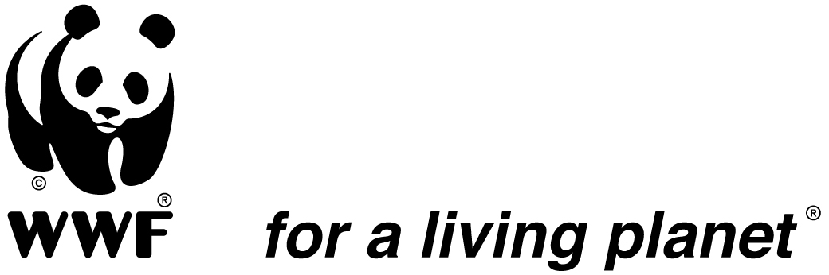

Brief Project/ programme Technical Progress Report Template

Half-year (6 Month) Report—due Jan. 31st

(Recommended length: 6 pages)
Project/ Programme Name | Strengthening Freshwater Knowledge to Support New Ramsar Designations (at least 1 million ha) in the Democratic Republic of Congo
Project Number
Reporting Period
Project Start Date (FY) | FY11
Date Report Completed (MM/YR) | January 2012
Report Completed By

- Progress on Activities and Related Financial Issues
- Provide a brief (3 / 4 page) summary of progress at the activity level hand Against the project workplan highlighting Any Areas That are well behind schedule

After the historic designation of the world’s largest Ramsar wetland site of Lac Tumba-Lac Tele, a number of other important wetland areas were identified and highlighted by the partners, including the reaches of Upemba-Kundelungo-Lufira and/or the mainstem Congo River above Matadi to Kinshasa. WWF-DRC has elaborated a project in order to expand freshwater conservation and pursue more integrated river basin management.
In expectation of new RAMSAR sites designation in the DRC as part of the project above, several advances have been made over the last six months in order to boost this process. Since launching the project, some significant advances have been made in the main tasks, especially the following activities:

- Compile and synthesize existing freshwater information for 1-2 key freshwater sites in the DRC, totaling at least 1 million ha:
- Key informations concerning Salonga freshwater have been collected.

- Conduct biological inventories and sociological surveys to fill key information gaps, particularly for fish and birds:
- The process is already started and contacts have been made with a potential consultant to conduct these inventories. The consultant will produce also a detailed map of the freshwater sites in line with RAMSAR guidelines.

- Support and assist advocacy for Government announcement of new RAMSAR designations before COP 11 (May 2012) or World Wetlands Day Feb 2011.

- A meeting was held with the Government RAMSAR Convention Focal Point in order to prepare the Government advocacy for new RAMSAR designation. This meeting aimed also to scaffold the production of official RAMSAR designation documents in line with requirements for submission by the Ministry of Environment to the RAMSAR secretariat.
(ii) Quantify and explain any financial consequences related to activity implementation (e.g. any major deviations in budget or expenditure).
- Outcomes and Impacts Achieved
Describe succinctly any achievements in terms of outcomes and impacts delivered against the project/programme’s stated objectives and goals, reporting information against the indicators and/or milestones in the strategic plan. In your text, seek to explain specifically what role the project/WWF played in bringing about the achievements in its complex, multi-stakeholder environment do not include any activity reporting in this section.

- WWF International Freshwater Program Manager and RAMSAR Convention Senior Advisor for Africa trip in DRC:
The aim of this visit was to prepare the participation of RAMSAR Convention to the Summit of Heads of State and Government on the three rainforest hydrologic basins (Amazon, Congo and Borneo-Mekong). It was also planned to hold a workshop with RAMSAR National actors in DRC and other local RAMSAR Partners.
During this visit in DRC, the trip team has held several meetings with key partners:
- Working meeting with Mr. Laurent Magloire Some from WWF together with Mr. Etienne Masumbuko, from COMIFAC;
- A meeting with Mr. Hubert Kapiamba Ilunga, Director of Water Resources DRC;
- A meeting with the Mr. Simon Sakibédé, CICOS Secretary General;
- A workshop session with DRC RAMSAR actors;
- A meeting with Christine Tam, Conservation Director WWF CARPO and Gilbert Madouka, Senior Expert Fishing Project CICOS;
- A meeting with Dr. Jean-Pierre d’Huart, Consultant du WWF-RDC;
- A meeting with Mr. Marc Languy, ICCN, UE Project (Head of Mission);

- Meeting between WWF-DRC Conservation Director and DRC Ramsar Convention Focal Point:
This meeting aimed to prepare administratives formalities. Both parties identified several keys actions to be carried out:
- Send a formal letter of request for support to WWF-DRC, expressing the MECNT intention to create two new RAMSAR sites in the DRC. These two sites will probably be the Upemba national park and the Salonga National Park;
- Organize a workshop to validate the information that will be gathered by stakeholders on this topic;

- WWF-DRC participation to the Summit of Heads of State and Government on the three rainforest hydrologic basins (Amazon, Congo and Borneo-Mekong);

- Challenges and Strengths Affecting Performance
Based on your analysis of the progress made, for each set of workplan activities, objective, goal or milestone the project/programme sought to achieve in this reporting period explain why it was or was not accomplished, discussing briefly the internal (e.g. management processes or capacity) and/or external challenges (e.g. stakeholder behaviour) and/or strengths that enabled or hindered performance. What challenges or enabling conditions will you face over the next six months?

The main problem is political insecurity and rebel infighting in selected areas around the country. Apart from that, following challenges have been identified and will be faced the next six months:

- The Ramsar sites management Institutional framework is not well defined;
- Collaboration between ICCN and MECNT is not good;
- Lack of mass awareness;
- Absence of a Ramsar national strategy;

- Adaptive Management
- How can the Network (including your office) help you to address these challenges, augment the strengths and improve your project/programme’s performance?

To better meet the challenges outlined in section 3, WWF-DRC and the international WWF network should carry the following actions:
- Develop an information network between DRC Ramsar family members (DRC-WWF, IUCN / CARPE, PF Ramsar, Direction of Water Resources of MECNT and ICCN, etc.) to minimize the risk of insecurity in selected areas;
- Work to have a Ramsar national strategy;
- Establish a mass awareness system

(ii) What changes are needed to project/programme strategies and activities, and how will any significant financial performance issues mentioned under (1)(ii) be addressed? Please attach the latest versions of your action plan (e.g. logframe) and monitoring plan, if changes have been made and you are sending this TPR to a donor office.

- Communications/Stories
Highlight any actions or successes meriting communications attention (e.g. success stories (from 1 & 2 above), positive media coverage, new opportunities or partnerships, or major events) as well as any significant communications activities undertaken or planned over the next 6 months.

Actions that deserve attention of communication, positive media coverage, new opportunities or partnerships, are the following:

- WWF-DRC participation to the Summit of Heads of State and Government on the three rainforest hydrologic basins (Amazon, Congo and Borneo-Mekong);

It is recognized, however, that significant progress on achieving outcomes and impacts may not be made in a 6-month period since reporting in July.

