WASIT NATURE RESERVE
Brendan Whittington-Jones & John Pereira | 1/3/18 | SHARJAH

IUCN DEFINITION
Protected Area: A clearly defined geographical space, recognized, dedicated and managed, through legal or other effective means, to achieve the long-term conservation of nature with associated ecosystem services and cultural values.

Summary

Wasit Nature Reserve is a wetland reserve established in 2007 by reclamation and rehabilitation of a waste water and rubbish dump. The nature reserve comprises a mix of terrestrial and aquatic habitats (trending from brackish to brine from winter to summer) fed by an underground fresh water source with origins in the interior of the emirate. Vegetation is a planted and recovered mix of native and exotic species partially irrigated with municipal Treated Sewage Effluent (TSE) water. The nature reserve habitats are particularly important for resident and migratory birds within a dense urban setting.
IUCN Category | IV: Habitat/Species Management Area
Proclaimed | 2007
Affection Plan | Yes
Fenced | Yes | Fence matches affection plan | Yes
Gazette/Decree | Yes – No. 7
Ecosystems | Aquatic/Terrestrial
Size (km²) | 0.8

Introduction

Wasit Nature Reserve was proclaimed with the vision of transforming a severely degraded and polluted waste site (Ramthah tip) into an ecologically diverse, urban wetland. It is the only urban wetland reserve in Sharjah and is a publicly accessible green space that now also serves as a wetland educational facility with the addition of the Wasit Wetland Centre in 2014. The landscaping, planting, vegetation management and natural maturation of the location has led to the formation of a complex matrix of small habitats. These include low dunes vegetated with halophytic succulents and scrubland, dense stands of mixed-species woodlands (native and exotic species - predominantly lining the perimeter of the nature reserve). The water’s edge is in part sparsely vegetated, densely vegetated with halophytic species or fringed by dense stands of reed beds (Phragmites australis).
In addition to the water table levels of the surrounding landscape, the primary water inflow is fresh water from inland, underground drainage. Water levels at the wetland fluctuate seasonally and likely also as a result of numerous anthropogenic factors such as nearby extraction and urban infrastructure development. Water levels are lowest at the end of the summer months, corresponding with an increase in salinity concentrations. Increased salinity can adversely impact the populations of the only resident fish species, Arabian toothcarp (Aphanius dispar dispar) although their resilience and tolerances for change have enabled their persistence. Fluctuating water levels also expose or inundate mud flats used by foraging birds.
Between 2010 and 2017, 111 bird species have been recorded at the location, 54 of which are listed on Appendix II of the Convention of Migratory Species. Twenty five bird species are known to breed in the nature reserve. An abundance of Black-winged Stilt (Himantopus himantopus - Highest Individual Count – 334 in 2014), Kentish Plover (Charadrius alexandrines - Highest Individual Count – 348 in 2015) and Pacific Golden Plover (Pluvialis fulva - Highest Individual Count – 54 in 2016) have been counted at the site.
The urban refuge is also important for the many invertebrate species observed in the associated habitats, including numerous butterfly species and the small, abundant marine snail Potamides conicus.
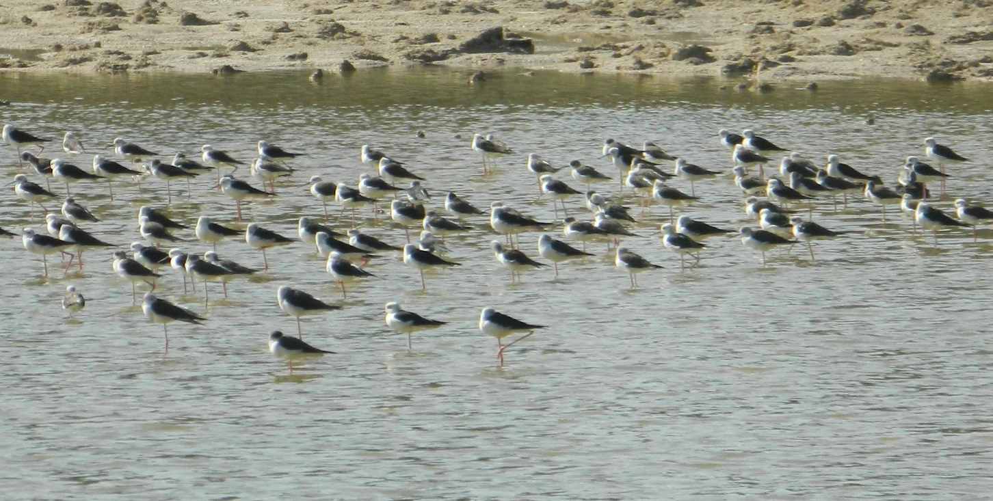
Figure 1: Aggregation of Black-Winged Stilts in the shallow waters of Wasit Nature Reserve

Key Features for PA Designation

Protected Area boundaries are clear, easily determinable and enforceable.

Effectively protects and allows persistence of ecosystems and viable populations of species.

Should ensure connectivity of ecosystems and species distributions.

Should include breeding/nursery/spawning habitats and adult territories.

Should allow for biodiversity and species distribution changes in response to climate change.

Should be aligned with current and anticipated cultural, social and economic requirements.

Should include clear, enforceable regulations understood by the public.

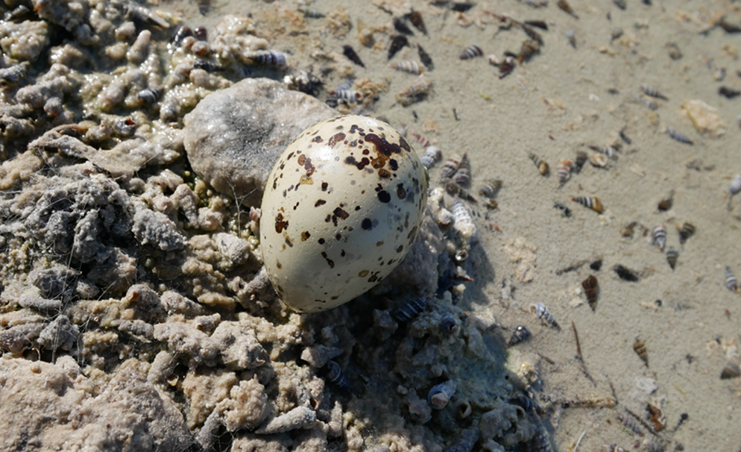
Figure 2: Egg of a Black-Winged Stilt in shallow waters with abundance of small marine snails

An Ecosystem Approach to Protection

An ecosystem approach to protection of habitats and species safeguards the vital components that ensure health, resistance to change and resilience in response to change are maintained. Despite the density of urban development adjacent to Wasit Nature Reserve, connectivity to underground water sources is crucial to survival. This approach means that nutrients, energy and other biotic and abiotic components that influence survival of connected habitats are considered fundamentally important to the entire ecological system’s functioning. Disconnecting or degrading habitats can negatively impact or even destroy adjacent, visually different habitats.

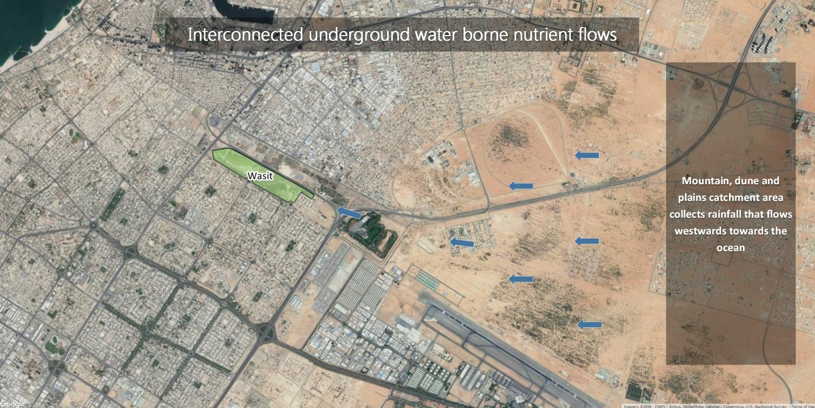
Figure 3: Image depicts the importance of the eastern desert ecosystem connectivity for Wasit Nature Reserve. Despite the substantial surrounding urban development; the dune and plains environment is a crucial component to absorb and concentrate water flow and associated nutrient and mineral cycling (Photo: Google Earth)

Wasit Nature Reserve

As a wetland, Wasit Nature Reserve requires permanent sources of water to sustain the ecological integrity of the system. It is believed that current sources include both water table seepage and fresh water inflow percolating underground from distant dunes, plains and mountains to the east. Water extraction, urban and industrial and infrastructure development all pose significant potential hazards for the ecosystem both through disruption of water supply and the influx of potential pollutants. It is vital that consideration of these lifelines inform measures for persistence of this location despite it being a considerably transformed and landscaped environment. This complexity of water quality and flow interacting with the engineered and remediated habitats provides a significant urban refuge for the many associated birds and invertebrate species. The ecological importance of the site as an extension of the modified western coastal habitats in Sharjah and neighbouring Emirates is reflected by the bird species compositions which are similar in both Al Zorah mangrove to the north and Ras Al Khor to the south. The manipulation of finer scale ecological niches within Wasit Nature Reserve will be subject to prioritization of ongoing management measures.

Key Ecosystem Habitats

Terrestrial | Marine
Permanent Saline, Brackish or Alkaline Marshes/Pools | Not Applicable
Low Sand Dunes - Vegetated
Reed Beds
Mud flats

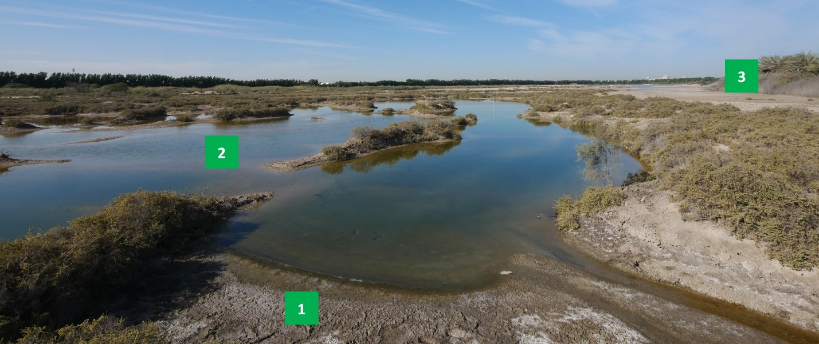
Figure 4: Wetland habitats within the Wasit Nature Reserve; 1 – Mud flats, 2 – Permanent brackish/saline pools, 3 – Reed beds (Photo: Pereira 2017)
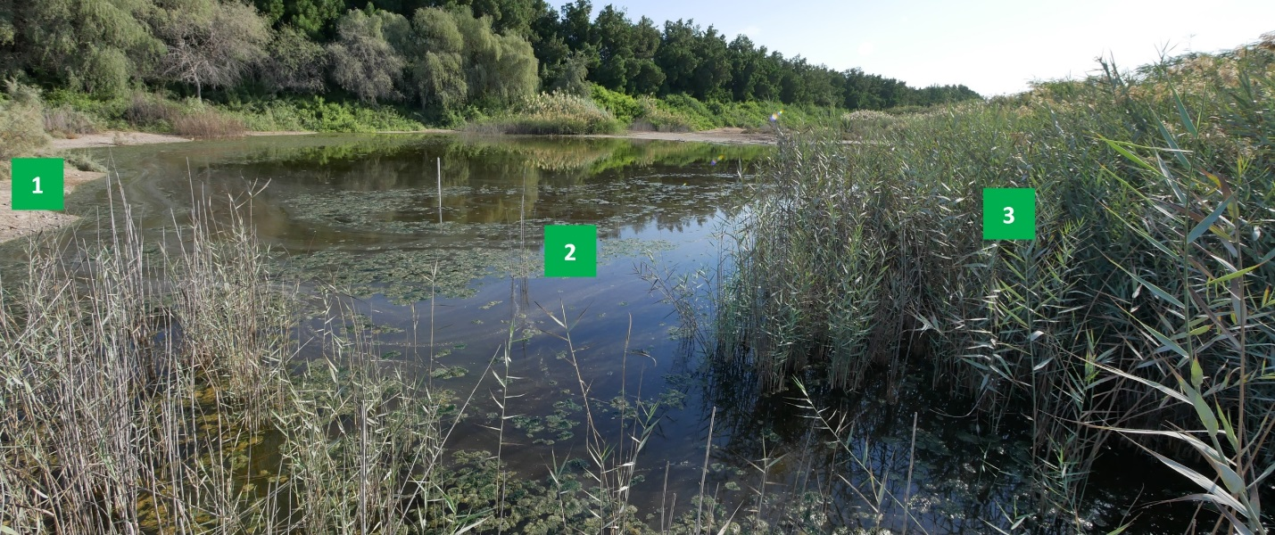
Figure 5: Wetland habitats within the Wasit Nature Reserve; 1 – Mud flats, 2 – Permanent brackish/saline pools, 3 – Reed beds (Photo: Pereira 2017)

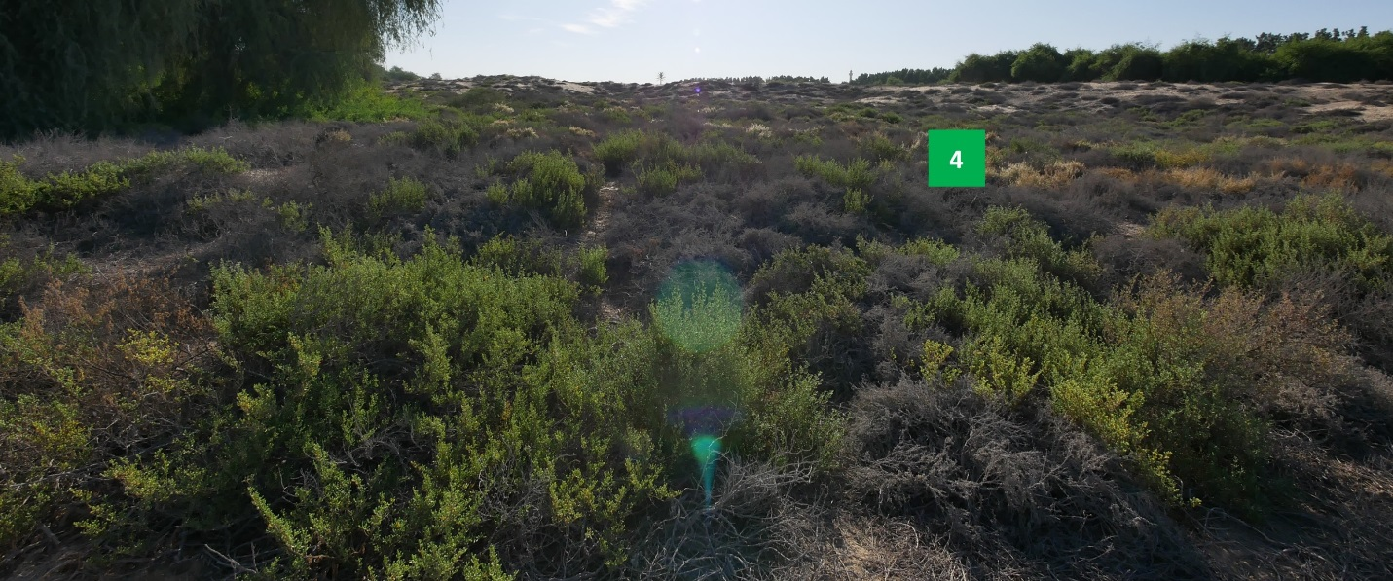
Figure 6: Landscaped sandy habitats within the Wasit Nature Reserve; 4 – Low sand dunes (vegetated) (Photo: Pereira 2017).

The Protected Area Aims

- Secure foraging habitat for threatened and common, resident and migratory bird species
- Protect a representative example of natural diversity of key habitats in an urban setting
- Enable easily accessible public exposure to wetland habitat and the associated species
- Facilitate education of the general public about wetland and migratory species conservation
- Persist as an example of remediated, formerly degraded habitat as an ecologically dynamic, managed wetland
- Secure a remnant wetland habitat connected to the desert ecosystems
- Ensure scientific research opportunities

Management and Operational Objectives

Monitoring, Research, and Evaluation:
- Baseline monitoring to understand habitat and species richness
- Long term monitoring of bird species abundance and diversity
- Long term monitoring of ecosystem ecological condition
- Long term evaluation of climate change impacts on species distribution and persistence

Law Enforcement and Emergency Response:
- Ensure adequate enforcement of regulations to increase compliance

Restoration:
- Remove litter and anthropogenic debris
- Ensure persistence of water sources
- Actively manage vegetation growth to facilitate habitat and associated species diversity

Partnership Coordination:
- Develop a collaborative network to increase biodiversity knowledge
- Develop partnerships for community outreach and education to improve compliance and understand of wetland significance in arid environments

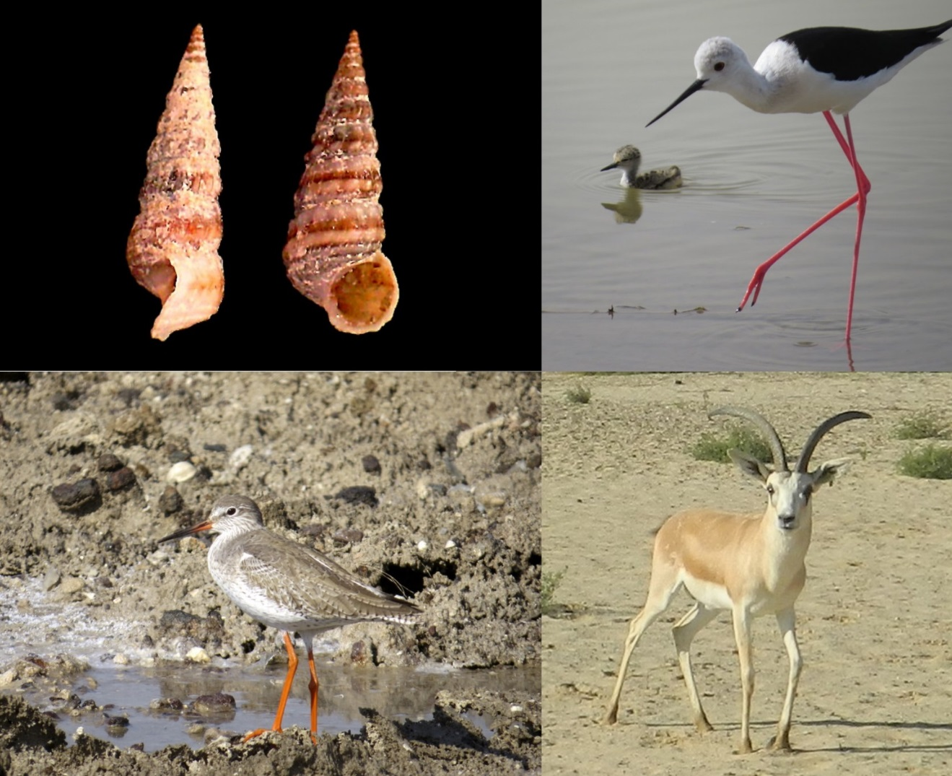
Figure 7: (Clockwise from top left) 1- Potamides conicus, 2 – Black-Winged Stilt, 3 – Sand Gazelle, 4 – Common Redshank (Photos: 1: Fadi Yaghmour, 2 & 4: John Pereira)

Species List

Biodiversity assessments have included repeatable bird surveys, camera trapping, occasional vegetation photographic assessments and general opportunistic observations.

Table 1: Summary of species recorded until (06-11-2017)

Classification | Order/Family | Common Name | Scientific Name | UAE Category | Red List
Mammals | Carnivora | Arabian red fox | Vulpes vulpes arabica | Least Concern | Least Concern
Mammals | Muridae | Black rat | Rattus rattus | Introduced | Least Concern
Mammals | Bovidae | Sand Gazelle | Gazelle marica | Introduced | Vulnerable
Mammals | Felidae | Domestic Cat | Felis catus | Invasive | Not Listed
Reptiles | Gekkonidae | Baluch Rock Gecko | Banopus tuberculatus | N/A | Not Listed
Reptiles | Gekkonidae | Rough-tailed bow foot gecko | Cyrtopodion scabrum | N/A | Not Listed
Reptiles | Gekkonidae | Yellow-bellied house gecko | Hemidactylus flaviviridis | N/A | Not Listed
Reptiles | Gekkonidae | Red sea house gecko | Hemidactylus robustus | N/A | Not Listed
Reptiles | Gekkonidae | Rock semaphore gecko | Pristurus rupestris | N/A | Not Listed
Reptiles | Lacertidae | White spotted lizard | Acanthodactylus schmidti | N/A | Not Listed
Reptiles | Scincidae | Ocellated skink | Chalcides ocellatus | N/A | Not Listed
Reptiles | Varanidae | Desert monitor lizard | Varanus griseus | N/A | Not Listed
Reptiles | Amphisbaenidae | Zarudny's worm lizard | Diplometopon zarudnyi | N/A | Not Listed
Reptiles | Typhlopidae | Flowerpot snake | Rhamphotyphlops braminus | N/A | Invasive
Reptiles | Boidae | Arabian sand boa | Eryx jayakari | N/A | Not Listed
Reptiles | Colubridae | Afro-asian sand snake | Psammophis schokari | N/A | Not Listed
Reptiles | Viperidae | Saw-scaled viper | Echis carinatus sochureki | N/A | Not Listed
Birds | Anseriformes | Common Pochard | Aythya ferina | Visitor | Not Listed
Birds | Anseriformes | Eurasian Teal | Anas crecca | Visitor | Not Listed
Birds | Anseriformes | Gadwall | Anas strepera | Visitor | Not Listed
Birds | Anseriformes | Garganey | Anas querquedula | Migrant | Not Listed
Birds | Anseriformes | Mallard | Anas platyrhynchos | Visitor | Not Listed
Birds | Anseriformes | Northern Pintail | Anas acuta | Visitor | Not Listed
Birds | Anseriformes | Northern Shoveler | Anas clypeata | Visitor | Not Listed
Birds | Anseriformes | Tufted Duck | Aythya fuligula | Visitor | Not Listed
Birds | Anseriformes | Egyptian Goose | Alopochen aegyptiacus |  | Not Listed
Birds | Galliformes | Grey Francolin | Francolinus pondicerianus | Resident | Not Listed
Birds | Podicipediformes | Black-necked Grebe | Podiceps nigricollis | Visitor | Not Listed
Birds | Podicipediformes | Little Grebe | Tachybaptus ruficollis |  | Not Listed
Birds | Phoenicopteriformes | Greater Flamingo | Phoenicopterus roseus |  | Not Listed
Birds | Suliforms | Great Cormorant | Phalacrocorax carbo | Visitor | Not Listed
Birds | Suliforms | Socotra Cormorant | Leucocarbo nigrogularis | Resident | Not Listed
Birds | Pelecaniformes | Glossy Ibis | Plegadis falcinellus | Resident | Not Listed
Birds | Pelecaniformes | Eurasian Spoonbill | Platalea leucorodia | visitor | Not Listed
Birds | Pelecaniformes | Little Bittern | Ixobrychus minutus | visitor | Not Listed
Birds | Pelecaniformes | Cattle Egret | Bubulcus ibis | Migrant | Not Listed
Birds | Pelecaniformes | Great Egret | Ardea alba | Visitor | Not Listed
Birds | Pelecaniformes | Little Egret | Egretta garzetta | Visitor | Not Listed
Birds | Pelecaniformes | Black-crowned Night Heron | Nycticorax nycticorax | Visitor | Not Listed
Birds | Pelecaniformes | Grey Heron | Ardea cinerea | Visitor | Not Listed
Birds | Pelecaniformes | Purple Heron | Ardea purpurea | Visitor | Not Listed
Birds | Pelecaniformes | Striated Heron | Butorides striatus | Resident | Not Listed
Birds | Pelecaniformes | Western Reef Heron | Egretta gularis | Resident | Not Listed
Birds | Falconiformes | Crested Honey Buzzard | Pernis ptilorhynchus | Visitor | Not Listed
Birds | Falconiformes | European Honey Buzzard | Pernis apivorus | Visitor | Not Listed
Birds | Falconiformes | Greater Spotted Eagle | Aquila clanga | Visitor | Not Listed
Birds | Falconiformes | Montagu's Harrier | Circus pygargus | Visitor | Not Listed
Birds | Falconiformes | Western Marsh Harrier | Circus aeruginosus | Visitor | Not Listed
Birds | Falconiformes | Shikra | Accipiter badius | Resident | Not Listed
Birds | Falconiformes | Eurasian Hobby | Falco subbuteo | Migrant | Not Listed
Birds | Gruiformes | Common Moorhen | Gallinula chloropus | Resident | Not Listed
Birds | Gruiformes | Eurasian Coot | Fulica atra | Visitor | Not Listed
Birds | Charadriiformes | Black-winged Stilt | Himantopus himantopus | Resident | Not Listed
Birds | Charadriiformes | Pied Avocet | Recurvirostra avosetta |  | Not Listed
Birds | Charadriiformes | Common Ringed Plover | Charadrius hiaticula | Visitor | Not Listed
Birds | Charadriiformes | Eurasian Golden Plover | Pluvialis apricaria | Visitor | Not Listed
Birds | Charadriiformes | Grey Plover | Pluvialis squatarola | Visitor | Not Listed
Birds | Charadriiformes | Kentish Plover | Charadrius alexandrinus | Resident | Not Listed
Birds | Charadriiformes | Lesser Sand Plover | Charadrius mongolus | Visitor | Not Listed
Birds | Charadriiformes | Pacific Golden Plover | Pluvialis fulva | Visitor | Not Listed
Birds | Charadriiformes | Red-wattled Lapwing | Vanellus indicus | Resident | Not Listed
Birds | Charadriiformes | White-tailed Lapwing | Vanellus leucurus | Visitor | Not Listed
Birds | Charadriiformes | Common Snipe | Gallinago gallinago | Visitor | Not Listed
Birds | Charadriiformes | Jack Snipe | Lymnocryptes minimus | Visitor | Not Listed
Birds | Charadriiformes | Bar-tailed Godwit | Limosa lapponica | Visitor | Not Listed
Birds | Charadriiformes | Common Greenshank | Tringa nebularia | Visitor | Not Listed
Birds | Charadriiformes | Common Redshank | Tringa totanus | Visitor | Not Listed
Birds | Charadriiformes | Spotted Redshank | Tringa erythropus | Visitor | Not Listed
Birds | Charadriiformes | Broad-billed Sandpiper | Limicola falcinellus | Visitor | Not Listed
Birds | Charadriiformes | Common Sandpiper | Actitis hypoleucos | Visitor | Not Listed
Birds | Charadriiformes | Curlew Sandpiper | Calidris ferruginea | Migrant | Not Listed
Birds | Charadriiformes | Green Sandpiper | Tringa ochropus | Visitor | Not Listed
Birds | Charadriiformes | Marsh Sandpiper | Tringa stagnatilis | Visitor | Not Listed
Birds | Charadriiformes | Ruddy Turnstone | Arenaria interpres | Migrant | Not Listed
Birds | Charadriiformes | Little Stint | Calidris minuta | Visitor | Not Listed
Birds | Charadriiformes | Temminck's Stint | Calidris temminckii | Visitor | Not Listed
Birds | Charadriiformes | Dunlin | Calidris alpina | Visitor | Not Listed
Birds | Charadriiformes | Ruff | Philomachus pugnax | Migrant | Not Listed
Birds | Charadriiformes | Red-necked Phalarope | Phalaropus lobatus | Migrant | Not Listed
Birds | Charadriiformes | Common Black-headed Gull | Larus ridibundus |  | Not Listed
Birds | Charadriiformes | Slender-billed Gull | Larus genei | Visitor | Not Listed
Birds | Charadriiformes | Gull-billed Tern | Gelochelidon nilotica | Visitor | Not Listed
Birds | Charadriiformes | Saunders's Tern | Sternula saundersi | Visitor | Not Listed
Birds | Charadriiformes | Swift Tern | Sterna bergii | Visitor | Not Listed
Birds | Charadriiformes | Whiskered Tern | Chlidonias hybrida | Migrant | Not Listed
Birds | Charadriiformes | White-cheeked Tern | Sterna repressa | Visitor | Not Listed
Birds | Charadriiformes | White-winged Tern | Chlidonias leucopterus | Migrant | Not Listed
Birds | Columbiformes | Eurasian Collared Dove | Streptopelia decaocto | Resident | Least Concern
Birds | Columbiformes | European Turtle Dove | Streptopelia turtur | Visitor | Not Listed
Birds | Columbiformes | Laughing Dove | Streptopelia senegalensis | Resident | Least Concern
Birds | Psittaciformes | Rose-ringed Parakeet | Psittacula krameri | Resident | Not Listed
Birds | Cuculiformes | Common Cuckoo | Cuculus canorus | Migrant | Not Listed
Birds | Caprimulgiformes | Egyptian Nightjar | Caprimulgus aegyptius | Visitor | Least Concern
Birds | Caprimulgiformes | European Nightjar | Caprimulgus europaeus | Migrant | Not Listed
Birds | Apodiformes | Common Swift | Apus apus | Migrant | Not Listed
Birds | Apodiformes | Pallid Swift | Apus pallidus | Visitor | Least Concern
Birds | Coraciiformes | European Roller | Coracias garrulus | Migrant | Not Listed
Birds | Coraciiformes | Indian Roller | Coracias benghalensis | Resident | Least Concern
Birds | Coraciiformes | Common Kingfisher | Alcedo atthis | Visitor | Not Listed
Birds | Coraciiformes | Pied Kingfisher | Ceryle rudis | Visitor | Not Listed
Birds | Coraciiformes | Blue-cheeked Bee-eater | Merops persicus | Migrant | Least Concern
Birds | Coraciiformes | European Bee-eater | Merops apiaster | Migrant | Least Concern
Birds | Coraciiformes | Little Green Bee-eater | Merops orientalis | Resident | Least Concern
Birds | Coraciiformes | Eurasian Hoopoe | Upupa epops | Visitor | Not Listed
Birds | Passeriformes | Daurian Shrike | Lanius isabellinus | Visitor | Least Concern
Birds | Passeriformes | Turkestan Shrike | Lanius isabellinus | Migrant | Least Concern
Birds | Passeriformes | Lesser Grey Shrike | Lanius minor | Migrant | Not Listed
Birds | Passeriformes | Red-backed Shrike | Lanius collurio | Migrant | Not Listed
Birds | Passeriformes | Southern Grey Shrike | Lanius meridionalis | Resident | Not Listed
Birds | Passeriformes | Woodchat Shrike | Lanius senator | Migrant | Not Listed
Birds | Passeriformes | House Crow | Corvus splendens | Resident | Least Concern
Birds | Passeriformes | Crested Lark | Galerida cristata | Resident | Least Concern
Birds | Passeriformes | Red-vented Bulbul | Pycnonotus cafer | Resident | Not Listed
Birds | Passeriformes | White-eared Bulbul | Pycnonotus leucotis | Resident | Least Concern
Birds | Passeriformes | Barn Swallow | Hirundo rustica | Visitor | Least Concern
Birds | Passeriformes | Rock Martin | Ptyonoprogne fuligula | Visitor | Least Concern
Birds | Passeriformes | Sand Martin | Riparia riparia | Migrant | Not Listed
Birds | Passeriformes | Willow Warbler | Phylloscopus trochilus | Migrant | Not Listed
Birds | Passeriformes | Common Chiffchaff | Phylloscopus collybita | Visitor | Not Listed
Birds | Passeriformes | Clamorous Reed Warbler | Acrocephalus stentoreus | Resident | Not Listed
Birds | Passeriformes | Eurasian Reed Warbler | Acrocephalus scirpaceus | Migrant | Not Listed
Birds | Passeriformes | Eastern Olivaceous Warbler | Iduna pallida | Migrant | Not Listed
Birds | Passeriformes | Graceful Prinia | Prinia gracilis | Resident | Not Listed
Birds | Passeriformes | Menetries's Warbler | Sylvia mystacea | Migrant | Not Listed
Birds | Passeriformes | Upcher’s Warbler | Hippolais languida | Migrant | Not Listed
Birds | Passeriformes | Brahminy Starling | Sturnus pagodarum | Resident | Not Listed
Birds | Passeriformes | black-throated Thrush | Turdus atrogularis | Visitor | Not Listed
Birds | Passeriformes | Siberian Stonechat | Saxicola group maura | Visitor | Not Listed
Birds | Passeriformes | Common Redstart | Phoenicurus phoenicurus | Migrant | Not Listed
Birds | Passeriformes | Rufous-tailed Scrub Robin | Cercotrichas galactotes | Migrant | Not Listed
Birds | Passeriformes | Eurasian Wryneck | Jynx torquilla | Migrant | Not Listed
Birds | Passeriformes | Scaly-breasted Munia | Lonchura punctulata | Resident | Not Listed
Birds | Passeriformes | Bank Myna | Acridotheres ginginianus | Resident | Least Concern
Birds | Passeriformes | Common Myna | Acridotheres tristis | Invasive | Least Concern
Birds | Passeriformes | Pied Myna | Sturnus contra | Resident | Not Listed
Birds | Passeriformes | Bluethroat | Luscinia svecica | Visitor | Not Listed
Birds | Passeriformes | Desert Wheatear | Oenanthe deserti |  | Least Concern
Birds | Passeriformes | Pied Wheatear | Oenanthe pleschanka | Migrant | Not Listed
Birds | Passeriformes | Whinchat | Saxicola rubetra | Migrant | Not Listed
Birds | Passeriformes | Spotted Flycatcher | Muscicapa striata | Migrant | Not Listed
Birds | Passeriformes | Purple Sunbird | Cinnyris asiaticus | Resident | Not Listed
Birds | Passeriformes | House Sparrow | Passer domesticus | Resident | Least Concern
Birds | Passeriformes | Yellow-throated Sparrow | Gymnoris xanthocollis | Visitor | Not Listed
Birds | Passeriformes | Streaked Weaver | Ploceus manyar | Resident | Not Listed
Birds | Passeriformes | Citrine Wagtail | Motacilla citreola | Visitor | Not Listed
Birds | Passeriformes | White Wagtail | Motacilla alba | Visitor | Not Listed
Birds | Passeriformes | Yellow Wagtail | Motacilla flava | Migrant | Not Listed
Birds | Passeriformes | Striolated Bunting | Emberiza striolata | Resident | Not Listed
Plants | Poaceae | Foxtail/buffel grass, sand-burr | Cenchrus ciliaris | Common | Not Listed
Plants | Asclepiadaceae | Broom Bush | Leptadenia pyrotechnica | Common | Not Listed
Plants | Asteraceae |  | Launaea capitata | Common | Not Listed
Plants | Boraginaceae | Turnsole | Heliotropium kotschyi | Common | Not Listed
Plants | Chenopodiaceae |  | Haloxylon salicornicum | common | Not Listed
Plants | Chenopodiaceae | Sea Blite | Suaeda vermiculata | Common | Not Listed
Plants | Euphorbiaceae |  | Euphorbia larica | Common | Not Listed
Plants | Fabaceae |  | Prosopis juliflora | Invasive | Not Listed
Plants | Mimosaceae |  | Acacia tortilis | Common | Not Listed
Plants | Mimosaceae | Ghaf | Prosopis cineraria | Common | Not Listed
Plants | Neuradaceae | Creeping thorn rose | Neurada procumbens | Common | Not Listed
Plants | Tamaricaceae |  | Tamarix aucheriana | Locally Common | Not Listed

APPENDIX 1

