Planning and management context for NSW national parks

The former Narriearra Station was gazetted as Caryapundy Swamp National Park on the 30th October 2020. This action was enabled by the National Parks and Wildlife Act (1974) (NPW Act) which specifies the purpose of reserving land as a national park or reserve is:
‘protect and conserve areas containing outstanding or representative ecosystems, natural or cultural features or landscapes or phenomena that provide opportunities for public appreciation and inspiration and sustainable visitor or tourist use and enjoyment.’
Under section 72 of the NPW Act, the park authority must prepare a Plan of Management (PoM) for the park as soon as practicable following its reservation. A PoM is a statutory document that outlines how a park will be conserved, used, developed and managed. If a park does not have an endorsed PoM in place, a Statement of Management intent (SMI) may be prepared as an interim measure to guide its management. A SMI will typically outline the key values, threats and management intent for a park prior to a PoM being adopted.
The SMI for Narriearra Caryapundy Swamp National Park (over page) is consistent with the purpose and objectives of the NPW Act. Management of the park is also guided by other NSW and Commonwealth environmental legislation, and a range of policies, procedures and operational guidelines developed by the NSW National Parks and Wildlife Service (NPWS).
In developing the SMI for Narriearra Caryapundy Swamp National Park, the NPWS carefully considered its nationally and internationally significant ecosystems. These include Caryapundy Swamp, an arid ephemeral wetland that supports rare and threatened biota and which is a critical stop-over point for migratory shorebirds. Equal consideration was given to the site’s location within the Bulloo River Catchment. Unregulated flow of this catchment has created Caryapundy Swamp and shaped the surrounding landscape which is dominated by lunettes, river channels and other features of geomorphological significance.
The SIMI for Narriearra Caryapundy Swamp National Park acknowledges the significant values of Caryapundy Swamp and its proposed listing as a Wetland of International Significance under the Ramsar Convention 1971. It also recognises the obligations of the NPWS should this action be successful and includes relevant objectives and provisions.
Further information on the SMI for Narriearra Caryapundy Swamp National Park and how this guides the management of the part can be obtained from the below links:
Managing parks prior to a plan of management policy.
SMI for Narriearra Caryapundy Swamp National Park

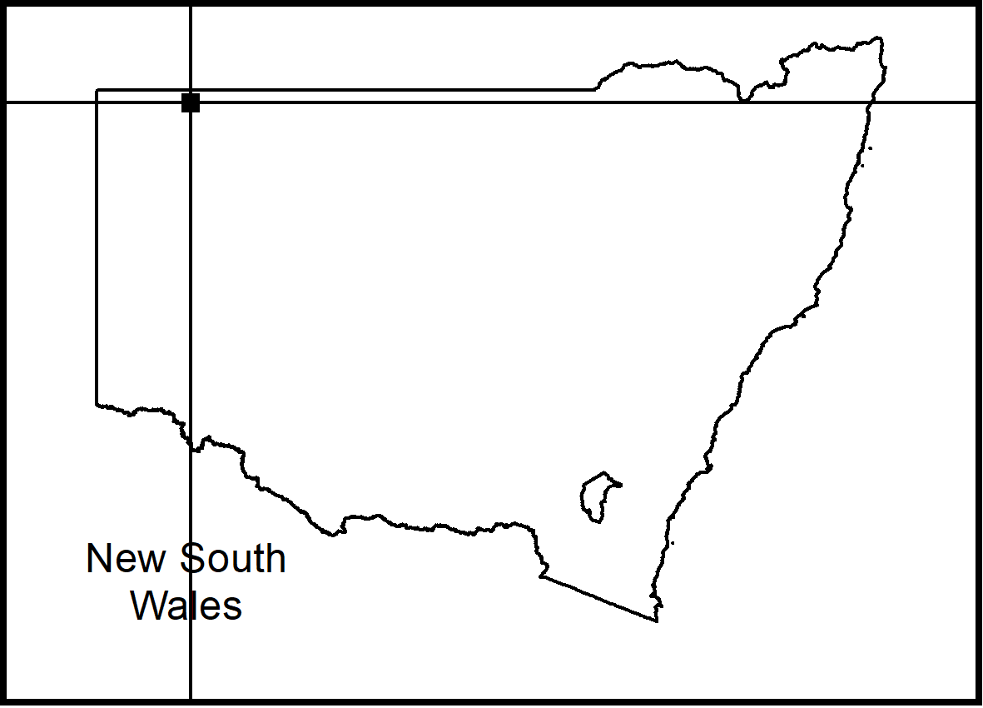
Statement of
Management Intent

Narriearra Caryapundy Swamp National Park

Introduction
NPWS acknowledges that this national park is in the traditional Country of the Karengappa Aboriginal People. Wongkumara People, and Malyangapa People also have traditional ties to the region. The park was established after the New South Wales Government purchased Narriearra Station which was the largest purchase of private land for national parks in the State’s history.
This statement of management intent outlines the main values, issues, management directions and priorities of the National Parks and Wildlife Service (NPWS) for managing Narriearra Caryapundy Swamp National Park. This statement, together with relevant NPWS policies, will guide the management of the area until a plan of management has been prepared in accordance with the National Parks and Wildlife Act 1974. The NPWS Managing Parks Prior to Plan of Management Policy states that parks and reserves without a plan of management are to be managed in a manner consistent with the intent of the National Parks and Wildlife Act and the ‘precautionary principle’ (see Principle 15).

Management principles
National parks are reserved under the National Parks and Wildlife Act to identify, protect and conserve areas containing outstanding or representative ecosystems, natural or cultural features or landscapes or phenomena that provide opportunities for public appreciation and inspiration and sustainable visitor or tourist use and enjoyment. Under the Act (section 30 E), national parks are managed to:
- conserve biodiversity, maintain ecosystem function, protect geological and geomorphological features and natural phenomena and maintain natural landscapes
- conserve places, objects, features and landscapes of cultural value
- protect the ecological integrity of one or more ecosystems for present and future generations
- promote public appreciation and understanding of the national park’s natural and cultural values
- provide for sustainable visitor or tourist use and enjoyment that is compatible with the conservation of the national park’s natural and cultural values
- having regard to the conservation of the national park’s natural and cultural values
- provide for the sustainable use (including adaptive re-use) of any buildings or structures or modified natural areas
- provide for appropriate research and monitoring.
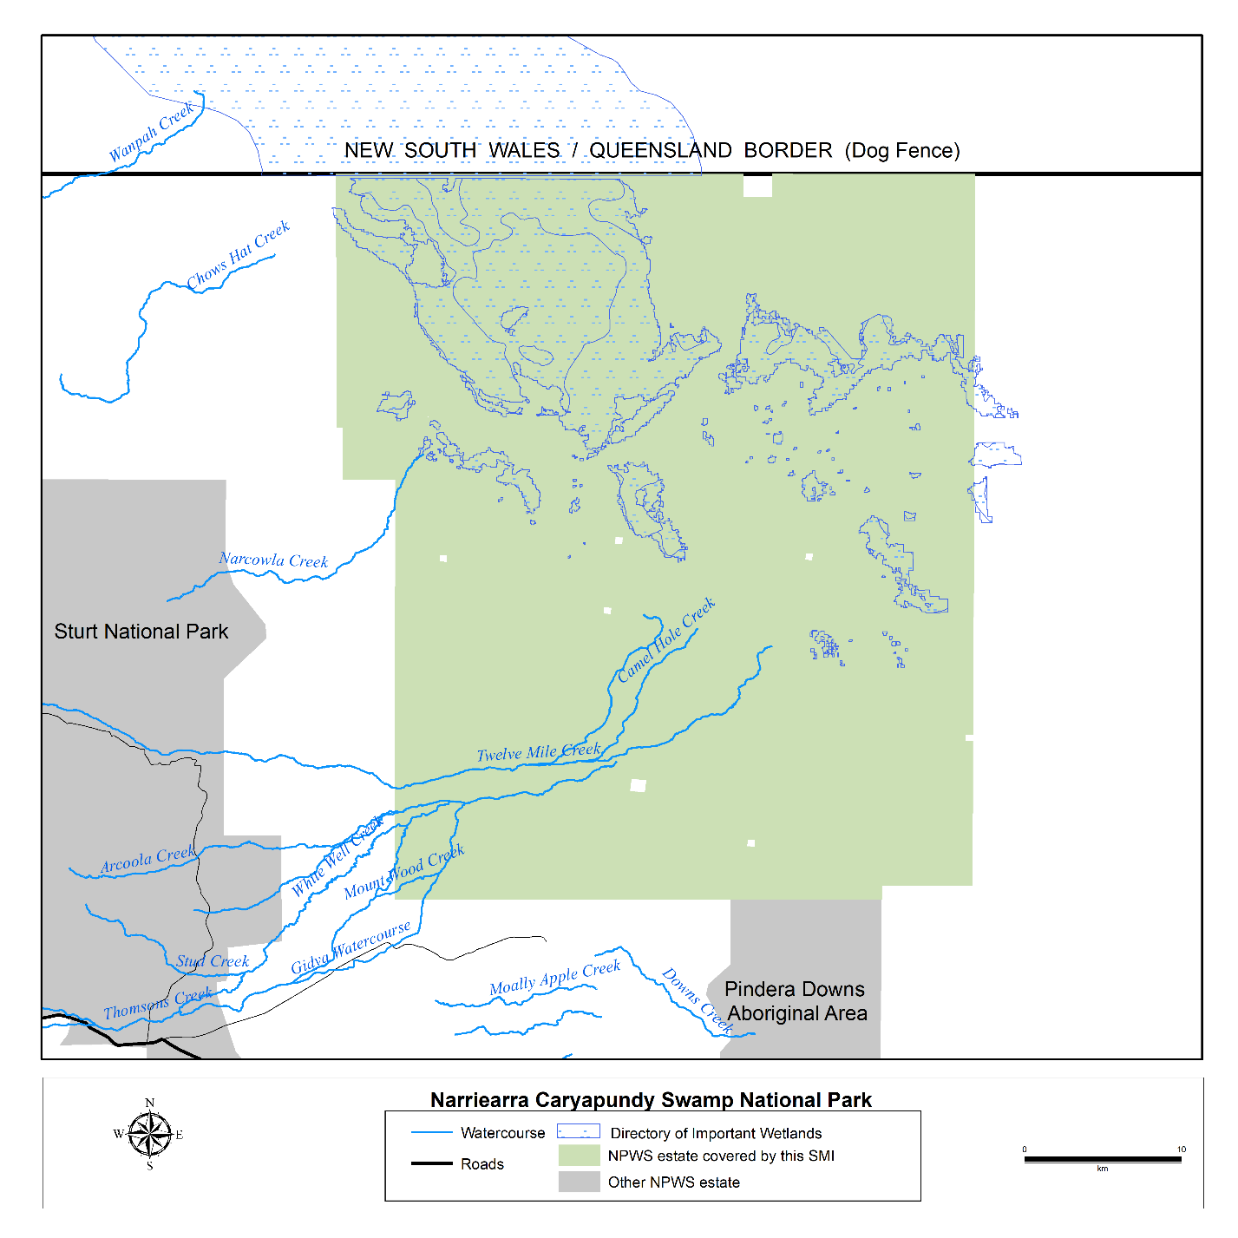

Context
Reservation details: Narriearra Caryapundy Swamp National Park was reserved on 30 October 2020.
Size: 153,844 hectares.
Background: Narriearra Caryapundy Swamp National Park is located in the remote channel country of the Bulloo Overflow in far north-western NSW, known as ‘corner country’. The park is 46 kilometres east of Tibooburra, 170 kilometres north of White Cliffs and 320 kilometres west of Bourke. The Dog Fence (or Dingo Fence) forms the northern boundary of the park on the NSW/Queensland border.
The park lies approximately 10 kilometres east of Sturt National Park and shares part of its southern boundary with Pindera Downs Aboriginal Area. Land to the east of the park is used for broad-acre sheep and cattle grazing.
The word ‘Caryapundy’ was recorded by Burke and Wills in November 1860 as a place name used by Aboriginal people. The word ‘Narriearra’ comes from Narriearra Station which was established on this land in 1916. The origin of this word is not known.
Narriearra Caryapundy Swamp National Park is located within the administrative areas of the Tibooburra Local Aboriginal Land Council, Western Local Land Services and the NSW Unincorporated Area.

Values
- The park makes a very significant contribution to the protection of NSW landscapes within the Channel Country Bioregion which are poorly represented in the reserve system of New South Wales; at sub-region level, nine of these were previously not reserved at all.
- Narriearra Caryapundy Swamp National Park protects approximately 24% of the Bulloo River Overflow. The overflow feeds Caryapundy Swamp, an ephemeral wetland that supports rare and threatened biota and is a critical stop-over point for migratory shorebirds.
- When fully inundated Caryapundy Swamp covers an area of some 144,648 hectares. Unregulated water flowing from the Bulloo River catchment during wet conditions has created Caryapundy Swamp and shaped its surrounding landscape, which is dominated by lunettes, river channels are other features of geomorphological significance.
- Caryapundy Swamp is in a relatively natural state compared to most inland river catchments in eastern Australia. This area is also identified as the Bulloo Floodplain Key Biodiversity Area (KBA) by Birdlife Australia. The KBA is important for the breeding and conservation of waterbirds in arid Australia, including 10 migratory bird species listed under the Environment Protection Biodiversity Conservation Act 1999 and international agreements.
- The park contains a diversity of landforms and ecosystems including aeolian dunes, sandplain grasslands, chenopod shrublands, gibber rises, freshwater and saline wetlands and coolabah-lined channels. They support a range of habitats and a high level of biodiversity for both flora and fauna including 39 mapped vegetation communities, 82 plant species and 167 animal species.
- Twenty-seven threatened animal species and one threatened flora species have been recorded to date.
- The park provides the only known habitat for the nationally threatened grey grasswren (Amytornis barbatus barbatus) in New South Wales. The habitat for this species has been declared as an Asset of Intergenerational Significance (AIS) under the National Parks and Wildlife Act 1972. Actions for the conservation of this species in this park, including monitoring the health and condition of the population, are included in an AIS Conservation Action Plan.
- At least one artesian bore within the park is potentially the site of a mound spring. It displays characteristics of the Artesian Springs Ecological Community in the Great Artesian Basin listed under the Biodiversity Conservation Act 2016 and the EPBC Act.
- Narriearra Caryapundy Swamp National Park forms an important part of the cultural landscape within New South Wales for Aboriginal peoples in terms of connections between people, land and spirit (Country). The Karengappa People are the known traditional owners of land now in Narriearra, while Wongkumara Country lies mostly within the south-western corner of Queensland and Malyangapa Country lies mostly south of the park.
- The Bulloo Lake system, Bulloo Overflow, 12 Mile and Thompsons Creek are nominated places of high Aboriginal cultural value including wells, campsites, small caves and soaks beside creeks. An abundance of Aboriginal cultural heritage sites has also been recorded including stone artefacts, grinding stones, stone arrangements and ceremonial sites. Further survey for Aboriginal cultural heritage sites, particularly in ephemeral swamps and their associated lunettes, is expected to identify additional sites requiring protection.
- Burke and Wills traversed the land now within Narriearra Caryapundy Swamp National Park during their ill-fated expedition through inland Australia from Melbourne to the Gulf of Carpentaria in 1860. The European explorers camped at two sites now within the park on the northward leg of their journey: Tongowoko waterhole (Camp 48) and Caryapundy Swamp. These sites are referred to in the explorers’ progress reports and form part of the now famous Burke and Wills story. The site of Camp 48 bears an engraved post stump of the explorers’ visit.
- Originally used for sheep grazing as Connulpie Downs run (1870) and Caryapundy Swamp (1872), Narriearra Station was subsequently established over these earlier leases in 1916 and with the establishment of bores, changed to cattle. A travelling stock route ran north-south through Narriearra Station via the Adelaide Gate. The Whittabrinnah Hotel was established on this route in the late 1880s. The pastoral history is evidenced by the remains of the Whittabrinnah Hotel, a collection of homesteads, shearing sheds, ground tanks and other historic structures in various stages of repair.
- The iconic Dog Fence (also known as the Dingo Fence) forms the northern border of the park. It dates from the 1880s, and at that time was the longest fence in the world, extending from eastern Queensland to the South Australian coastline.

Issues
- The natural and cultural values of Narriearra Caryapundy Swamp National Park complement those of Sturt National Park not far to the west. There is potential for synergies to be realised for the two parks in many aspects of protected area management including survey and information gathering, staff resourcing, management operations and visitation.
- The remote location of Narriearra Caryapundy Swamp National Park, together with harsh summer conditions and lack of mobile phone coverage, presents a challenging work environment and destination for park visitors.
- Managing issues that affect the Bulloo Overflow will require integration with Bulloo Downs Nature Refuge and other stakeholders across the New South Wales/Queensland border.
- Narriearra Caryapundy Swamp National Park was established towards the end of one of the worst droughts in the history of the region. Destocking of the park will assist regeneration but natural park values will continue to be susceptible to feral animals and weeds and the vagaries of boom and bust cycles associated with arid Australia. Management of the park will need to take account of variable ecosystem processes in the longer term.
- Threats to the nationally threatened grey grasswren include habitat loss, grazing by introduced herbivores, hydrological changes that alter flood patterns, and potential predation by foxes and cats.
- Not all the infrastructure associated with pastoral use of the former Narriearra Station will be required for park management by NPWS. Artificial water points (ground tanks and flowing bores), former homesteads and the existing network of tracks and roads will be evaluated and some decommissioned where excess to NPWS requirements and approved visitor use.

Key management directions
- A Fire Management Strategy has been developed for the park.
- The park will be managed in cooperation with the Aboriginal community and Tibooburra Local Aboriginal Land Council.
- Opportunities for Aboriginal people to access Country, to maintain, renew or develop cultural practices and associations will be maintained.
- Opportunities for Aboriginal people to be involved in park management including the collection and management of information about cultural sites and values and the protection and interpretation of cultural sites will be maintained.
- Non-commercial cultural use of wild resources by the Aboriginal community, such as collection of medicinal plants and bush tucker, will be supported subject to NPWS policies and licences as appropriate.
- Facilitate surveys and assessment of biodiversity and cultural values throughout Narriearra Caryapundy Swamp National Park to inform future management.

- Feral animal control and weed control will be carried out in accordance with NPWS policies and procedures. All potentially effective means of feral animal and weed control will be available. The objective will be to reduce and maintain feral animal densities to a level that ensures no significant ecological impact, to the greatest extent practicable. Work will be undertaken in cooperation with park neighbours and will complement the Western LLS Regional Strategic Pest Animal Management Plan and Western LLS Strategic Weed Management Plan.
- Access to the Dog Fence will be maintained for the Border Fence Maintenance Board of NSW.
- The existing network of roads and trails in the park will be rationalised to ensure access is available for NPWS management purposes and visitation. Narriearra Road (the former Adelaide Gate Road) will be maintained as the primary public access route to the park. Park roads and management trails may be closed during and after wet conditions.
- The network of ground tanks in the park will be rationalised to retain only those tanks needed for park management and visitation. Tanks which are excess to these purposes will be decommissioned.
- Visitor facilities will be developed to provide safe access, sites for camping and opportunities to experience the park’s values.
- A self-guided driving route may be established for visitors along specified park roads, by means of park signage and interpretation, to include the historic Whittabrinnah Hotel site and day use and camping areas. This route may be extended in the future.
- Bird hides may be established for visitor and research use within grey grasswren habitat and at other suitable locations adjoining existing ground tanks.
- Derelict structures and infrastructure may be stabilised or removed as appropriate, following an assessment of heritage value.
- All management activities will be preceded by the preparation of an environmental assessment or heritage assessment where this is a requirement of NPWS policy or legislation.
- Environmental repair and threat management programs, such as erosion mitigation measures, management of feral animals and wild dogs, management of weeds, and activities arising from threatened species requirements may be implemented in accordance with NPWS policies and procedures.
- Non-intrusive works may be undertaken where necessary to protect cultural heritage items from further deterioration, to ensure the safety of visitors and wildlife or to prevent damage to park assets.
- A plan of management will be prepared to set out the on-going management objectives for the park. The plan of management is a statutory document under the National Parks and Wildlife Act which will be available for public comment. NPWS will also encourage the community to contribute to the on-going conservation of the park by promoting and raising public awareness of its special values.
- The NSW Government acknowledges the special values of Caryapundy Swamp and has nominated it for listing as a Wetland of International Importance under the Ramsar Convention 1971. If listed, NPWS will be required to meet the obligations of the Ramsar Convention including applying management effort to maintain or enhance the ecological character of the site (where possible). NPWS will also involve local Aboriginal people and other stakeholders in the integrated management of Caryapundy Swamp’s land, water and living resources consistent with their wise and sustainable use.

For additional information or enquiries about any aspect of this park or this statement, contact the NPWS Tibooburra Office on (08) 8091 3308.

Disclaimer: This is a statement of intent to guide the management of the park prior to the development of a plan of management. Any statements made in this publication are made in good faith and do not render the Department of Planning Industry and Environment liable for any loss or damage. Provisions in the final plan of management may vary from those identified in this document as a result of new information and community consultation. The map in this statement is intended to show the park’s location and basic features only, and is not suitable for use when navigating to or exploring within the park. | Published by:  Environment, Energy and Science Group,  Department of Planning, Industry and Environment,  Locked Bag 5022, Parramatta NSW 2124  Phone: 1300 361 965 (environment and national parks enquiries);email: info@environment.nsw.gov.au; website: www.environment.nsw.gov.au.  ISBN 978 1 XXXX XXX X  EES 2021/XXXX  Month 2021

Alternative spellings exist for each of the three Aboriginal People groups concerned.

