

The Royal Society for the Conservation of Nature

The Hashemite Kingdom of Jordan

Integrated Ecosystem Management for the Jordan
Great Rift Valley Project (IEM- Jo) Project

Research and Survey Section

Fifa Proposed Protected Area
Breeding Birds Baseline Survey 2010

Dr.Fares Khoury
Mohammed Dhessat
Tareq Qaneer

June 2010

Contents

 |  | Page
 | Acknowledgment
 | Summary
1 | Introduction
1.1 | General Introduction and Background
1.2 | Site location and Description
1.3 | Survey Objectives
2 | Materials and methods
2.1 | Line transects – field methods and data analysis
2.2 | Casual records
2.3 | Survey period, stratification and distribution of survey effort
3 | Results
3.1 | Species-specific population densities
3.2 | Species accounts
4 | Discussion
4.1 | Important records
4.2 | Bird communities and habitats
4.3 | Identification of key species of special interest
4.4 | The threat of habitat fragmentation
5 | Recommendations
5.1 | Future research
5.2 | Monitoring programs
5.3 | Site management
5.4 | Site extensions
5.5 | Landscape management
6 | References

Acknowledgments

The team members would like to express their gratitude for all who helped in carrying out this survey, namely, Enas Sakkijha, head of Research and Survey Section for her continuous support and Natalia Boulad and Yasmin Hujaer for GIS support.

Summary

The Fifa proposed reserve represents two types of vegetation and bird habitats in Jordan: the salt marsh and tropical vegetation that is dominated mainly by Tamarisks. A breeding bird survey was carried out during early June 2010 to establish a complete species list and estimate the densities of breeding species within the proposed reserve. Ten line transects were carried out in the reserve, which covers an area of around 23 sq. kilometers, and is characterized by Tamarix stands that vary locally in density and associated vegetation, growing on a flat plain bordering the southern tip of the Dead Sea.
Bird diversity was relatively low (c. 20 breeding species), but the population sizes of some species were remarkably high. The bird community at the proposed reserve includes, Little Green Bee-eater, Crested Lark, Rufous Bush robin, Spectacled Bulbul, Olivaceous and Graceful Warblers all of which were common and frequent in many parts of the reserve. Less frequent were Sand Partridge Great Grey Shrike and Dead Sea Sparrow that were confined to certain areas or had low density. The Fifa proposed reserve has been previously identified as Important Bird Area because it is an important stop over site for migratory birds, particularly storks, and passerines. Two key species for conservation were identified, including a top predator (Great Grey Shrike), and a species indicative of the health of shrubs forming the dense scrub vegetation growing on moist soils (Dead Sea Sparrow).
The human impact within the proposed area itself is relatively low due to its location in a military zone, but grazing occurs in most areas except for a narrow strip along the border. The dominance of very opportunistic species, e.g. Crested Lark, Graceful Warbler and Spectacled bulbul may be facilitated by land encroachment mainly for agriculture in the areas surrounding the Fifa proposed area. This impact, in combination with recent drought and habitat degradation within the proposed area may be responsible for the absence of some resident and breeding species that were previously recorded in the area and have conservation importance at national and regional levels. One species that is currently spreading throughout the Jordan Valley, the Namaqua Dove, was moderately frequent.
The area of the reserve is rather small, and its biodiversity will be affected further if the natural habitats in the surroundings are lost or highly fragmented. Recommendations are provided on how to manage the reserve once established and the natural landscape of its surroundings with the aim to better protect the natural ecosystem, which is essential for both wild birds, and other animals.
1. Introduction

1.1. General Introduction and background:
The Great Rift Valley is a globally important ecological corridor that links Africa with western Asia. The Jordan Valley is used by millions of birds that migrate each year between Africa and Europe. Apart from its significance for migratory birds, the Jordan Rift Valley also holds many large and internationally important ecosystems, including desert, mountains, wetlands, sea and forest; e.g. the Dead Sea, the Gulf of Aqaba and the Jordan and Yarmouk river systems, as well as numerous specialized habitats of regional importance such as the salt marshes, the sand dune deserts and acacia woodlands of Wadi Araba, and the deciduous oak woodlands along the northern rift margins. The Jordan Rift Valley is an economically important area under heavy development pressure and used by a multitude of stakeholders. Any intervention to secure its ecological integrity must therefore be realistic in scope and targeted at measures that are critical to retaining key ecological functions. Moreover, the entire ecosystems and habitats between Aqaba and the Dead Sea, including Fifa are threatened by major developments inevitably associated with the possible establishment of the Red-Dead water conduit.
As part of the World Bank – funded project (Integrated Ecosystem Management for the Jordan Great Rift Valley Project /IEM- Jo) the Royal Society for the Conservation of Nature has decided to establish four protected areas along the rift and its margins, in addition to seven special conservation areas. The reserves include Jebel Masuda, Qatar and Fifa in the southern Jordan Valley and Wadi Araba and the Yarmuk Reserve that is close to the northern part of the Jordan Valley. A core issue in this project is the safeguarding of globally significant biodiversity and restoring ecological integrity along the Jordan Rift Valley. The project will mainstream biodiversity conservation into the land-use planning process and thus introduce and apply the principles of integrated ecosystem management in the Rift Valley.

Saline and tropical vegetation cover very small areas in Jordan. The remnant patches of these habitats in the Jordan Valley are currently under the severe threat of land encroachment and degradation due to drought and overgrazing. The Fifa area that is located at the southern tip of the Dead Sea is probably unique in Jordan as it combines saline vegetation (e.g. Tamarix sp, Suadea sp.) with tropical vegetation (Acacia sp. Salvadora persica) forming a dense shrubland. In conjunction with this Scrubland, the dense palm groves growing around fresh water springs are very important stop over sites for migratory birds (especially passerines) and birds that have very specific habitat requirements for nesting, e.g. the Dead Sea Sparrow.

1.2. Site location and description:

1.2.1. Location

Fifa proposed reserve (23.2 km²) is located at the southern tip the Dead Sea along the western border of Jordan in a military zone. It lies mostly within the Karak Governate with a smaller portion within Tafilla Governate (See Map1).The elevation is -421m below sea level (Center Coordinates; East °34 '24.188 , North °73 '1.135). It is situated to the west of Fifa village, and the proposed reserve area is named according to Ghour Fifa. Fifa proposed area is centered between Wadi Um Jufna in the north and Wadi Dahel in the south. It is located around 100 km south of the capital city Amman and 17 km north-west of Tafila city.

Map1 showing location of Fifa Proposed Protected in Jordan:
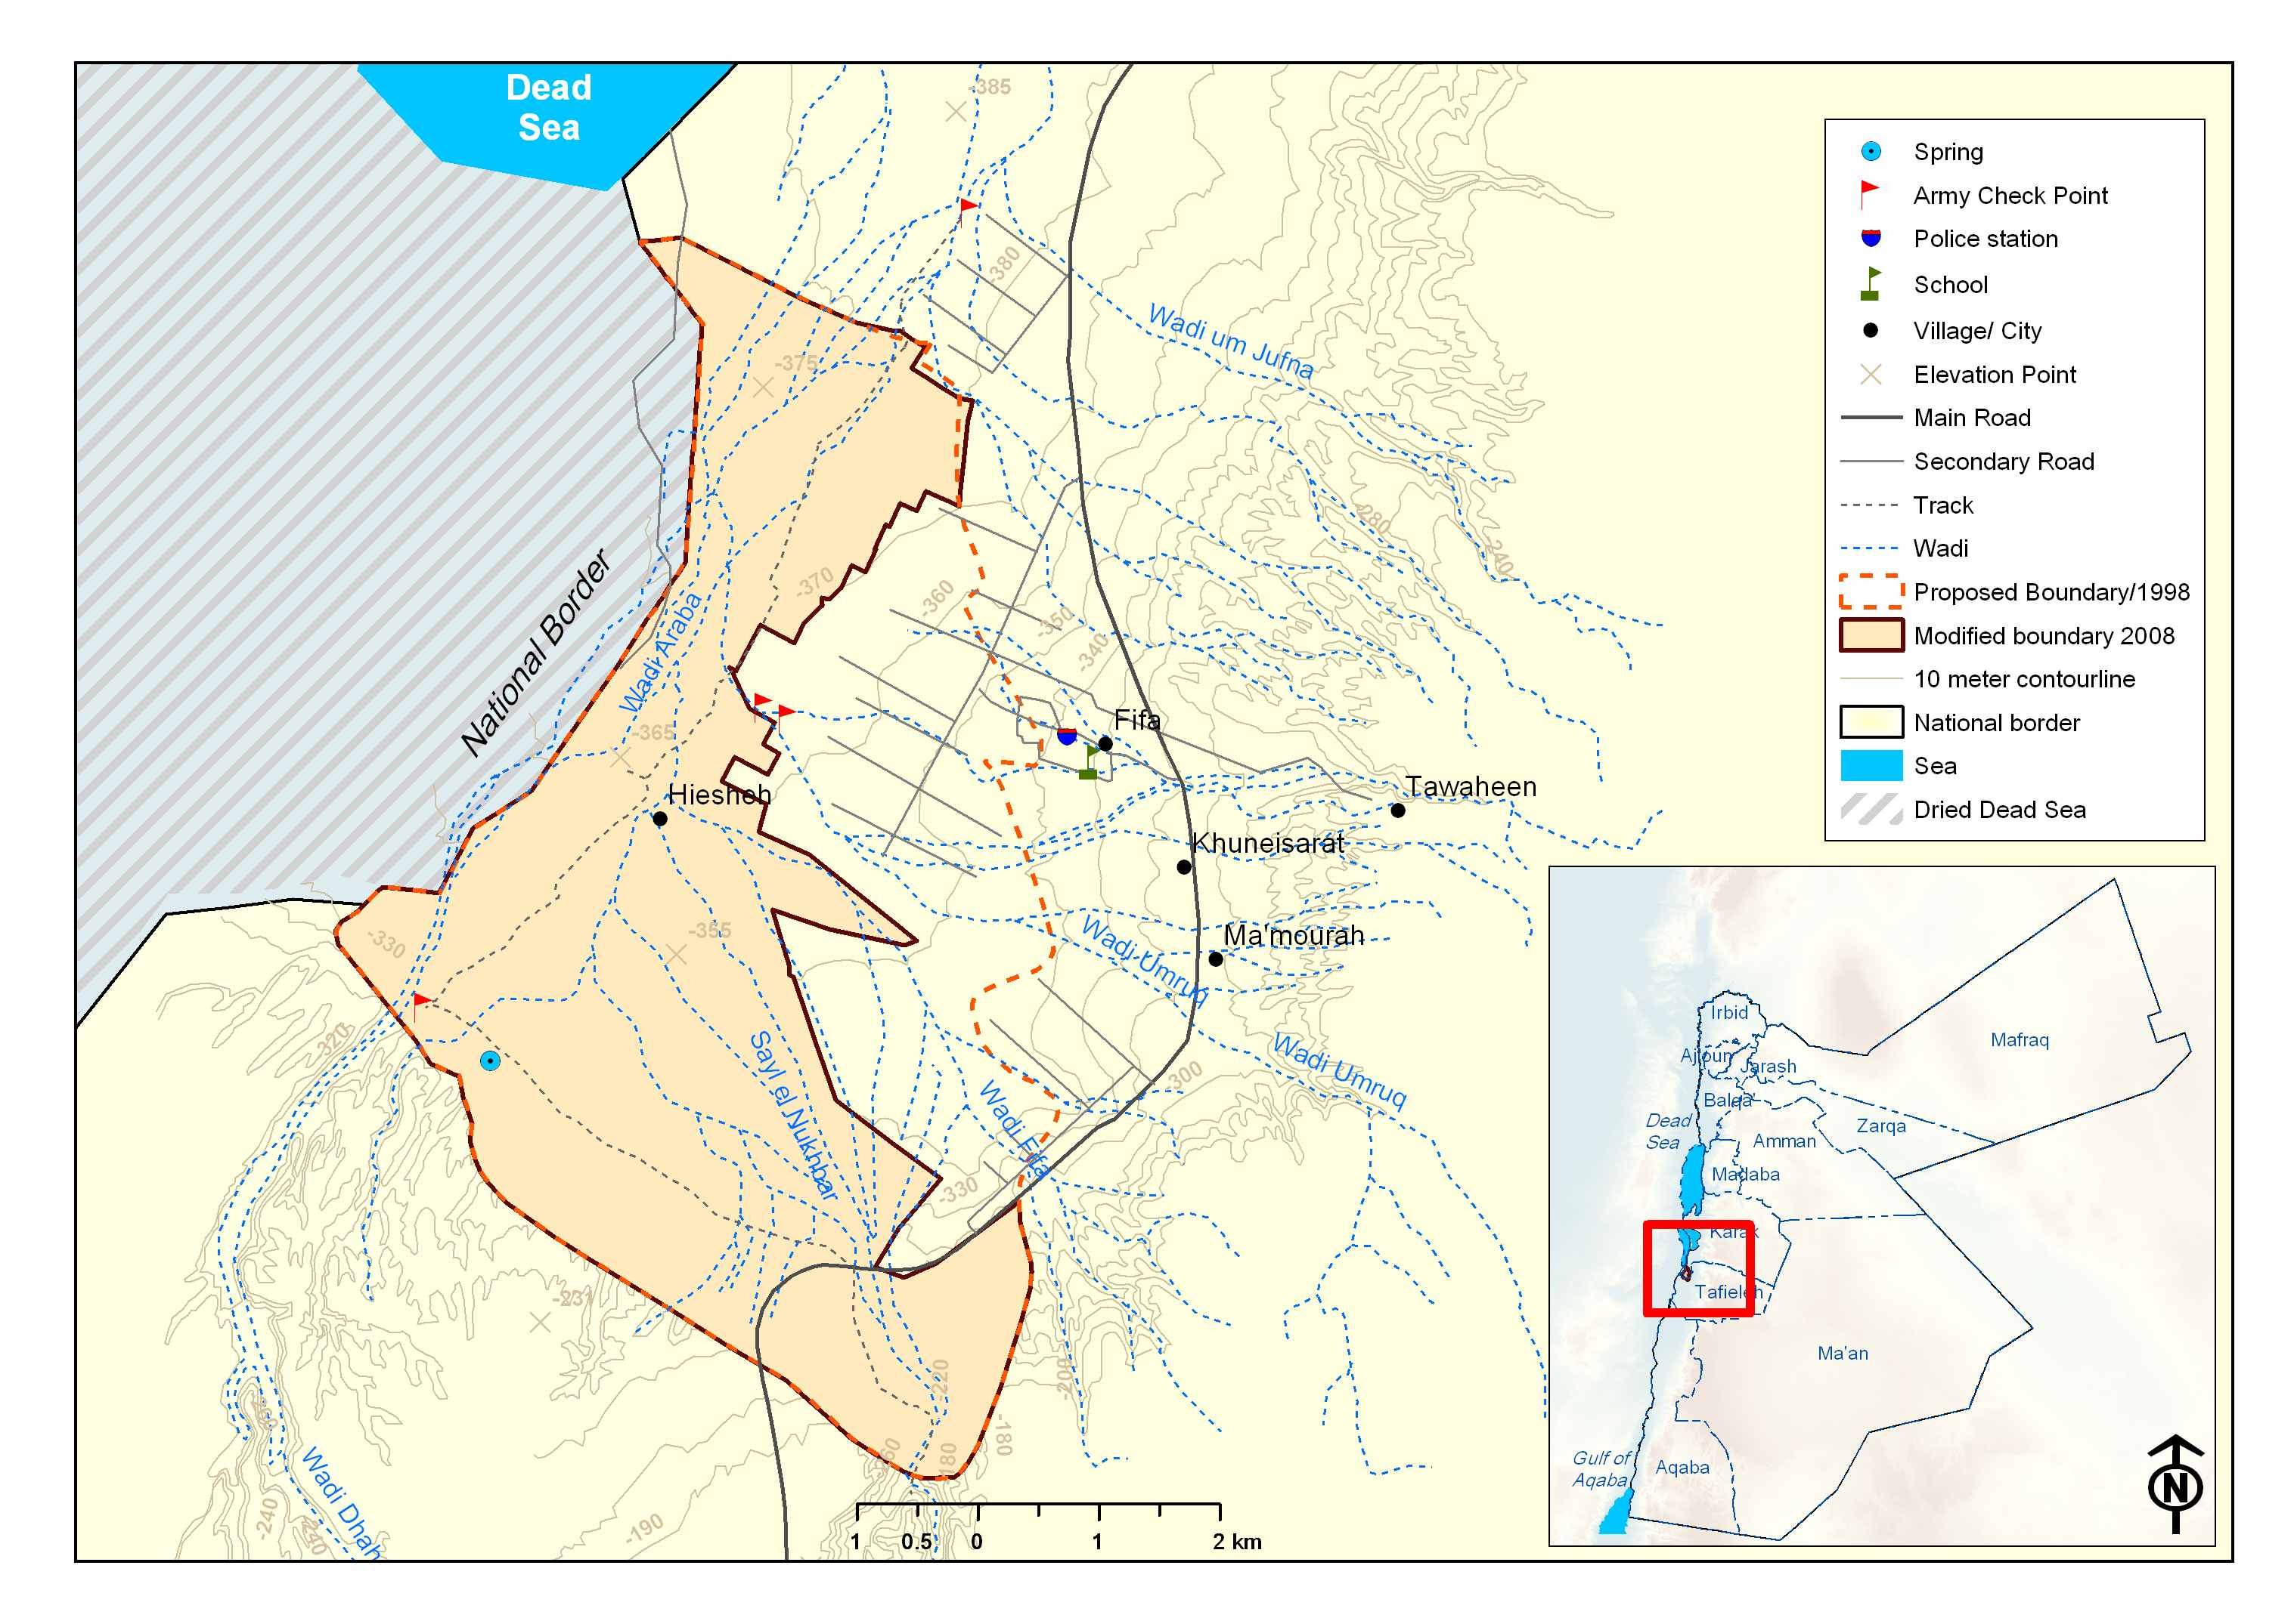

1.2.1. Climate

According to the Jordan Metrological Department, the climate of the proposed reserve area is characterized by moderate winters with minimum average temperature of 10º C that could reach 8.7º C in January as the lowest temperature value and hot summers with maximum average temperature of 40º C that could reach 42º C in July as the highest temperature value. The annual average precipitation in the area is around ninety Millimeters per year falling mainly in November - March. The relative humidity average value is around 51%. These data were obtained from Ghour Al-Safi weather station between the period of 1995 and 2005.

1.2.3. The Biogeographical Zone and vegetation type of Fifa area:
Fifa is located in the Sudanian penetration zone characterized by the presence of several plant species of African origin, e.g. Acacia tortilis, Salvadora persica, and others. The ecosystem of the Fifa area is classified generally as salt marsh dominated mainly by Tamarix shrubs. This type of ecosystem is usually found in low-lying and flat areas which are partly inundated by (saline) water, at least seasonally. In Jordan, this ecosystem is found in the hot and arid Jordan Valley where springs and (temporary) streams lead to high soil moisture, hence the relatively dense halophytic vegetation. Surrounding the salt marsh vegetation, drier scrub dominated by tropical shrubs (e.g. Acacia, Ziziphus…) and dwarf shrubs can be found, while palms and a dense grass layer proliferate at freshwater springs.

Map2 showing Vegetation Types in Fifa Proposed Protected Area:

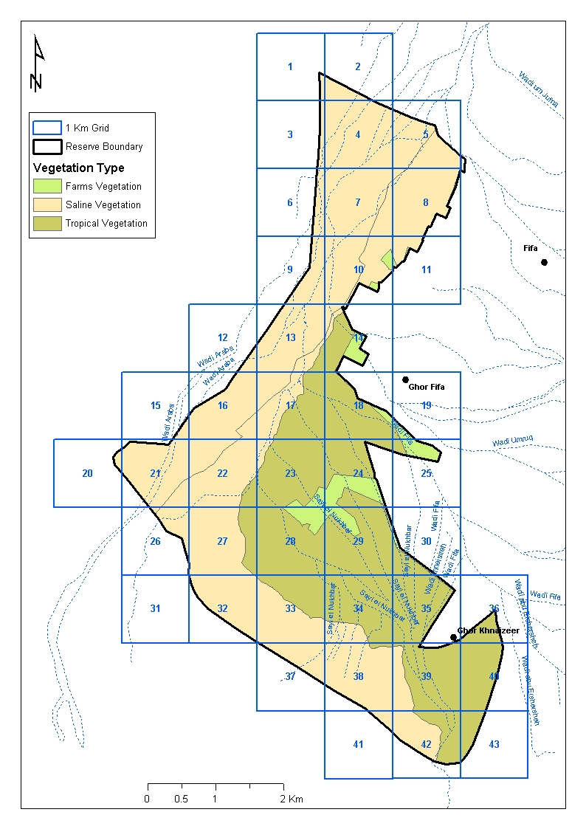

1.2.4. Land use
The proposed area is situated within a military zone, so land use is limited only to grazing by goats of the local Bedouin population. Although the intensity of grazing could not be assessed during this survey, it could have a profound impact on the vegetation and some birds, particularly nesting Dead Sea Sparrows.
The main issue affecting the opposed Fifa area is probably land encroachment, pesticide use and habitat degradation in the areas immediately surrounds the proposed reserve. As the area of this proposed reserve is small, the isolation of its natural habitats from other patches will lead to an increased vulnerability of local bird populations and ultimately to the loss of diversity.

1.3. Survey objectives:
The survey of breeding birds is part of the extensive ecological baseline surveys that aim to gather more detailed information on the distribution, conservation status and ecological associations of all major biodiversity components in the target areas of the Rift Valley project. This part will add to the value and understanding of the ecological state of the Fifa area and will consequently assist in developing, modifying and fine-tuning the management of the entire project.

Rapid assessments were previously carried out in 2008 to provide the minimum needed baselines to initiate planning and priority interventions. The extensive baseline assessments process will ensure the rapid assessments process validation and adaptation. It will give a more focused and detailed assessment of the status of bird diversity in the Fifa area.
The prime aim of this survey was to identify the distribution and abundances of breeding birds in the Fifa proposed Reserve. This survey is considered the base of a monitoring program focusing on the breeding birds of the proposed reserve in case it will be established. Ultimately, the aim was to identify the special importance of the area for particular bird communities and species and determine key/indicator species for conservation. The survey was carried out in a period early June), when both residents and summer visiting migrants are expected to occur and be active in the breeding process. Other migrating species were also recorded and added to the species list. However, it was not our aim to cover migratory species passing through, as this would have needed a much longer period and the use of mist nets to record inconspicuous species.
Further objectives included training RSCN researchers on species identification and survey techniques and the provision of recommendations for the future management policy and actions in the reserve.

In summary, the objectives for of the breeding bird survey were to

- Identify the community of breeding birds and distribution of species.
- Produce a map showing the nesting sites for Dead Sea Sparrow
- Identify species and habitats of special conservation status; indicators for management and / or threatened at all levels being global, national or local.
- Identify threats on the bird diversity and recommend appropriate conservation measures.
- Provide capacity building for the research staff.

2. Materials and Methods

The breeding survey was carried out from in summer 2010, and comprised of 10 line transects that were carried out once during early (6-8th )June in addition to casual sightings.
Slight differences in habitat occurred between the eastern, central and western areas. The area with the densest vegetation including a large reed bed was located in a sensitive and inaccessible border area at the south-western tip of the proposed area. Generally, the typical salt marsh was found in the central and western parts, mainly along the wide and flat wadis that cross the area, while more open vegetation was found along the eastern borders of the proposed reserve; palms and dense grass was found locally as little patches at fresh water springs. We carried out casual sightings at these springs, while the 10 transects were distributed in the remaining areas.

2.1. Line transects – field methods and data analysis:
The line transect method is a suitable method to survey birds in very open woodland or scrub habitat (Bibby et al. 2000), where tree cover is low as is the case in the Fifa reserve .
Ten Quadrants, within which line transects were located, were randomly selected in the reserve (see above). The two-belt method was used according to Bibby et al. (2000). Most transects had a length of 1000m with an inner belt of 50 m on each side. GPS was used to save coordinates and the route of the transect.

Map3 showing grids and transect routes:
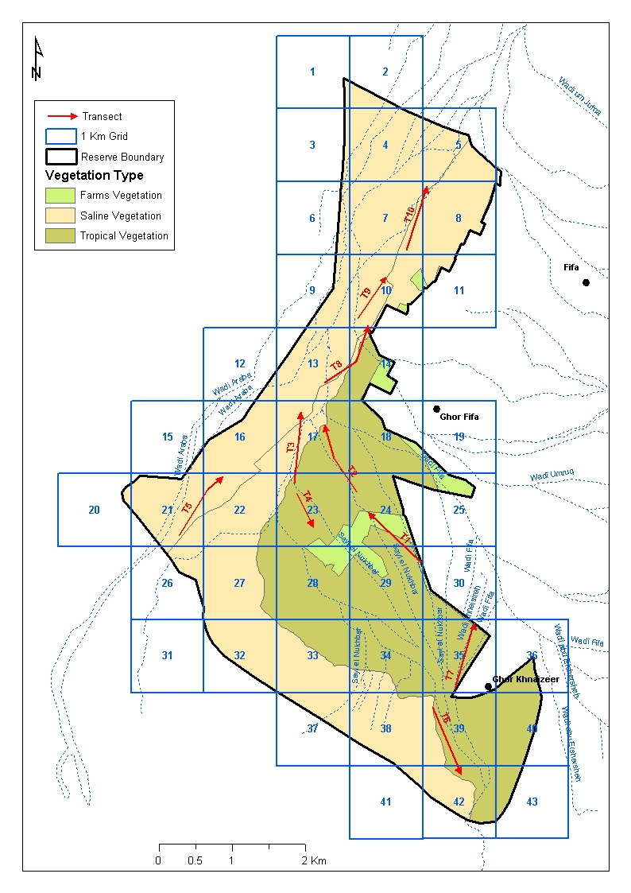

Most transects were performed in the morning, with a few carried out in the afternoon. The team consisting of 2-3 observers counted the birds, usually detected visually and acoustically, within and beyond 50 m and calculated the density of each species according to the linear model (Bibby et al 2000):

D = 10Nk/L

Where D=relative density (per ha)
k = (1 - √(1 - p))/w
p = the probability of detection at 50 m = N1/N
and where N=total number of individuals, N1 = number of individuals within 50 m, L=transect length (km), w = centre to inner band (=50m).

2.2. Casual recordings and transects:
Casual records included all records obtained while walking/driving to the spot counts and during reconnaissance visits to the reserve. The results of casual observation are summarized in the species account.

2.3. Survey period, stratification and distribution of survey effort:
The breeding birds' survey was carried out during 3 days in early June, thus coinciding with the breeding season of resident and summer visiting species. This period was sufficient to carry out a comprehensive survey of breeding birds, and the number of samples (10 transects) was representative, and within grids that covered more than 50% of the small area of the reserve. Line transects were carried out in the morning hours between 7 and 11 am, and a few were carried out during the afternoon. The team consisted of 2-3 researchers, which worked together so as to train the less experienced members of the team.
The densities of most breeding species could be estimated, while migratory species were hardly recorded due to the late date of the survey, but some of the late migrants are listed in the species account. The 10 grids for transects were chosen randomly and were scattered over all parts of the reserve (see above).

3. Results

3.1. Species-specific population densities:

The number of breeding species may reach 19-22 (see species account), but the density of only 16 species, some of which were quite frequent and common, could be estimated using the line transect technique.
The Sand Partridge was observed mainly in the eastern and marginal, drier parts of the proposed reserve area, mainly along the dry wadis that flow towards the north / north-west. The Little Green Bee-eaters was fairly common and frequent along large wadi stretches which had steep banks. The Stone Curlew, Desert Lark and Blackstart avoided dense salt marsh habitats and were seen along the margins of the reserve. The Crested Lark was common and frequent all over. The few Great Grey Shrikes that were recorded preferred open habitats that nevertheless had some high shrubs or trees. Most other species were doves and passerines that depend on shrubs and the relatively dense vegetation of the salt marsh.
Several of these have large population densities at Fifa, their density equaling or exceeding 100 pairs. These include Rufous Bush Robin, Olivacous Warbler, Graceful Warbler and Spectacled Bulbul. The two latter two species along with Palm and Collared Doves also dominated in the dense palm groves at water springs. The most dense salt marsh habitats were required by Turtle Dove and Dead Sea Sparrow, the latter requiring a combination of extensive and dense Tamarix stands, preferably growing on moist or water inundated soils, and the proximity of water for drinking. Of special interest was the frequent presence of Namaqua Dove, which has started to invade the Jordan Valley one or two decades ago, this species was apparently breeding in open salt marsh vegetation.

Map4 Total abundance of birds:
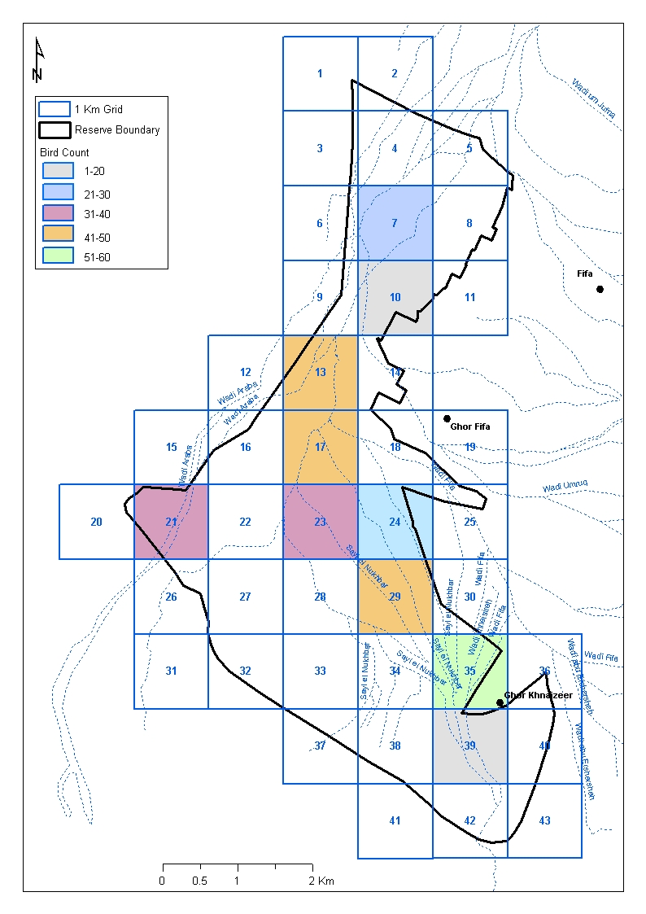
Map5 showing nesting areas of Dead Sea Sparrow:
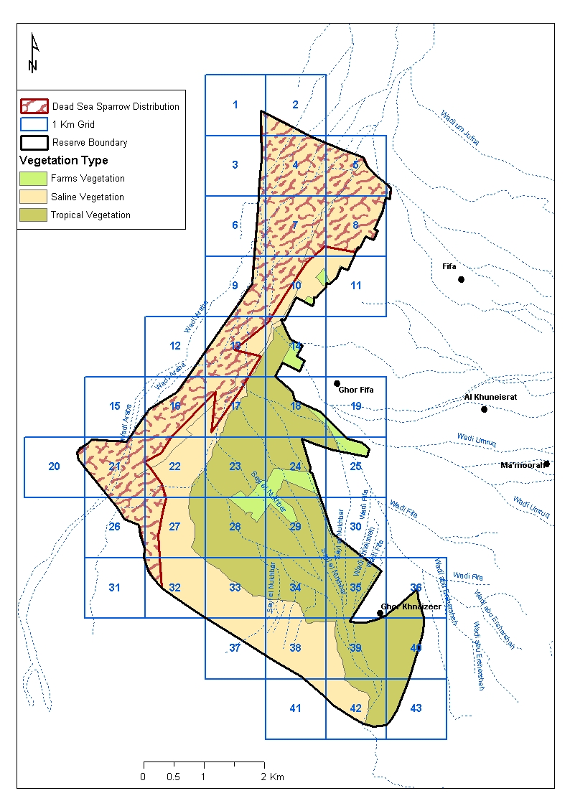

Tab. 1. Frequencies (%), densities (per Km²), and estimated population size (pairs in 23 km2) of breeding species. For other possible breeding and migrant species see species account.

Species | Frequency | Density\km2 | Population size
Long-legged Buzzard | - | - | -
Sand Partridge | 10 | 0.2 | 5
Stone Curlew | 10 | ≤ 0.2 | 1-2
Spur-winged Lapwing | 10 | ≤ 0.2 | 1-2
Collared Dove | 100 | 5 | 57
Turtle Dove | 30 | 3 | 34
Laughing Dove | 20 | 2 | 23
Little Green Bee-eater | 80 | 7 | 80
Crested Lark | 70 | 20 | 230
Desert Lark | 30 | 3 | 30
Namaqua Dove | 50 | 1 | 10
Rofus Bush Robin | 30 | 25 | 280
Black start | 40 | 7 | 80
Graceful Prinia | 90 | 32 | 350
Olivaceous Warbler | 50 | 16 | 180
Scrub Warbler | 20 | 2 | 20
Great Grey Shrike | 10 | ≤ 0.2 | 2-3
Spectacled Bulbul | 90 | 30 | 340
House Sparrow | 20 | 2 | 20
Dead Sea Sparrow | 40 | 5.5 | 60

3.2 Species accounts:

Species Accounts (status in Jordan) {status at Ajloun Reserve}
PM = Passage migrant, SV = Summer visitor, B = Breeds, R= Resident, WV = Winter visitor

Little Bittern Ixobrychus minutus (PM, SV) / {PM, SV?}
One individual was recorded at the northern border of the proposed reserve near a water drainage canal lined with reeds.

Honey Buzzard, Pernis apivorus (PM) / {PM}
A late migrant with few individuals still lingering until June, i.e. when this survey was carried out. This is just one among many migratory species that pass through and use the Fifa area.

Long-legged Buzzard, Buto rufinus (R) / {R}
Does not breed at the site, but birds resident in surrounding hills and mountains probably use Fifa area for feeding. A single bird was recorded at the site.

Sand partridge, Ammoperdix heyi (R) / {R}
Recorded in the drier parts of the reserve, at the southern and eastern margins and mainly along the large wadis. Pairs and juveniles were observed. As hunting is not allowed in this flat area (military zone), this species is apparently able to exist; outside the proposed reserve, it is otherwise recorded only in rocky and rugged areas with limited access due to topography.

Stone Curlew, Burhinus oedicnemus (R, SV) / {R}
A rare bird with 1-2 pairs estimated breeding mainly in open habitats with scattered dwarf shrubs.

Spur – winged Plover, Vanellus spinosus (R) / {R}
A rare bird with 1-2 pairs breeding along the western borders of the reserve. Due to drought conditions in previous, much of the open water that used to exist at Fifa (containing killifish) disappeared. Probably the only aquatic bird species currently breeding at the site.

Collared Dove, Streptopelia decaocto (R) / {R}
A common and frequent species, recorded in all parts of the reserve. Its presence in large numbers indicates the proximity of agriculture and human disturbance.

Turtle Dove, Streptopelia turtur (PM, SV, B) / {PM, SV, B}
Uncommon breeding species in the proposed reserve. Recorded mainly in the most dense salt marsh habitats with dense and high Tamarix shrubs.

Palm Dove, Streptopelia senegalensis (R) / {R}
This species was not as frequent as previous species but was common at palm groves.

Namaqua Dove, Oena capensis (R, PM, SV) / {R}
This species was rather frequent in the salt marsh habitat dominated by Tamarix and Suadea sp.. Pairs were often seen together, but nests were not found. This species has been spreading its range throughout the southern Jordan Valley including Fifa where it appears to be well established as resident and breeding species.

Little Green – Bee-eater, Merops orientalis (R) / {R}
A typical birds of Wadi Araba, it prefers areas with scattered shrubs and trees and wadis with steep sandy banks to build nests in. At Fifa it was fairly common especially along the flat wadis and found in most areas except habitats with very dense vegetation. Many fledged juveniles were observed that were still dependent on their parents.

Crested Lark, Galerida cristata (R) / {R}
Common and frequent in all parts except areas with very dense vegetation. An opportunistic species that indicates human impacts.

Desert Lark, Ammomanes deserti (R) / {R}
Local and uncommon in open, rocky/stony desert habitats particularly in the southern and eastern parts of the proposed area.

Rock Martin, Ptyonoprogne fuligula (R) / {R}
Although this species does not breed within the proposed area, it was frequently observed flying over and feeding at the site.

Rufous Bush Robin, Cercotricas galactotes (PM, SV) / {PM, SV}
A common summer visitor at Fifa that bred in remarkably high densities (10-14 pairs per sq Km). All areas with suitable habitat (Tamarix stands) were occupied by pairs and singing males. A few fledglings were also recorded during the survey.

Blacktsart, Cercomela melanura (R) / {R}
A fairly common, but localized resident species, especially in the eastern part of the proposed reserve. It generally avoids salt marsh habitat and prefers wadis and open, dry habitats with scattered shrubs and acacias.

Graceful Warbler, Prinia gracilis (R) / {R}
Very common resident, in all areas with dense vegetation.

Scrub Warbler, Scotocerca inquieta (R) / {R}
Localized and uncommon resident, mainly in the central parts of the proposed reserve, in dry salt marsh vegetation with a moderate density of low shrubs.

Olivacuous Warbler, Hippolais pallida (PM, SV) / {PM, SV}
Common summer visitor in most parts of the proposed reserve, with highest density in areas with dense and high vegetation.

Spectacled (Yellow-vented) Bulblul, Pycnontus xanthopygos (R) / {R}
Very common resident in all parts of the proposed reserve. An opportunistic species that may benefit from human impact.

Tristram's Grackle, Onychognathus tristramii (R) / {R}
Although this species does not breed within the proposed area, small groups were frequently observed flying over and feeding at the site.

Greater Grey Shrike Lanius excubitor (R) / {R}
As breeding raptors are absent, this is considered as a suitable key species representing the top predator among breeding bird species. Numbers were small, and this species apparently preferred open habitats with scattered trees and high shrubs, particularly Acacia, Ziziphus and other thorny vegetation.

Spanish Sparrow, Passer hispaniolensis (R, WV) / {R}
Unlikely to breed within the proposed site; it is known to breed in large Ziziphus and Eucalyptus trees in the agricultural landscape east of the proposed reserve area. Nevertheless, large numbers were observed visiting the site to feed on the seeds of shrubs.

House Sparrow, Passer domesticus (R) / {R}
Breeds locally in the buildings at army camps, and occasionally observed feeding in the proposed reserve.

Dead Sea Sparrow, Passer moabiticus (R) / {R}
Breeds in the central and western parts of the proposed reserve area, and the population size was estimated at 60 pairs. This species is the most important key species as it has very specific habitat requirements. It breeds in dense shrubs and low trees in flat areas that have moist or inundated soils and in the proximity of drinking water. As it builds very large nests in shrubs that are accessible to humans it generally avoids areas with human disturbance. The nesting sites were mapped and are meant to indicate the potential core areas of the reserve in case established, where disturbance should be completely avoided.

4. Discussion

4.1. Important records:
At a national level, the Fifa area harbors important populations of Little Green Bee-eater and Dead Sea Sparrow. Both have a restricted breeding range and in Jordan itself. The Dead Sea Sparrow is threatened and occurs only in certain habitats along the River Jordan and the southern Ghor. The reserve appears to be of regional and international importance for bird migration, which needs further investigation.
More thorough investigation of some areas may also produce other rare or restricted range species e.g. Black Francolin, Blue-cheeked Bee-eater, Nubian Nightjar and Clamourous Reed Warbler. But this would need permission to reach the western border of the site that coincides with the political border.

4.2. Bird communities and habitats:
The proposed reserve area represents salt marsh and tropical vegetation that is a unique habitat for birds. Variations in habitat included differences in tree and shrub cover due to difference in edaphic conditions and moisture.
Generally, bird diversity was low in the proposed reserve area, but this it to be expected from a salt marsh habitat. Species preferring dense shrub cover included Collared Dove, Rufous Bush Robin, Olivacuous Warbler, Graceful Warbler and Spectacled Bulbul. Turtle Dove and Dead Sea Sparrow preferred the densest stands of Tamarix in relatively moist areas, while scrub warbler preferred drier and more open areas with low shrubs.
Open areas included Sand Partridge, Stone Curlew and Desert Lark, while areas with scattered shrubs and trees attracted Little Green Bee-eater, Blackstart and Great Grey Shrike.
Palm groves at springs cover a very small area and their avifauna includes some of the most common species found also in the salt marsh: Palm and Collared Dove, Graceful Warbler, and Spectacled Bulbul.
Except for the Crested Lark and Little Green Bee-eater, the common species within the reserve all build their nests in shrubs or trees. The few ground-nesting species include the Sand partridge and Desert Lark, while Black starts usually nest in holes in the ground and between rocks. Little Green Bee-eaters dig their own nests in the steep sandy banks of dry wadis. The various bird species represent various feeding guilds including many insectivores: aerial insectivores (Little Green Bee-eater), foliage gleaners (Warblers) and ground insect feeders (Rufous Bush Robin, Black start). Great Grey shrike can be considered the top predator among breeding birds as breeding raptors are missing. In addition to large insects, this species also feeds on small vertebrates.

4.3. Identification of key species of special interest:
The following species should be considered a key species for conservation:
- Great Grey Shrike: although this species is not threatened and is widespread in many parts of Jordan, this species is recommended as key species as it the top predator (absence of breeding raptors). Its numbers indicate the condition of the habitat, particularly the abundance of its food that consists of large insects and small vertebrates.
- Dead Sea Sparrow: A species with restricted range and very specific habitat requirements including extensive and undisturbed stands of Tamarix growing on moist soils and the proximity of fresh water.

5. Recommendations

5.1 Future research:

- establish the importance of the reserve for migratory birds
- establish the status of Nubian Nightjar, and other species that may breed.

5.2. Monitoring programs:
- Carry out regular surveys of breeding birds every 1-2 years as part of a monitoring program. Fieldwork: 2 researchers; 1 week during May (1 session, all transects should be carried out in early morning).

5.3 Site management:
Parts of the proposed Fifa protected area may be heavily used as rangeland by local Bedouins, this may have a profound impact on plant and bird community structure.
The following should be considered while developing and implementing the management plan:
- Cooperate with local livestock owners and offer them appropriate incentives to release grazing pressure in the reserve, and exclude any use in the sensitive nesting areas of Dead Sea Sparrow during the breeding season (February – July).
- Prohibit wood-cutting and burning of the vegetation especially in the palm groves around springs
- Encourage sustainable development and control and manage farming in the surroundings of the reserve once/if established in a way that does not affect water resources, destroy all natural vegetation or exposes the ecosystem components including wildlife to pesticides.
- Control invasive species from spreading into the proposed reserve, particularly Prosopis juliflora.

5.4 Site extension:
- The Fifa proposed protected area is small and the natural habitats may get isolated in future, thus making the local bird populations very vulnerable. Extensions at this phase of the project should be considered, including parts of the deserts of Wadi Araba in the south and more Salt marsh habitat to the north.

6. References

- Andrews, I. (1995) The Birds of the Hashemite Kingdome of Jordan. Musselburgh.

- Bibby, C., Burgess, N., Hill, D. & Mustoe, S. (2000): Bird Census Techniques. Academic Press.

Appendix1 Shows Birds List of Fifa Proposed Protected Area:
Common Name | Scientific Name | Arabic Name
Bonell's Eagle | Hieraaetus fasciatus | عقاب بونيلي
Booted Eagle | Hieraaetus pennatus | عقاب المسيرة الصغيرة
Steep Buzard | Buteo buteo vulpinus | صقر السهوب
Long-legged Buzzard | Buto rufinus | الصقر الحوام
Honey Buzzard | Pernis apivorus | صقر العسل
Black Kite | Milvus migrans | الحدأة السوداء
Sand Partridge | Ammoperdix heyi | الحجل
Stone Curlew | Burhinus oedicnemus | الكروان الصحراوي
Spur-winged Lapwing | Vanellus spinosus | الزقزاق شوكي الجناح
Rock Dove | Columbia livia | الحمام الازرق
Collared Dove | Streptopelia decaocto | اليمام المطوق
Turtle Dove | Streptopelia turtur | الحمامة الرقطية
Laughing Dove | Streptopelia senegalensis | الحمام الضاحك
Namaqua Dove | Oena capensis | الحمام طويلة الذنب
Hoopoe | Upupa epops | الهدهد
European Bee Eater | Merops apiaster | الوروار
Little Green Bee-eater | Merops orientalis | الوروار الأخضر الصغير
Crested Lark | Galerida cristata | القبرة المتوجة
Desert Lark | Ammomanes deserti | قبرة البادية
Dunn's Lark | Eremalauda dunni
Rock Martin | Ptyonoprogne fuligula | خطاف الصخور
Sand Martin | Riparia riparia | خطاف الشواطئ
Barn Swallow | Hirundo rustica | السنونو
Nightingale | Luscinia megarhynchos | العندليب
Rofus Bush Robin* | Cercotrichas galactotes | الحمرة
Black Start* | Cercomela melanura | الشحيتي
Whinchat | Saxicola rubetra | ابلق الحقل
Black Cap | Sylvia articapilla | ابو قلنسوة
Lesser White throat | Passer moabiticus
Reed Warbler | Acrocephalus scirpaceus | هازجة القصب
Graceful Prinia* | Prinia gracilis | الهازجة طويلة الذنب
Scrub Warbler* | Scotocerca inquieta | هازجة الشجيرات
Olivaceous Warbler* | Hippolais pallida | الخشع الزيتوني الشاحب
Spotted Flycatcher | Muscicapa striata | نقشرة الصفصف
Masked Shrike | Lanius nubicus | الدقناش الطبي
Great Grey Shrik* | Lanius excubitor | الصرد
Arabian Babler | Turdoides squamiceps | الثرثارة العربية
Bullble* | Pycnontus xanthopygos | البلبل
Tristram Starling* | Onychognathus tristramii | السوادية
House Sparrow* | Passer domesticus | العصفور الدوري
Spanish Sparrow* | Passer hispaniolensis | العصفور الإسباني
Dead Sea Sparrow* | Passer moabiticus | عصفور البحر الميت
Note: Species With * mark recorded in both Rapid Assessment and Breeding Survey 2010.

I Example recording form

Location: Fifa Date: Observers:
Time of transet: Coordinates:
N:
E:

Photo number:
Species | Numper in | Numper out | Notes

Habitat:
Dominant plants:
 | In the start point | After 500m | In the end point
Slope:
Rock:
Stone:
Gravel:
Soil/Sand:
Tree:
Shrub:

Survey team

Dr., Fares Khoury, survey supervisor, Hashemite University, Jordan.

Mohammed Dhessat. B. Sc Degree in Biological Science (2005). Mutah University . Avi Fauna research team- RSCN.

Tareq Qaneer.B.Sc degree in agriculture (2008), University of Jordan. Avi Fauna research team- RSCN

