The Royal Society for the Conservation of Nature / Conservation Monitoring Centre

Dead Sea Sparrow *Passer moabiticus* Survey in Fifa Protected Area

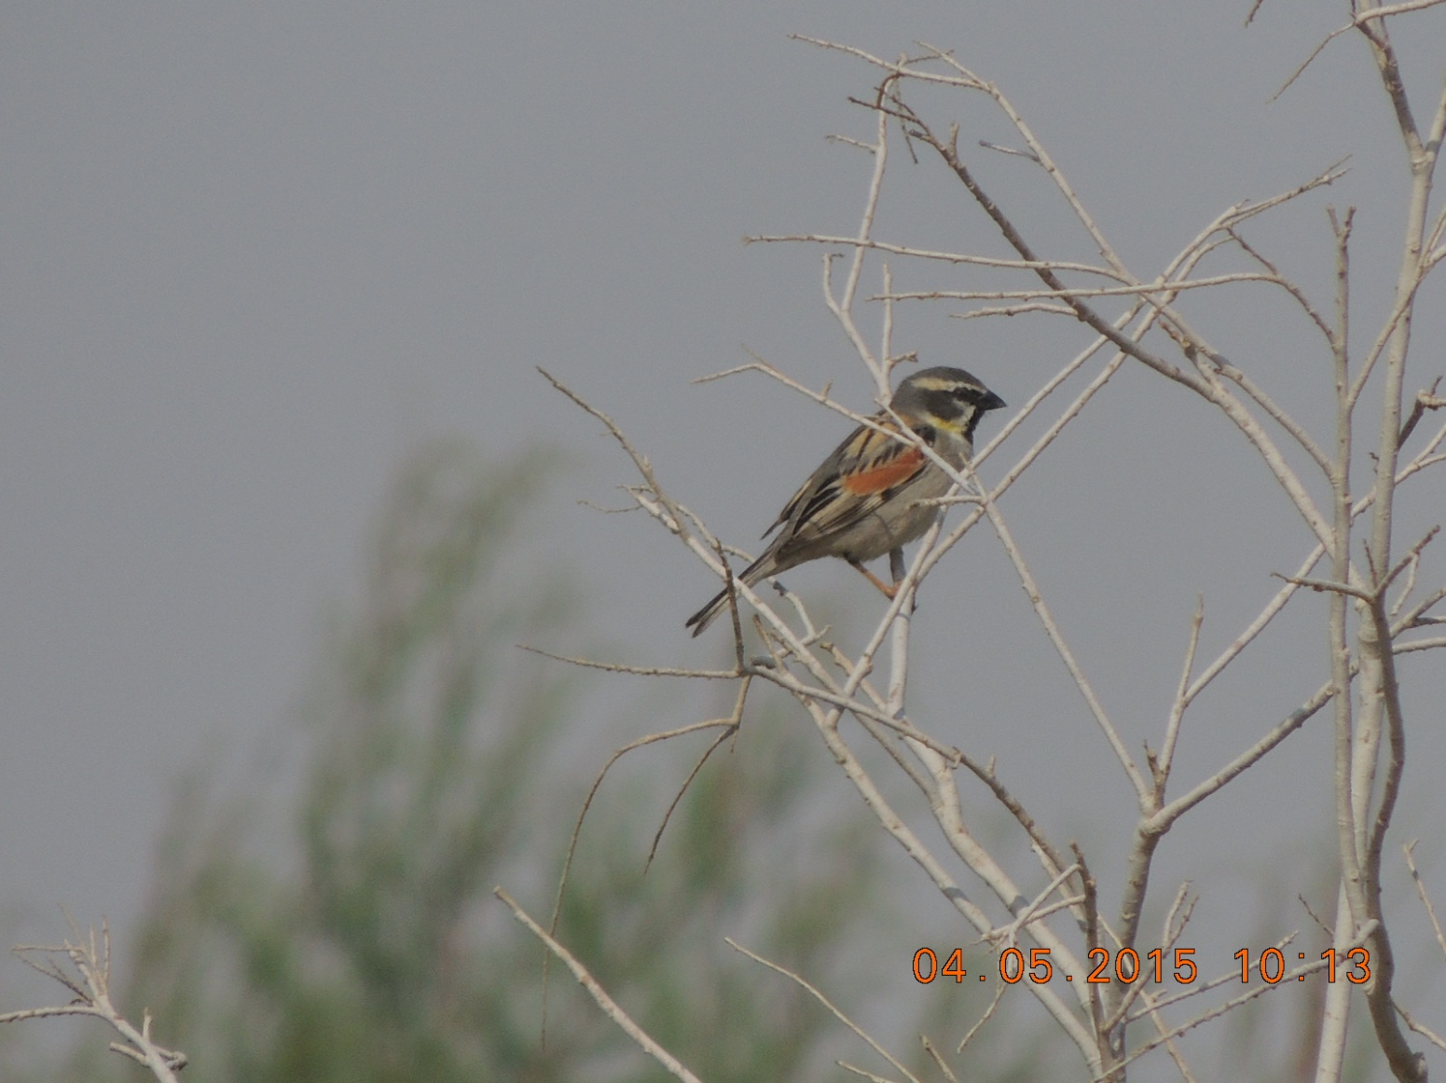

Report prepared by Tareq Qaneer, RSCN

May, 2015

**الملخص العربي**

يعتبر عصفور البحر الميت من الطيور المغردة الصغيرة المهددة على الصعيد الوطني نتيجة لتدمير الموائل. توزيعه العالمي محصور ضمن مناطق الشرق الأوسط على ضفاف نهري دجله والفرات في العراق وسوريا وبعض المناطق في إيران وأفغانستان إضافة إلى بعض المناطق في وادي الأردن والمحاذية للبحر الميت ضمن مناطق توزيع الأثل والقريبة من المصادر المائية في الأردن وفلسطين.

جاءت هذه الدراسة استجابة لتوصيات دراسة الطيور الأساسية في محمية فيفا بإجراء دراسة تفصيلية حول حالة عصفور البحر الميت في المحمية نتيجة لتسجيل أعداد وفيرة منه في الدراسة الأولية وتوفر الموئل المناسب لهذا الطائر في المحمية الذي يعد الموئل الأفضل في الأردن، إضافة إلى إدراجه من الأنواع المؤشرة لصحة النظام الحيوي في محمية فيفا نظراً لارتباطه بغابات الأثل، كما جاءت استجابة لجهود الجمعية الملكية لحماية الطبيعة في بناء قاعدة بيانات شاملة للتنوع الحيوي في الأردن تضمن توفير معلومات شامله للأنواع تساهم في فهم حالة الأنواع والعمل على حمايتها ضمن خطط عمل وطنية.

هدفت الدراسة إلى توفير معلومات كافية عن حالة عصفور البحر الميت في محمية فيفا من ضمنها حجم المجتمع، والموئل، والمهددات بحيث تضمن تأسيس برنامج مراقبة منتظم يقيس كفاءة الإدارة في حماية الأنواع والموائل. واعتمدت الدراسة طريقة المسير بخطوط مستقيمة بطول 500 متر عبر اختيار 17 مربع بطريقة عشوائية غطت ما نسبته 20% من المحمية كعينة ممثلة لمنطقة الدراسة استطاعت أن تغطي مناطق لم تدرس من قبل وذلك لتقدير حجم المجتمع، و تم خلال هذه الطريقة عد الأعشاش وأخذ قياسات الطول وقطر أشجار التعشيش لتحديد موائل التعشيش. بالإضافة إلى ذلك تم اختيار 28 نقطة عشوائية ضمن مناطق الأثل لأخذ قياسات الأشجار وذلك لتقدير وفرة الموائل في المحمية. تم تنفيذ الدراسة على مرحلتين مابين 3-5 و27 أيار من عام 2015.

ومن خلال الدراسة تم تقدير حجم مجتمع عصفور البحر الميت في محمية فيفا بحوالي 780 زوج، وهذا التقدير جاء من خلال تقدير الكثافة بحوالي 56.5 زوج لكل كيلو متر مربع، إضافة إلى رسم خريطة توزيع لمناطق تكاثر عصفور البحر الميت في المحمية. هذه النتيجة تجعل من محمية فيفا الموئل الأهم لطائر عصفور البحر الميت في الأردن. كما تطرقت الدراسة إلى وصف الموئل وتبين أنه يوجد علاقة طردية قوية بين وجود أعشاش عصفور البحر الميت وكثافة غطاء نبات الأثل، حيث أنه كلما زاد كثافة نبات الأثل زاد عدد الأعشاش، كما تبين أنه يوجد علاقة عكسية بين وجود الأعشاش و المسافة من المصادر المائية، حيث انه كلما قلت المسافة من المصادر المائية زاد عدد الأعشاش.

وأخيراً، تناولت الدراسة المهددات على عصفور البحر الميت في محمية فيفا، حيث أوصت الدراسة بتطوير برنامج مراقبة خاص بعصفور البحر الميت في محمية فيفا يتضمن مراقبة الموئل وحجم المجتمع كما أوصت بدراسة خاصة لوصف الموئل في مواسم مختلفة. كما تطرقت التوصيات إلى أهمية التعاون مع المؤسسات المختلفة والمعنية في الحفاظ على المصادر المائية خارج المحمية والتي تغذي الأودية والينابيع في المحمية، إضافة إلى ذلك أهمية العمل على الحد من أعداد الأنواع النباتية المدخلة ومنع دخولها إلى المحمية. كما أشارت التوصيات إلى أهمية دعم التنمية المستدامة وتطوير برامج الزراعة المحلية حول المحمية بحيث تحد من استنزاف المصادر المائية واستخدام المبيدات الكيميائية. إضافة إلى ذلك أوصت الدراسة بزيادة الوعي بأهمية هذا النوع المهدد وأهمية محمية فيفا كموئل مهم المنطقة لهذا النوع عن طريق إيجاد برامج تعليمية متخصصة للمدارس واستخدام المنشورات التوضيحية.

**Summery**

The Dead Sea Sparrow is a small passerine with a disjunctive distribution in the Middle East. Until 50 years ago, it bred only on the banks of the Euphrates and Tigris in Iraq, Syria, at very few localities in Iran and Afghanistan and in the lower Jordan Valley and certain areas near the Dead Sea.

The general distribution of the species was known to be along the northern rift valley in line the banks of the Jordan River, and locally along the shores of the Dead Sea. One of the original sites, discovered over 100 years ago, was at the mouth of Wadi al Hasa in Ghor- Fifa-Safi. The Dead Sea Sparrow inhibits areas which include extensive and undisturbed stands of *Tamarix* growing on moist soils, and the proximity of fresh water.

Based on recommendations of the bird baseline of Fifa Protected Area to investigate the status of Dead Sea Sparrow in the reserve and considered this species as an indicator species of Fifa Protected Area, a detailed survey was carried out to *understand the status of Dead Sea Sparrow in and around Fifa Protected Area.*

The survey was carried out during the breeding season of the Dead Sea Sparrow in two field visits, between 3th - 5th May and 27 May 2015. A total of 17 lines transect were randomly selected to identify the breeding population density. In addition, a total of 28 random points that covered the whole *Tamarix* area in the reserve were sampled to determine the Dead Sea Sparrows habitat use.

The total number of breeding pairs in Fifa is estimated at 780 pairs. This was roughly estimated from a density of 56.5 pairs per sq Km. The nesting sites were mapped according to the results and suitable habitat which occur in the area of 13.8 km2. There was a positive significant relationship between *Tamarix* tree cover and the number of Dead Sea Sparrow nests while there was a negative significant relationship between the number of Dead Sea Sparrow nests and distance of water. Recommendations were made to develop a monitoring program at the reserve, and involve further research on habitat selection in different seasons, population size in Fifa. Other recommendations for management focused on taking needed actions to protect natural water resources, stop the invasion of non-native plant species, particularly *Prosopis juliflora,* promote sustainable development and control and manage farming in the surroundings of the reserve, and protect the foraging sites and raising the awareness of the importance of this endangered species and the importance of Fifa Protected Area for the species.

Acknowledgement

The Team is especially thankful of Mr. Nashat Hamidan (Head of the Research and Survey Section), for his kind assistance and support to make this work achievable. Also we deeply thank to Dr. Omar Attum for field assistance, and for his valuable knowledge and advice during the implementation of this survey, without his kind help and support this work would have not been completed. We also thankful for the logistical support provided by Fifa Nature Reserve staff and the Jordanian armed forces.

Table of Contents

1. Introduction 7

1.1. Overview 7

1.2. Site Description 8

1.3. Team Member 10

2. Methods 11

3. Results 14

4. Discussion 19

5. Recommendations 22

6. Reference 23

7. Appendics 24

7.1. Appendix 1 24

1. **Introduction**
   1. Overview

The Dead Sea Sparrow is a small passerine with a disjunctive distribution in the Middle East. Until 50 years ago it bred only on the banks of the Euphrates and Tigris in Iraq (and probably Syria), at very few localities in Iran and Afghanistan and in the lower Jordan Valley and certain areas near the Dead Sea (Snow and Perrins, 1998). In the last 50 years the breeding range of this species was expanded to many parts of the Middle East, particularly in the Occupied Palestine (Yom-Tov & Mendelssohn 1976), and southern Turkey (Kumerlove, 1965). Based on (Snow and Perrins, 1998), The Dead Sea Sparrow breeds locally in west Afghanistan and the Middle East, including Jordan, Syria, Occupied Palestine, Iraq, Iran, Cyprus and south Turkey.

The Dead Sea Sparrow breeds with a restricted ranged and very specific habitat requirements. These requirements include extensive and undisturbed stands of *Tamarix* growing on moist soils, and the proximity of fresh water (Yousef et al., 2004). The breeding season of Dead Sea Sparrow extends from late March to the beginning of July (Yom-Tov and Ar 1980)

According to Khoury et.al, (2006), the Dead Sea Sparrow breeds in Jordan in *Tamarix* thickets which line the banks of the Jordan River, and locally along the shores of the Dead Sea. One of the sites, discovered over 100 years ago, was at the mouth of Wadi al Hasa in Ghor Fifa-Safi (Khoury et.al, 2006). The Dead Sea sparrow becomes a flagship species for the conservation programme in the Fifa-Safi important bird area (IBA).

This species is least concern under the IUCN criteria (IUCN Red List 2014), but its recent assessments in Jordan using IUCN red list criteria show that the species is regionally threatened due to the various direct threats to the breeding habitats which are located only along the River Jordan and in Sweimeh and Fifa (RSCN, 2013).

Based on recommendations of the bird baseline of Fifa Protected Area to investigate the status of Dead Sea Sparrow in the reserve and considered this species as an indicator species of Fifa Protected Area, a detailed survey was carried out specifically to *understand the status of Dead Sea Sparrow in and around Fifa Protected Area.* Specific objectives are:

* Identify the breeding population size of Dead Sea Sparrows in Fifa Protected Area.
* Examine the habitat use (breeding and nesting) of Dead Sea Sparrow in Fifa Protected Area.
* Identify threats that affect the Dead Sea Sparrow, and recommend an appropriate conservation measures.
  1. Site Description

Fifa Nature Reserve is located at the southern end of the Dead Sea along the western border of Jordan (30° 56ʹ N, 35° 24ʹ E) (Figure 2). Fifa Nature Reserve is centered between Wadi Um Jufna in the north, Wadi Dahel to the south and west of Fifa village. The reserve (26.4 km2 and -421 m) is listed as an Important Bird Area according to Birdlife International (RSCN, 2000) (map 1).

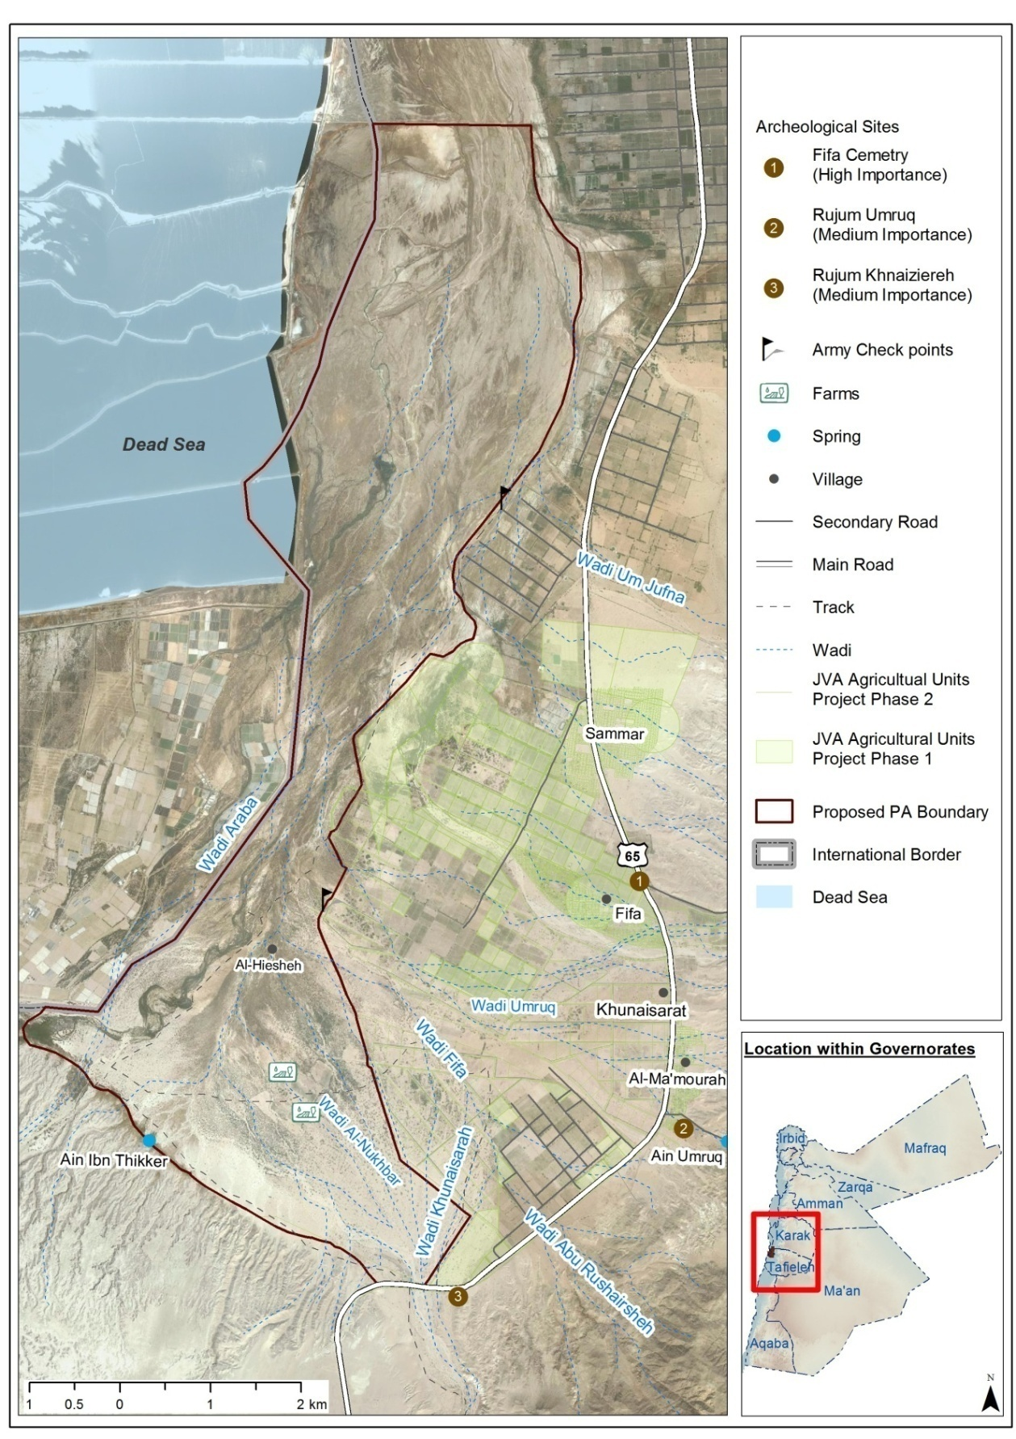

**Map 1. Fifa Protected Area boundary and its location in Jordan**

Fifa PA holds high ecological value and species diversity, as it holds the presence of at least seven nationally threatened plant species, that have a conservation importance, such as Toothbrush Tree *Salvadora persica*, Maru *Maerua crassifolia*, Giant reed *Arundo donax*, Shittim *Acacia tortilis*, Sea-blight *Suaeda monoica*, Date palm; *Phoenix dactylifera*, Acacia; *Acacia raddianna* and Short pricklegrass; *Crypsis schoenoides* (RSCN, 2011)

In addition, there are two vegetation communities in Fifa Protected area, distributed according to altitude. In the lower elevations, *Tamarix* is dominant there are pure stands and some mixed with Nitraria this extends over the majority of the area. In the upper elevations, the Acacia succeeds as the dominant species (RSCN, 2011).

* 1. Team Member
* Tareq Qaneer. B.Sc degree in Agricultural Science/Animal science (2008). University of Jordan. AviFauna Researcher – RSCN Headquarter.
* Sameh Khatabeh, B.Sc degree in Agriculture Science/ Nutrition and Food Technology (2003). Jordan University of Science and Technology. Ajloun Forest Reserve site ecologist. RSCN.
* Musbah Al khtebah, Diploma degree in accounting. Fifa Protected Area site ecologist. RSCN.

1. **Methods**

The survey was carried out during the breeding season of the Dead Sea Sparrow in two field visits, between 3th - 5th May and 27 May 2015.

**Identify the breeding population size**

Line transects method was used. The study site was divided into a grid system with 500 X 500 m dimensions using ArcGIS. As the study area is represented by two major vegetation type (the saline vegetation, and tropical) and due to the fact that Fifa is located in military area, a total of 50 grids located in the military area were excluded. A total of 17 line transects (Appendix 1) were selected randomly by Arc-GIS in each vegetation type 10 ((20 * 50)/100) grids in saline and 7 ((20 * 36)/100) grids in tropical (stratified random selection) in the access area (Map 2) in order to target sufficiently representative sample of 20% of 500 meter square of Fifa habitats.

Transects were carried out in the morning between 06:00 and 11:00, with observers walking from south to north in order to be able to observe birds. Transects were included walking in line in selected grids for 500 meters searching for any active nest (map 2). Nests were identified either by a direct eye contact of conspicuous nests or through recording males calls on *Tamarix* trees within and beyond 50m and calculated the density of the nests as the following equation according to the density formula in (RSCN, 2005) by calculate the area and then divided the total number of nests within the area on the total area.

The estimated density was then multiplied by the suitable breeding area of Dead Sea Sparrow in Fifa Protected Area to estimate the total population size in the reserve.

**D = N/A**

Where D= relative density (per km)

N = number of nests within 50 m

A = L × W

L= transect length (km), W = center to inner band (= 50 m in each site × 2= 0.1 km)

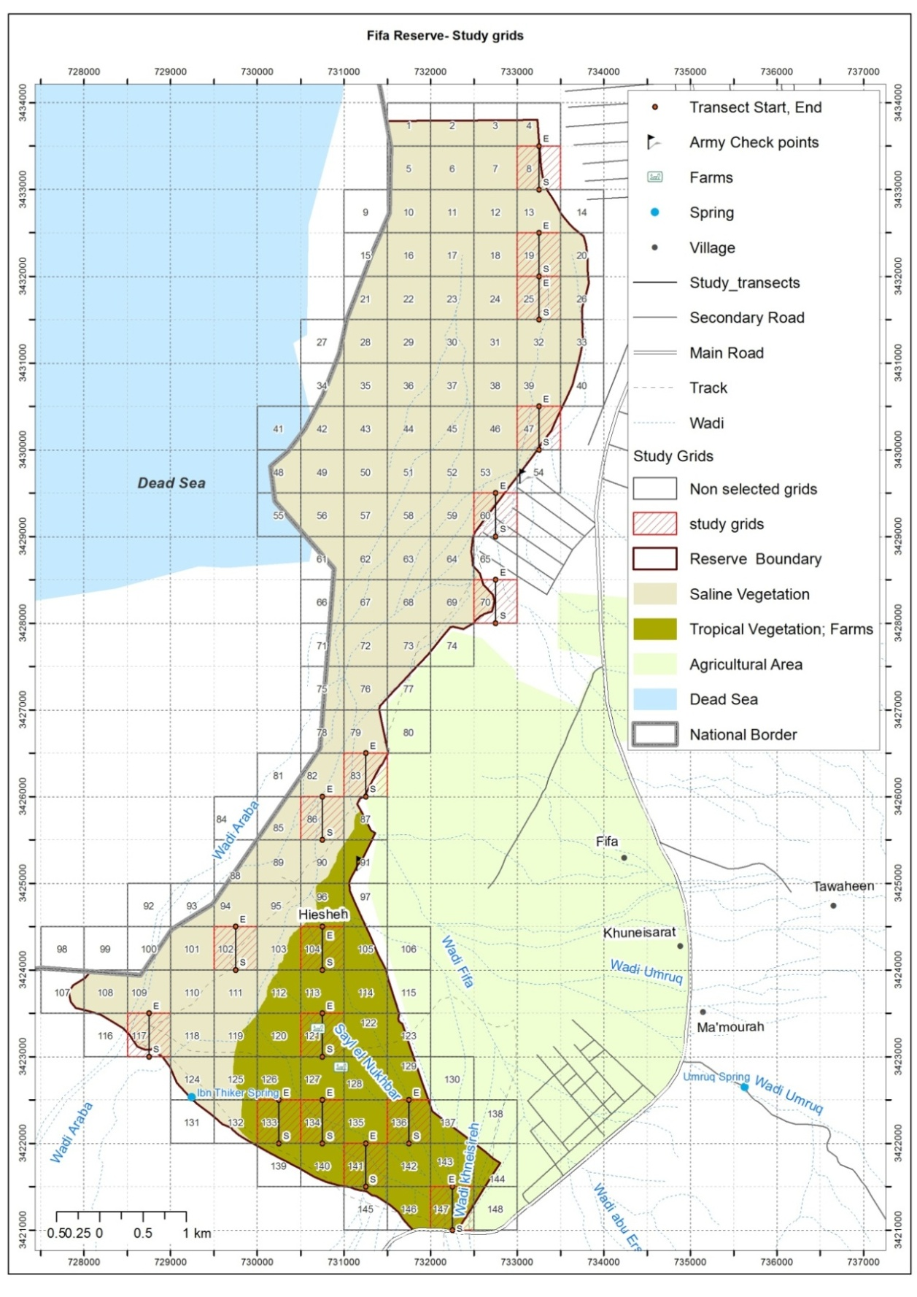

**Map 2: Study area and survey line transects**

**- Examine the habitat use (breeding and nesting)**

To examine the habitat use at the local level in stud area, in each grid within the nesting area the diameter and height of nesting trees were recorded for both live and dead stems. We sampled a 28 random point in the reserve that covered the whole *Tamarix* area in the reserve to determine if the Dead Sea Sparrows are selecting or randomly using trees. In Addition, we recorded the diameter and height of trees at random points at the landscape level. The landscape level is defined the available habitat and quality within Fifa Protected Area. Percent tree cover was sampled in each survey transect by one line transects (500 m), post-hoc, using satellite imagery in Google Earth to determine if there was a relationship between percent tree cover and number of nests.

**- Examine the effects of human disturbance on Dead Sea Sparrow nest selection**

To examine the effects of human disturbance on Dead Sea Sparrow nests we calculated the distance of each nest from the nearest human impact including roads, settlements, and agricultural area. We also recorded the presence/absence of small campfires and grazing at nest sites.

We examined if there was a significant relationship between the number of Dead Sea Sparrow nests and percent tree cover and the distance of nests to nearest water source, roads, settlements, and agricultural area through the use of a linear regression.

1. **Results**

The total number of breeding pairs in Fifa is estimated at 780 pairs. This was estimated from a density of 56.5 pairs per sq Km (see formula in method section) and an ecological distributional area. The nesting sites were mapped according to the results and suitable habitat which occur in the area of 13.8 km2 (map3). There was a significant positive relationship between *Tamarix* tree cover and the number of Dead Sea Sparrow nests with the number of nests increasing as tree cover increased (r = 0.87, P < 0.0001; (figure 1)). Tree cover explained 76 percent of the variation (r2 = 0.76) in the number of Dead Sea Sparrow nests. There was a negative significant relationship between the number of Dead Sea Sparrow nests and distance to water with the number of nests increasing as the distance decreased (r= -0.54, P < 0.23; (figure 2)). Distance to water explained 29 percent of the variation (r2= 0.29) in the number of Dead Sea Sparrow nests. There was no significant relationship between the number of Dead Sea Sparrow nests and distance of settlement (r= -0.32, P < 0.2; (figure 3)), road (r= -0.123, P < 0.64; (figure 4)) and agricultures (r= 0.04, P < 0.88; (figure 5)).

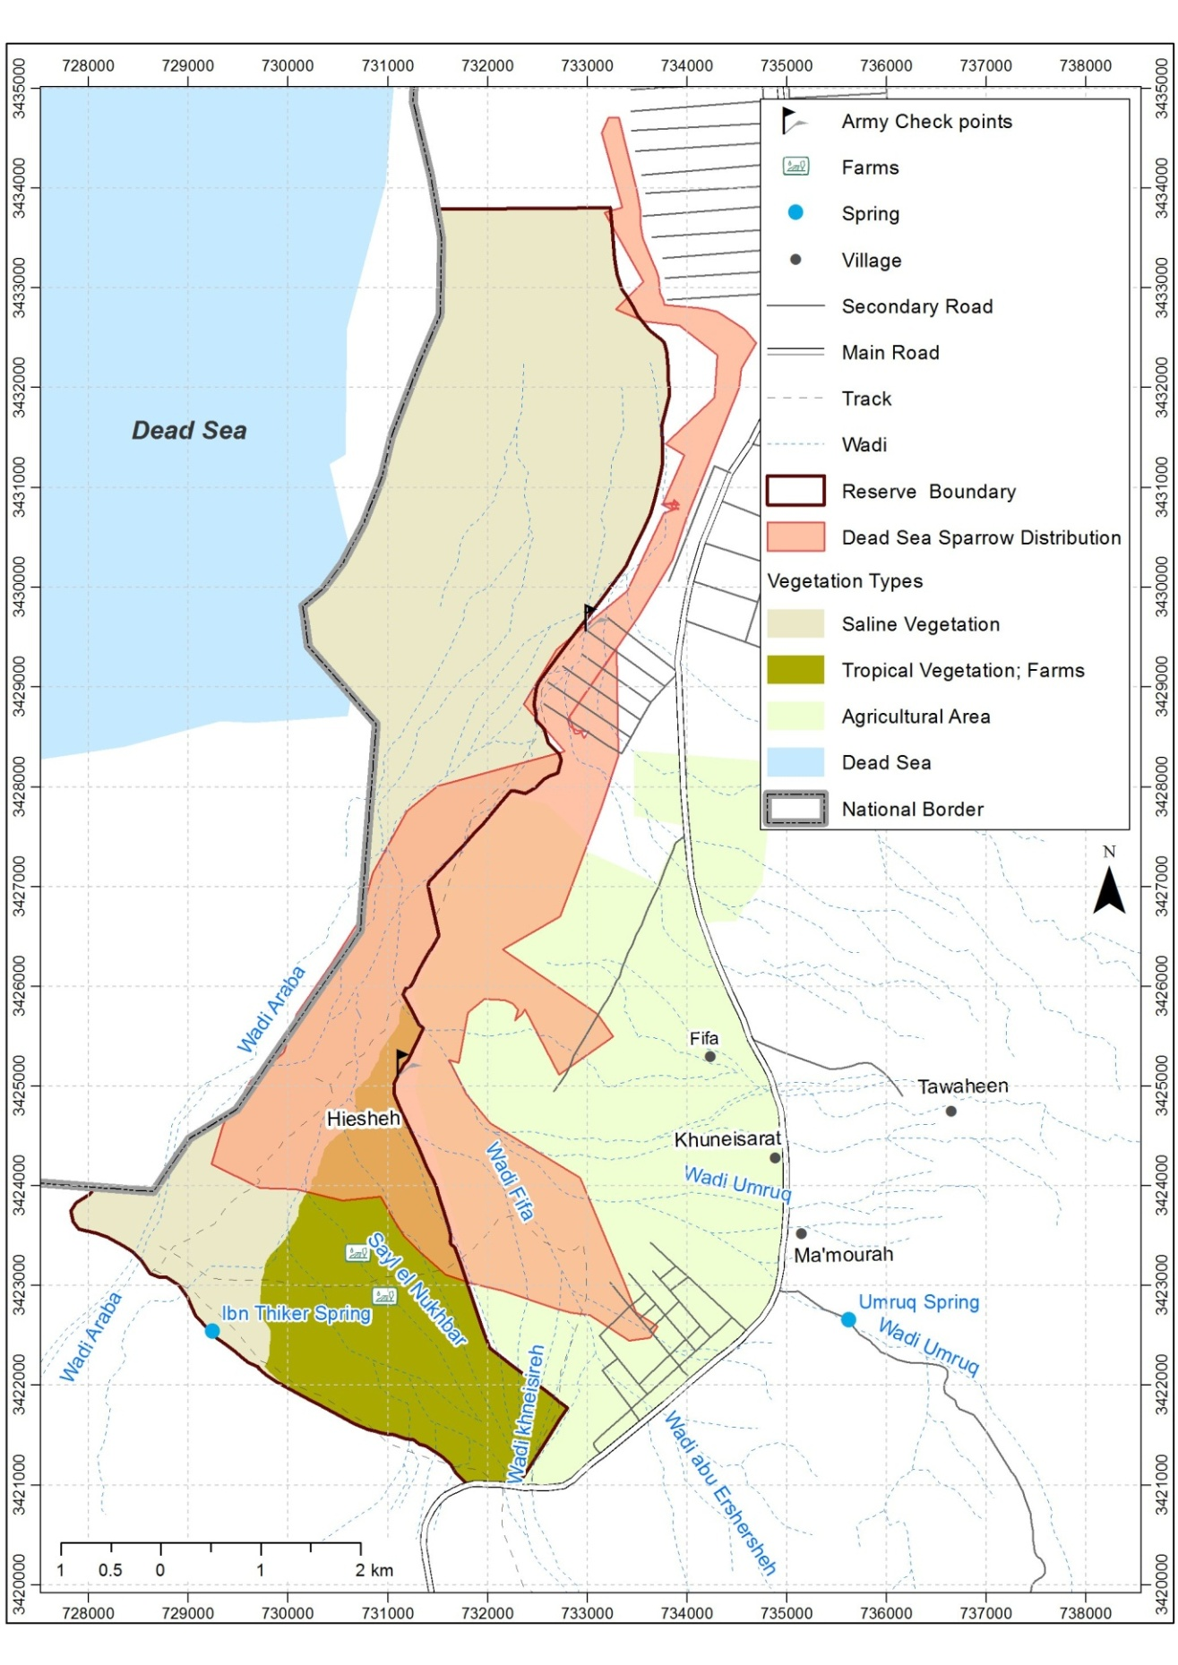

**Map 3: the area of nesting sites of the Dead Sea Sparrow in Fifa Protected Area**

**Figure 1: The relationship between *Tamarix* tree cover and the number of Dead Sea Sparrow nests.**

**Figure 2: The relationship between distance to water and the number of Dead Sea Sparrow nests.**

**Figure 3: The relationship between distance to settlement and the number of Dead Sea Sparrow nests according to linear regression and where the results showing that no relationship.**

**Figure 4: The relationship between distance to road and the number of Dead Sea Sparrow nests according to linear regression and where the results showing that no relationship.**

**Figure 5: The relationship between distance to agriculture and the number of Dead Sea Sparrow nests according to linear regression and where the results showing that no relationship.**

1. **Discussion**

At the national level the distribution of the Dead Sea Sparrow was found in the area of the bank of Jordan River, Sweimeh and Fifa area (Khoury et al.,2006). Khoury et, al. (2006) estimated the breeding population in Jordan as 1200-2000 breeding pairs and they described Sweimeh as the most important site for Dead Sea Sparrow in Jordan. This study estimated the population size of Dead Sea Sparrow in Fifa as 780 pairs, which higher than the 50 pairs recorded in Sweimeh (Khoury, 2006) and represent more than half of Jordan population of Dead Sea Sparrow.

Due to Land encroachment for farming in the area of the bank of Jordan River and the habitat degradation in Sweimeh and the bank of Jordan River, the habitats of Dead Sea Sparrow at Sweimeh and the bank of Jordan River recently became severely degraded and this bird is currently possibly extinct as breeding species in Sweimeh (RSCN, 2011). Whereas, this study showed that the larger number of breeding pairs recorded in Fifa is due to the potential increased availability of Dead Sea Sparrow habitat in Fifa than the smaller and more fragmented potential habitat in Suweimeh. Accordingly, it was clearly recognized that Fifa area holds the presence of densest population of Dead Sea Sparrow in Jordan.

Khoury et al*.,* (2006) stated the mean height of *Tamarix* at breeding sites ranged from 2- 5.5 m and in Fifa here a few nests were found at heights ranging from 1.5 - 2 m, such areas were usually undisturbed and well protected by military presence. This survey showed that the height of 71% of *Tamarix* trees in FiFa ranged from 2 to 5.5 (figure 6). Higher tree cover has greater potential to host multiple nests and better conceal nests from predators and disturbance.

This suggested that the population of Dead Sea Sparrow in Fifa is due to the presence of the suitable and undisturbed habitats for breeding and foraging. Hence, these results proved and making Fifa Protected Area one of most important healthy sites for Dead Sea Sparrow in Jordan.

**Figure 6: the percent of Tree height in Fifa Protected Area**

Water shortage is one of the most important threats affecting the breeding range of Dead Sea Sparrow in Jordan; Yousef et al (2004) reported that the breeding habitat of Dead Sea Sparrow is low-lying flat areas with *Tamarix* thickets where water is available throughout the year. Meanwhile, all breeding sites visited in current survey, where nests were found, were *Tamarix* thickets in the proximity of water (figure 7), i.e. surface water in the form of streams or springs was always present within less than 100 m. The streams were also dry during the study period and only remnant pools containing very saline water were found. These streams had at least some running water throughout the year, including in summer.

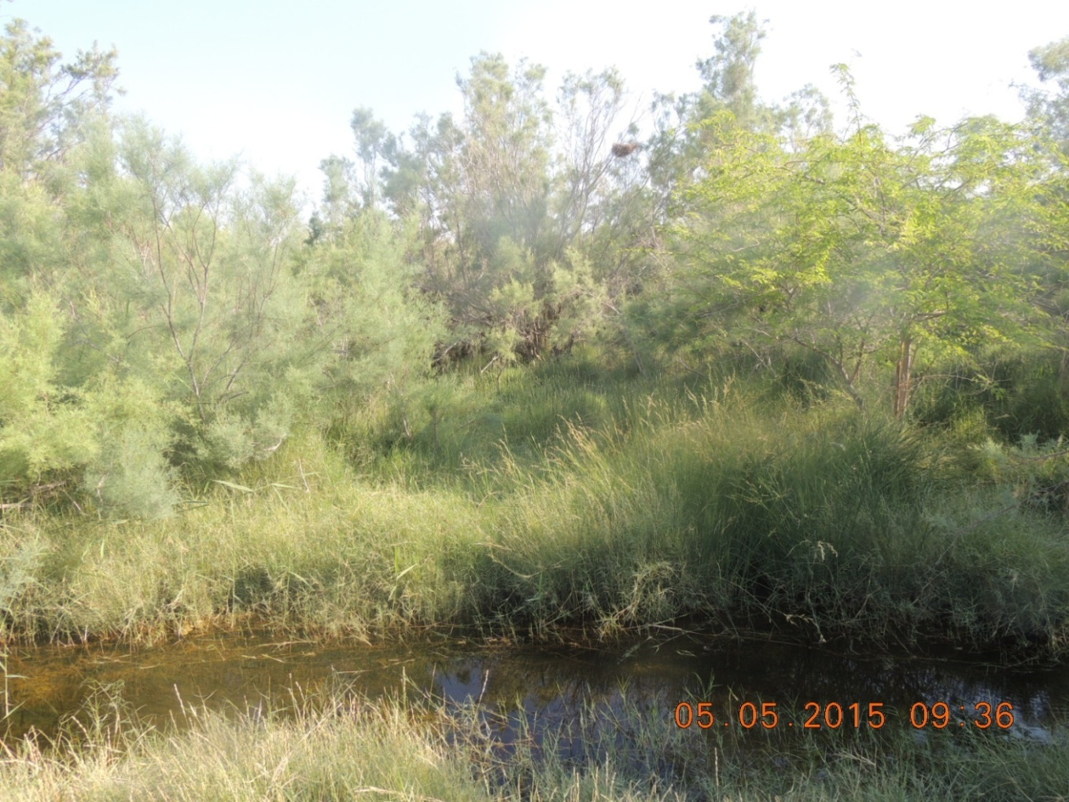**Figure 6: the nests location in Fifa Protected Area proximity to water**

The agricultural fields surrounding Fifa Protected Area offer good foraging habitat, Yom-Tov et al., (1980) stated that Dead Sea Sparrow prefers more open farms and fields for feeding. Consequently, there are great risks to Dead Sea Sparrow populations created by the systematic use of pesticides and herbicides in the agriculture. For that reason, several activities related to crops cultivation, overgrazing, awareness campaigns to avoid using of poisonous materials should be conducted.

Based on the results, it appears that Fifa Protected Area is an important site for the breeding population of the Dead Sea Sparrow in the region. In addition, these results raised the conservation value of the Fifa Protected Area as a refuge for this threatened species in Jordan. Therefore, several conservation measures were adopted on the national and international level to protect this species.

1. **Recommendations**

* Develop a monitoring program to carry out regular surveys of Dead Sea Sparrow every 2-3 years. Monitoring should involve further research on the habitat selection and use in the different seasons, in addition to impacts, including the effect of land use on habitats and on the hydrological system which is connected to the water resources at the breeding habitat.
* It is recommended to cooperate with the Jordan Valley Authority to protect natural water sources which feed the perennial streams and springs.
* It is recommended to cooperate with the Forestry Department to stop the invasion of non-native plant species, particularly *Prosopis juliflora.*
* Encourage sustainable development and control and manage farming in the surroundings of the reserve in a way that does not affect water resources, and reducing the impact of unsustainable agricultural practices on use of pesticides and its associated effects.
* Develop an active awareness program targeting school students on the importance of protecting endangered species and habitats that show the significant importance for Dead Sea Sparrow in Fifa Protected Area.
* Implement an active patrolling plan to conserve the target species and its foraging sites in Fifa and Safi Area.

1. **Reference**

* Khoury, F. , Al-Omari, K., Azar, J. and Al-Hasani, I. (2006): Observations on the avifauna of the eastern Jordan Valley, during July–August 2005. Sandgrouse 28 (2): 119–126.
* Kumerlove, H. (1965): Der Moabsperling *Passer moabiticus* Tristram, Bturvogel in der Turkei. Journal of Ornithology 106: 112.
* RSCN. (2000). Important Bird Areas in the Hashemite Kingdom of Jordan. The Royal Society for the Conservation of Nature. Amman, Jordan.
* RSCN. (2005). Field research manual. The Royal Society for the Conservation of Nature. Amman, Jordan.
* RSCN. (2011). Ecological Management Plan for the Natural *Tamarix* Woodland at the Northern Shore of the Dead Sea. The Royal Society for the Conservation of Nature. Amman, Jordan (Unpublished report).
* RSCN. (2013).The State of Jordan's Bird Report. The Royal Society for the Conservation of Nature. Amman, Jordan.
* Yom-Tov, Y., and Ar, A. (1980): On the breeding ecology of the Dead Sea Sparrow *Passer moabiticus*. Israel Journal of Zoology, Proceedings, 29: 171-187.
* Yom-Tov, Y., Mendelssohn, H. and Ar, A. (1976): Extension of range of the Dead Sea Sparrow *Passer moabiticus* and its effect on breeding success. Israel Journal of Zoology, Proceedings, 25: 202-203.
* Yousef, R., Zduniak, P., and Tryjanowski, P. (2004): Age, Sex and Seasonal related biometrics of the Dead Sea Sparrow *Passer moabiticus*. Ardeola Journal, 51 (2): 297-302.
* Snow, D. W. & Perrins, C.M. (1998): The Birds of the Western Palearctic, concise edition. Oxford University Press, Oxford.

1. **Appendics**
   1. Appendix 1

The coordinates of lines transect were performed in Fifa Protected Area

|  |  |  |
| --- | --- | --- |
| **Name** | **POINT_X** | **POINT_Y** |
| 8S | 733250 | 3433000 |
| 8E | 733250 | 3433500 |
| 25S | 733250 | 3431500 |
| 25E | 733250 | 3432000 |
| 19S | 733250 | 3432000 |
| 19E | 733250 | 3432500 |
| 47S | 733250 | 3430000 |
| 47E | 733250 | 3430500 |
| 60S | 732750 | 3429000 |
| 60E | 732750 | 3429500 |
| 70S | 732750 | 3428000 |
| 70E | 732750 | 3428500 |
| 83S | 731250 | 3426000 |
| 83E | 731250 | 3426500 |
| 86S | 730750 | 3425500 |
| 86E | 730750 | 3426000 |
| 104S | 730750 | 3424000 |
| 104E | 730750 | 3424500 |
| 102S | 729750 | 3424000 |
| 102E | 729750 | 3424500 |
| 117S | 728750 | 3423000 |
| 117E | 728750 | 3423500 |
| 121S | 730750 | 3423000 |
| 121E | 730750 | 3423500 |
| 133S | 730250 | 3422000 |
| 133E | 730250 | 3422500 |
| 141S | 731250 | 3421500 |
| 141E | 731250 | 3422000 |
| 134S | 730750 | 3422000 |
| 134E | 730750 | 3422500 |
| 136S | 731750 | 3422000 |
| 136E | 731750 | 3422500 |
| 147S | 732250 | 3421000 |
| 147E | 732250 | 3421500 |