Integrated Ecosystem Management for the Jordan Rift Valley Project (IEM- JO) Project
Flora Baseline Survey
Fifa protected Area

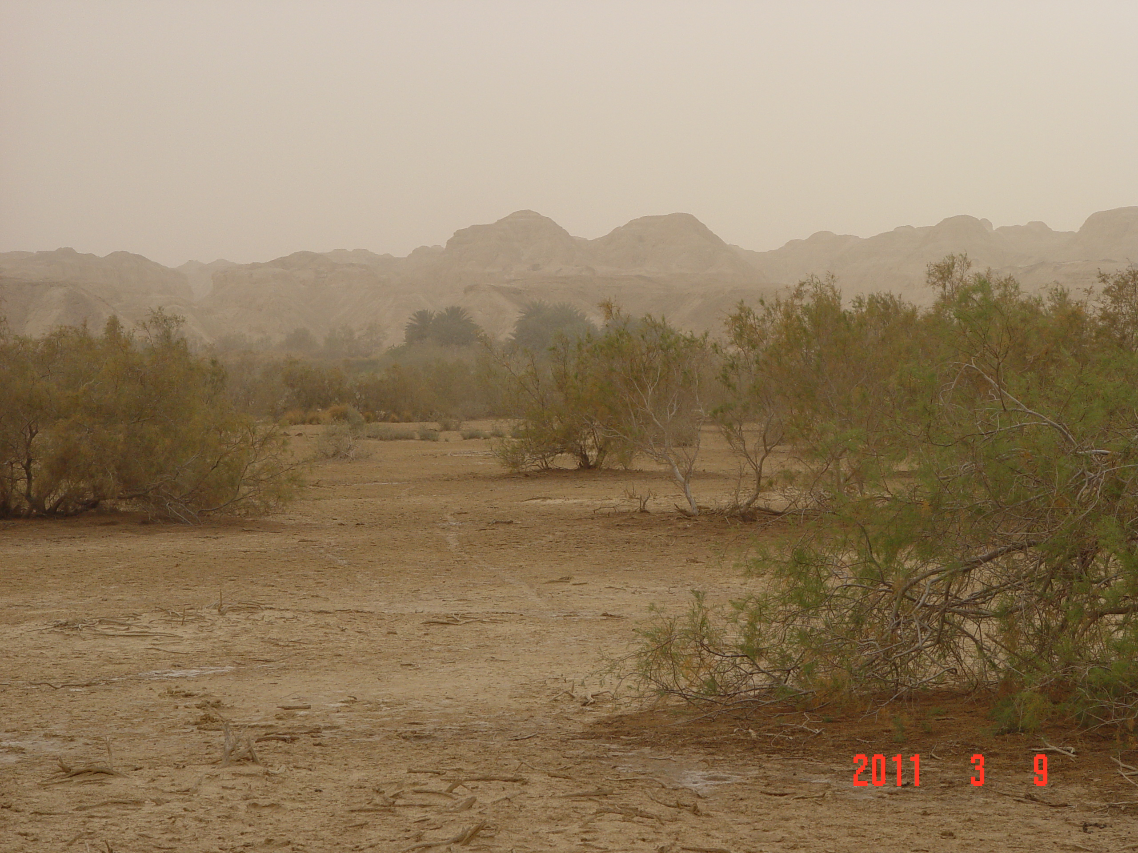

The Royal Society for the Conservation of Nature

“RSCN”

Integrated Ecosystem Management for the Jordan Rift Valley Project (IEM- JO) Project

Flora Baseline Survey

Fifa Protected Area

Research and Survey Section

Yaseen Ananbeh

March 2011

Summary
Flora baseline survey in Fifa protected Area was carried out in 2010, and aimed to establish a baseline data for plant species, draw their Vegetations community distribution map and. During the survey, Identify floral hotspots areas for diversity in the PA, Identify threats to habitats at PA two methods were used: the sampling plots method where a total of 25 plots selected systematic. For each plot, a plot of 20X25 meter was used to study plant species. In addition, Line transect method were used and involved selecting a start point systematic using a hand- held GPS, and start walking t All species noticed were recorded; many plants were identified in the field and the unidentified plants were classified using taxonomy guides. The obtained data were filled into a special datasheet record any plant species inside PA.

A total of 80 species of plant at Fifa PA that belonging to 60genera and 30 families were recorded. Seven threatened plants species which comprise (9% ) ,four Rare plant which comprise (5%) were recorded in Fifa PA represented from total plant checklist, , Salvadora persica , Acacia tortilis, Calligonum comosum, Calotropis procera, Phoenix dactylifera,, Ochradenus baccatus, Ziziphus spina-christi are threatened, where Astragalus sanctus, Dipcadi erythraeum, Suaeda monoica, Eptadenia byrotechina and considered a locally rare plant. Depending on their uses; palatable species plants have highest percentage with 57% from the recorded species, medicinal with 16%, edible for human uses and species used for their wood plants with 8%respectively, poisonous species have 3% the lowest percentage at PA Fifa.

Results showed that the the high soil salinity in Fifa PA caused low plant diversity of these habitat, only plant species with high adaptability to salinity can grow in those location ,those specie were : Tamarix tetragyna, Nitraria retusa, Arthrocnemum macrostachym, Suaeda monoica, Phoenix dactylifera

The other part of the field work concentrated on working in Fifa protected area in order to define the main vegetation communities,The 10 vegetation communities recorded : Tamarix tetragyna (24%). , Mix ( Tamarix tetragyna Lycium shawii) (12%)., Haloxylon salicornicum (8%), Acacia tortilis associated with Tamarix tetragyna (7%) Mix ( Tamarix tetragyna with Alhagi graecorum(7%)., mix Tamarix tetragyna with Nitraria retusa(6%)., mix Tamarix tetragyna with Arthrocnemum macrostachym(5%)., Mix (Tamarix tetragyna with Suaeda monica (5%)., Palm trees (Phoenix dactylifera (0.08 %)., Juncus rigidus (0.7 %).
,

The study also highlighted the threats and impact that are facing Fifa Protected Area and recommendations some solutions, The main threat Intensive agriculture farming, Off roads construction, Firing activities.

Acknowledgements

First of all, the survey teams are grateful to the management of the RSCN, namely Mr. Mohammad Yousef “Director of Conservation and the team would like to thank all the staff in the Research and Survey Section for their unlimited support to achieve this survey especially Mrs. Whose assistance was undeniable Special thanks also to Mr Ehab Eid , Field Research Coordinator. for his support and help in the field work ,Special thank to Natalia Boulad and Heba Daoud for her assistance in the making GIS map .

Summary 3
Acknowledgements 4
1. Introduction 6
Project Background 6
1.2 Reasons for Establishing Fifa Protected Area 8
1.3 Site Description 9
1.3.1 Location 9
1.3.2 Climate 10
1.3 .3 Bio- geographical Zones at Fifa Protected Area 10
1.4.4 Vegetation description 10
1.5 The Objectives of the Survey 11
1.6 Survey Team Members 11
2. Materials and Methods: 12
2.1 Materials 12
2.2 Methods 13
2.2.1 Line transects 13
2.2.2 Plots 15
3. Results 19
3.1 Species Checklist 19
3.2 Vegetation Composition 23
3.3 Flora Attributes 24
a. Frequency 24
b. Plant density 25
C. Plant diversity 26
D. Species Abundance 27
F. Species richness 28
3.4 Vegetation Types 29
3.4.1 Saline vegetation 29
3.4.2 Tropical vegetation 29
3.5 Updating Vegetation Community 30
3.6 Rare and Threatened Species 32
4. Threats to the vegetation in Fifa protected area: 33
5. Recommendations 37
6. References: 38
7:Apendiex 39

1. Introduction

Project Background

Jordan's main geographical features—the Jordan Rift Valley, the forested highlands and the Badia or eastern desert—create a variety of very different ecosystems and environments. Jordan’s geographical position at the crossroads of Africa, Asia and Europe has made it a centre for the extensive exchange of both natural and cultural resources.

Several efforts have been afforded to biodiversity conservation in Jordan, The first attempt was performed during 1974, through the World Wild Fund (WWF) and the International Union for the Conservation of Nature (IUCN), and followed by another mission funded by the IUCN and the WWF and conducted by John E. Clarke in 1977-78. This mission produced a report in the late 1979 that recommended a network of twelve sites that could be under conservation to insure conserving 4% of the entire landmass of Jordan as protected areas.

Since the establishment date of the Royal Society for the Conservation of Nature (RSCN) at 1966 it was given the role of establishing and managing the reserves in Jordan by the government, accordingly seven natural reserves were established, six still under the control and management of the RSCN; these are: Shaumari Wildlife Reserve, Azraq Wetland Reserve, Ajloun Forest Reserve,Dibeen Forest Reserve, Mujib Nature Reserve and Dana Biosphere Reserve ,while only one reserve is under the management and control of Aqaba Special Economic Zone Authority (ASEZA), which is Wadi Rum Protected Area.

During 1998, the RSCN resolute that a re-evaluation survey was needed to evaluate the ecological, social and economical situation for the proposed protected areas after two decades of Clarkes' mission. RSCN, in consultation with the General Corporation for Environment Protection (GCEP) –The Ministry of Environment now- and with assistance from the IUCN and a fund from the Global Environment Facility (GEF), carried out the first review of the proposed nature reserves network during 1997-2000. RSCN used IUCN international Standards to evaluate and update the list of the proposed sites according to the vegetation cover representation in each reserve (National Protected Area Report, 2007), and as a result …sites were

A second review was conducted in 2005, in order to choose four sites to be established as Protected Areas (PAs) along the Jordan Rift Valley through the preparations for the Integrated Ecosystem Management in the Jordan Rift Valley Project (IEM- JO). As a result, Fifa Protected Area (PA) was proposed to be established under the IEM- JO project .

The project was launched in 2007. It aims to apply the principles of integrated ecosystem management to the existing land use master plan of the Jordan Rift Valley and to establish a network of well managed protected areas that meets local ecological, social and economic needs. This objective could be achieved using holistic and participatory approachs that guarantee the balancing between ecological, social and economic components management within the ecosystems. The Jordan Rift Valley is an integral part of the Great Rift Valley and provides a globally critical land bridge between Africa, Europe, and Asia that supports a large variety of ecologically diverse habitats of international importance and funnels millions of migrating birds between these continents each year. On the other hand; in Jordan this area is under heavy development pressure referring to its' location as well as containing the most productive agricultural land resources locally.

1.2 Reasons for Establishing Fifa Protected Area

Fifa PA was proposed to be established after the RSCN review at 1998; because it represents two natural vegetation types; the saline vegetation which is found at Mujib Nature Reserve and represents 7.18% of its total size area and tropical vegetation type, which is not well represented in the established reserves and constitute about 1.46% of the total size area of all natural reserves in Jordan.

Fifa PA holds high ecological value and species diversity, as it holds the presence of at least seven nationaly threatened plant species, that have a conservation importance, such as Toothbrush Tree; Salvadora persica, Maru; Maerua crassifolia, Giant reed; Arundo donax, Shittim; Acacia tortilis, Sea-blight; Suaeda monoica, Date palm; Phoenix dactylifera, Acacia; Acacia radianna and Short pricklegrass; Crypsis schoenoides.

1.3 Site Description

1.3.1 Location

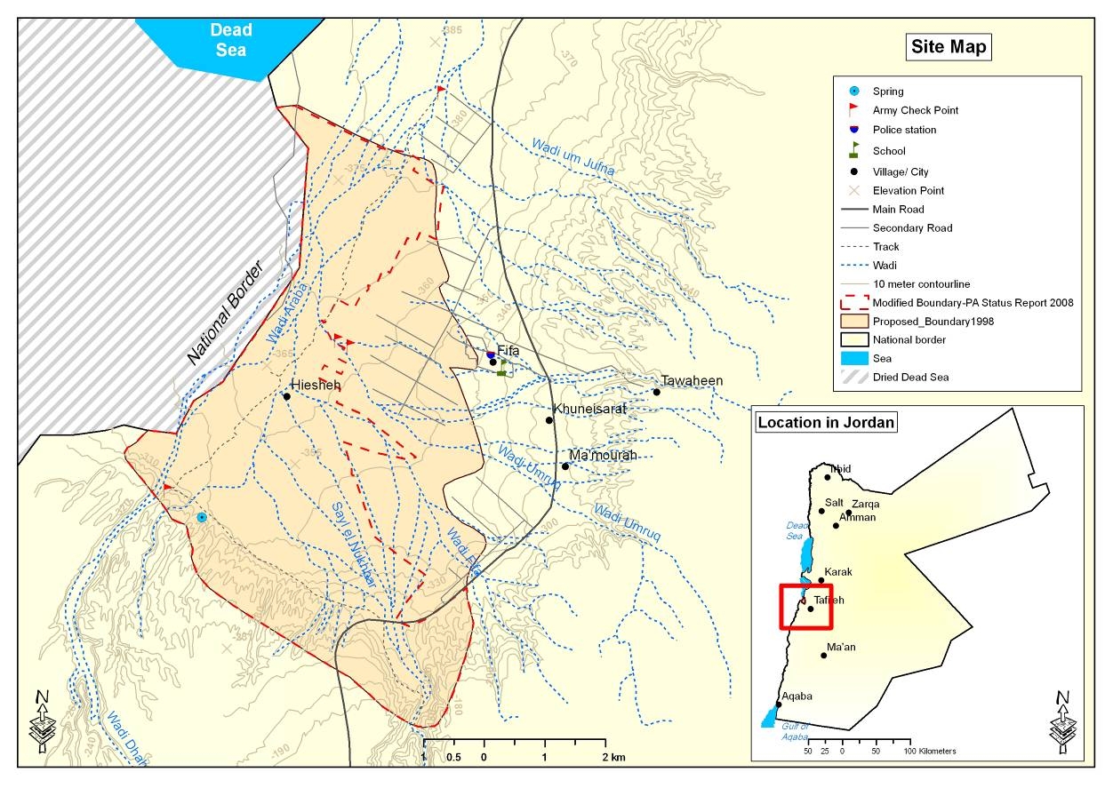
Fifa PA (Center Coordinates; East °34 ‘24.188, North °73 '1.135) has a total size area of 22.3 km². It is located along Aqaba- Dead Sea highway. The PA was named according to Ghor Fifa, and it is situated mostly within the Karaka Governate with samller portion on the south-eastern part of the PA within Tafilla Governate (See Map 1.1). It is about 100 km south of the capital city Amman and 17 km north-west of Tafila city, and the elevation is about40_ -421m below sea level

Map 1.1 Fifa Protected Area location and boundaries by RSCN review (1998)

1.3.2 Climate

Fifa protected area characterized by warm winter with a minimum average temperature of 10 ⁰C and hot summer with a maximum average temperature of 40 ⁰C. The annual average precipitation is around 6 mm and the relative humidity average value around 51% These data were obtained from Ghour Al-Safi weather station between the period of 1995 and 2005. (Jordan Metrological Department,)

1.3 .3 Bio- geographical Zones at Fifa Protected Area

Al-Eisawi (1996) described the vegetation of Jordan. He also divided the country into four main bio- geographical zones. The Mediterranean, Irano-Turanian Sudanian and the Saharo- Arabian Zones.Fifa PA is situated in the Sudanian zones , Fifa PA has a hetrogeneous habitat, mainly saline vegetation and tropical vegetation, it is representing the Sudanian bio- geographical zone, which is characterized by a rainfall ranges between 50-100 mm/year, very hot summer and warm winter temperature ranges from 15 - 45º C. Soil is mostly alluvial, saline, and hammada (See map 1.2). Fifa PA is a part of the Jordan Rift Valley that represents the Acacia-subtropical vegetation and the Sudanian bio-geographical zone. The area is composed heterogeneous habitats, including Acacia woodland, and Tamarix vegetation .

1.4.4 Vegetation description

There are two vegetation types in Fifa Protected area, distributed according to altitude. In the lower elevations, Tamarix is dominant there are pure stands and some mixed. with Nitraria this extends over the majority of the area. In the upper elevations, the Acacia succeeds as the dominant species.

1.5 The Objectives of the Survey

The Objectives of the Survey were :

- Update plant checklists for Fifa PA
- Update vegetation map for Fifa PA
- Identify floral hotspots areas for diversity in the PA
- Problems Facing Fifa PA

1.6 Survey Team Members
1.6.1 Flora Research Team Members
- Yaseen Ananbeh. B. Sc in Agricultural Science,(2002), Jordan University of Science and Technology. Irbid Jordan. Flora Researcher. RSCN Headquarter.

- Anas Abu Yahya, M.Sc. in Agriculture Science/ Field Crops Production (2006); Jordan University of Science and Technology- Flora Researcher, RSCN Headquarter.

- Ehab Eid. M. Sc Degree in Conservation, Access and Management of Species in Trade (2010). International University of Andalucía; Spain. Field Research Coordinator.RSCN Headquarter

- Hatem Taifour, M.Sc Degree in Agriculture Science (2003). Jordan University of Science and Technology. Consultant .
- Abdullah Abu Rumman , Modern Language 2007. University of Jordan, manager of product development Wild Jordan.

1.6.2 GIS Team Members

- Natalia Boulad, B.Sc. in Civil Engineering/ Environmental Engineering (1999); University of Jordan- GIS officer, RSCN Headquarter.
- Yasmine Hajeer, M.Sc. in Horticulture (2003); Jordan University of Science and Technology- GIS officer, RSCN Headquarter.
- Heba Daoud B.Sc. Surveying and Geomatics Engineering (2010). Balqa Applied University Technology- GIS officer, RSCN Headquarter.

2. Materials and Methods:
Fifa PA flora baseline survey was conducted during mid March 2011, with a total of Four field working days with 8 working hours per day, totaling of 32 hours /person power to cover the whole selected area.

2.1 Materials
Materials used for the survey were:
- Field guides and identification references:
- Flora Palaestina
- Wildflowers of Jordan
- Flowers of the Eastern Mediterranean
- Maps generated at RSCN headquarters using GPS data
- Global Positioning System (GPS) Garmin 5 Plus. Readouts in meters displayed with six digits East and seven digits North.
- Plastic specimen-bags
- Compass
- Measuring tape
- Vegetation data sheets for plots and transects
- Plant pressers (Swedish wooden type)
- Newspapers for pressing botanical sampl

2.2 Methods

2.2.1 Line transects

(25) Transects were conducted in Fifa Protected area to cover Macro plot were study,. Due to the regular landscape, transects were fixed east west directions with lengths10X500m (see Map 1). Three researchers walking parallel within the grid from easternmost side toward west, total cover 10 M width during walking 500M length. All species noticed were recorded; many plants were identified in the field and the unidentified plants were classified using taxonomy guides. The obtained data were filled into a special datasheet, (see Appendix 1) and the checklist was arranged into (Table 1)
The information collected was as follows:
- Transect number
- GPS coordinates (start, end and intermediate points which were obtained for long transects).
- Habitat description
- Species present
- Date

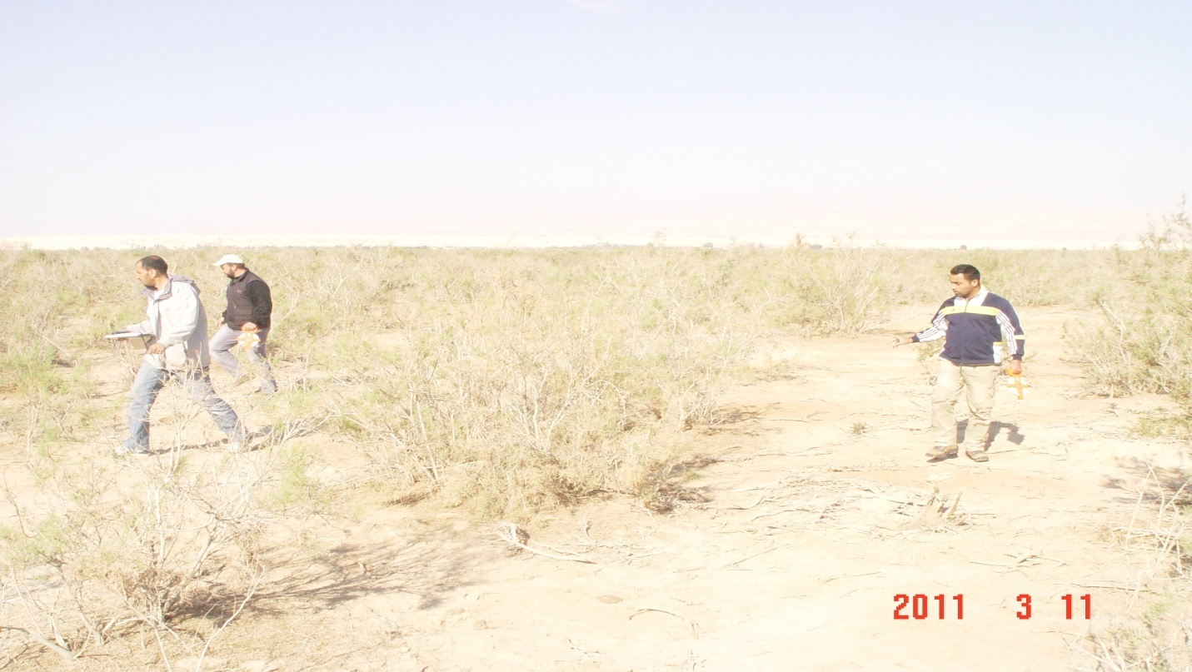

Figure 1: Line transect method used in flora baseline survey at Fifa PA

2.2.2 Plots

A plot with a boundary of 500 meters square (25 x 20) inside Macro plot (25000m) 500x500m was chosen and fixed for each of the selected systematic take quadrates in the end of Macro plot . The total number of plots was 25; they were chosen to cover different habitats in Fifa Protected Area. Within each plot, all species were recorded along with their respective abundance. A plant was not taken into account if its root was outside the quadrate, even if its shoot system is inside. The obtained data was filled into datasheets (see Appendix 1). The calculations of density, relative density, frequency; relative frequency and abundance were carried out for each plant species. Abundance was measured by the Braun- Blanquet scale of + to 5 corresponding to percent coverage, see table 2. The presence of species which tend to indicate the health of the ecosystem were noted and measured.

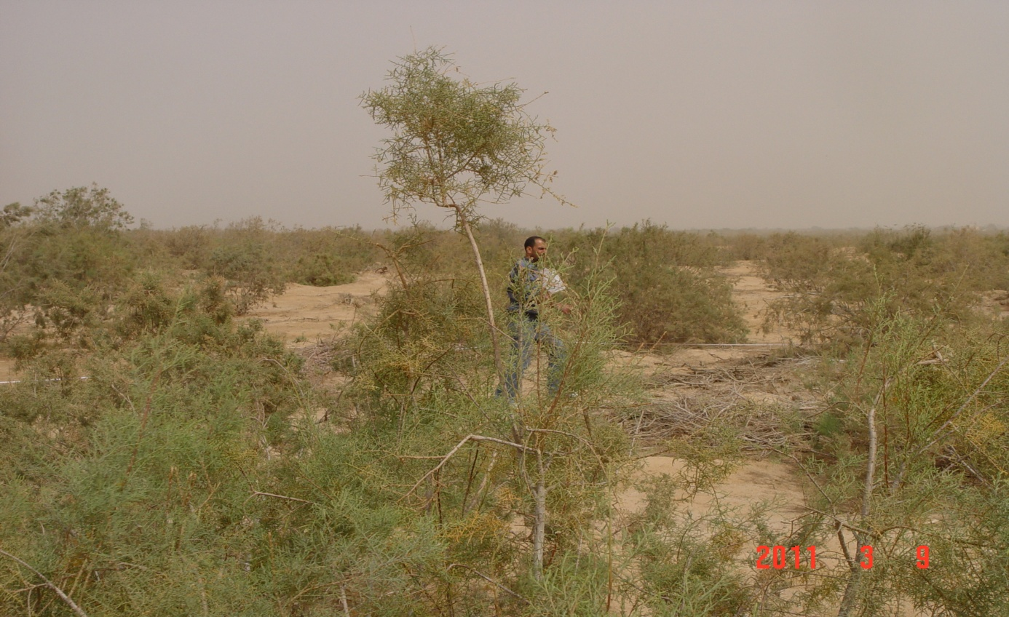

Figure 2: Plot method used in Fifa PA

Table 2: Braun-Blanquet Scale
Code | Cover %
+ | < 1%
1 | 1-5%
2 | 6-25%
3 | 26-50%
4 | 51-75%
5 | 76-100%

As mentioned above, there were three measurements taken for species recorded; density, frequency and abundance. Below is a brief description for each one of them:

a.Density
Density is an expression of the numerical strength of a species where the total number of individuals of each species is divided by the total number of quadrates studied and expression in number per m² (Ambasht, 1982), see Appendix 3.

Density of a Species per m² = Total number of individuals of a species in all the quadrates
Total numbers of all quadrates studied X area of quadrates

b.Frequency
Frequency is defined as the percentage of occurrence of a species in a series of samples of uniform size contained in a single stand, the number and sizes of plants in each sample being ignored see Appendix 3. The frequency of a species is determined using the following formula:

Frequency = Total number of quadrates in which the species occur X 100
Total number of quadrates studied

c.Abundance
The abundance is the number of individuals of different species in the community per unit area. The abundance can be calculated as follows:

Abundance = Total number of individuals of a species in all quadrates
Total number of quadrates in which the species occurred

The total area of Fifa 22.3 km² PA was divided into a grid system composed of 130 plots of 250000m² (500mx500m) area for each one, and for statistically representative systematic plots were chosen plot and leave the another plot to be Proposed (see map 2):purposes take 30 plot , choose 25 plots systematic that formed 19%of the total area, as shown in Map 2. But was canceled 5 plot , for the following reasons:
1 – plot not accessible to him (for any military or topographical)
2 - the path of the West - or to be the end of the transect (500 meters) is located outside the protected area or in the fact that the farmer was always the direction of the path always united to the western corner of the east corner of the plot In the end transect we are working plot (20 * 25 meters).

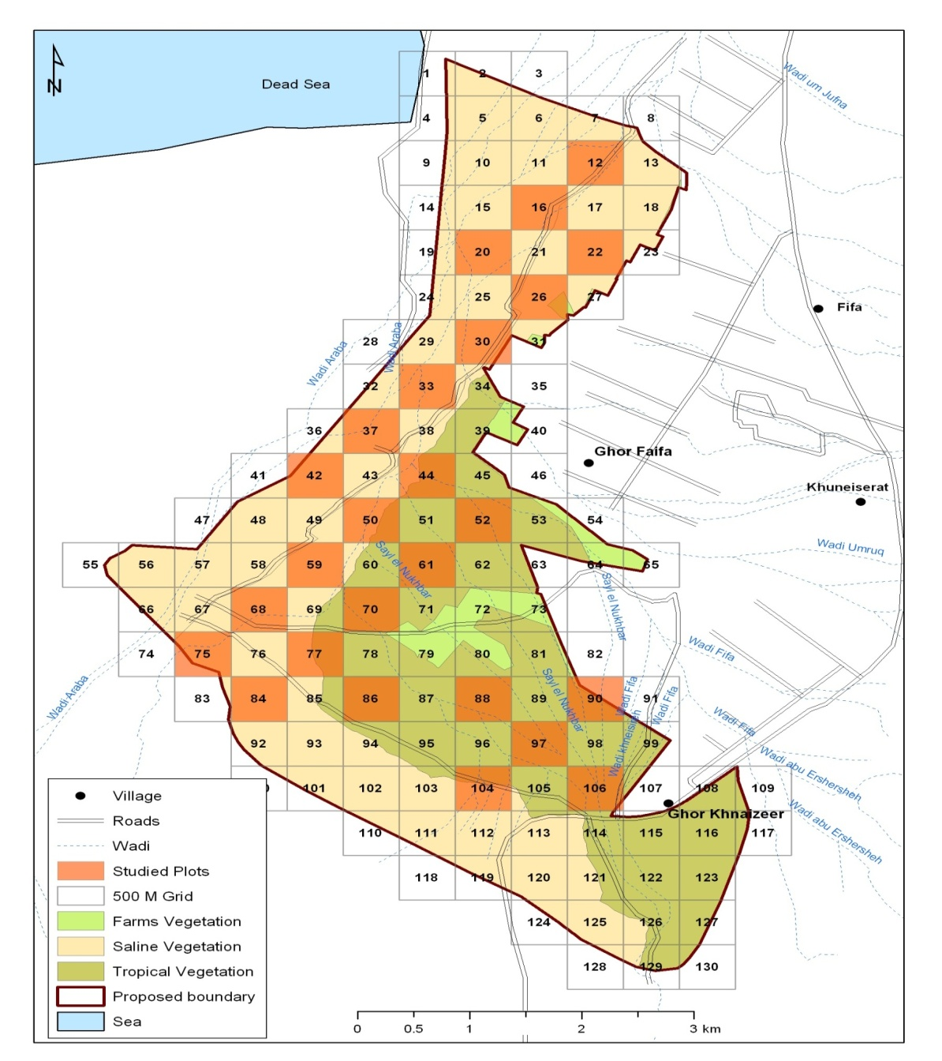

Map 2: proposed and studied plot in Fifa PA.

3. Results

3.1 Species Checklist
A total of 80 species were recorded during the survey that belonging to 60 genera and 30 families shown in Table 1, and they categorized according to their families, and from other side to their locally status and uses. In addition; the area of presence for all species within the PA were added. The complete information’s of every plot that recorded in this baseline survey are shown in annex 1.
 | Specie | Arabic Name | Status* |  | Uses** |  |  | *** Plot number
 | ARECACEAE (PALMAE) | النخيليه
1 | Phoenix dactylifera | نخيل | Threatened |  | Medicinal, Edible |  |  | 75
ASCLEPIADACEAE
2 | Calotropis procera | عشير | Threatened |  | N/A |  |  | 97
 | AIZOACEAE
3 | Aizoon canariense |  | Common |  | N/A |  |  | 37,22,77
4 | Aizoon hispanicum | اصبع العروس | Common |  | N/A
5 | Mesembryanthemum nodiflorum |  | Common |  | N/A |  |  | 104,52
 | AMARANARNTHACEAE
6 | Aerva javanica | شجرة النعجة | Common |  | N/A |  |  | 97
 | BORIGAINACEAE
7 | Heliotropium hirsutissimum | لسان النعجة | Common |  | Palatable |  |  | 104,70,86
 | CHENOPODIACEAE
8 | Anabasis articulata | عجرم | Common |  | Medicinal |  |  | 30,33,37,22,50,59,16,44,52
9 | Atriplex halimus | قطف ملحي | Common |  | Medicinal, Palatable |  |  | 22,59,16,44,52,26
10 | Haloxylon salicornicum | حماد | Common |  | Medicinal, Palatable |  |  | 42,50,12,68,75,77,104,16,44,52,86,106,97
11 | Salsola vermiculata | روثا ، حمض | Common |  | Palatable
12 | Salsola baryosma |  | Common |  | Palatable |  |  | 42,50
13 | Seidlitzia rosmarinus | حمض، شنانة |  |  | N/A |  |  | 50,12,68,77
14 | Suaeda aegyptiaca |  | Common |  | Palatable |  |  | 70
15 | Suaeda monoica | سويدة | Common |  | Palatable |  |  | 30,33,37,42,50,59,12,68,77,70,61,26
16 | Suaeda palaestina |  | Common |  | Palatable |  |  | 20,30,33,37,75,52
17 | Suaeda vera | سويدة | Rare |  | Palatable |  |  | 52
 | COMPOSITAE (ASTERRACEAE)
18 | Aaronsohnia factorovskyi | أقحوان أقرع | Common |  | Medicinal, Palatable |  |  | 77,104
19 | Artemisia sieberi | شيح | Common |  | Medicinal, Palatable |  |  | 42,59
20 | Filago desertorum | قطينه | Common |  | Palatable |  |  | 50,12,68,70,86,106,26
21 | Filago pyramidata | قطينه |  |  |  |  |  | 77,104,16,44,61,90,88
22 | Filago palaestina |  | Common |  | Palatable
23 | Centaurea aegyptiaca |  |  |  |  |  |  | 12,68,16,44
24 | Iflago spicata | قرطف | Common |  | Palatable |  |  | , 30,33,4277,104,61.90,97
25 | Lactuca orientalis | مرار | Common |  | Palatable |  |  | 12,68,104
26 | Launaea mucronata | جثجاث | Common |  | Palatable |  |  | 22,50,59,77,86,90,106,97, 26
 | CRUCIFERAE (BRASSICACEAE)
27 | Anastatica hierochuntica | كف مريم | Common |  |  | Medicinal, Palatable |  | 104,61,106
28 | Erucaria boveana |  | Common |  |  | Palatable |  | 50,59
29 | Carrichtera annua |  |  |  |  | Medicinal, Edible |  | 59
30 | Diplotaxis acris | مقرة | Common |  |  |  |  | 77,16,44,97
31 | Diplotaxis harra |  | Common |  |  | Palatable |  | 44
32 | Farsetia aegyptiaca | جرباء | Common |  |  | Palatable |  | 42,104,52
33 | Savignya parviflora |  | Common |  |  |  |  | 59,97
34 | Zilla spinosa | سلة، صلة | Common |  |  |  |  | 20,16,44
 | CISTACEAE
35 | Helianthemum lippii |  | Common |  |  |  | Palatable | 77
 | CUCURBITACEAE
36 | Citrullus colocynthis | حنظل | Common |  |  |  | Medicinal, Poisonous | 37,77,16,31
 | GRAMINEAE (POACEAE)
37 | Schismus arabicus |  | Common |  |  |  | Palatable | 42,22,50,77,104,70,61,86,106,88, 26
38 | Cynodon dactylon | نجيل | Common |  |  |  | Palatable | 16,44,97
39 | Pennisetum ciliaris |  | Common |  |  |  | Palatable | 104
40 | Phragmites australis | قصيب | Common |  |  |  | N/A | 20,30,37,50,75,106
 | GERANIACEAE
41 | Erodium hirtum | ابرة العجوز | Common |  |  |  | Palatable | 42,12,68,,77,61,86,90
42 | Erodium laciniatum |  | Common |  |  |  | Palatable | 20,70,26
43 | Monsonia nivea |  | Common |  |  |  | Palatable | 59
 | JUNCACEAE
44 | Juncus rigidus |  | Common |  |  |  | N/A | 30,33
 | LILIACEAE
45 | Dipcadi erythraeum |  |  | Rare |  |  | Woody | 104,90
46 | Gagea reticulata | .زعيتمان |  | Common |  |  | Palatable | 104
 | MALVACEAE
47 | Malva parviflora | خبيزه |  | Common |  |  | Medicinal, Edible | 30,33,22,50,59,12,68,77,16,44,70,61,86,  90,106,88,26
 | MIMOSACEAE
48 | Acacia tortilis |  |  | Threatened |  |  | T Woody, Palatable | 86,90,106,97,88
49 | Prosopis juliflora | سلم |  | Invasive |  |  | Palatable | 70,61,90,106,97,88,26
 | PAPILIONACEAE
50 | Alhagi graecorum | عاقول |  | Common |  |  | N/A | 20,22,75,84,26
51 | Astragalus hamosus |  |  | Common |  |  | Palatable | 77
52 | Astragalus sanctus |  |  | Common |  |  | Palatable | 30,33,37,22
53 | Astragalus spinosus |  |  | Rare |  |  | N/A | 104,88
54 | Astragalus tribuloides |  |  | Common |  |  | Palatable | 12,68,26
55 | Astragalus sp |  |  | Common |  |  | Palatable | 75
56 | Prosopis farcata | سلم |  | Common |  |  | Palatable | 84
57 | Tephrosia apollinea |  |  | Common |  |  | Palatable | 20,84
58 | Trigonella stellata | نفل |  | Common |  |  | Palatable | 22, 77,104,70,106,97
 | PAPAVERACEAE
59 | Roemeria hybrida |  |  | Common |  |  | Palatable | 77
 | PLANTAGINACEAE
60 | Plantago cylindrica |  |  | Common |  |  | Palatable | 77,90,88
61 | Plantago ovata |  |  | Common |  |  | Palatable | 50,77,104,70,61,86,97
 | POLYGONACEAE

62 | Emex spinosa | حمض | Common | Palatable, | 20, 30,12,68
63 | Rumex cyprius | حميض | Common | Palatable, Edible | 12,68,70,86,26
64 | Calligonum comosum |  | Threatened | N/A | 12,68,61,88
 | RANUNCULACEAE
65 | Adonis dentata | دحنون | Common | Palatable | 22,52
 | RESEDACEAE
66 | Reseda boissieri |  | Common | Palatable | 22
67 | Ochradenus baccatus | قرضة | Threatened | Palatable | 70,90,106,97,88
 | RHAMNACEAE |  |  |  | 70
68 | Ziziphus spina-christi | سدر | Threatened | Woody,Edible | 70,97,88
 | RUTACEAE
69 | Haplophyllum tuberculatum |  | Common | Medicinal, Poisonous | 90
 | NEURADACEAE
70 | Neurada procumbens | نيروندا | Common | N/A | 59,104,61
 | SALVADORACEAE
71 | Salvadora persica | اراك | Threatened | Medicinal | 52,86
 | SOLANACEAE
72 | Lycium shawii | عوسج | Common | N/A | 70,61,26
 | TAMARICACEAE
73 | Tamarix aphylla | طرفة | Common | Woody | 84,90
74 | Tamarix tetragyna | طرفه | Common | Woody | 30,20,37,42,50,59,12,75,84,77,16,44,52,70,61  ,86,90,106,97,88,26
 | UMBELLIFERAE (APIACEAE(
75 | Eptadenia byrotechina |  | Rare | Woody | 106
 | ZYGOPHYLLACEAE
76 | Fagonia bruguieri |  | Common | N/A | 104,16,86,90.97
77 | Fagonia mollis |  | Common | N/A | 42,77,44,88,26
78 | Peganum harmala | حرمل | Common | Medicinal, Poisonous | 59,77
79 | Zygophyllum simplex |  | Common | N/A | 30,37,97
80 | Nitraria retusa | غرقد | Common | N/A | 20,59,12,84,77,16,44.70,61,26
*Status; Common, Rare, Threatened
**Uses; Medicinal, Ornamental, Palatable, Edible, Wood, Poisonous
*** Plot number where specie recorded

3.2 Vegetation Composition

A total of 80 plant species were recorded at Fifa PA baseline survey that belonging to genera and 30 families. Seven threatened plants species which comprise (9% ) ,four Rare plant which comprise (5%) were recorded in Fifa PA represented from total plant checklist, , Salvadora persica , Acacia tortilis, Calligonum comosum, Calotropis procera, Phoenix dactylifera,, Ochradenus baccatus, Ziziphus spina-christi are threatened, where Astragalus sanctus, Dipcadi erythraeum, Suaeda monoica, Eptadenia byrotechina and considered a locally rare plant. Depending on their uses; palatable species plants have highest percentage with 57% from the recorded species, medicinal with 16%, edible for human uses and species used for their wood plants with 8%respectively, poisonous species have 3% the lowest percentage at PA Fifa.

.
..
Regarding to plants families; 30 families were recorded in this survey that added a diverse value for the site, where the majority of species were represented by Gramineae (63%), followed by Tamaricaceae ,Papolionacea families represented (60%) for both ,Cruciferae represented (8%) and the other recorded families had close percentages..

3.3 Flora Attributes

a. Frequency

The recorded frequency values were grouped into 4 represented categories: high (> 75%), moderate (50.1-75%), low (25.1-50%), and very low (< 25%).

From data analysis the frequency was found in range (4% to 68%)for plant species in Fifa PA ,the most frequent family species was Malvacae represented by Malva parviflora ,followed by Gramineae(Poaceae) represented mainly by Schismus arabicus, followed by Zygophyllaceae represented mainly by Nitraria retusa, followed by Chenopodiace represented by,( Haloxylon salicornicum and Suaeda monoica)show the same frequency percentage , followed by Compositae) represented mainly by Launaea mucronata, followed by Mimosaceae) represente mainly by Prosopis juliflora, finally families Papolionacea and plantaginacea represented mainly by Plantago ovate and Trigonella stellata.

(None of the identified species recorded a high frequency value (> 75%). Malva parviflora and Schismus arabicus scored moderate frequency values of 68 % and 52%, respectively Nitraria retusa, Suaeda monoica,Haloxylon salicornic Launaea mucronata, Prosopis juliflora , Plantago ovata , Trigonella stellata, Ifloga spicata, Rumex cyprius , Anabasis articulata Erodium hirtum , Atriplex halimus scored low frequency values(25.1-50%), The majority of species (66 out of 80) showed very low frequency in Fifa protected area.

.

b. Plant density

The plant density values were grouped into 4 categories: high (> 10), moderate (5.1-10), low (1-5), and very low (< 1 plant per m⁻²).
In this study was found that the averaged of species density 0.0000002 per 1 m⁻² ,the highest density was for Schismus arabicus,with density, 0.000130 per 1 m⁻² the low density Filago desertorum with density 0.00017 per 1 m⁻² followed by Trigonella stellata with density0,000010 per 1 m⁻² ,Tamarix tetragyna with density 0.000006 per 1 m⁻² and .Malva parviflora with density 0.000005 per 1 m⁻² showed very low density compared to plant density values categories. The majority of species (n=80) showed very low density.

Figure3: Density values of recorded plant species in Fifa PA

C. Plant diversity

A total of 80 plant species were recorded at Fifa PA baseline survey that belonging to genera and 30 families. Seven threatened plants species which comprise (9% ) ,four Rare plant which comprise (5%) were recorded in Fifa PA represented from total plant checklist, , Salvadora persica , Acacia tortilis, Calligonum comosum, Calotropis procera, Phoenix dactylifera,, Ochradenus baccatus, Ziziphus spina-christi are threatened, where Astragalus sanctus, Dipcadi erythraeum, Suaeda monoica, Eptadenia byrotechina and considered a locally rare plant.

Regarding to plants families; 30families were recorded in this survey that added a diverse value for the site, After calculation the percentage of each family in relation to the total number recorded. The result showed of the family Chenopodiaceae which itself comprise (13%) followed by the family Compositae and Papolionacea, 11 % then family Crucifera which comprise( 9%), followed by Zygophyllaceae which comprise (6%) ,The majority of others family were represented by, 1%

D. Species Abundance

The categorization of computed abundance values of the recorded species showed a grouped into three categories as follow:
Low (< 7), moderate (10-40) and high (> 50)
Schismus arabicus showed highest species number among others, where Filago desertorum of moderate abundance values, followed by Trigonella stellata ,Tamarix tetragyna, Malva parviflora,Anabasis articulata of Low abundance values. (Figure4).
Our findings showed weak values of species abundance that confined In Fifa PA is attributed to the sever saline habitat which restricts the occurrence and growth only of well adapted plants to such situation.Evenari et al .(1985) mentioned general rule that is applicable to the deserts: the more the the extreme the habitat, more the pronounced the dominance of afew and sometimes only one species. As many saline habitats many studies showed that sabkhat are characterized by the absence or rare abundance of annuals .the high soil salinity in Fifa PA caused low plant diversity of these habitat, only plant species with high adaptability to salinity can grow in those location ,those specie were : Tamarix tetragyna, Nitraria retusa, Arthrocnemum macrostachym, Suaeda monoica, Phoenix dactylifera

Figure 4 : Abundance values of most recorded species in Fifa PA

F. Species richness
;
The records of this parameter indicated presence of spatial diversity among different plant species within plots , plot 77 represented 8% ,plot 104 represented 6% within tropical vegetation due to low salinity ,had good species richness. Generally; the values of species richness indicated low plant diversity in Fifa PA. It seems that the synergism of soil salinity. Species richness per macro-plot (10mx500m) averaged. 15.8 of 25 plot were studies in Fifa PA Again the values of species richness indicated low plant diversity in Fifa Protected Area. It seems that the synergism of the harsh climate conditions soil salinity main reason to decline annual plant (herb ) .

,

Figure 5: Species richness percentages of plots

3.4 Vegetation Types

Fifa PA lies within the Sudanian Biogeographical Zone, in which two vegetation types were identified, the Saline and Tropical vegetation types (Map 3.2). The following describes the vegetation types that are present at the PA

3.4.1 Saline vegetation

The saline vegetation type was located in the western part of the PA from 35 25 987E, 53 154 987N to 35 23 537E ,54 992 30N and extends to 35 26 090E 38 052 30N. Saline vegetation represents 78 % of the total PA with an area of 17.4 Km² Tamarix tetragyna, Arthrocnemum macrostachym.,Nitraria retusa,.and Suaeda monica, Juncus rigidus Alhagi graecorum, Lycium shawii are the leading species of this vegetation.

3.4.2 Tropical vegetation

The Tropical vegetation type was represented in the eastern part of the PA from 35 26 321E ,53 209 30N to 35 25 166E ,56 478 30N and represents 22% of the total PA with an area of 4.9Km².

The soil present with the tropical vegetation in the PA is alluvial (Al-Esawi, 1996) with a light color, classified as desert silt formed from alluvial material that settled in the past. The soil is entirely deficient of organic matter, infertile and saline. The leading species of this vegetation are Salvadora persica, Calotropis procera and Zizphus spina-christi, Ochradenus baccatus, Aerva javanica

3.5 Updating Vegetation Community
Vegetation structure (physiognomy or architecture) refers to the number of strata and spatial distribution of plant species. Eight vegetation plant community was defined in Fifa protected area General vegetation structure was determined visually for each habitat type ( map3) describes the distribution pattern of vegetation community characteristic in Fifa PA. 10 Vegetation Communities were recorded :
- Tamarix tetragyna is the characteristic spesies of these stand accompined with phragmites australis ,its the largest amount in Fifa PA, the absence of annuals was remarkable, located mainly in the northern west part in Fifa PA.
- .Mix ( Tamarix tetragyna Lycium shawii) This group comprise by dominace of Tamarix tetragyna , Lycium shawii, Calligonum comosum, Seidlitzia rosmarinus, Suaeda monoica and some annual plant , Filago desertorum, Centaurea aegyptiaca
- Mix tamarix tetragyn with Arthrocnemum macrostachym, Arthocnmum macrostachym is the characteristic spesies of these stand accompined with tamarix tetragyna ,Seidlitzia rosmarinus, Salsola baryosom, Atriplex halimus Suaeda monoica these area slightly saline with high amoun of moisture .located in Eastren part in PA.
- ( Tamarix tetragyna with Alhagi graecorum , Alhagi graecorum is the characteristics spesies , a accompanied with, Ziilia spinosa, Atriplex halimus,Aizon canariense , Malva parviflora located in eastern north part in FIFA pa
- Mix tamarix tetragyna with Suaeda monoica, Suaeda monoica is the characteristic spesies of these stand accompined with tamarix tetragyna Arthocnmum macrostachym ,Seidlitzia rosmarinus, , Atriplex halimus Suaeda monoica and annual herb , such as Plantago ovate , Malva parviflora, Trigonella stellata .located in Eastren part in PA
- Mix ( Tamarix tetragyna Nitraria retusa ) This group comprise by dominace of Tamarix tetragyna , Lycium shawii, Calligonum comosum, Seidlitzia rosmarinus, Suaeda monoica and some annual plant , Filago desertorum, Centaurea aegyptiaca

- Haloxylon salicornicum is the characteristic spesies of this group ,its companied with Artimesia sieberi.Salsola vermiculata,faresitia aegyptica , Suaeda monoica, iflago spicata
- Vegetation is characterized by the dominance of juncus rigidus , and tamarix spp . with highest cover favour to juncus rigidus, ,Alhagi graecorum ,Halxylon salicornicum,Phonix dactylifera , Prosopis farcata . located in eastern part
- Phoenix dactylifera is the characteristic spesies of these stand accompanied with phragmites australis juncus rigidus ,, tamarix spp ., ,Alhagi graecorum ,Halxylon salicornicum,Phonix dactylifera , Prosopis farcata . located in eastern part
- This area is characterized by the of Acacia tortilis scattered with Tamarix tetragyna , Ochradenus baccatus, Prosopis juliflora Tamarix aphylla, Dipcadi erythraeum,located in southern west in PA

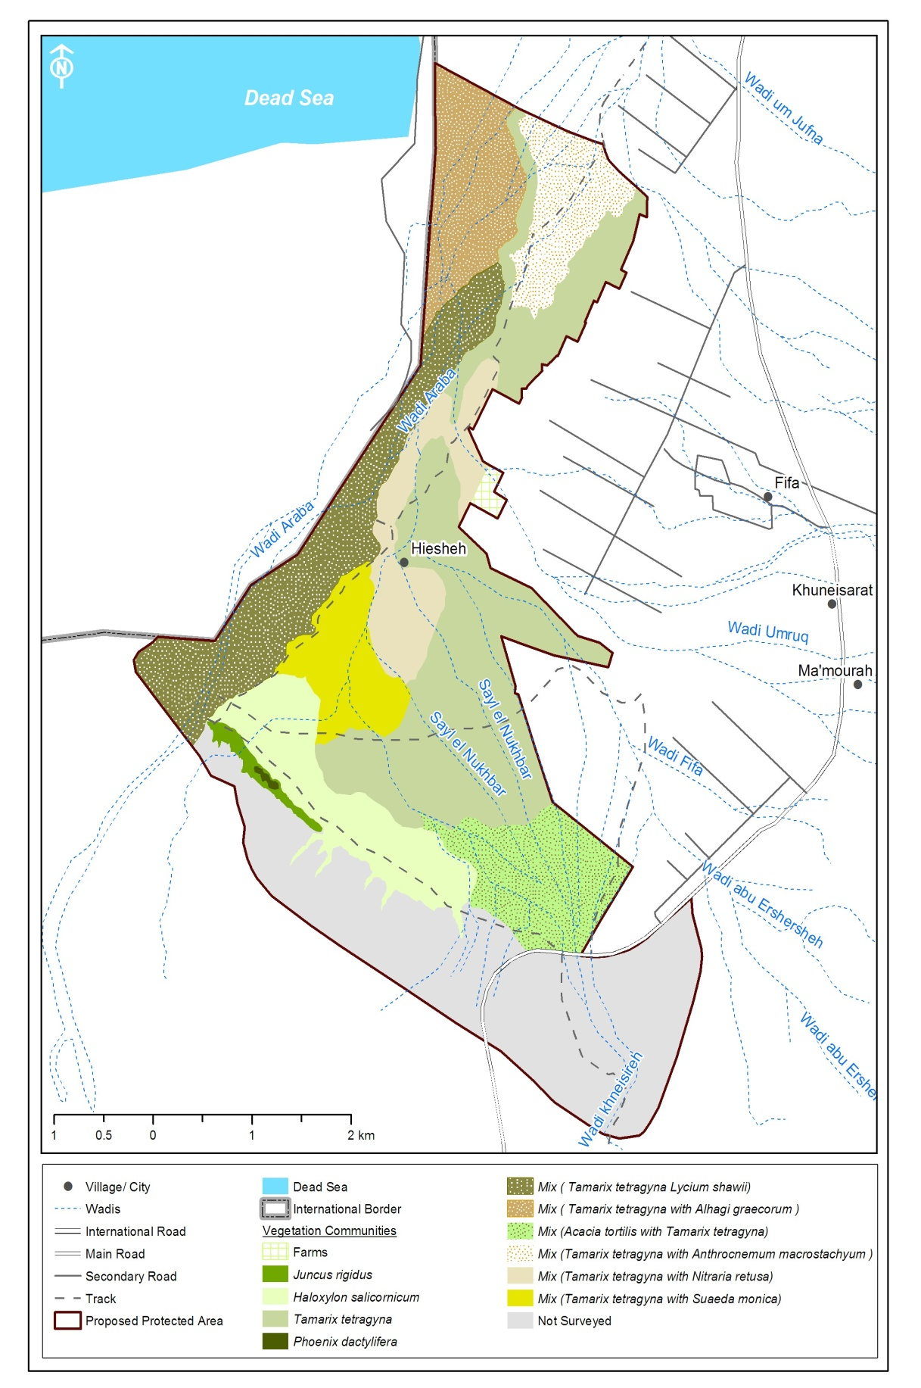

Map 3: vegetation plant communities in Fifa PA

3.6 Rare and Threatened Species

Seven threatened plants species which comprise (9% ) ,four Rare plant which comprise (5%) were recorded in Fifa PA represented from total plant checklist, threatened plants includes Salvadora persica , Acacia tortilis, Calligonum comosum, Calotropis procera, Phoenix dactylifera,, Ochradenus baccatus, Ziziphus spina-christi,,rare plant Astragalus sanctus, Dipcadi erythraeum, Suaeda monoica, Eptadenia byrotechina.

sies gives the PA an ecological value and protection potential, threatened plants includes Salvadora persica Toothbrush Tree, a species which is not represented in the reserves network of Jordan, that gives the PA more ecological value
Vegetation

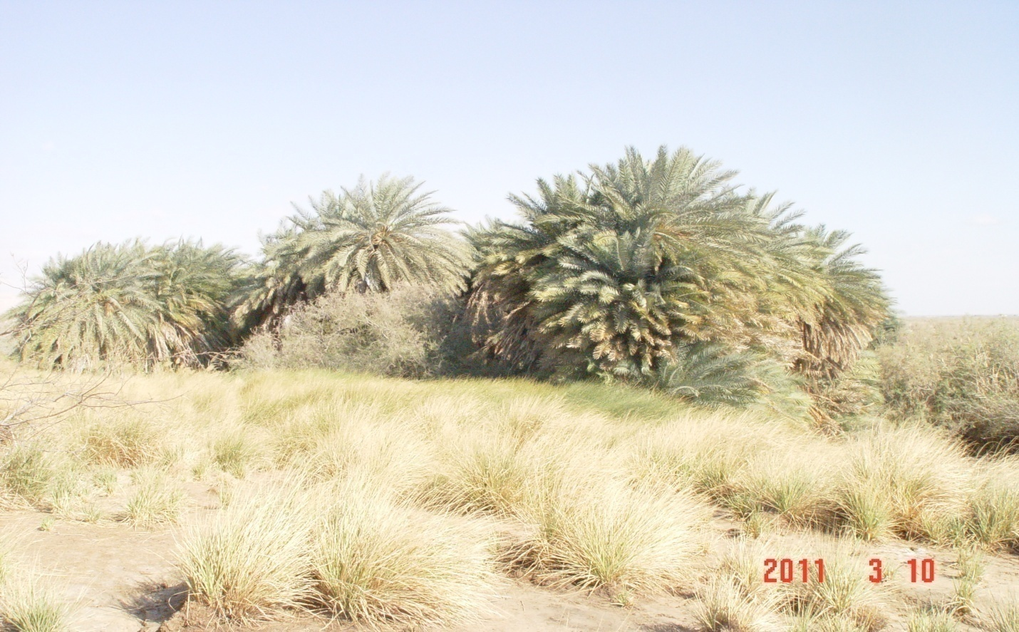

Figure 6 : Overview of threatened plants Phoenix dactylifera in fifa PA

4. Threats to the vegetation in Fifa protected area:
According to Flora baseline survey in the PA; threats to the vegetation are represented below:
Intensive agriculture farming:
The main threats on Fifa Protected area intensive agriculture has lead to habitat destruction and natural vegetation that includes the probable pesticide usage and chemical fertilizer inside the agricultural area as well as water pumping to the agricultural areas., the main crops that are grown in winter tomato, eggplant . the crops in winter stay on the field until Aprile/ May for example, The summer crop are : Cucumber,Water mellon with growing period extends from May until July/August tMore over other threats recorded are off roads construction and disturbing the wild fauna. Agricultural lands cuts more than one quarter of the previously proposed PA which indicates for a threat on the wild plant species in the PA.

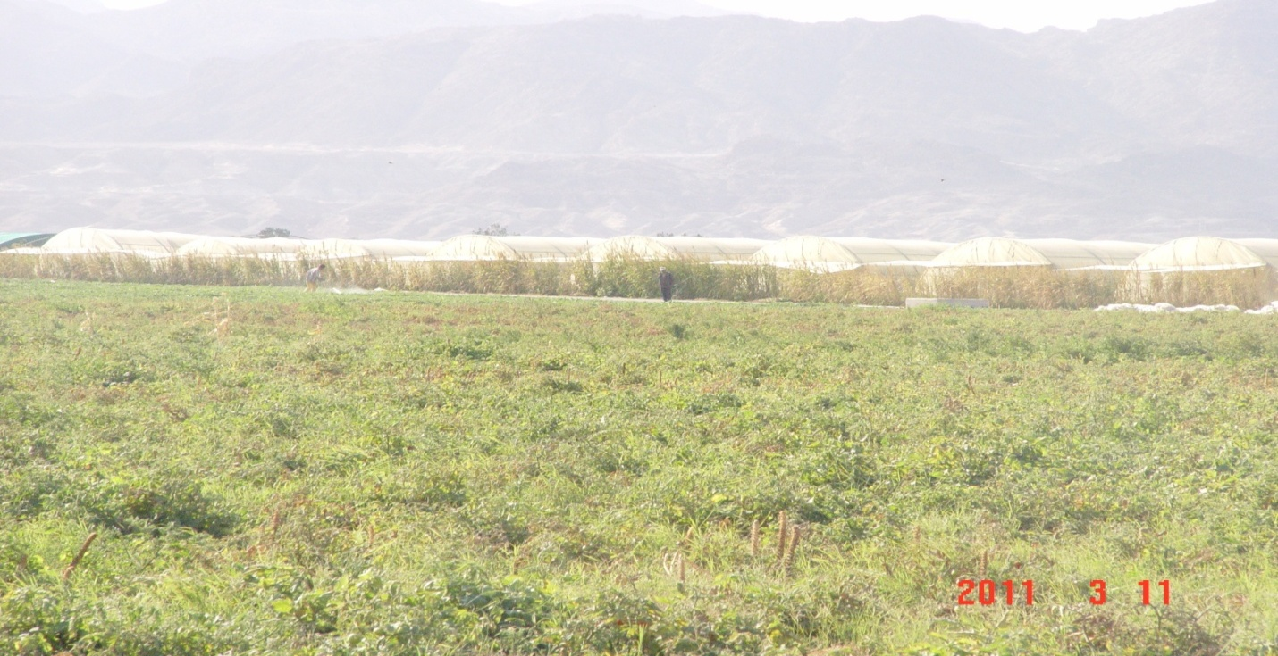
Figure7: Overview of Intensive agriculture in Fifa PA

2. Off roads construction:
Military purposes, is one of the main factors causing degradation of different habitats. Habitats degradation is especially noticeable in Tamarix zone due to the uncontrolled movements of 4WD vehicles. This uncontrolled driving is severally damaging the different plant communities

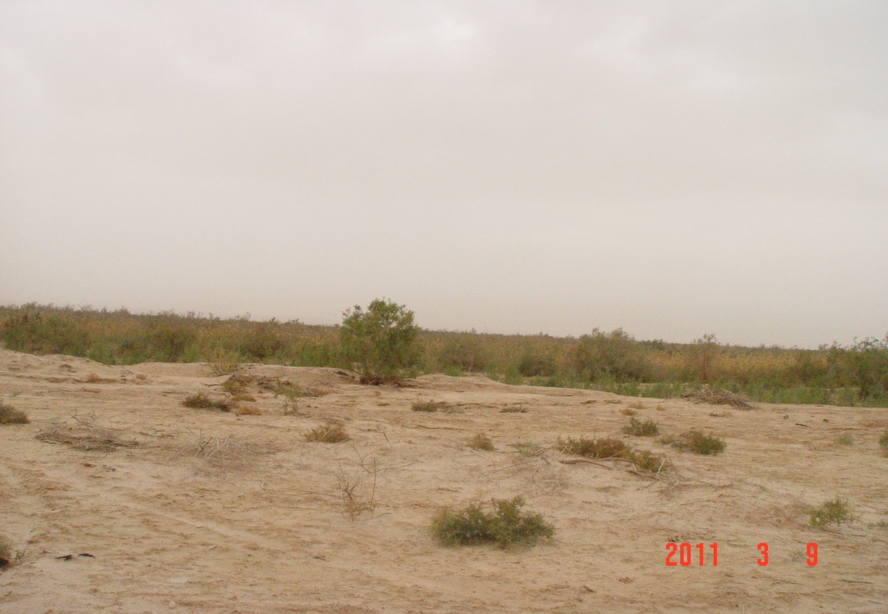

Figure8: Overview Off roads construction at fifa PA

- Firing activities :
Threats recorded in this area consisted of especially near water spring site ( aieen ben Thekeer, mainly in Phoenix dactylifera and Juncus rigidus zone to.

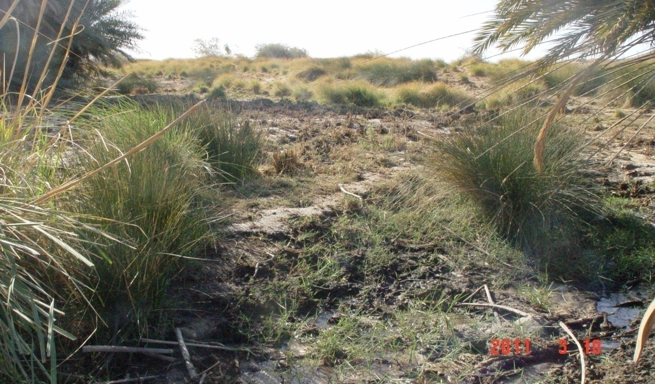

Figure 9: Overview of firing activities in Fifa PA

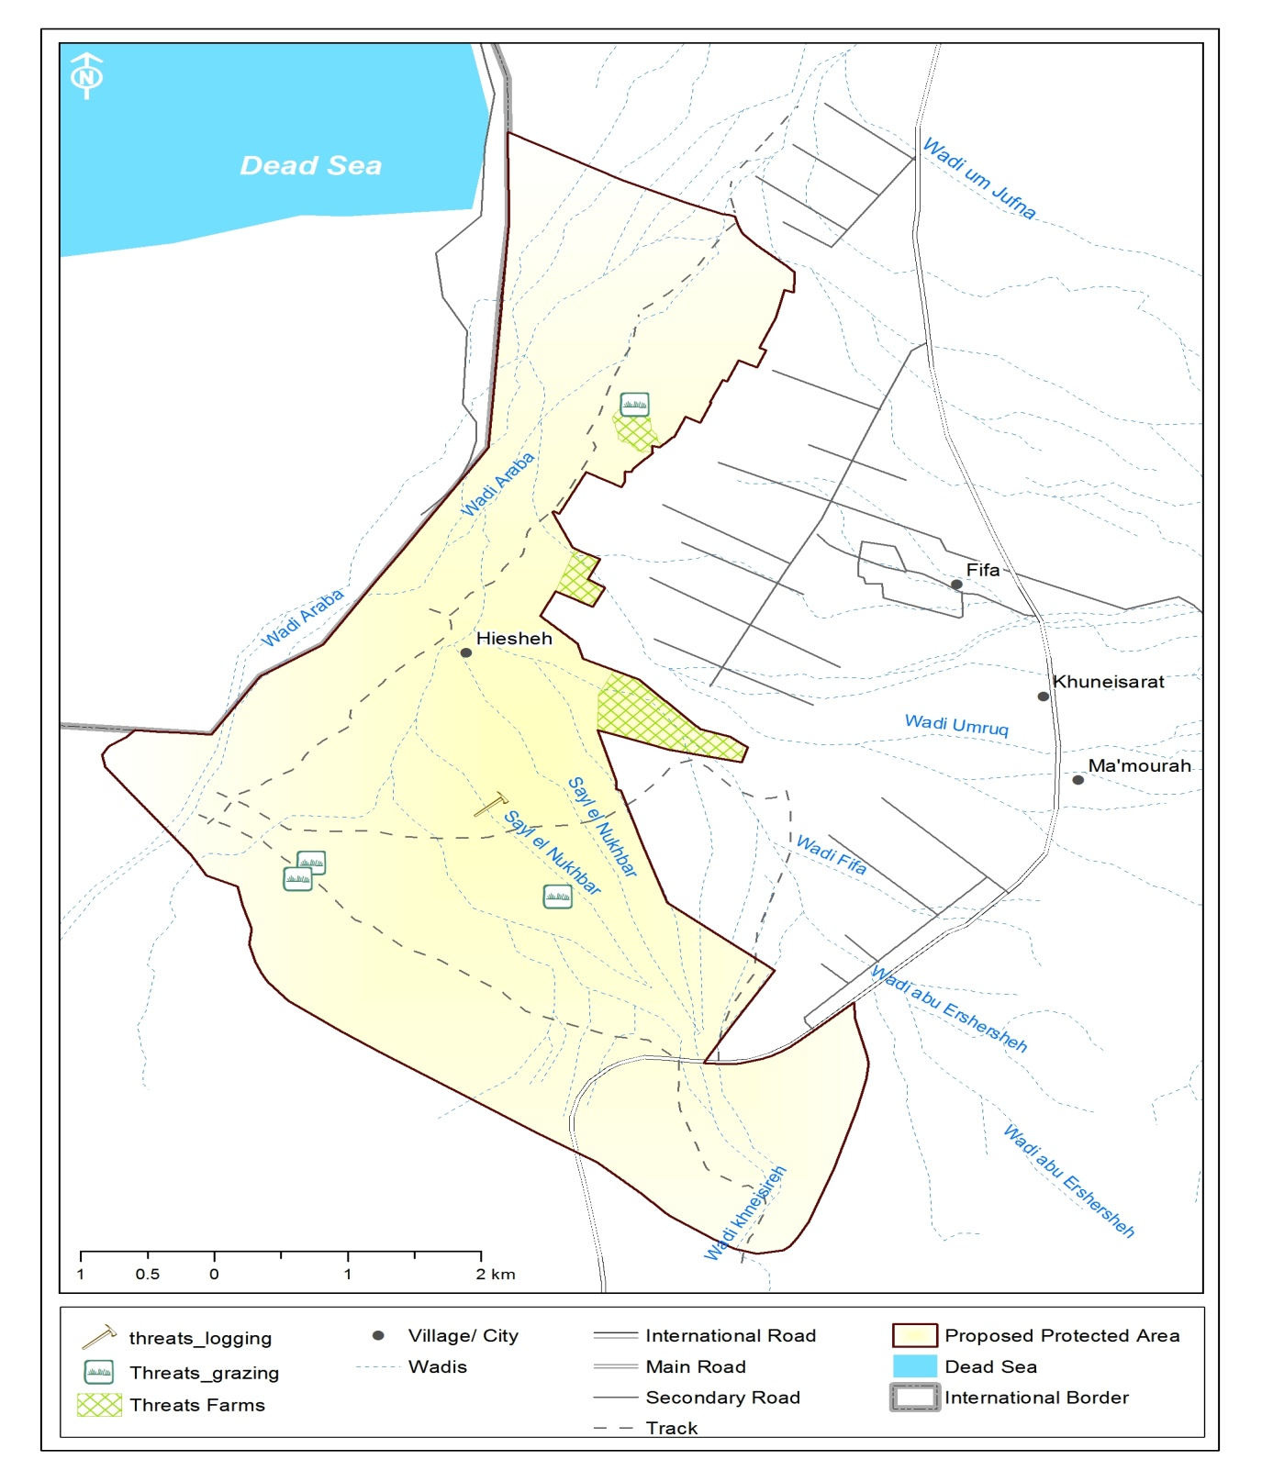

Map 5 : Main threat to vegetation at Fifa PA .

5. Recommendations

- Prevent Agriculture practices within the Protected Area

Different Agriculture practices should be banned inside the protected Area from local people , which mainly cultivated by . The plowing of the soil and the use of pesticide and chemical material will seriously affect the different natural flora and fauna negatively.

- Controls Off-road Driving

Off-road driving is considered threat to vegetation existing in areas where military activity is concentrated , limited Off-road path for military should marked

6. References:

- Oraib N.2006 :Geobotanical study of Wadi Araba and Wadi RUM deserts in South West Jordan Beuren Germany.
- Al Eisawi, D. 1998: Wild Flowers of Jordan and Neighboring Countries. Amman.

- Al Eisawi, D. 1996: Vegetation of Jordan. UNESCO Cario Office .
- Royal Society for Conservation of Nature (RSCN),1996. Mujib Nature Reserve Baseline Survey, Amman- Jordan
- Burnie, D. 1995: Wildflowers of the Mediterranean. Dorling Kindersley Limited, London
- Royal Society for Conservation of Nature (RSCN),1994 :Dana Nature Reserve vegetation Baseline Survey, Amman- Jordan
- Zohary, M. 1972: Flora Palaestina. The Israel Academy of Sciences and Humanities, Jerusalem

7. Appendixes’: Examples of Vegetation Data Sheets
Transect Number: Researchers
Start Coordinates: E End Coordinates: E
N N
Altitude : m
Exposure : N S E W NE NW SE SW Others
Bio-Geographical Zone:
Vegetation Type(s) :
Dominant Species : Date:
 | Specie | Coordinates |  | Notes
 |  | East | North
1
2
3
4
5
6
7
8
9
10
11
12
13
14
15
16
17
18
19
20
21
22
23
24
25
26
27
28

VEGETATION PLOT SHEET

Date :
Researchers :
Plot Number:
Central Coordinates : E
N
Altitude : m
Exposure : N S E W NE NW SE SW Others
Bio-Geographical Zone:
Vegetation Type(s) :
Dominant Species :
Notes;

 | Specie | # of Individual | *Phenology | **Type
1
2
3
4
5
6
7
8
9
10
11
12
13
14
15
16
17
18

Key to Species List:
*Phenology: **Type:
V : Vegetative T: Tree
Fl: Flowering S: Shrub
Fr: Fruiting Ch: Chamaeophyte
D : Dry G: Grass
H: Herb
B: Bulbous

Appendix 2: Frequency (%)of recorded plant species in Fifa PA

 | Plant species | Frequency (%) |  | Plant species | Frequency (%)
1 | Aaronsohnia factorovskyi | 8 | 37 | Haloxylon salicornicum | 44
2 | Acacia tortilis | 20 | 38 | Haplophyllum tuberculatum | 4
3 | Adonis dentata | 12 | 39 | Helianthemum lippii | 8
4 | Aerva javanica | 4 | 40 | Heliotropium hirsutissimum | 12
5 | Aizoon canariense | 8 | 41 | Ifloga spicata | 28
6 | Aizoon hispanicum | 12 | 42 | Imperata cylindrica | 8
7 | Alhagi graecorum | 20 | 43 | Juncus rigidus | 8
8 | Anabasis articulata | 28 | 44 | Lactuca orientalis | 8
9 | Anastatica hierochuntica | 12 | 45 | Launaea mucronata | 40
10 | Androcymbium palaestinum | 0 | 46 | Lycium shawii | 12
11 | Artemisia sieberi | 8 | 47 | Malva parviflora | 68
12 | Astragalus spinosus | 4 | 48 | Mesembryanthemum nodiflorum | 4
13 | Astragalus hamosus | 4 | 49 | Monsonia nivea | 4
14 | Astragalus sanctus | 12 | 50 | Neurada procumbens | 16
15 | Astragalus tribuloides | 8 | 51 | Nitraria retusa | 48
16 | Atriplex halimus | 28 | 52 | Ochradenus baccatus | 20
17 | Calligonum comosum | 12 | 53 | Peganum harmala | 4
18 | Calotropis procera | 8 | 54 | Pennisetum ciliaris | 8
19 | Carrichtera annua | 4 | 55 | Phoenix dactylifera | 4
20 | Centaurea aegyptiaca | 8 | 56 | Phragmites australis | 24
21 | Citrullus colocynthis | 8 | 57 | Plantago cylindrica | 20
22 | Cynodon dactylon | 8 | 58 | Plantago ovata | 32
23 | Deverra triradiata | 4 | 59 | Prosopis juliflora | 36
24 | Dipcadi erythraeum | 8 | 60 | Prosopis farcta | 4
25 | Diplotaxis acris | 16 | 61 | Reseda boissieri | 8
26 | Diplotaxis harra | 4 | 62 | Roemeria hybrida | 4
27 | Emex spinosa | 12 | 63 | Rumex cyprius | 28
28 | Erodium hirtum | 28 | 64 | Salsola baryosma | 8
29 | Erodium laciniatum | 16 | 65 | Salsola vermiculata | 4
30 | Erucaria boveana | 8 | 66 | Salvadora persica | 12
31 | Fagonia bruguieri | 16 | 67 | Savignya parviflora | 8
32 | Fagonia mollis | 24 | 68 | Schismus arabicus | 52
33 | Farsetia aegyptiaca | 12 | 69 | Seidlitzia rosmarinus | 12
34 | Filago desertorum | 24 | 70 | Suaeda aegyptiaca | 4
35 | Filago pyramidata | 24 | 71 | Suaeda monoica | 44
36 | Gagea reticulata | 4 | 72 | Suaeda palaestina | 12
73 | Suaeda vera | 8 | 74 | Tamarix aphylla | 8
75 | Tamarix tetragyna | 8 | 78 | Zilla spinosa | 8
76 | Tephrosia apollinea | 8 | 79 | Ziziphus spina-christi | 12
77 | Trigonella stellata | 32 | 80 | Zygophyllum simplex | 12

Appendix 3: Density values of recorded plant species in Fifa PA

 | Plant species | Density |  | Plant species | Density
1 | Aaronsohnia factorovskyi | 0.000 | 37 | Haloxylon salicornicum | 0.001
2 | Acacia tortilis | 0.001 | 38 | Haplophyllum tuberculatum | 0.000
3 | Adonis dentata | 0.000 | 39 | Helianthemum lippii | 0.000
4 | Aerva javanica | 0.000 | 40 | Heliotropium hirsutissimum | 0.001
5 | Aizoon canariense | 0.001 | 41 | Ifloga spicata | 0.002
6 | Aizoon hispanicum | 0.000 | 42 | Imperata cylindrica | 0.000
7 | Alhagi graecorum | 0.004 | 43 | Juncus rigidus | 0.000
8 | Anabasis articulata | 0.011 | 44 | Lactuca orientalis | 0.000
9 | Anastatica hierochuntica | 0.001 | 45 | Launaea mucronata | 0.002
10 | Androcymbium palaestinum | 0.000 | 46 | Lycium shawii | 0.000
11 | Artemisia sieberi | 0.000 | 47 | Malva parviflora | 0.025
12 | Astragalus spinosus | 0.000 | 48 | Mesembryanthemum nodiflorum | 0.001
13 | Astragalus hamosus | 0.000 | 49 | Monsonia nivea | 0.000
14 | Astragalus sanctus | 0.001 | 50 | Neurada procumbens | 0.001
15 | Astragalus tribuloides | 0.000 | 51 | Nitraria retusa | 0.003
16 | Atriplex halimus | 0.001 | 52 | Ochradenus baccatus | 0.000
17 | Calligonum comosum | 0.000 | 53 | Peganum harmala | 0.000
18 | Calotropis procera | 0.000 | 54 | Pennisetum ciliaris | 0.000
19 | Carrichtera annua | 0.000 | 55 | Phoenix dactylifera | 0.000
20 | Centaurea aegyptiaca | 0.000 | 56 | Phragmites australis | 0.001
21 | Citrullus colocynthis | 0.000 | 57 | Plantago cylindrica | 0.004
22 | Cynodon dactylon | 0.003 | 58 | Plantago ovata | 0.005
23 | Deverra triradiata | 0.000 | 59 | Prosopis juliflora | 0.000
24 | Dipcadi erythraeum | 0.000 | 60 | Prosopis farcta | 0.000
25 | Diplotaxis acris | 0.001 | 61 | Reseda boissieri | 0.000
26 | Diplotaxis harra | 0.000 | 62 | Roemeria hybrida | 0.000
27 | Emex spinosa | 0.001 | 63 | Rumex cyprius | 0.002
28 | Erodium hirtum | 0.002 | 64 | Salsola baryosma | 0.000
29 | Erodium laciniatum | 0.003 | 65 | Salsola vermiculata | 0.000
30 | Erucaria boveana | 0.000 | 66 | Salvadora persica | 0.000
31 | Fagonia bruguieri | 0.001 | 67 | Savignya parviflora | 0.000
32 | Fagonia mollis | 0.001 | 68 | Schismus arabicus | 0.652
33 | Farsetia aegyptiaca | 0.000 | 69 | Seidlitzia rosmarinus | 0.000
34 | Filago desertorum | 0.083 | 70 | Suaeda aegyptiaca | 0.000
35 | Filago pyramidata | 0.001 | 71 | Suaeda monoica | 0.003
36 | Gagea reticulata | 0.000 | 72 | Suaeda palaestina | 0.000
73 | Suaeda vera | 0.000 | 74 | Tamarix aphylla | 0.000
75 | Tamarix tetragyna | 0.029 | 78 | Zilla spinosa | 0.000
76 | Tephrosia apollinea | 0.000 | 79 | Ziziphus spina-christi | 0.000
77 | Trigonella stellata | 0.052 | 80 | Zygophyllum simplex | 0.000

Appendix 4: Species percentage of each family recorded in Fifa PA

ARECACEAE | 1 | 0.033
AIZOACEAE | 3 | 0.1
ASCLEPIADACEAE | 1 | 0.033
AMARANTHACEA | 1 | 0.033
BORAGINACEAE | 1 | 0.033
CHENOPDIACEAE | 10 | 0.3
COMPOSITAE | 9 | 0.3
CRUCIFERAE | 7 | 0.23
CISTACEAE | 1 | 0.033
CUCURBITACEAE | 1 | 0.033
GRAMINEAE (POACEAE) | 4 | 0.13
GERANIACEAE | 3 | 0.1
JUNCACEAE | 1 | 0.033
LILIACEAE | 2 | 0.066
MALVACEAE | 1 | 0.033
MIMOSACEAE | 2 | 0.066
PAPILIONACEAE | 9 | 0.3
PAPAVERACEAE | 1 | 0.033
PLANTAGINACEAE | 2 | 0.066
POLYGONACEAE | 3 | 0.1
RANUNCULACEAE | 1 | 0.066
RESEDACEAE | 2 | 0.033
RHAMNACEAE | 1 | 0.033
RUTACEAE | 1 | 0.033
NEURADACEAE | 1 | 0.033
SALVADORACEAE | 1 | 0.033
SOLANACEAE | 1 | 0.033
TAMARICACEAE | 2 | 0.066
UMBELLIFERAE (APIACEAE( | 1 | 0.033
ZYGOPHYLLACEAE | 5 | 0.166

