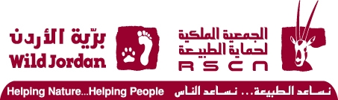
Integrated Ecosystem Management in the Jordan Rift
Valley Project (IEM- JO)

Rodent’s & Reptiles Baseline Survey

Fifa proposed Protected Area

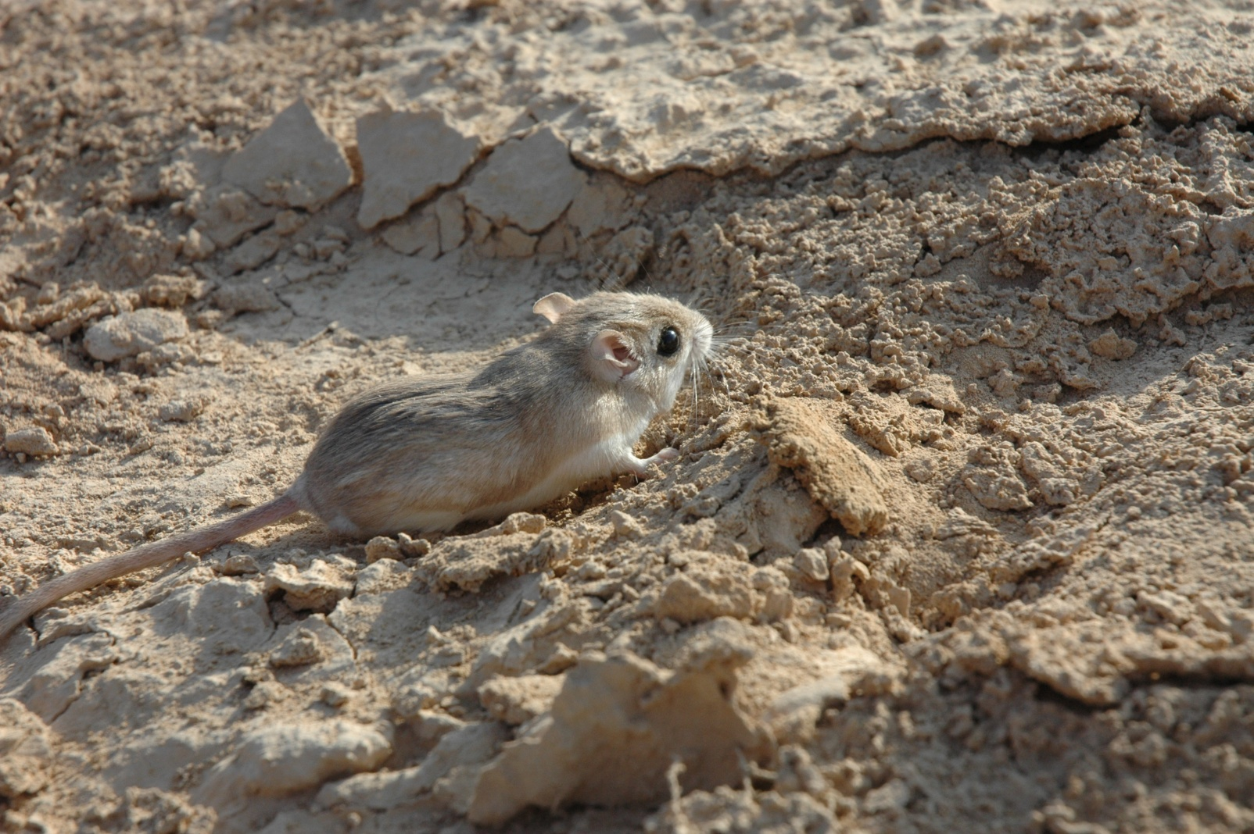

The Royal Society for the Conservation of Nature
(RSCN)

Research and Survey Section

Integrated Ecosystem Management in the Jordan Rift Valley Project (IEM-JO)

Ecological Baseline Surveys
Rodents & Reptiles Baseline Survey
Fifa Proposed Protected Area

Report Prepared by:
Thabit Alshare
Ehab Eid
Omar Abed

April 2011

Table of Contents

SUMMARY

Fifa proposed protected area covers an area of 26.4 km² with an elevation of -421 meter below sea level. It is located within the Jordan Rift Valley which is considered a globally important ecological corridor and holds many large and internationally important ecosystems. Fifa PA was proposed to be established after the RSCN review at 1998; because it represents two natural vegetation types; saline vegetation and tropical vegetation.

The rapid assessment survey for rodents and reptiles species was conducted in 2008, and Sherman live-trapping was used as well as opportunistic and interview methods. Results showed the presence of three Rodents species belongs to tow families and they are Acomys cahirinus, Gerbillus nanus, Gerbillus dasyurus. Moreover, four herpetofaunal species were recorded and these are Mesalina olivieri, Uromastyx aegyptia, Varanus griseus, Bufo viridis. Main threat was habitat degradation which is affecting their distribution and status.

The current survey aimed to identify Rodents and Amphibians species and their status, draw a map indicating distribution of these species and to identify threats on species in Fifa proposed protected area. In accordance, four methods were using 1) Sherman trapping method, 2) spoor route, 3) interviews and 4) opportunistic observation methods. Results showed the presence of four rodents species belong to two families these are: Gerbillus dasyurus, Gerbillus nanus, Acomys cahirinus and mus musculus. Which is consequently raising the number of knowing rodents species in the area? Apparently, it was found that Wagners gerbil; Gerbillus dasyurus is the most common and distributed species in Fifa PA.

The military presence adds constrains to the current survey as it limited the survey size area and the time available to perform different methods. In addition, it was difficult to perform other methodologies which are used for surveying nocturnal species such as Night –Rout method.

Threats on rodents and amphibians species in Fifa PA were illustrated and represented by habitat degradation due to agricultural expansion, road-killing and chemical pesticides use. The recommendations focused on the need to prepare and implement a memorandum of understanding with army to facilitate surveying in the site as well as adopting awareness campaign targeting local community, farmers and army soldiers in Fifa PA.

Acknowledgments

The survey teams are grateful to the management of the RSCN, namely Mr. Mohammad Yousef “Director of Conservation and Mrs. Enas Sakijha “Research and Survey Section Head” for their continuous support and help.

Appreciation is extended to the Military personal for their understanding and assistant to perform the survey.

- Introduction

  - Project background

1.1.2 Overview

The Jordan Rift Valley is part of the Great Valley it extends from Yarmouk in the most northern part of Jordan reaching the Gulf of Aqaba in its southern part. It consists of three Ghor, the Northern, Middle and Southern Ghor and all are considered a globally important ecological corridor, and have a strategically critical component, since it is a major route between Africa and northern Europe and used by millions of migrating birds each year. According to the Birdlife International report on Important Birds Areas (IBAs) for the Middle East, ten sites within the Jordan rift valley were listed as IBAs in Jordan (Evans, 1994). Moreover, the Jordan rift valley holds many large and internationally important ecosystems as well as numerous habitats of regional importance. Most importantly; the area is under heavy development pressure and used by multitude of stakeholders. Due to the Jordan rift valley importance, the area acknowledged attention from the national and international level.

  - History of Fifa Proposed Protected Area Establishment

Jordan’s network on protected areas has been established after a mission executed by John E. Clarke over the period of 1977 and 1978. The mission has recommended establishing a network of twelve sites to ensure conserving 4% of the entire landmass of Jordan as protected areas (Clarke, 1979). Six sites of Clarke network have been designated as nature reserves, and these are: Shaumari Wildlife Reserve, Azraq Wetland Reserve, Ajloun Forest Reserve, Mujib Nature Reserve and Dana Biosphere Reserve, and Wadi Rum Protected Area.

Although, Fifa was not considered within Clarkes report, but its importance as a natural habitat for wildlife species in the Jordan rift valley was emphasized after the re-evaluation survey conducted by the Royal Society for the Conservation of Nature (RSCN), in consultation with the General Corporation for Environment Protection (GCEP) –The Ministry of Environment now- and with the assistance from the IUCN and a fund from the Global Environment Facility (GEF) during 1997-2000. Results of this survey recommended including Fifa within Jordan’s network of protected areas.

During the preparations for the Integrated Ecosystem Management in the Jordan Rift Valley Project (IEM- JO) in 2005, 14 criteria’s were used by the RSCN to identify the most four important areas in the Jordan rift valley to be established as protected areas. Also, and according to the Global Environmental Facility (GEF) biodiversity projects, the protection of a particular site should contribute to the protection of globally significant biodiversity and should have the following criteria’s: 1) a site may harbor globally significant species or unique habitats 2) a site may be essential for the survival of a globally significant biodiversity, 3) a site may be important for its cumulative importance to globally significant biodiversity.

The IEM-JO project was launched in 2007 and aimed to apply the principles of integrated ecosystem management to the existing land use master plan of the Jordan Rift Valley and establish a network of well managed protected areas that meet the ecological, social and economic needs. After that, a series of visits to Fifa were performed by the Research and Survey Section (RSS) teams from the RSCN to establish a rapid assessment survey aimed to identify the protected area boundaries, main features, areas with special interest, any probable extensions and its faunal and floral content. In consequence, the RSS recommended modifying the proposed PA boundaries to exclude private lands and farms to ensure physically connected boundaries which make its management easier and possible.

  - Reasons for Establishing Fifa Proposed Protected Area

Based on the preparation stage for the IEM-JO project, and after applying the criteria on the proposed protected areas within the Jordan Rift Valley, Fifa was one of two sites which have the highest conservation value and good viability scores. Accordingly, it was proposed to be established as one of four protected areas in the Jordan valley. As well, the area consists of saline soil wadi system with perennial streams that make a unique oasis ecosystem in the Jordan valley (Al Eisawi, 1996). In addition, it is the only recorded locality in Jordan for the rare plant Toothbrush Tree Salvadora persica and it is embedded within a large Important Bird’s Area in Jordan identified by birdlife (Evans, 1994; RSCN & BirdLife, 2000). The area is considered one of the last refuges for many important animals such as Caracal caracal. Lastly, Fifa establishment will add further 0.57% and 5.51% vegetation representation of the saline and tropical vegetation covers in Jordan correspondingly which recently constitutes 10.45% and 3.35% respectively.

1.1.3 Site Description

1.1.3.1 Location

Fifa PA (Center Coordinates; East °34 ‘24.188, North °73 '1.135) has a total size area of 33.1 km² and was named according to Ghor Fifa. It is situated within Karak Governate with smaller portion within Tafila Governate located in the south-eastern part (Map 1.1). The area is located along Wadi Araba highway, far away from the capital city Amman about 137 km and 25 km north-west of Tafila city. The elevation is about - 421m below sea level. Fifa was declared as a rangeland reserve and it is under protection since 1948 by the presence of the Jordanian army.
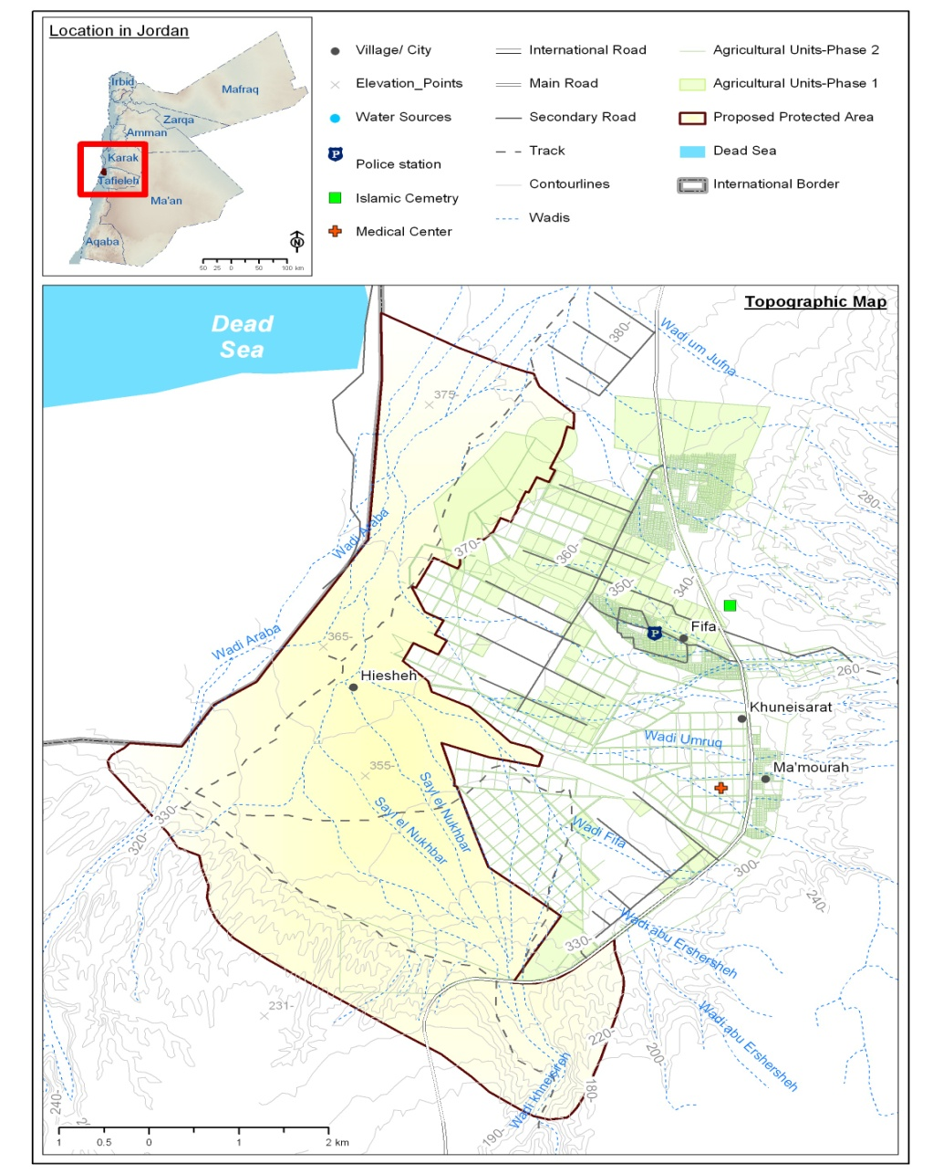
Map (1.1): Location of Fifa Proposed Protected Area and its Boundaries

1.1.3.2 Climate

Fifa climate is characterized by warm winters with a minimum average temperature of 10º Celsius, and a hot summer with a maximum average temperature of 40º Celsius. The annual average precipitation in the area is around six millimeters per year, and the relative humidity average value is around 51%. Information on climate was obtained from Ghor Al-Safi weather station over the period of 1995 and 2005 (Jordan Metrological Department).

1.1.3.3 Bio- geographical Zones at Fifa Protected Area

Jordan has four main bio-geographical zones according to Al-Eisawi 1996; these are: 1) the Mediterranean, 2) Irano-Turanean, 3) Sudanian Penetration and 4) the Saharo- Arabian zones. Fifa is located within the Sudanian penetration bio-geographical zone (Map 1.2), which is characterized by a rainfall ranges between 50-100 mm/year, very hot summer and warm winter temperature ranges from 15 - 45º C. Soil is mostly alluvial, saline, and Hamada. This eco-zone is considered the hottest zone in Jordan.

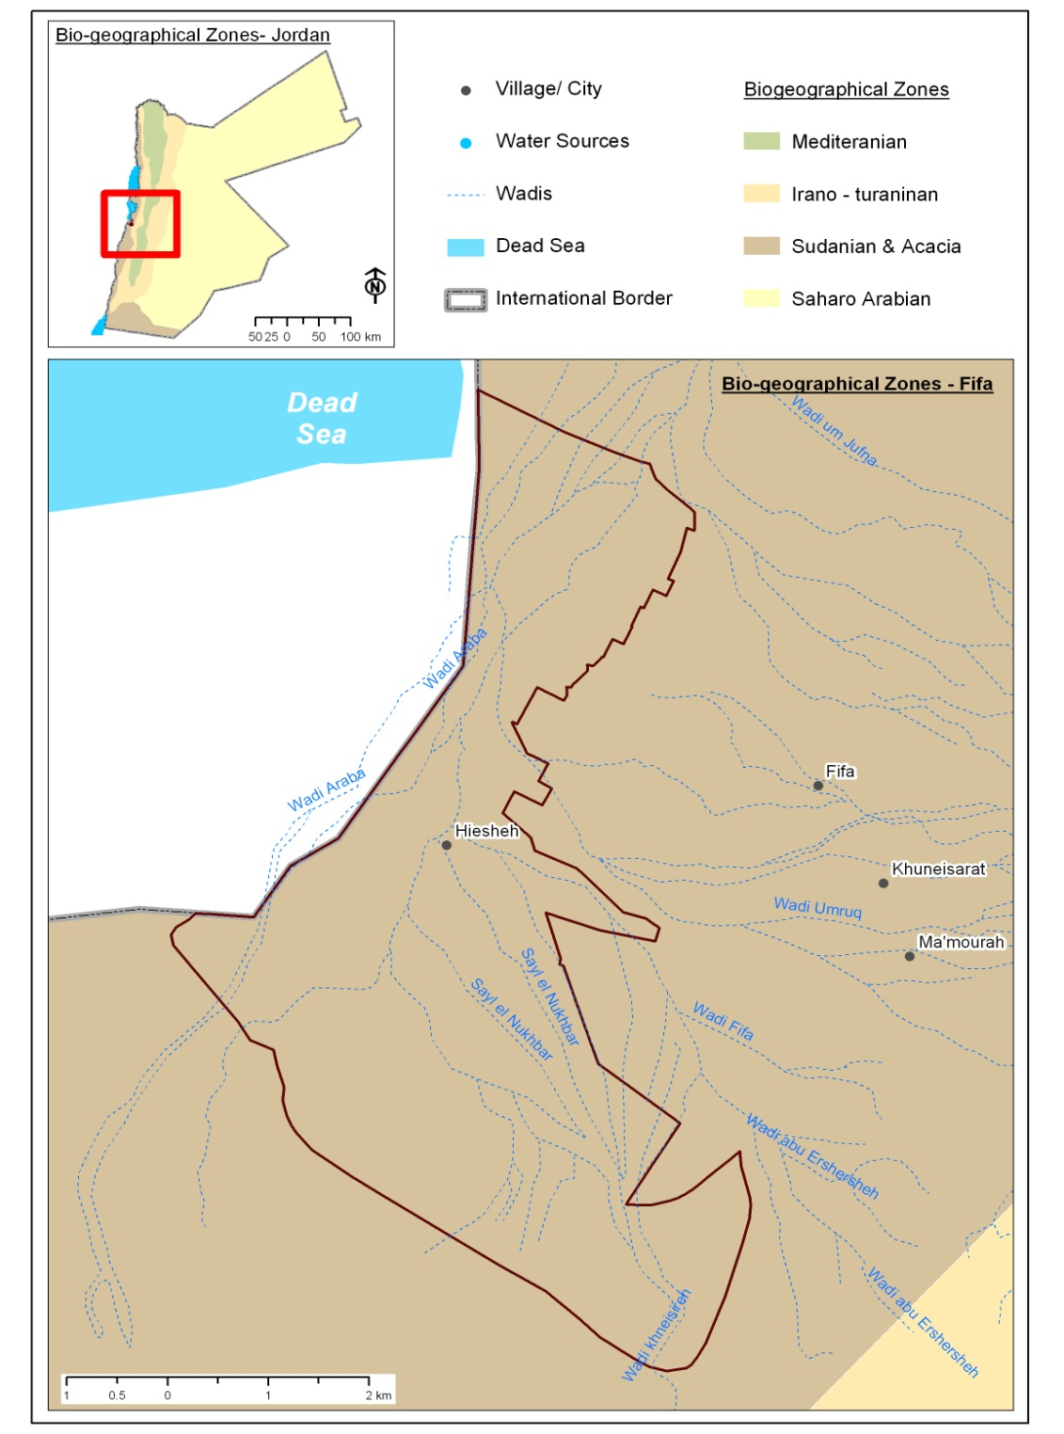
Map 1.2: Location of Fifa within the bio-geographical zone of Jordan

  - Objectives of the survey

The survey has aimed to achieve the following objectives:
- Identify Rodents & Reptiles species inhabiting Fifa proposed protected area and their status.
- Draw a map indicating Rodents & Reptiles distribution in Fifa
- Identify threats on Rodents & Reptiles species in the studied site

  - Survey Team Member

1.3.1 Research Team Member

- Thabit Al Share. B. Sc Degree in Natural Resources /Soil, Water and Environment (2006). Jordan University of Science and Technology. Fauna Researcher. RSCN Headquarter.
- Omar Abed. B. Sc degree in Agricultural Science/Animal science (2007). University of Jordan. Fauna Researcher. RSCN Headquarter.
- Loay Al Azam. B. Sc degree in Agricultural Science/ Plant science (2008). Jordan University of Science and Technology. Researcher at Dibeen Reserve. RSCN.

1.3.2 Geographical Information System “GIS” Team Member

- Natalia Boulad. BSc in Civil Engineering – Major Field/ Environmental Engineering – Minor Field (1999). University of Jordan. GIS officer. RSCN Headquarters
- Yasmine Hageer. M. Sc Degree in Horticulture (2003). Jordan University of science and technology. GIS officer. RSCN Headquarters

1.3.3 Research Coordinator

- Ehab Eid. M. Sc Degree in Conservation, access and management of species in trade (2010). International University of Andalucía. Field Research Coordinator. RSCN Headquarter.

Methods

  - Sherman-traps Method

One of the simplest and most effective traps for small mammals is the Sherman live trap. A total of 193 trapping nights were conducted using Sherman’s live- traps of 23X7X7 cm size as follows: 97 and 96 trapping nights at the Tamarix, Date Palm and Acacia areas respectively (see map 2.1). Traps were fixed late evening and checked at the early morning of the next day see Figure (2.1). Animal caught was identified and then released directly at the same capturing site. Mixture of white oats and peanut butter was used as bait.
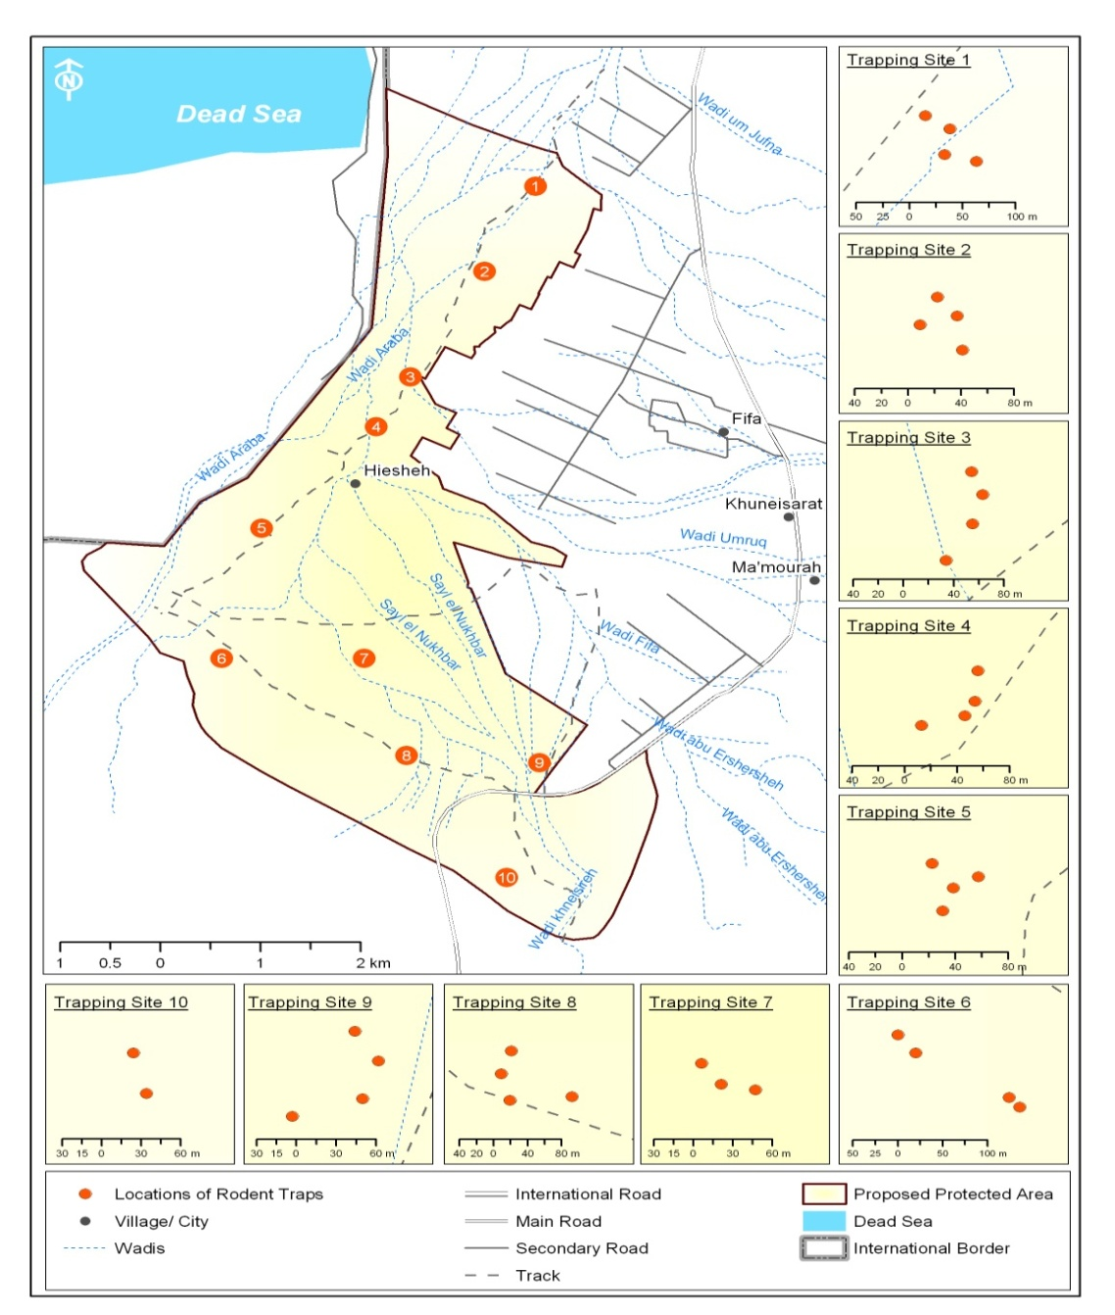
Map (2.1): Sherman Living –Trapping location at Fifa PA.
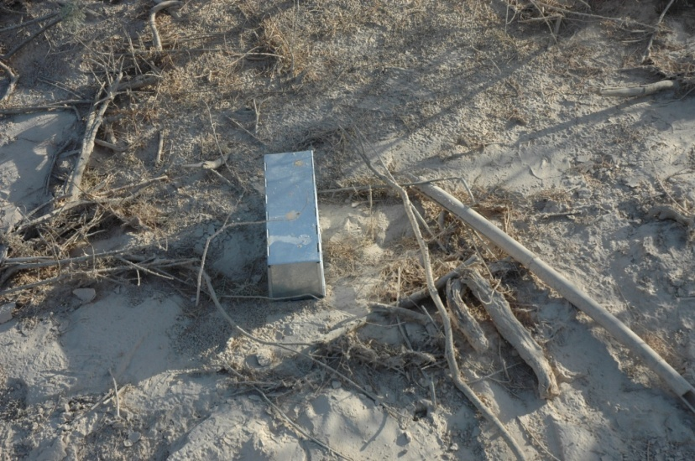

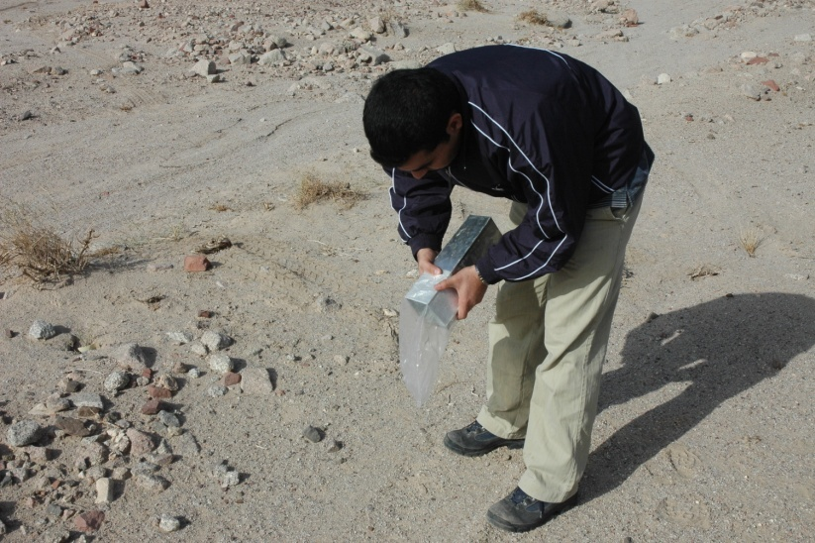

Figure (2.1): Live-Trapping methods were used at Fifa PA.

  - Reptiles Spoor Routes

Two day walking routes were achieved equally at the Tamarix, Acacia and Date palm area respectively see map (2.2). Locations were selected to be at the same site for rodent’s trapping site. Through this method, researchers were walking slowly in the early morning hours, in parallel and recording any presence for reptilian species see figure (2.2).

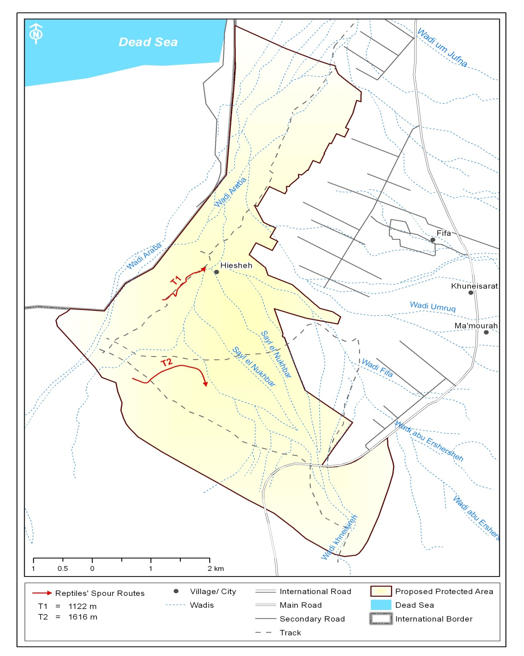
Map (2.2): Spoor Routes located at Fifa PA.

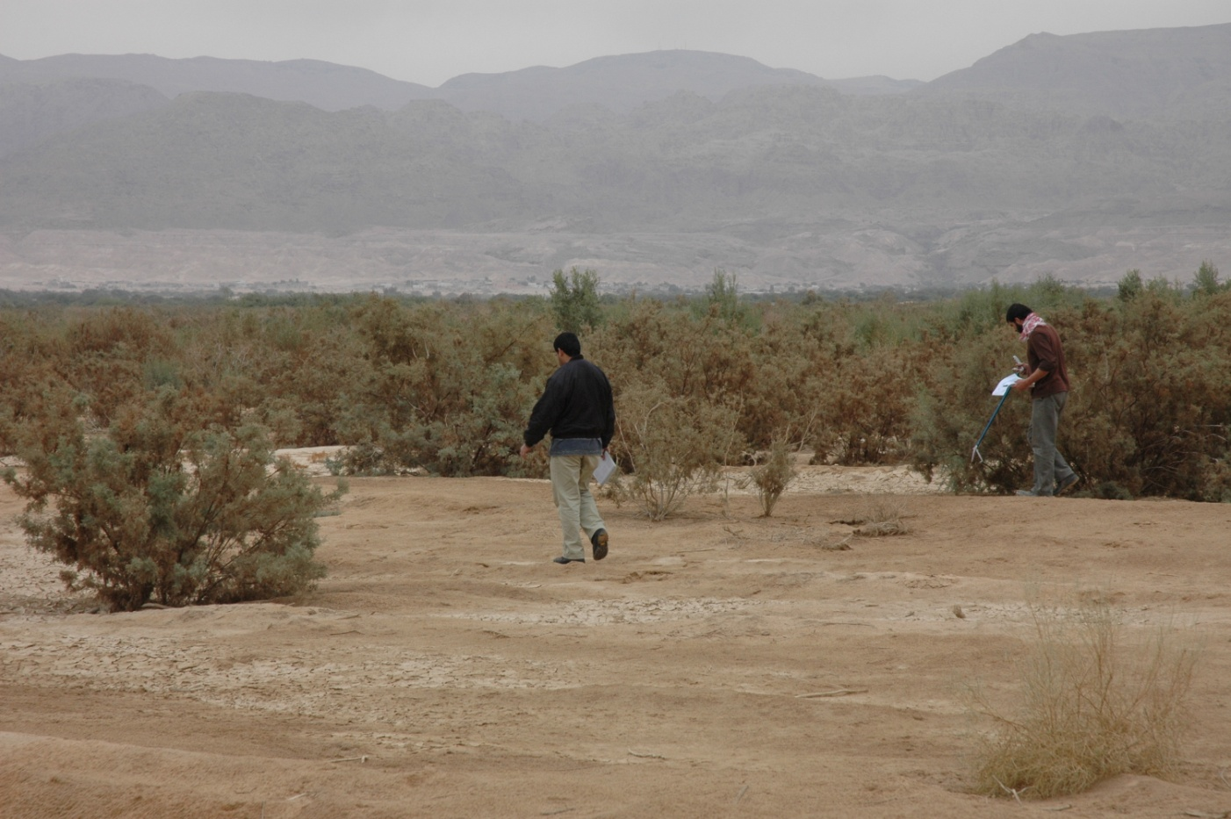
Figure (2.2): shows the Researchers during spoor routs method at Fifa PA.

  - Interviews

During the field visit, ten interviews were done with military. Information were collected on the Rodents and Reptiles species which is inhabited the protected area, their present and past status and threats.

2.4 Opportunity observation

During the survey in the study area, fauna team was recording all opportunistic records for reptiles, amphibians and Rodents dens. Time of sighting, location and number were recorded.

- Results

3-1 Sherman-traps Method

Four Rodents species belong to two families inhabiting in Fifa proposed protected area see map (3.1). Apparently. The Gerbillus dasyurus was the most common and distributed species, followed by Gerbillus nanus, Acomys cahirinus and mus musculus. The following table 3.1 below illustrates them with number of trapping.

Table 3:1 shows the results of Reptiles species with number of trapping
Scientific Name | Common Name | Trapping #

Tamarix and Acacia vegetation area

Gerbillus dasyurus | Wagners gerbil | 30
Gerbillus nanus | Baluchistan gerbil | 1

Date Palm vegetation area

Acomys cahirinus | Cairo Spiny Mouse | 3
mus musculus | House mouse | 1

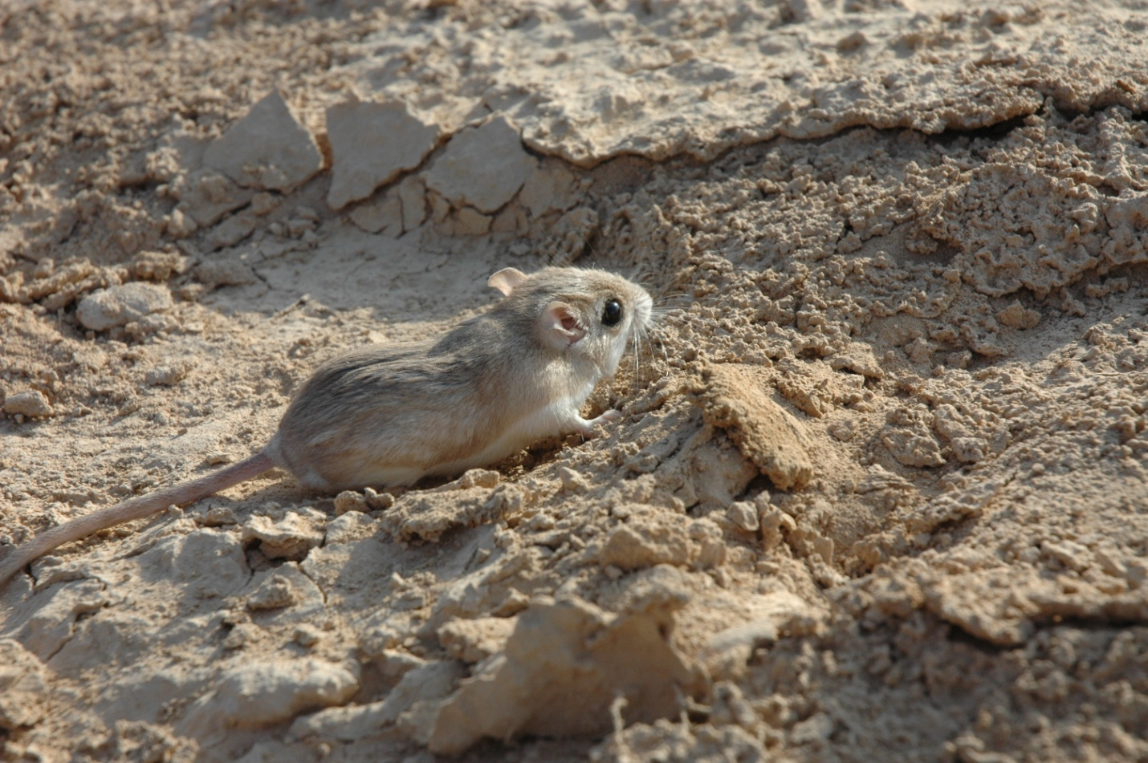
Figure (3.1): Shows results of live traps at Fifa PA.

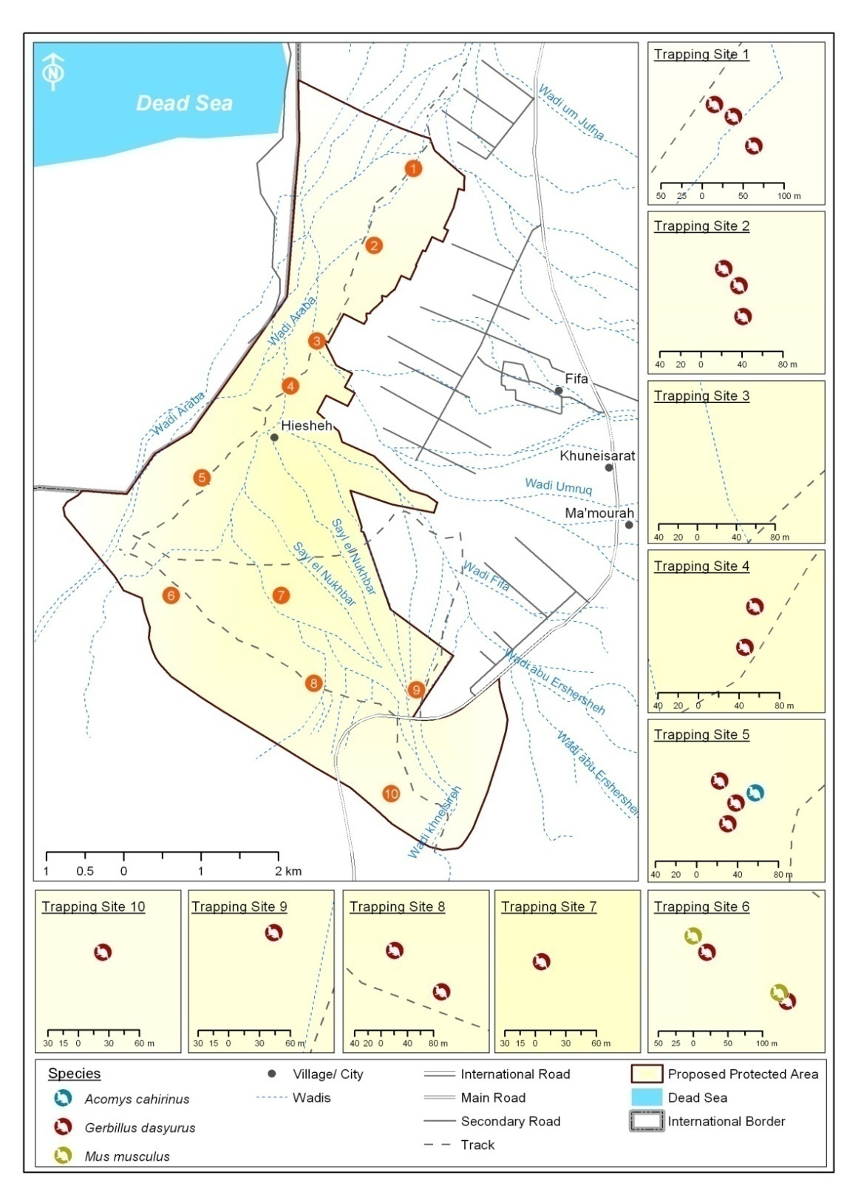
Map 3.1: Results of Sherman Live-trapping Locations in Fifa

3.2 Reptiles Spoor Routes

Two spoor routs were achieved during the baseline survey the first one was achieved in the Tamarix, Acacia area and the second one was in the Date palm area see map (3.2) , no record to any reptiles species during the survey just the team was recorded some of holds to Uromastyx aegyptia as figure(3.2) shows .

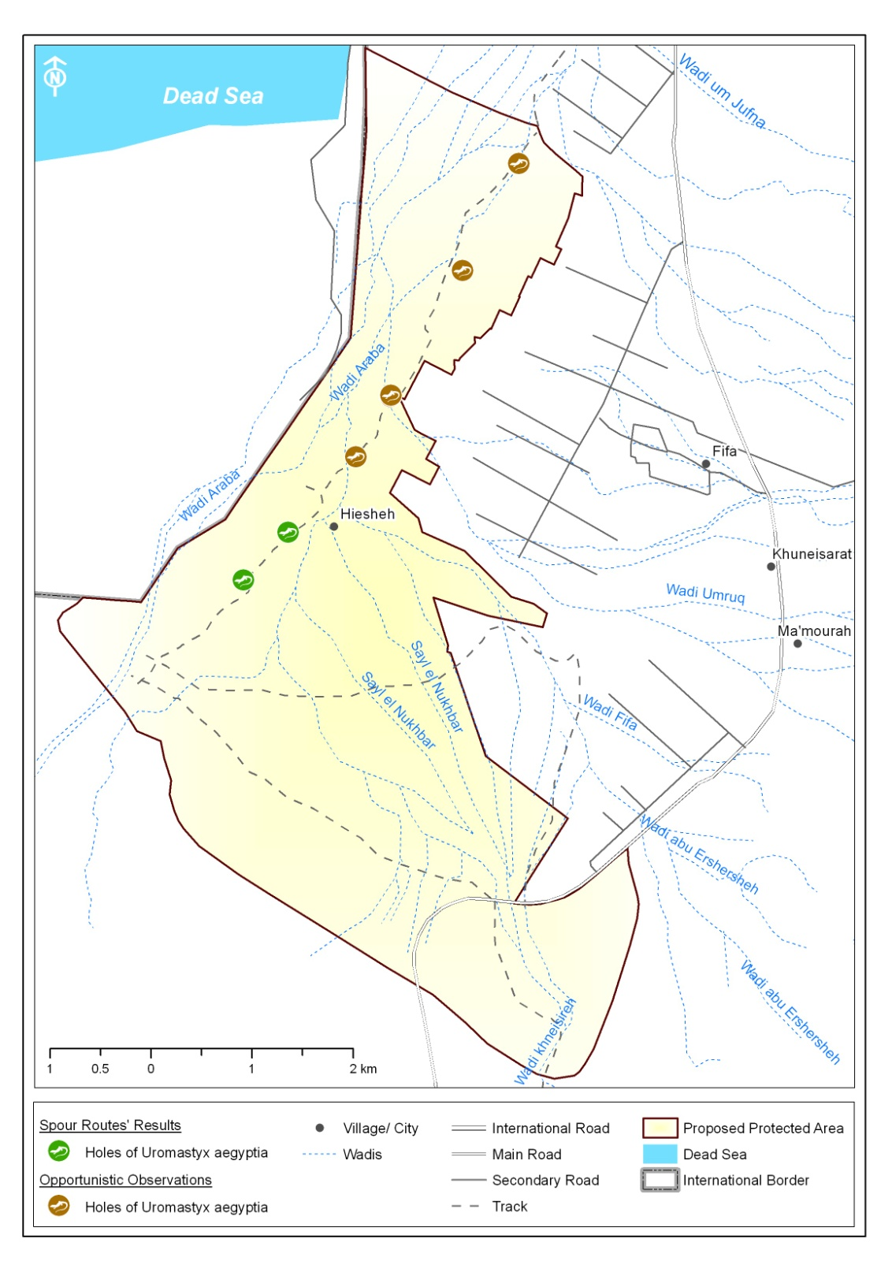
Map (3.2): Results of Reptiles Spoor Routes Locations in Fifa

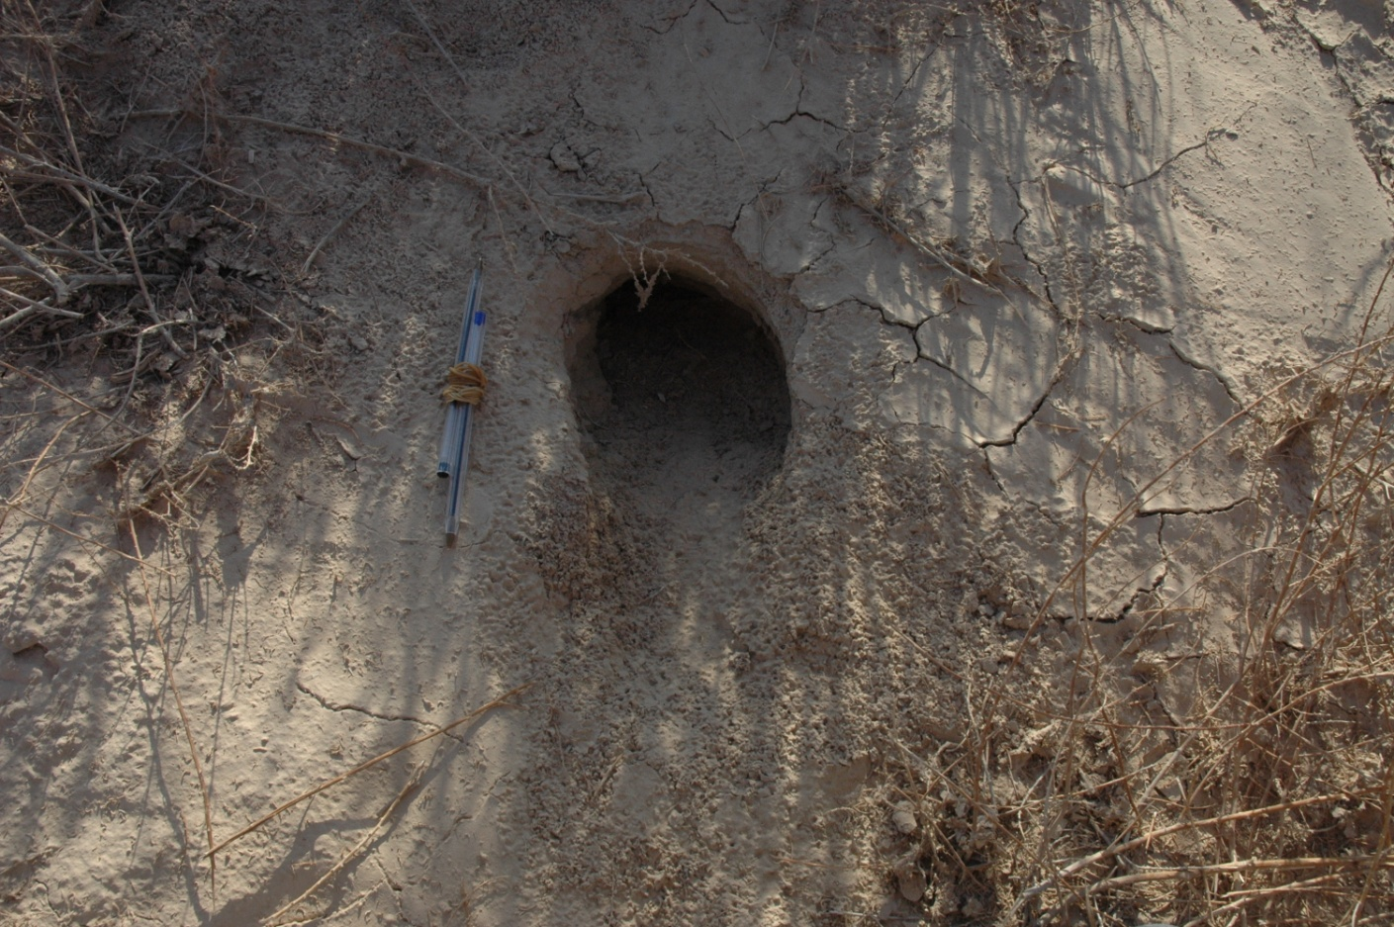

Figure 3.1: Shows some hole for the Uromastyx aegyptia at Fifa PA

3.3 Interviews

Ten interviews were achieved with military during the survey at Fifa proposed protected area .the interviews focused on the Rodents and Reptiles small mammals species, the results of the interviews shows two species of rodents belong to two families, Apparently; Hystrix indica,and Spalax leucodon. Concerning to the reptile’s species the team were recorded seven species of reptiles belong to three families. Apparently;Uromastyx aegyptia, Coluber rogersi,Coluber nummifer, Coluber rhodorachis, Eirenis Coronella, Spalerosophis diadema and Echis coloratus.

3.4 Opportunity observation

Opportunistic records of nesting areas of the Egyptian spiny-tailed lizard; Uromastyx aegyptia.was observed, as well as burrows for rodent’s species. Moreover, a spine belongs to the Indian crested porcupine; Hystrix indica was found.map (3.4) shows the results of the opportunistic observation at Fifa PA.
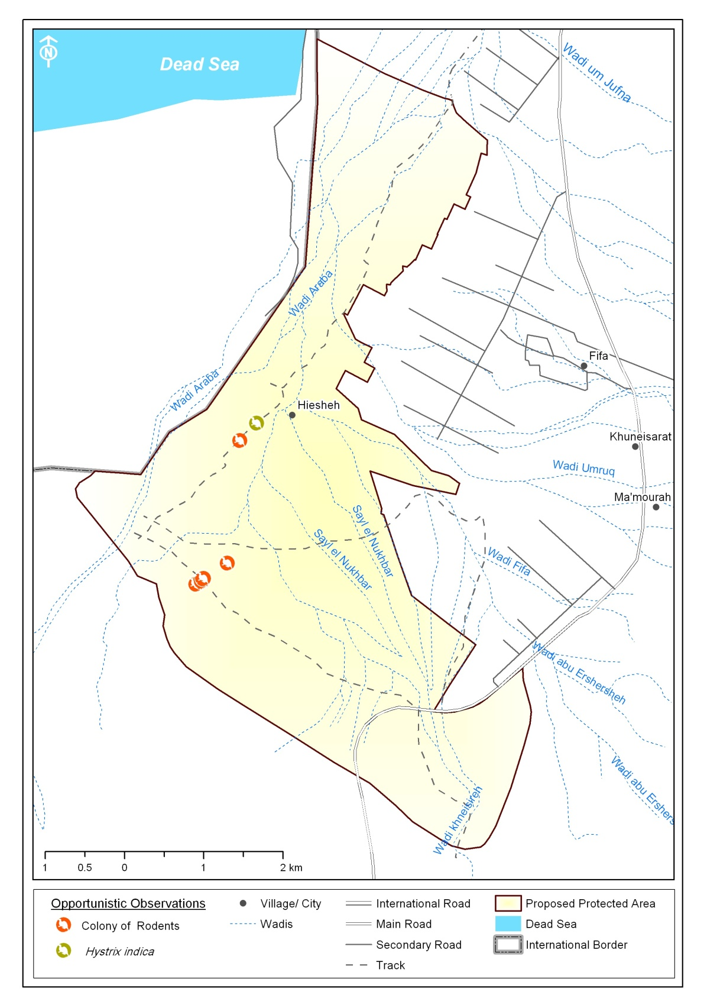
Map m3.4: Shows the results of Opportunistic Observation location at Fifa PA.

- Discussion

The Rodents of Jordan consist of seven families with total of 28 species recorded so far (Amr, 2000). Concerning to the reptile’s of Jordan there are 98 species classified as follows: 56 Lizards species, 37 snake’s species and 5 turtle’s species. The current survey showed that Fifa hold four Rodents species and seven Reptiles species. These results show that the protected area is not abundant by wildlife species and if the situation continues, the biodiversity of the site will be getting worse. This is an indication to the failure of the site to be a nature reserve.

Since Fifa is a boundary proposed protected area with the occupied Palestinian territory, it was protected by army since 1948 with the presence of two army battalions. One of this battalion is located inside the protected area with several monitoring towers distributed along the western part of Fifa and separating the prohibited zone from the intensive inspection areas (Map 1.3). This situation add further constrains to the current survey as it limited the survey size area and the time available to perform different methods. In addition, it was difficult to perform other methodologies which are used for surveying nocturnal method. This in consequence adds more biases to the survey results.

Threats on Rodents and Reptiles species in Fifa are represented by the following:
- Habitat degradation by agricultural expansion and fragmentation: the eastern part of Fifa is entirely changed into agricultural areas. and poisoning by using chemical pesticide
- Off-road presence: the presence of a network of dirt roads in Fifa affects habitats and continuously used by army four wheel drive

- Recommendations

- A memorandum of understanding with army should be established and the need to surveying nocturnal carnivores species should be addressed to facilitate work and find out the exact status of these species
- Awareness programs on the negative effects of using chemical pesticides on wild fauna should be implemented and targeted local farmers and army personnel. In addition, presentation on wildlife and biodiversity of Jordan should be implemented and targeting army personnel in Fifa.

- References

- Amr, Z. S., Kalishaw, G., Yousef, M., Chilcot, B, J & Al- Budari, A. 1996. Carnivores of Dana Nature Reserve (Carnivora: Canidae, Hyaenidae and Felidae), Jordan. Zoology in the Middle East, 13:5-16.
- Amr, Z.S. 2000. Jordan Country Study on Biological Diversity: Mammals of Jordan. United Nations Environment Program, Amman.
- Harrison, D. and Bates, P.J. 1991. The Mammals of Arabia. Harrison Zoological Museum Publications. Kent.
- Qumsiyeh, M. B. 1996. Mammals of the Holy Land. Texas Tech University Press. Lubbock.

