The Hashemite Kingdom of Jordan

The Royal Society for the Conservation of Nature
Fifa Protected Area

Nubian Nightjar Caprimulgus nubicus Survey
April - May 2014

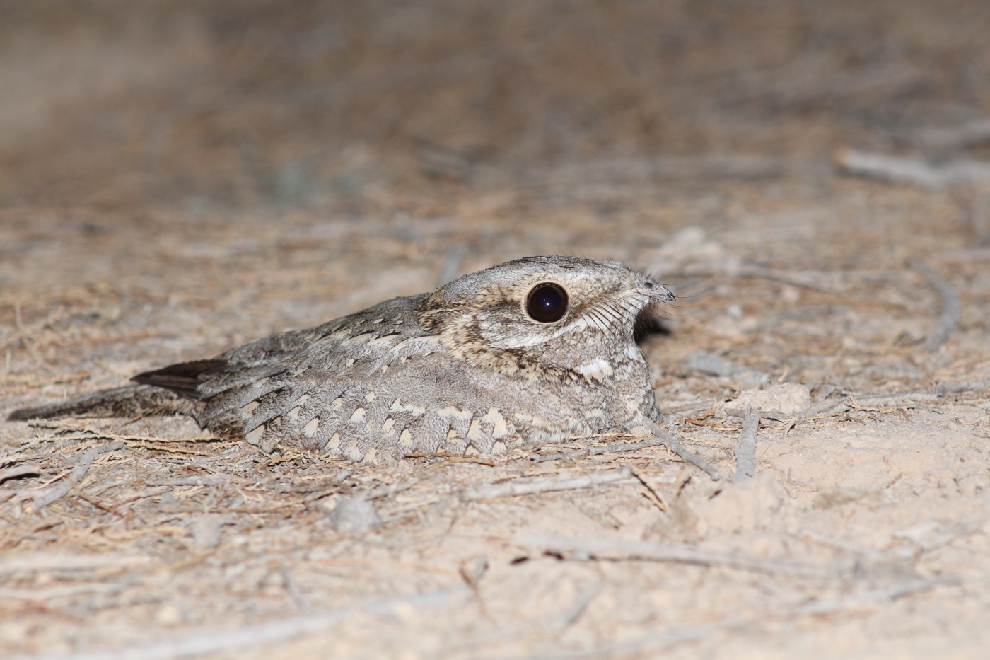

Report prepared by Tareq Qaneer

الملخص العربي

جاءت هذه الدراسة إستجابه لتوصيات دراسة الطيور الأساسيه في محمية فيفا بإجراء دراسة للتحقق من حالة السبد النوبي في المحمية نتيجه لتوفر الموئل المناسب لهذا الطائر في المحمية، كما جاءت استجابة لجهود الجمعية الملكية لحماية الطبيعة في بناء قاعدة بيانات شاملة للتنوع الحيوي في الأردن تضمن توفير معلومات شامله للأنواع تساهم في فهم حالة الأنواع والعمل على حمايتها ضمن خطط عمل وطنية.

يعتبر السبد النوبي طائر ليلي، وهو من الأنواع المهدده في الأردن وفلسطين نتيجه لتدمير الموائل، تم تسجيل السبد النوبي في الأردن ضمن مناطق توزيع شجر الطرفا في مناطق السبخات الملحيه من البحر الميت وحتى العقبه ووادي فيدان وطاسان، ونتيجه لتدمير الموائل أصبحت محمية فيفا والغور الصافي هي الموئل الوحيد للسبد النوبي في الأردن.

هدفت الدراسة الى توفير معلومات كافيه عن حالة السبد النوبي في محمية فيفا تضمن تأسيس برنامج مراقبة منتظم يقيس كفاءة الإدارة في حماية الأنواع والموائل. وقد تم خلال الدراسه تسجيل 52 ذكر ينادي للتزاوج كسلوك ايجابي لوجود التزاوج، وهو الرقم الأكبر في المنطقه والذي يجعل من محمية فيفا الموئل الأهم لطائر السبد النوبي في الأردن و الشرق الأوسط.

وأخيراً، تناولت الدراسه المهددات على طائر السبد النوبي في محمية فيفا، حيث أوصت الدراسه بتطوير برنامج مراقبه للسبد النوبي يتضمن مراقبة الموئل وحجم المجتمع في منطقة فيفا والصافي، كما اشارت التوصيات الى أهمية إيجاد بديل عضوي للإستخدامات الزراعية التقليديه حول المحمية التي تستنفذ المصادر المائيه وتستخدم المبيدات الكيميائيه، اضافه الى ذلك أوصت الدراسه بزيادة الوعي بأهمية هذا النوع المهدد اضافه الى أهمية محمية فيفا كموئل مهم ووحيد في المنطقه لهذا النوع عن طريق إيجاد برامج تعليميه متخصصه للمدارس واستخدام المنشورات التوضيحيه.

Summary

The Nubian Nightjar Caprimulgus nubicus is the smallest Nightjar in the Middle East; the species is relatively widespread in the arid part of eastern Africa, though recorded as uncommon. In the Middle East it is much scarcer, with localized populations along the Rift Valley from Palestine in the north to the Red Sea coast of the southern Arabian Peninsula.
The general distribution of the species was known to be along the southern rift valley from the Dead Sea south to Aqaba. The Nubian Nightjar inhabits areas which include patches of salt marsh which they use for roosting and breeding, and forage mainly in open habitats, including agricultural fields.
Based on recommendations of the bird baseline of Fifa Protected Area to investigate the status of Nubian Nightjar in the reserve and considered this species as an indicator species of Fifa Protected Area, a detailed survey was carried out specifically to understand the status of Nubian Nightjar in and around Fifa Protected Area. Specific objectives are:
- Provide baseline data on the status of Nubian Nightjar in and around the reserve including distribution map, and population size estimation that will establish baseline information against future changes in species numbers and distribution.
- Assess the ecological and conservation importance of species and identify key areas.
- Provide future recommendations for conservation and reserve management.

A total of 52 calling males illustrating a positive presence of a nesting behavior were recorded. All the males found to be involved in territorial activity in breeding season. According to the results it was clearly recognized that Fifa area holds the largest population of Nubian Nightjar in Jordan and in the region. Recommendations were to develop a monitoring program at the reserve, and involve further research on habitat, ecology, population size in Fifa and Safi area. Other recommendations were made for management focusing on taking needed actions to promote an alternative organic farming system of traditional farming in surrounding area of Fifa, protect the foraging sites and raising the awareness of the importance of this endangered species and the importance of Fifa Protected Area for the species.

Acknowledgement

The team would like to express their gratitude to Nashat Hamidan (Head of the Research and Survey Section), for his understanding, assistant in the field work, his support to make this work achievable and for his valuable knowledge and advice during the report writing of this survey.
Also we are deeply thanks to Jerome dubos, for his helped with the survey and assistant in the field work a great photos were taken for the Nubian Nightjar. Thankfulness is extended to the Jordanian army and specifically the soldiers in Fifa area, for their high collaboration in order to facilitate the work at the night in the sensitive military area.
Finally, we will not forget our exceptional GIS team, represented by Ms. Natalia Boulad and Ms. Mayyada Naghaway, for their efforts in preparing all required maps, which indeed assisted the research team before, during and after the survey.

Table of Contents

1. Introduction 7
1.1. Overview 7
1.2. Natural History 8
1.3. Site Description 9
1.4. Team Members 12
2. Methods 13
3. Results 15
4. Discussion 16
5. Recommendations 20
6. Reference 21
7. Appendics 23
7.1. Appendix 1 23

- Introduction
  - Overview
The Jordanian countryside and its wildlife communities is significant due to a variety of reasons including the location of country which is at the meeting point of three different faunal elements: the African, Oriental and Palaearctic (RSCN, 2013). In addition, the geological changes that have happened in the past have resulted in the formation of very different ecological regions which support the presence of different habitats and micro-habitats. Furthermore, bird diversity is increased because Jordan is on major migration routes that connect Europe and Asia with the African continent (Newton, 2008). A total of 434 species belonging to 66 families, have been recorded in Jordan (RSCN 2013), as well as numerous specialized bird of regional importance. One of them is the Nubian Nightjar Caprimulgus nubicus.
The Nubian Nightjar is the smallest Nightjar in the Middle East; the species is relatively widespread in the arid part of eastern Africa, though recorded as uncommon Perlman (2008). In the Middle East it is much scarcer, with localized populations along the Rift Valley from Palestine in the north to the Red Sea coast of the southern Arabian Peninsula (Cleere 1999, Holyoak 2001).
This species is least concern under the IUCN criteria (IUCN Red List 2011), but it's critically endangered in Occupied Palestine, mainly due to habitat destruction, and it is currently found only south the Dead Sea (Alon & Mayrose 2003). As a result, Nubian Nightjar numbers in the occupied Palestine have dropped dramatically.
In Jordan, the general distribution of the species was known to be along the southern rift valley from the Dead Sea south to Aqaba (Andrews, 1994). A study was conducted by Perlman (2008) showed that the Nubian Nightjar inhabits areas which include patches of salt marsh which they use for roosting and breeding, and forage mainly in open habitats, including agricultural fields.
However, the knowledge about the distribution and local densities of many bird species inhabiting the rift valley in Jordan is still need more investigation, one of the most inconspicuous of these species is the Nubian Nightjar. The status of the population of Nubian Nightjar in Jordan is unclear. Even though there are only three documented records of Nubian Nightjar in Jordan from Wadi Fidan and Tassan spring (Holyoak, 2001) which are currently being degraded by agricultural expansion. Pettersson (2011) reported five calling Nubian Nightjar in one point in Fifa protected areas, and Qaneer et.al, (2012) confirmed Nubian Nightjar in Fifa by recording four calling birds in Fifa protected area. In addition, previous studies in adjacent localities in the Occupied Palestine confirmed the presence of the Nubian Nightjar where a total of 21 individuals were counted and expected this population is a small population of a larger population in Jordanian side (Fifa-Safi area) (Perlman, 2008).
The difficulty in recording this species is the result of its nocturnal habits and its distribution along the rift valley mainly in military zones that require special permits. Based on the recommendations of the bird baseline of Fifa Protected area to investigate the status of Nubian Nightjar in the reserve and considered this species as the indicator species. A baseline survey establish for periodic based monitoring program urgently needed for this species to measure the conservation effectiveness at the reserve. The main objective of the survey is to understand the status of Nubian Nightjar in and around Fifa Protected Area. Specific objectives are:
- Provide baseline data on the status of Nubian Nightjar in and around the reserve including distribution map, and population size estimation that will establish baseline information against future changes in species numbers and distribution.
- Assess the ecological and conservation importance of species and identify key areas.
- Provide future recommendations for conservation and reserve management.

  - Natural History
The Nubian Nightjars in Jordan appear to be resident (Andrews, 1994). Perlman (2008) noted that the Nubian Nightjar in Occupied Palestine is resident and not summer visitor as what Shirihai 1996 noted. The Nubian Nightjar responded strongly to the lunar cycle. On nights with a full moon, with high nocturnal light intensity levels, the Nubian Nightjar foraged through most of the night. On dark nights with no moon, the Nubian Nightjar foraged only during the twilight of dusk and dawn (Perlman 2008).
The breeding cycle of the Nubian Nightjar began in early March, when the birds became very vocal and apparently strictly maintained their territories (Holyoak 2001). It was always linked t period of full moon (Perlman 2008).

  - Site Description
Fifa Area is located at the southern end of the Dead Sea along the western border of Jordan in a military zone; it is located around 100 km south of the capital city Amman and 17 km north-west of Tafila city. It lies mostly within the Karak Governate with a smaller portion within Tafilla Governate (See Map1). It is situated to the west of Fifa village, and the reserve area is named according to Ghour Fifa. Fifa Protected Area is centered between Wadi Um Jufna in the north and Wadi Dahel in the south. The elevation is -421m below sea level.

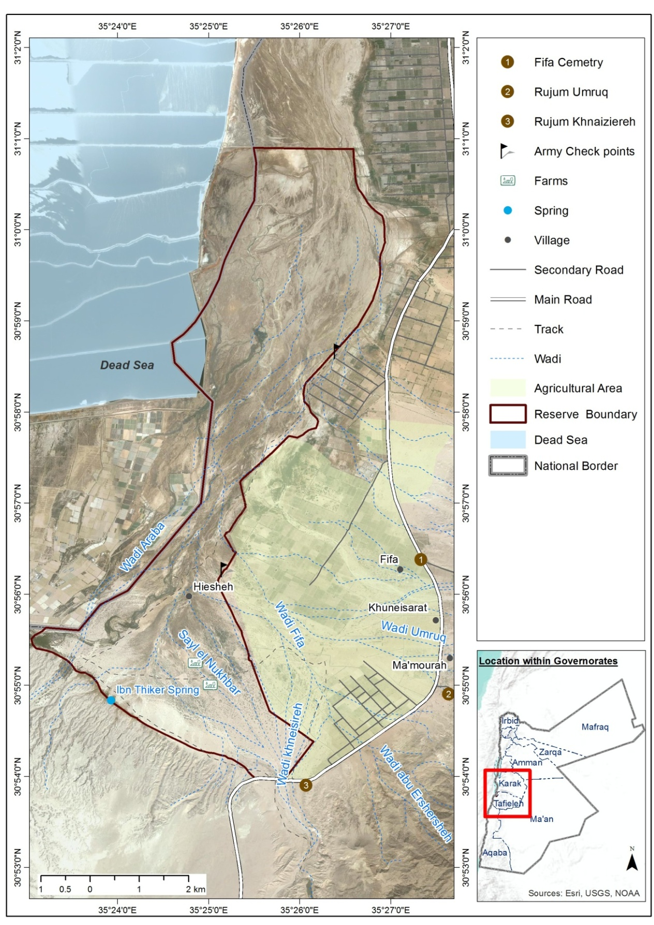

Map 1: Fifa Protected Area boundary and its location in Jordan
Fifa Protected Area is one of the 391 sites identified for their importance for birds in the Middle East. As well, it was considered as an important natural habitat for wildlife species in Jordan after the RSCN review at 1998; because it represents two natural vegetation types; the saline vegetation, and tropical vegetation type, which is not well represented in the established reserves and constitute about 1.46% of the total size area of all natural reserves in Jordan.
Fifa PA holds high ecological value and species diversity, as it holds the presence of at least seven nationally threatened plant species, that have a conservation importance, such as Toothbrush Tree Salvadora persica, Maru Maerua crassifolia, Giant reed Arundo donax, Shittim Acacia tortilis, Sea-blight Suaeda monoica, Date palm; Phoenix dactylifera, Acacia; Acacia raddianna and Short pricklegrass; Crypsis schoenoides (RSCN, 2011)
In addition, there are two vegetation communities in Fifa Protected area, distributed according to altitude. In the lower elevations, Tamarisk is dominant there are pure stands and some mixed with Nitraria this extends over the majority of the area. In the upper elevations, the Acacia succeeds as the dominant species (RSCN, 2011).

  - Team Members
- Pete Ellis, RSPB Northern Isles Manager, RSPB Shetland Office, Virkie, Shetland, ZE3 9JN.
- Tareq Qaneer. B.Sc degree in Agricultural Science/Animal science (2008). University of Jordan. Avifauna Researcher – RSCN Headquarter.
- Ibrahim Mahasneh, Reserve Manager, RSCN Fifa Protected Area, Jordan.

- Methods
As described by Perlman (2008), the Nubian Nightjar activity is closely linked to the lunar cycle, the survey was carried out in the full moon time of April and May 2014. Since the full moon confined to three days in the month the survey was carried out in two field visits. The first field visit started 14 to 16 April, and the second visit was in 15-16 May.
A single method was used in the survey that the spot counts because it is the most suitable method to survey birds in dense woodlands (Bibby et al 2000). A total of 37 spot counts have been carried out in the reserve (Appendix 1) that covered all area hold Nubian Nightjar habitat (tamarisk salt-marsh). As the study area is represented by two major vegetation type (the saline vegetation, and tropical) and due to the fact that Fifa is located in military area, the spot counts selected based on accessibility and suitability to represent the vegetation types (map 2). Also, based on recommendations from Pettersson (2011), two spot counts selected north the reserve holds an almost similarly area of tamarisk salt-marsh.
Counts were performed within the period of one hour after dusk until one hour before dawn for 10 -12 minutes. The Nubian Nightjar were identified either vocally, using their males distinctive calls and very vocal nature during the breeding season, or through the direct eye contact.
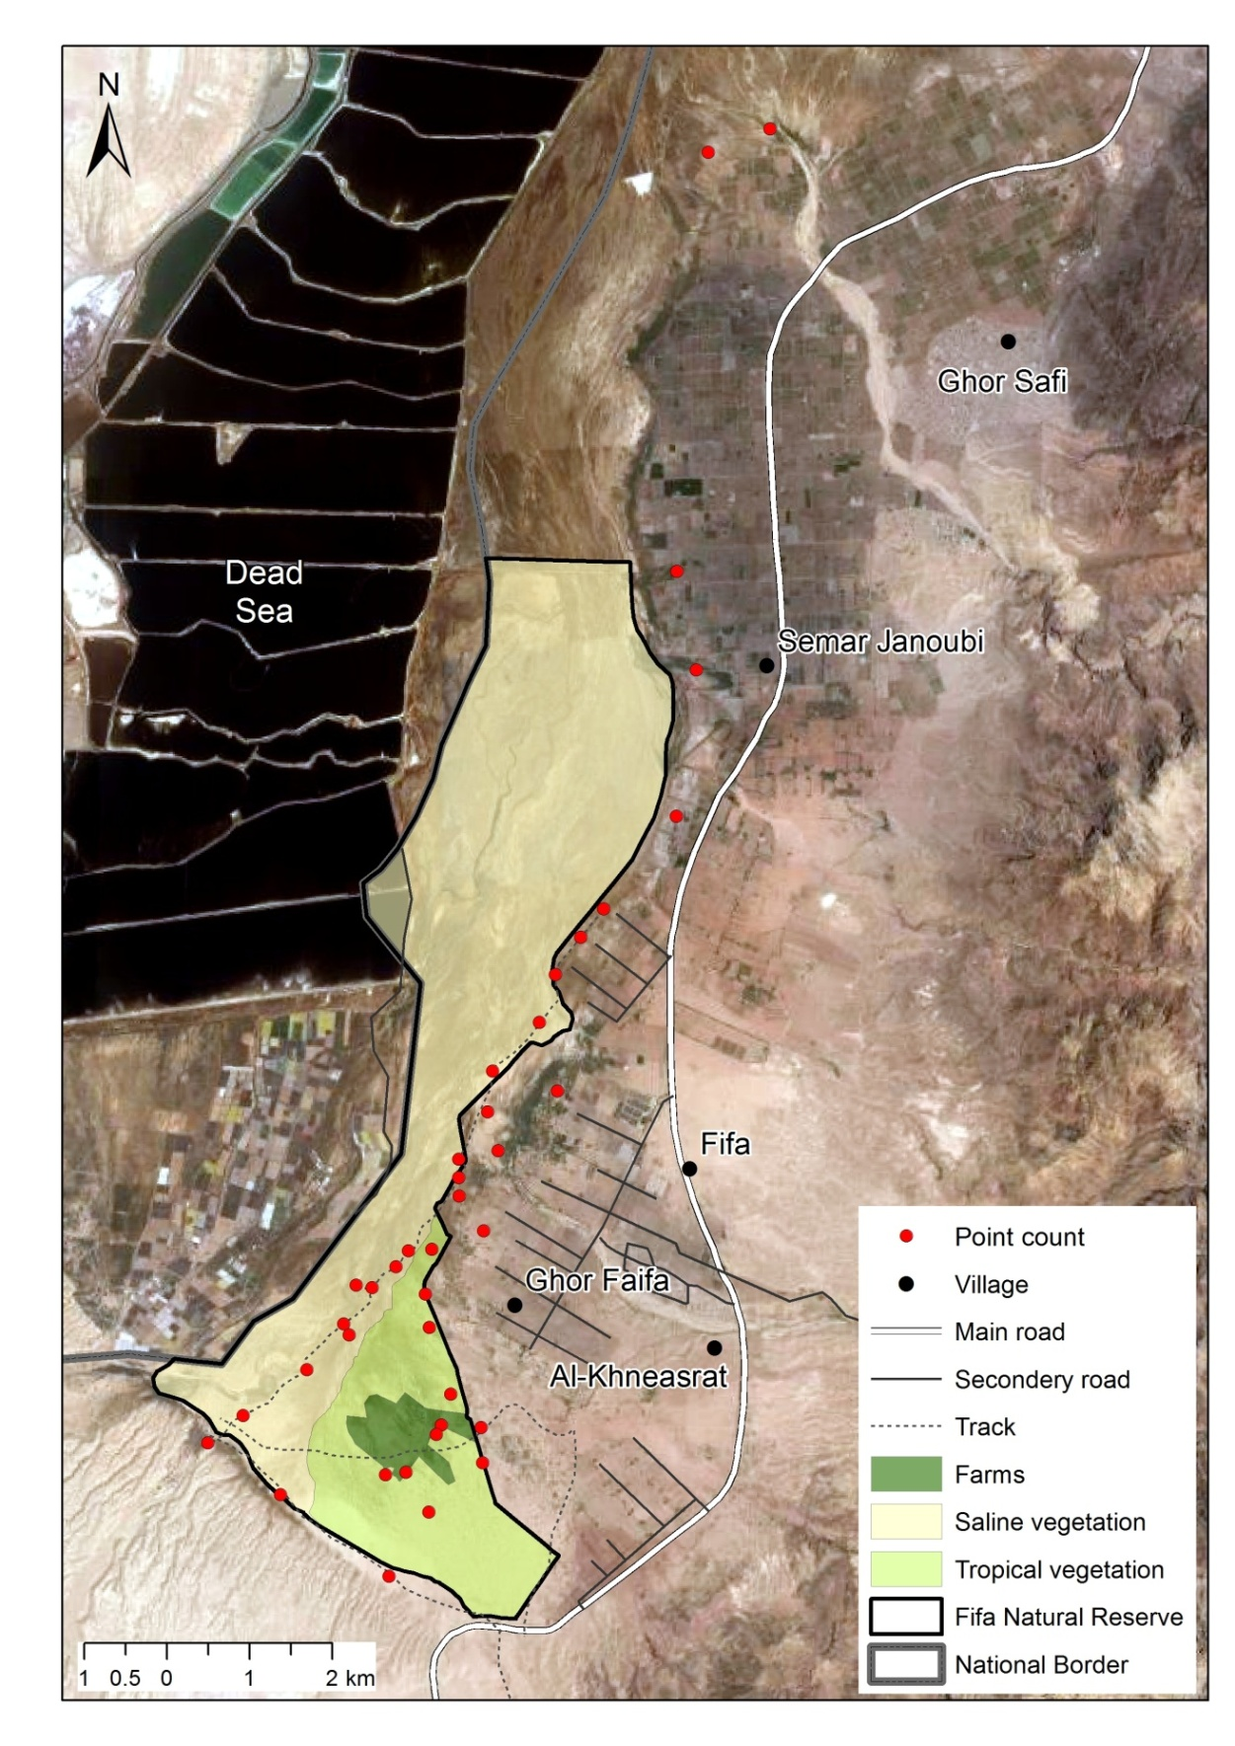

Map 2: Study area and survey Spot counts

- Results
A total of 52 calling males illustrating a positive presence of nesting behavior were recorded (map 3). All the males found to be involved in territorial activity. The Nubian Nightjar was found to be distributed in the saline and tropical vegetation with dense salt marsh at the southern part of the reserve. The number of individuals varied with the sites in the range 1-5 (map 3), it was in average of 2.3 individuals, the highest in the area near the agricultural fields, and the lowest was in the area with low density of tamarisk out of agricultural field.

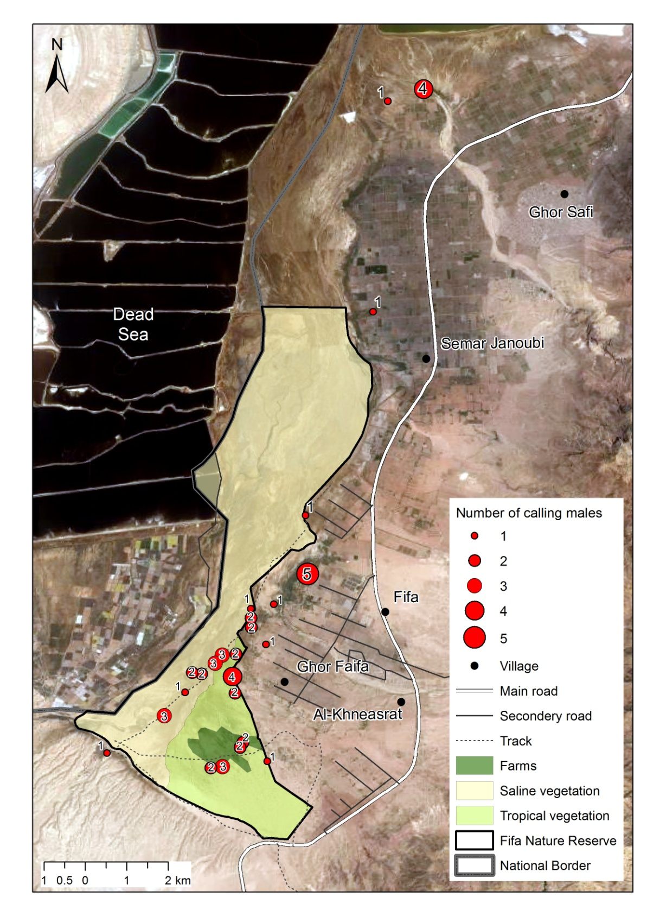

Map 3: Results of Nubian Nightjar counts in Fifa Protected Area, notice the largest records in the area nearby of the agricultural fields

- Discussion
The Nubian Nightjar in the region requires heterogeneous habitats, with dense salt marsh patches of at least 50 ha for breeding and roosting, and adjacent open areas for foraging especially near water sources (Perlman, 2008). These appropriate habitats are extensive and healthy (RSCN, 2013) in Fifa which it making Fifa reserve one of most important healthy sites for Nubian Nightjar in Jordan. The status of Nubian Nightjar in Jordan unclear and this survey has contributed in identifying the status of Nubian Nightjar in Jordan.
Shirihai (1996) indicated that the population of the Nubian Nightjar in the region declining greatly in recent decades, and is threatened, it is regarded as critically endangered, and the main cause for this decrease is presumably habitat loss due to agricultural development. However In this study, we recorded 52 territory calling male of Nubian Nightjar, this is a distinguished increase compared to four calling male found by Qaneer (2011), but this is a result of the more hours were spent in this survey in the field searching for Nubian Nightjar, moreover to cover more areas were needed a special permit.
Perlman (2008) recorded 21 territorial Nubian Nightjar in only area for Nubian Nightjar in Occupied Palestine were it is located directly against Fifa (Map 4). This study confirmed Perlman (2008) suggestion and stressed on Fifa and As Safi population as largest population in the region. Accordingly, it was clearly recognized that Fifa area holds the presence of densest population of Nubian Nightjar in Jordan and in the region.
In Occupied Palestine, Perlman (2008) stated that merely small patches of Nubian Nightjar habitats have survived, but according to (map 4) in Jordanian side (Fifa area) this habitats is vast and occurs by a magnitude of 24 km². Otherwise in Occupied Palestine the area of Nubian Nightjar are represented by 18 km² of degraded area by agricultural development altered the ecosystem structure, creating a mosaic of agricultural fields, most covered by plastic greenhouses; only small, isolated patches of natural scrub remaining (Alon and Mayrose, 2003).
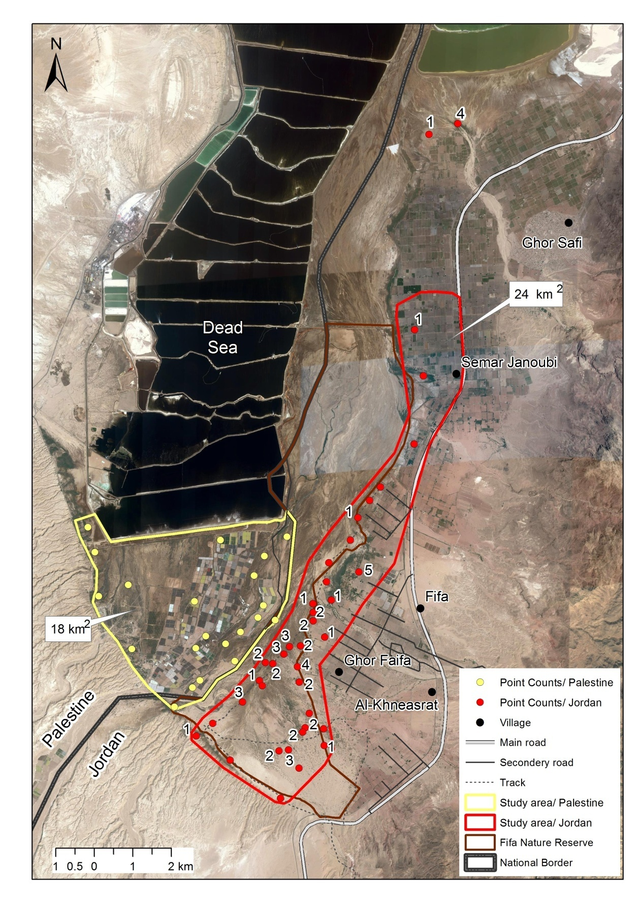

Map 4: Territories of Nubian Nightjars in Fifa and the Kikar Sdom (Occupied Palestine) region. The black line marks the approximate border between Occupied Palestine and Jordan.
This suggested that the population of Nubian Nightjar in Fifa is due to the presence of the suitable habitats for breeding, roosting and foraging. Otherwise in Occupied Palestine Perlman (2008) noted that the main reasons for the decline of Nubian Nightjar is for the loss of breeding and foraging habitats and the excessive use of the natural water source for agriculture.
Holyoak (2001) reported that the nightjars preferred foraging in agricultural fields compared to their relative distribution in the total area of their home range. Meanwhile, the results of current survey have revealed that the distribution of Nubian Nightjar is related to existence of fairly agricultural areas where they can easily forage in agricultural fields.
On the other hand, Holyoak (2001) stated that Nubian Nightjar is highly dependent on noctuid and other small or medium-sized moths for food. Consequently, there are great risks to nightjar populations created by the systematic use of pesticides and herbicides in the agriculture areas in Fifa that prevent the development of a diverse fauna. The risk for secondary poisoning of Nubian Nightjar through moths seems rather low, as nightjars apparently forage almost exclusively on the wing (Cleere, 1999; Holyoak, 2001). Therefore, a reduction in the use of pesticides and herbicides nearby potential nightjar habitats is necessary.
The presence of the Nubian Nightjar, raised the conservation value of the Fifa Protected Area as a refuge for this threatened species in the region. From the results, it is evident that the protection of the substantial areas of salt marsh habitats in Fifa and As Safi area are important for the survival of the species in Jordan and region. This habitat is the best for breeding and roosting, and its destruction will lead to smaller potential breeding and roosting habitat for the Nubian Nightjar.
This survey proved that the area of Fifa is one of important if not the most important sites for the Nubian Nightjar in the Western Palaearctic, and of international importance for the conservation of this northernmost and isolated population (Snow and Perrins, 1998).

- Recommendations

- Develop a monitoring program to collect all records about the Nubian Nightjar in Jordan. Monitoring should involve further research on habitat, ecology, population size in Fifa and Safi area.
- Promote an alternative organic farming system of traditional farming in surrounding area of Fifa by using a comprehensive participatory approach and adaptive management schemes aiming at reducing the impact of unsustainable agricultural practices on use of water natural resources and pesticides and its associated effects.
- Devoting small tracts of land for the regeneration of small patches of salt marsh in the agricultural areas nearby of Fifa Protected Area might create more favorable territories for nightjars.
- Develop an active awareness program targeting School students on the importance of protecting endangered species and habitats that show the significant importance for Nubian Nightjar in Fifa Protected Area.
- Implement an active patrolling plan to conserve the target species and its foraging sites in Fifa and Safi Area.

- Reference

- Alon, D & Mayrose, A. 2003 (Avifauna). In: Dolev A &A Perevolotzky (eds). The Red Book of Vertebrates in Israeal. NPA & SPNI publications, Jerusalem.
- Andrews, I. J., 1995. The birds of the Hashemite Kingdom of Jordan. I. J. Andrews, Musselburgh.
- Bibby, C., Burgess, N., Hill, D. & Mustoe, S. (2000). Bird Census Techniques. Academic Press.
- Cleere, N. 1999. Nubian Nightjar. In: Del Hoyo, J, A Elliott & J Sargatal (eds). Handbook of the Birds of the Word. Volume 5: Barn Owls to Hummingbirds. Lynx Edicions, Barcelona.
- Holyoak, D. 2001. Nightjars and their Allies. Oxford University Press, UK.
- Newton, I., 2008. The Migration Ecology of Birds. Academic Press, London.
- Perlman, Y. 2008. The natural history of the Nubian Nightjar Caprimulgus nubicus in Israel. Snadgrouse (30): 117-124.
- Pettersson, T., Mild, K., & Waern, P. 2011. Trip report: Jordan, 19th March to 2nd April 2011 (Unbublished report).
- Qaneer, T. Eid, E. 2011. Endangered Birds Species in the Jordan Rift Valley Area. Royal Society for the Conservation of Nature, Amman. (Unpublished report).
- RSCN, (2013). The State of Jordan's Birds Report. The Royal Society for the Conservation of Nature. Amman, Jordan.
- RSCN. 2010. Fifa Proposed Protected Area Breeding Birds Baseline Survey. Royal Society for the Conservation of Nature, Amman. (Unpublished report).
- RSCN. 2011. Fifa Protecded Area Flora Baseline Survey. Royal Society for the Conservation of Nature, Amman. (Unpublished report).
- Shirihai, H. 1996. The Birds of Israel. Academic Press Limited. London, UK.
- Snow, D. W. & Perrins, C.M. (1998): The Birds of the Western Palearctic, concise edition. Oxford University Press, Oxford.

- Appendics
  - Appendix 1

The coordinates of spot counts were performed in Fifa Protected Area and Safi Area
Number | East | North
1 | 731783 | 3425779
2 | 731471 | 3426189
3 | 731924 | 3426748
4 | 732610 | 3427497
5 | 731104 | 3424990
6 | 731169 | 3424589
7 | 731163 | 3425532
8 | 730881 | 3425501
9 | 730739 | 3425304
10 | 730463 | 3425043
11 | 730268 | 3425066
12 | 730131 | 3424593
13 | 730206 | 3424463
14 | 729711 | 3424022
15 | 728959 | 3423440
16 | 728543 | 3423097
17 | 729442 | 3422500
18 | 730789 | 3421563
19 | 731872 | 3422973
20 | 731840 | 3423403
21 | 731359 | 3423413
22 | 730947 | 3422824
23 | 730704 | 3422787
24 | 731242 | 3422358
25 | 731298 | 3423294
26 | 731457 | 3423793
27 | 731461 | 3426410
28 | 731449 | 3426634
29 | 731782 | 3427217
30 | 731823 | 3427713
31 | 732363 | 3428321
32 | 732535 | 3428906
33 | 732826 | 3429366
34 | 733095 | 3429719
35 | 733928 | 3430870
36 | 734106 | 3432646
37 | 733831 | 3433829
38 | 734024 | 3438906
39 | 734762 | 3439212

