The Royal Society for the Conservation of Nature / Conservation Monitoring Centre

The Spiny-tailed Lizard’s (Uromastyx aegiptia)

Baseline Survey

Fifa Protected Area

Prepared by: Omar A. Abed
Date: August, 2014

Table of Contents

Acknowledgment 3
Summary 5
1. Introduction 6
1.2 Objectives 7
1.2 Team members 7
2. Materials and methods 8
2.1 Site descriptions 8
2.2. Line Transects 10
3. Results 13
4. Discussion 15
5. Recommendations 19
6. Reference 20

الملخص بالغة العربية
أتت هذه الدراسة إستجابة لتوصيات دراسة الزواحف عام 2011 و التي أجريت في محمية فيفا الطبيعية أحدى أهم المحميات المنخفضة في الأردن لحتوائها على نمطي النبات الملحي و الإستوائي و الذان يحتويان على أفضل تمثيل لنبات الأراك ضمن نمط الإقليم السوداني. و قد هدفت هذه الدراسة الى معرفة توزيع حيوان الضب و معرفة الموائل المهمة له داخل محمية فيفا الطبيعية.

أجريت الدراسة في الفترة الواقعة بين 14 نيسان و 30 حزيران من عام 2014. و أظهرت الدراسة ان 89% من جحور الضب التي شوهدت خلال الدراسة هي جحور نشطة بتواجد الضب ، و تتواجد في المنطقة الإستوائية و الواقعة في الجنوب الشرقي من المحمية كما بينت الدراسة ان حيوان الضب يفضل المناطق ذات الطبيعة الرملية الخشنة مع الحصى و محاطة بنبات الطلح. و الجدير بالذكر بأن تجمعات حيوان الضب تتركز أيضا في المناطق المرتفعة نسبيا بعيدا عن مجاري المياه الموسمية.

وأخيرا، فقد تلخصت الدراسة عن مجموعة من التهديدات و التي تؤثر على مجتمع الضب المتواجد في المحمية فيفا، وتركزت في النشاطات الزراعية الخاطئة و تدهور الغطاء النباتي و انجراف التربة الناتج من فيضانات المياه الموسمية و اصطياد الضب لأغراض الدواء و الغذاء. و اخيرا قدمت الدراسة مجموعة من التوصيات للمحافظة على مجتمع الضب تمثلة بالمحافظة على مجتمع الأكاسيا و الذي يعتبر أخر و أدوام مصدر للماء و الغذاء لحيوان الضب في المحمية، و مراقبة انجراف التربة الحاصل في منطقة تواجد الضب سنويا و خصوصا بعد المواسم المطرية وفصل الشتاء.

Acknowledgment

Gratitude is given to the Royal Society of conservation of Nature (RSCN) for its ongoing quest for the Conservation of Nature in Jordan and the attention paid to the importance of research in achieving nature conservation aims.

We would like to thank the Head of the Conservation monitoring center Mr Nashat Hamidan on the diligent and constant support, the manger of Fifa protected area Mr Ibrahim Al Mahasneh for his kind hospitality and supported in field work. We would to thank RSCN researchers, Tareq Qaneer and Anas Sabbarenie for their help, and support in the field work. Appreciation is extended to the military soldiers for their understanding and assistant to perform this survey, and contributions to make it possible.

Summary
Uromastyx aegyptia (The Spiny-tailed Lizards) of the genus Uromastyx are inhabitants of the deserts and semi-deserts areas. In Jordan, the population of Uromastyx in Fifa Protected Area is considered limited, due to restriction of tropical habitat area 6.56 km². The field work was carried out between April 16th and June 30th of 2014. Twenty plots were chosen randomly by ArcGIS random selection. A total of 200 transects were performed in study area (10 transects in each selected plot).

The results show 89% of observed burrows are active and inhabited in tropical vegetation type, in gravel sandy soil area and around Acacia tortilis trees. Uromastyx aegyptia in Fifa Protected Area prefer tropical vegetation habitat with gravels sandy soil and limited plant production and avoid water streams habitats, the habitat selection of U. aegyptia in Fifa Protected Area is explained by distribution of A. tortilis patches, coarse sand soil with gravels and seasonal water flow.

Introduction

Fifa Protected Area (FPA) is the lowest reserve in the world being situated at around 400 m below sea level (BSL). It is characterized by short winter seasons with a moderate temperature average reaching 10 Cº in January, and long summer seasons with maximum average temperature reaching to 40 Cº in July. An annual average precipitation reaches 90 millimeters per years (Jordan Metrological Department 1995, 2005).

The FPA is considered the hottest area in Jordan, its located in the Sudanian penetration ecoregion with saline and tropical vegetation type. This type of ecosystem includes many categories that formed special habitat for many species such as: Uromastyx aegyptia (The Spiny-tailed Lizards) which considered threatened species at national and international level (IUCN 2014).
Uromastyx of the family Agamidae are inhabitants of the deserts and semi deserts areas with low precipitation and high temperature, it is one of the largest members in its genus, with body lengths around 60-70 cm and a weight up to 2.5 kg (Cunningham 2001, Disi et al. 2001, Nemtzov 2008, Wilms et al. 2009b). Uromastyx has a bimodal activity with late morning and afternoon peaks, it is widely distributed within tropical areas in North Africa, Arabian Peninsula, Iran, Iraq, Palestine and Jordan (Arnold 1986, Robinson 1995, Leviton et al. 1992, Cunningham 2001, Wilms et al. 2009b).

In Jordan, Uromastyx were recorded in arid environment system within Aqapah, Disah, Wadi al Fidan, Wadi Al Hashad, Gharandal, Ghawr Fifa, Ghawr as Safi, Safawi, Azraq, Al Shawmari and Burqu (Disi et al. 2001, RSCN 2010). Otherwise, Uromastyx burrows are considered an important ecological function by providing refuges for many species that would not be able to dig through the hard desert crust to escape the harsh conditions in the desert, such as: snakes, geckos, spiders and many arthropods (Bouskila 1983, 1986, Bouskila and Molco 2002, Nemtzov 2008).

Therefore, the study of Uromastyx aegyptia in FPA came to reveal the status of Uromastyx in Wadi Araba, which is considered a clear indicator of the integrity of tropical vegetation type in saline areas and to develop an initial a plan to protect the Uromastyx in arid areas in Jordan.

1.2 Objectives

The objectives of this survey are to:

- Identify distribution of U. aegyptia in Fifa Protected Area.

- Identify habitats selection for U. aegyptia in Fifa Protected Area.

1.2 Team members

- Omar Abed. B. Sc degree in Agricultural Science (2007). University of Jordan. Fauna Researcher. RSCN Headquarter.
- Thabit Al Share. B. Sc Degree in Natural Resources /Soil, Water and Environment (2006). Jordan University of Science and Technology. Fauna Researcher. RSCN Headquarter.
- Haron Al-Saedeen from Fifa Protected Area. Ranger
- Ibraheem Al-Hwati from Fifa Protected Area. Ranger

Materials and methods

2.1 Site descriptions

The study site is located in the southwestern part of Jordan, about 33.5 km SSE of the Dead Sea, and 157 km northern of Aqaba city with East 731366.653, North 3427479.77 (figure 1).

Two major vegetation types were recorded in FPA, saline vegetation 19.9 km² and tropical vegetation 6.56 km² with 0.56 km² farms. The area is intersected by wadis and dominated by sparse vegetation of perennial grasses and woody plants such as: Acacia tortilis, Phoenix dactylifera, Nitraria retusa, Tamarix spp. and Salvadora persica.

Tropical vegetation type was represented in the southeastern part of the reserve; the area is flat sandy soil with small gravels and wadis. This part of the reserve is classified as desert silt formed from alluvial material that settled in the past (Al-Esawi, 1996). The soil is entirely deficient of organic matter, infertile and saline. The leading species of this vegetation are Acacia tortilis, Salvadora persica, Calotropis procera, Zizphus spina-christi, Ochradenus baccatu and Aerva javanica (Al-Esawi, 1996, RSCN 2010).

Saline vegetation type was represented in the long north-south western parts of the reserve, its infertile sandy soil with high salt content, with Tamarix tetragyna, Arthrocnemum macrostachym, Nitraria retusa, Suaeda monica, Juncus rigidus Alhagi graecorum and Lycium shawii (Al-Esawi, 1996, RSCN 2010).

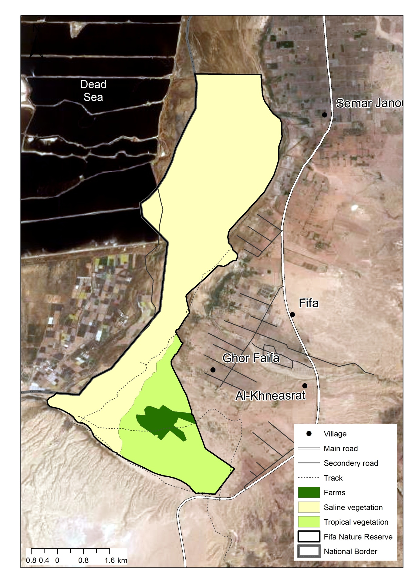Figure (1) location and vegetation types of Fifa Nature reserve

2.2. Line Transects

The field work was carried out between April 16th and June 30th 2014. Twenty plots were chosen randomly by Arc-GIS random selection (figure 2). The surveys were performed in the early morning (6:00 am) and afternoon (4:00 pm) to avoid high temperature which reaches to 40 C⁰ (Jordan Metrological Department 2005). The team used Garmin GPS +/- 5 meters accuracy with a scaled map 1:50,000.

During this survey, a total of 200 transects were performed in study area, by 10 transects in each selected plot. The selected plots were systematically scanned for Uromastyx burrows, at least by five researchers walking in a parallel direction with a 50 m distance between each transect depending on area topography (figure 3 and 4). The plants and soil type of each burrow were determined. The burrows were considered active either if an Uromastyx was observed directly or if fresh tracks were found near an open and clean burrow entrance. Otherwise, the burrow was classified as inactive (Wilms et al. 2010). In addition, the team recorded any burrows observed through movement by vehicle between plots.
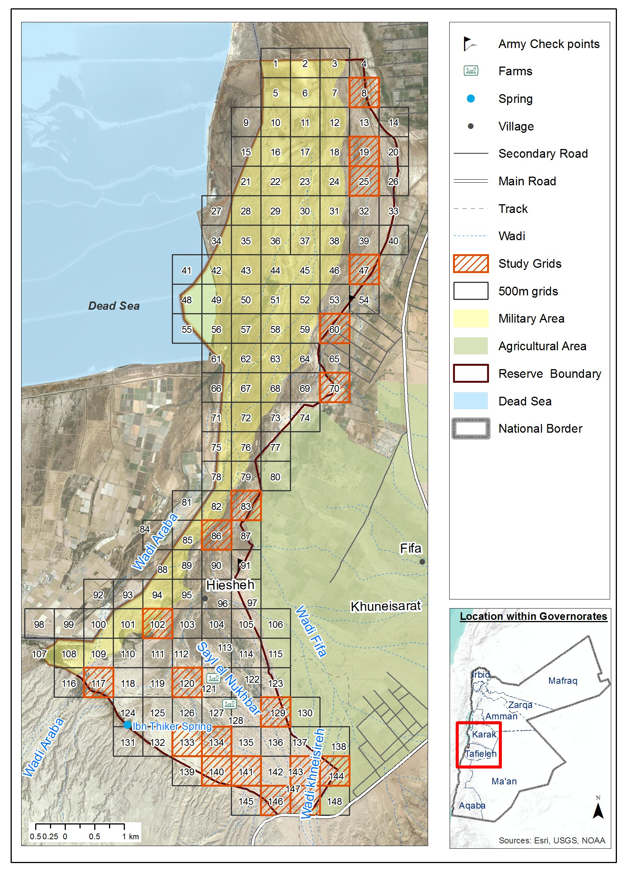
Figure (2) locations of studied plots and military restricted area.
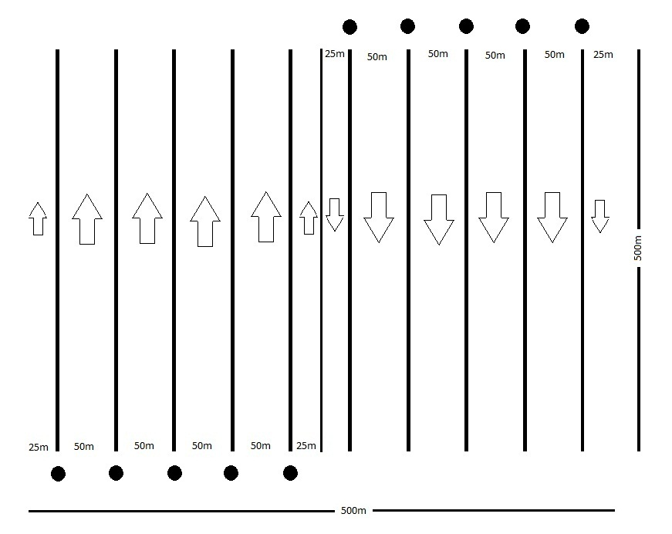
Figure (3) shows the distance between researchers’ and walking directions and distance in line transect method.
Figure (4) line transects method during survey.

Results

A total of 42 Uromastyx burrows were observed among which 37 burrows forming 89% of total were active. Most of Uromastyx colonies were found in tropical vegetation type within gravel sandy soil area and around Acacia tortilis trees and small rocks (figure 5).

Figure (5) shows size of habitats availability in FPA and proportion of U. aegyptia use for each habitat.

Four different soil types were found in FPA as follow: fine sandy soil, coarse sand with gravels, dry water streams (wadi) and salt plains (Sabkha). Around 93% of Uromastyx burrows distributed within coarse sand with gravels in southeastern part of FPA (figure 6). In addition, Uromastyx avoid agricultural lands and high salinity areas which found in middle and northwestern part of the reserve.

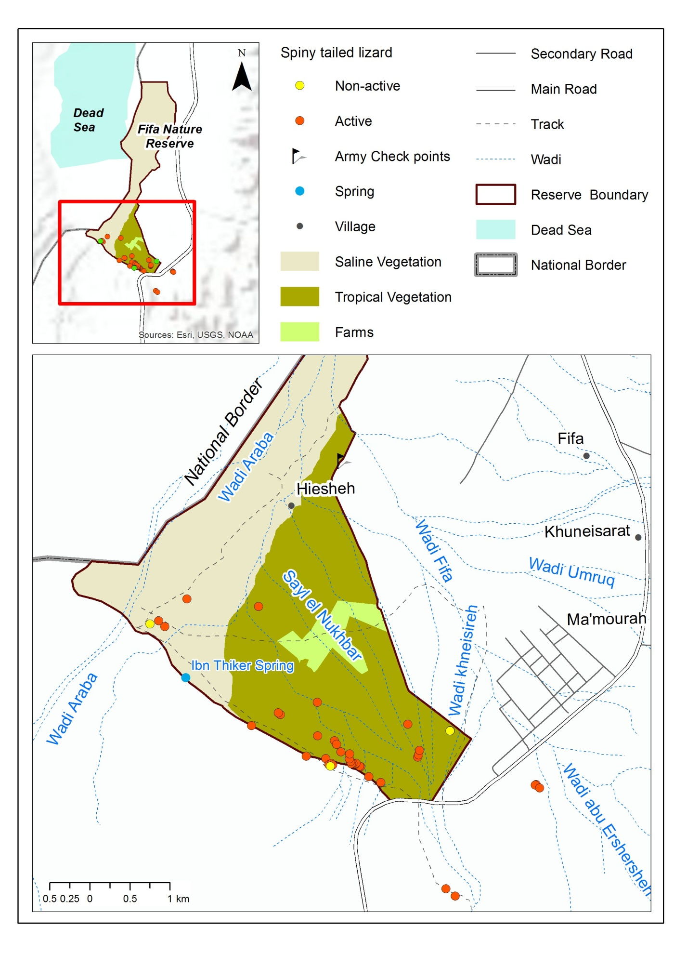
Figure (6) locations of U. aegyptia burrows in FPA.

Discussion

Uromastyx in FPA prefer tropical vegetation habitat with gravels sandy soil and limited plant production. Bouskila (1986), Disi et al. (2001) and Wilms et al. (2009b) stated that Uromastyx prefers open habitats with hard digable sandy soil structure and sparse vegetation and avoids dry water courses (figuer7). Uromastyx prefers flat gravel plains, mainly because of soil physical properties and fine sediments that provides a stable underground to dig burrows (Wilms et al. 2009b). Otherwise, the fine sandy soil might be disadvantageous to dig burrows in, because of its low stability to dig deep burrows which can be reach to 1025 cm length and 180cm depth (Bouskila 1983, 1984 and Disi et al. 2001).

The U. aegyptia burrows in FPA are appear in upland areas and avoid water streams habitats, this survey showed that around 97.8% of Uromastyx burrows were found in upland areas with Acacia tortilis trees (figure 8). Mandeville (1990) and Wilms et al. (2009b) stated that habitat selection by U. aegyptia in central-western Saudi Arabia desert (Mahazat as-Sayd), are intersected by wadis which dominated by sparse vegetation of perennial grasses, and small trees, mainly Acacia spp..

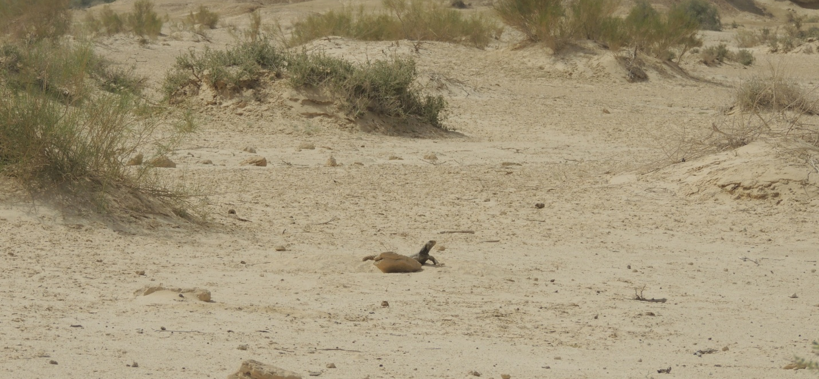
Figure (7) Tropical habitat type in Fifa Nature Reserve.

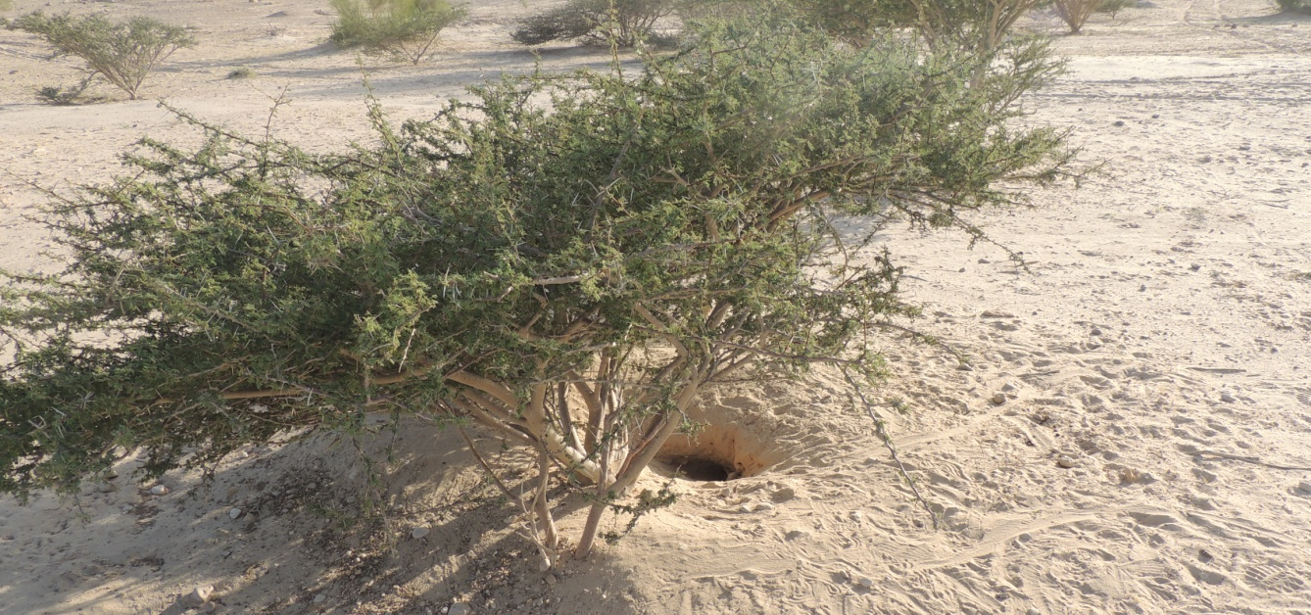
Figure (8) Burrow of Uromastyx aegyptia beneath Acacia tortilis tree.

The vegetation cover and soil type considered the main factors to habitat selection for U Uromastyx in desert areas. Wilms et al. (2009b) stated that U. aegyptia burrows were found in areas which contains fine and medium gravels and coarse sand, and avoid rock habitat areas. The same study show that Uromastyx avoid area with 0% vegetation coverage but show preference for areas which have < 5% vegetation coverage.

In the Arabian Peninsula, U. aegyptia prefers many tropical plants found in FPA such as, Aerva javanica, Citrullus colocynthis, Haloxylon spp., Heliotropium spp., Leptadenia pyrotechnica, Fagonia spp., Pennisetum spp,. Neurada procumbens, Plantago spp., Zygophyllum spp., Astragalus gyzensis and Launaea capitata (Mandevile 1965, Jongbloed 1997, Cunningham 2001). Otherwise, Bouskila (1986) has identified 38 plant species in U. aegyptia diet in southern of occupied Palestine, most important plants were identified in U. aegyptia diet are, Acacia torilis, Aaronsohnia faktorovsky, Zygophyllum Simplex, Plantago ovate, Erodium bryoniifolium, Erucaria boveana, Echium rauwolfii, Launaea angustifolia, Trigonella stellata, hammada salicornica, launea nudicaulis and Pulicaria undulata. The same study shows that A. tortilis is the main plant was eaten by U. aegyptia in summer, it’s considered a long lasting water and food resource (figure 9).

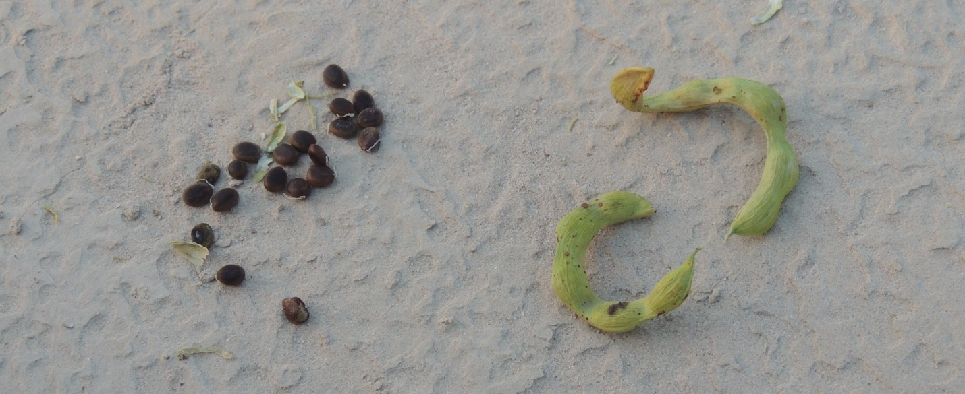
Figure (9) Fruits and seeds of A. tortilis trees in FPA.
Finally, the habitat selection of Uromastyx in FPA is explained by the distribution of A. tortilis patches, coarse sand soil with gravels and season water flow. In addition, Uromastyx is locally used for food and medicinal purposes. U. aegyptia is effected by off-road of military and agriculture vehicles which caused the deterioration of vegetation cover in limited Uromastyx habitat. It’s worth mentioning that, soil erosion in FPA has another negative effect on population of Uromastyx in FPA.

Recommendations

- Preservation of the Acacia tortilis community which considered a long lasting water and food resource for U. aegyptia in FPA.

- Monitoring of soil erosion of U. aegyptia areas yearly, after winter season and water flood.

Reference

AL-Eisawi, D.M. 1996. Vegetation of Jordan. Book published By UNESCO (ROSTAS), Cairo Office. Cairo.

Arnold, E. N. 1986. A key and annotated checklist to the lizards and amphisbaenians of Arabia. Fauna of Saudi Arabia 8:385-435.

Bouskila, A. 1983. The burrows of the dabb-lizard Uromastyx aegyptius. Israel Journal of
Zoology 32:151-152.

Bouskila A.1986. Habitat selection in the desert lizard Uromastyx aegyptius and its relation to the autecological hypothesis, pp. 119-128 in: Z. Dubinsky and Y. Steinberger (eds.), Environmental Quality and Ecosystem Stability, Volume III A/B, Bar-Ilan University Press, Ramat-Gan, Palstine.

Bouskila A. and D. Molco 2002. Status of Spiny-tailed lizards (Uromastyx spp.) in Palestine.
Unpublished report for the Palestine Nature and Parks Authority.

Cunningham. P. L. 2000. The use of burrows by Hoopoe Lark (Alaemon alaudipes). Tribulus 10. 1 :2 1 . El-Ghonemy, A. A. 1985. Ecology and flora of Al Ain Region. University of the United Arab Emirates, Al Ain.

Cunningham. P. L. 2001. Note on the diet, survival rate, and burrow specifics of Uromastyx aegyptius microlepis from the United Arab Emirates. Asiatic Herpetological Research Vol. 9, pp. 30-33.

Disi A. M., Modry D., Necas P. and Rifai L. 2001. Amphibians and reptiles of the Hashemite Kingdom of Jordan. Edition chimaira Frankfurt am main. Bp 159-161.

The IUCN Red List of Threatened Species, 2014. http://www.iucnredlist.org

Jordan Metrological Department 1995, 2005

Jongbloed, M. 1997. Observations in a Dhub colony. Tribulus 7.2:23-24.

Leviton, A. E., S. C. Anderson, K. Adler and S.A. Minton. 1992. Handbook to Middle East Amphibians and Reptiles. Scociety for the Study of Amphibians and Reptiles, Oxford, Ohio.pp 252.

Mandeville, J. 1965. Plants eaten by Uromastyx microlepis Blanford and other notes on this lizard in Eastern Arabia. Journal Bombay Natural History Society 62(1): 161 -163.

Nemtov, S.C. (2008). Uromastyx Lizards in Palestine. NDF Workshop Case Studies, WG 7 Reptiles and Amphibians, Case Study 5, Mexico.

Robinson, M. 1995: Food plants and energetics of the herbivorous lizard, Uromastyx aegyptius microlepis, in Kuwait. – Journal of the University of Kuwait (Science), 22: 255–262.

RSCN, 2010. Flora and fauna Unpublished reports.

Wilms, T. M., P. Wagner, M. Shobrak and W. Böhme 2009b: Activity profiles, habitat selection and seasonality of body weight in a population of Arabian spiny-tailed lizards (Uromastyx aegyptia microlepis Blanford, 1875; Sauria: Agamidae) in Saudi Arabia. – Bonner zoologische Beiträge, 56: 259–272.

Wilms, T. M., Wagner, M. Shobrak, Lutzmann, N. Böhme 2010. and Aspects of the ecology of the Arabian spiny-tailed lizard (Uromastyx aegyptia microlepis Blanford, 1875) at Mahazat as-Sayd protected area, Saudi Arabia. Salamandara 46, pp 131-140.

