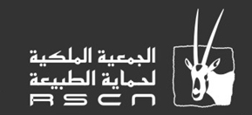
بسم الله الرحمن الرحيم

Fifa Proposed Protected Area
Management Plan

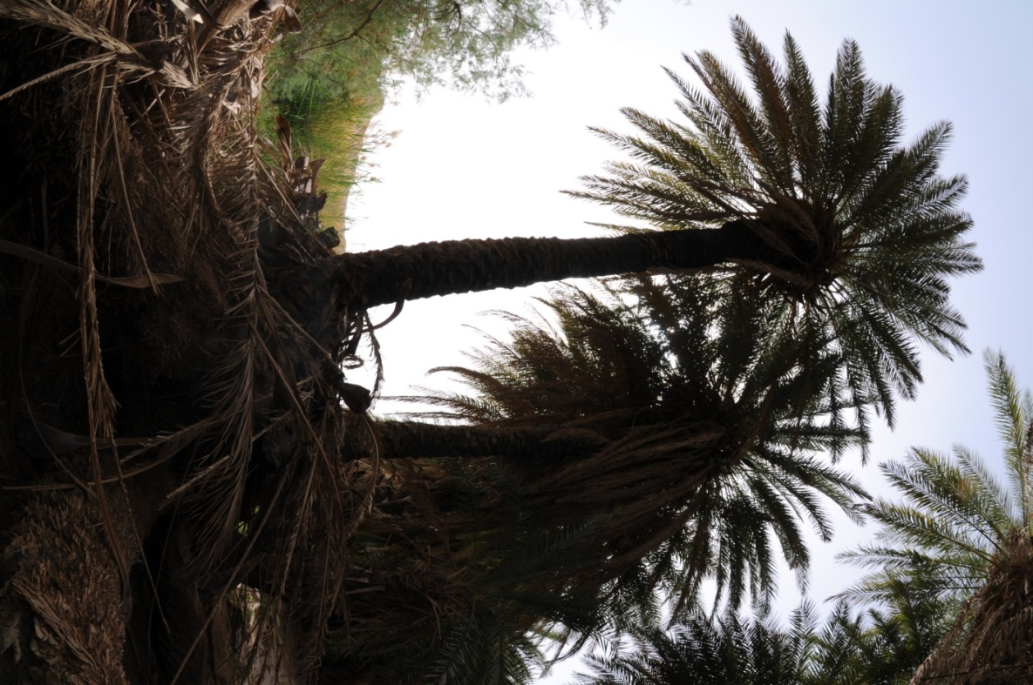

The Royal Society for the Conservation of Nature /
Jordan Rift Valley – Integrated Ecosystem Management Project

Contents
Preface 5
Introduction 8
Chapter one: Site description 9
1.1- General information 9
1.1.1- Location 9
1.1.2- Land Tenure 9
1.1.3- Available Maps 9
1.1.4- Photography Coverage 11
1.2- Ecological information 11
1.2.1- Physical information 11
1.2.2- Biological information 16
1.2.3- Cultural information 21
1.3- Factors that affecting management 24
1.3.1- The military status of the area 24
1.3.2- Agricultural land expanding toward the protected area 24
1.3.3- Red – Dead Canal 24
1.3.4- Grazing 24
1.4- References 25
Chapter Two: Site Evaluation 26
2.1- Standard Criteria of Evaluation 26
2.2.1- Size 26
2.2.2- Diversity 26
2.2.3- Naturalness 27
2.2.4- Rarity 27
2.2.5- Fragility 27
2.2.6- Typicalness 27
2.2.7- Position in the ecological unit 27
2.2.8- Potential for improvement 28
2.2.9- Public use / access 28
2.2.10- Other Factors 28

Chapter Three: Problem Analysis 29
Chapter Four: General objective, operational objectives, and outputs. 31
Chapter Five: Zoning Plan 34
5.1- Rehabilitation zone 34
5.2- Conservation and biological connectivity zone 34
5.3- Management intervention zone 34
5.4- Buffer zone 34

List of Maps

Map 1 Base map of Fifa protected areas. 10
Map 2 Location of the protected area in Wadi Araba drainage basin. 12
Map 3 Geology of Fifa Protected Area 14
Map 4 Vegetation types of Fifa protected area 17
Map 5 vegetation community of Fifa protected area. 19
Map 6 Zoning Plan of Fifa protected area 35

Preface
In 1963, the late king Hussein noticed the signs of biodiversity deterioration in the eastern desert in particular and the whole Jordan in general, upon which he proclaimed to the Jordan government at that time to investigate the situation, and comes up with achievable recommendations.
Thus, the government arranged for an international expedition performed by experts from the British Natural History Museum (BNHM) in coordination with the Royal Hunting Club, that developed later to be the Royal Society for the Conservation of Nature (RSCN).
As a result, the expedition proposed the establishment a network of protected areas along Jordan Rift Valley covering an area of 2,200 km², however, the proposed protected areas were not deemed to be established due to the prevailing political situation at that time.
In 1979, a joint effort between RSCN, World Wild Fund (WWF) and the International Union for the Conservation of Nature (IUCN) took place to investigate the Jordanian potential protected areas, which was known later as Clark mission / report that recommended to establish a total of 12 protected areas based on the representation of land type and vegetation cover.
Based on these recommendations and in a matter of 20 years, six protected areas were established and became fully functioning which are: Shumari wildlife Reserve, Azraq Wetland Reserve, Dana Biosphere Reserve, Mujib Protected Area, Ajloun Forest Protected Area, and Wadi Rum Protected area.
In 1998, RSCN found that there is a need for Clark's report revision, in consultation with the Ministry of Environment; RSCN conducted a detailed review aiming to update the network of protected areas that were proposed in 1979 by Clark. The final output of this review was a new system of protected areas following the standards of IUCN, and as a result, another six protected areas were proposed including Dibeen Forests, Jordan River (Baptism Site), Qatar, Fifa, Aqaba Mountains, Al Yarmouk and Burqu Areas.
In 2005, RSCN started to prepare the Integrated Ecosystem Management in the Jordan Rift Valley project document that stressed on four sites to be initially allocated as protected areas in the Rift Valley as follow: Jabal Masouda, Qatar, Fifa and Al Yarmouk. Two years later, the Ministry of Planning on behalf of the Jordan government signed the agreement with the Global Environment Facility GEF being the donor of the project.
The Project’s overall objective is ‘to apply the principles of integrated ecosystem management to the existing land use master plan of the Jordan Rift Valley and establish a network of well-managed protected areas that meets local ecological, social, and economic needs'. The project will be implemented during a period of six years between 2008 and 2013.
The project development objective will be achieved through the following outcomes:
- Consultative planning and management procedures involving all relevant stakeholders, and based on IEM principles, successfully introduced to the Rift Valley to support the conservation of key biodiversity sites.
- A network of 4 PAs and 7 SCAs in the JRV legally established and operating as models of IEM principles to support biodiversity conservation.
- Elements for ‘climate proofing’ biodiversity conservation within PAs and SCAs introduced into the conservation planning and implementation stages of the project.
- Sustainable financing mechanisms for PAs strengthened through increased capitalization of $ 2 million for the endowment fund, and adoption of economically viable, nature-based livelihood options by local communities in PAs and SCAs.
- Project managed successfully, and development objective achieved through an effective monitoring program
The Project is a collaborative national effort and provides an outstanding opportunity for shared planning and management of some of Jordan’s most vulnerable ecosystems and economic regions.
Several government and nongovernment institutions will be instrumental in its planning, implementation and sustainability. This includes:
- The Ministry of Environment
- The Ministry of Planning and International Cooperation
- The Ministry of Tourism and Antiquities
- The Ministry of Water and Irrigation represented by the Jordan Valley Authority
- The Jordan Hashemite fund for Human Development
- The International Union for Conservation Nature – IUCN
- The Ministry of Defense
- The Ministry of Agriculture
- Development Zones Commission
- The Aqaba Special Economic Zone Authority
- Petra Regional Authority
- The Natural Resource Authority
- Jordan River Foundation
- Noor Al Hussein Foundation

Purpose of proposing Fifa to be a protected area
The proposed site in Fifa [23.2 km2] was targeted because the site is the last remnants of what was formerly a much larger area of vegetation characteristic of the Sudanian biogeographical zone, hosting two important vegetation types in Jordan that are the saline vegetation and the tropical vegetation. It includes more than seven plant species that are of conservation importance, and is the only recorded locality in Jordan where the rare Siwak [Ara'ak] tree Salvadora persica occurs in considerable numbers.
In addition, the site is embedded within a larger IBA identified by BirdLife and RSCN, around 100 species of birds have been recorded; some are globally threatened such as the Corncrake Crex crex. Seven species of large mammals were recorded in the site including the Caracal and Striped Hyena.
Fifa proposed protected area was on the top priority of the 2nd protected area review in 2005 by RSCN that recommended the establishment of the site as a protected area due to the rapid degrading of its rangeland and biodiversity.
The protected area review in 1998 stressed that all land tenure types of the proposed protected areas at that time were governmental ownership, and no signs of development were found at that time. However, two agricultural development schemes were developed in the past few years by the Rift Valley Authority (RVA) in the northeastern side of the proposed protected areas resulting in reducing the size from the originally proposed [33.1 km2] to the current size.
In general, three main considerations should be kept in mind when looking for the landuse of Fifa, which are:
- The military status of the area.
- The potential impact of the proposed Red-Dead canal.
- The existence of few private lands inside the protected area that is irrigated through pipes provided by the RVA.

Introduction
This is the first management plan for Fifa protected area based on the standard criteria and guidelines of management planning. The plan is considering the biological and ecological values same as social, cultural, and economical values. These values were presented in chapter one, the chapter of general information, that is followed by the evaluation of these values in chapter two, and the problem analysis in chapter three, objectives and outputs in chapter four, and chapter five for zoning plan.
Below is the basic administrative data of the site:
Site Name | Fifa Protected Area
Central coordinates | North – West | 35°22.591 E | 30°58.304
 | South – East | 35°26.509 | 30°53.578
Legal Status | Proposed Protected Area
District | Southern Ghor
Governorate | Al-Karak
Area | 23.2 Km2
Authority of land management and use | The Royal Society for the Conservation of Nature.  Yajouz Street, Jubaiha City.  P.O. Box 1215  Zip Code: 11941  Tel: 962 (6) 5337931 / 2  Fax: 962 (6) 5347411  Email: adminrscn@rscn.org.jo  Website: www.rscn.org.jo

Chapter one: Site description

1.1- General information

1.1.1- Location
The proposed protected area of Fifa [will be referred as protected area later in this management plan] is located south-west of Jordan, with the international border forming its western edge [Map 1]. The area of the proposed site is 23.2 km2, and it is administratively belonging to the district of south Ghor. Fifa is located between two governorates namely Karak with the largest part of the site laid in, and Tafeelah that is covering minor part at the southern border of the site. Fifa is located 140 km far of Amman the capital, and 26 km northwestern Tafeelah governorate. It has the lowest point on earth reaching -420 below sea level.
The protected area can be reached by three main roads as following:
- Dead Sea Road [65] for those who come from Amman or Aqaba.
- Karak to Dead Sea Road [65].
- Tafeelah to Dead Sea Road [65].
There is a network of off-roads inside the protected areas created for military purposes, in addition to another network that is facilitating the farmer movement to their own lands.

1.1.2- Land Tenure
The land of the protected area is a state land, except of few parcels at the eastern borders that is used for agriculture. Most of the protected area [78 %] land is very sensitive in term of border security, and needs military entrance permission to be reached.

1.1.3- Available Maps
There is one topographical map with 1:50000 scale covering the area, the map name is Fifa and it is produced by the Royal geographical centre.
Sheet No. I3051
Serial No. K 737
Location and Date of issue: Amman / 1961
In addition to a group of digital maps based on the collected field data, prepared internally by the GIS unit in Research and Survey section / RSCN such as the maps in this management plan.

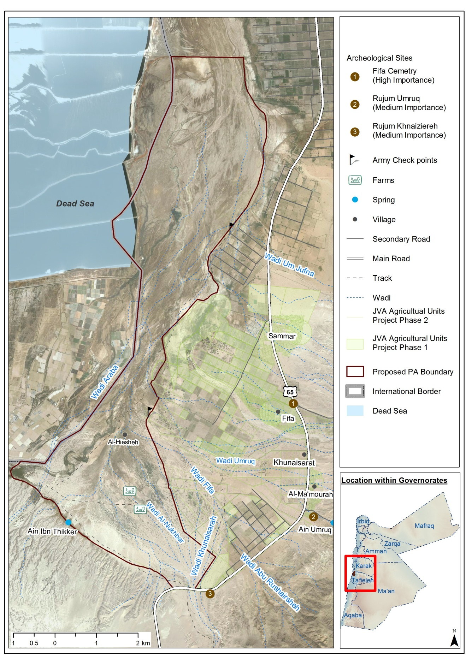
Map 1 Base map of Fifa protected areas showing the mean features and the agricultural expansion toward the western side of the PA.

1.1.4- Photography Coverage
There is a group of photos describing the flora and fauna of the area are available at the research and survey section in RSCN, in addition to the research techniques and methods for the purpose of documentation. It should be notice that photography is considered sensitive issue at the site due to the military status of the area at the international border.

1.2- Ecological information

1.2.1- Physical information

1.2.1.1- climate
Due to its location in the Sudanian Penetration Biogeographical Zone, the area is considered one of the hottest sites in Jordan. Temperature ranged from 15 – 45 during the year and may reach much higher in summer. Rainfall average is 50-100 ml annually.

1.2.1.2- Hydrology
Fifa is located in Wadi Araba drainage basin that has an area of [2,938 Km2] as in map 2, and expanded from the southern edges of Dead Sea up to 100 km further south, maximum width of the basing is 25-35 km. The average annual rainfall in the eastern mountains of the basin reached 300 ml, while the area of Wadi Araba is 100 ml. Evaporation rates reached 2,800 ml at the southern shores of the Dead Sea in comparison to 3,500 ml at the south eastern parts of the basin.
As for the aquifer water and its sustainable use, Abed (2000) explained that water extraction from Wadi Araba reached 3,5 million cubic meter annually based on the annual report of water authority between 1995-1996, Salameh et al. (1992), Abo Ajameyeh & Bender (1998) both agreed that the safe extraction yield is 8 million cubic meter a year, according to them, the feeding rate of the northern Wadi Araba aquifer reached 35 mcm, and the external drainage reached 23,2 mcm annually, and the permanent water running is 14,7 mcm annually.
In general, a total of 21 mcm of water is available annually as water resources in the basin and 8 mcm are available water resources. Most of the extracted water is used in industry 4,5 mcm, then for irrigation 0.57 mcm. It is worth to know that this water is not drinkable due to its high salinity.
Two water springs are located around the protected area (Map 1), which are Tolah spring and Umruq. The flow rate of Tolah spring was estimated to be 18 cubic meter/ hour in average, and it can be reached its maximum of 42 cubic meters/ hour, with minimum of 2.4 cubic meter / hour. As for Umruq spring, its flow rate is 33 cubic meter / hour, maximum of 65 cubic meter/ hour, and minim of 12,6 cubic meter/ hour.
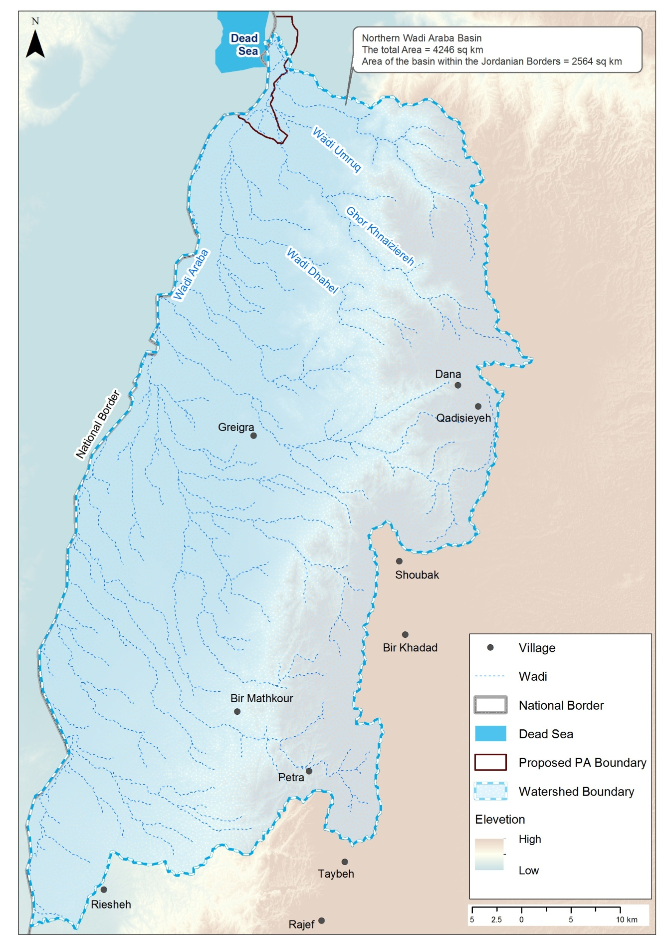
Map 2 Location of the protected area in Wadi Araba drainage basin.

1.2.1.3- Geology
Fifa natural reserve is situated at the southernmost part of the Dead Sea Basin. The reserve consists of recent to subrecent sediments with no older rocks cropping in the reserve. Consequently, there are no pronounced topographic or geological features. However, the following features can be distinguished:
- Flat-lying area or sabkha which comprises most of the land of the reserve. Most probably it is made of the fine material (clay and silt) forming the distal parts of alluvial fans. The soil is rather saline with Nitraria retusa and Tamarix sp.. Relatively large trees of Salvadora persica appears in the less saline areas.
- Wadis dissecting the flat area. The wadis are flowing from east to west, when approaching the central basin they change direction to the NNW; i.e. towards the base level which is the Dead Sea.
- Khnaizereh Escarpment. Approximately 100 m high cliff at the southernmost reserve. It consists of the varved, typical Lisan Formation sediments interbedded with friable sandstone and pebbly sandstone. The escarpment is due to the presence of a normal listric fault having the same name with the down throw being to the north.
The reserve, as part of the rift valley, was occupied by the Lisan Lake 65-15 ka before present. The flat nature of the reserve is due to the sedimentation of the Lisan deposits, underlying the sabkha sediment, which suffered very little after being deposited. The brackish to saline nature of the Lisan Lake water is possibly the main reason for the salinity of the reserve soil. Another reason for the salty soil is its nearness to the Dead Sea and the salt pans associated with the potash industry.
Just east of the reserve, lies the Dead Sea Transform, a plate boundary separating the Arabian Plate (Jordan) from the micro, Sinai-Palestine plate. Jordan moves, and is moving, northwards by an average of 5 mm/year relative to Palestine. This transform is the centre for earthquakes in the area

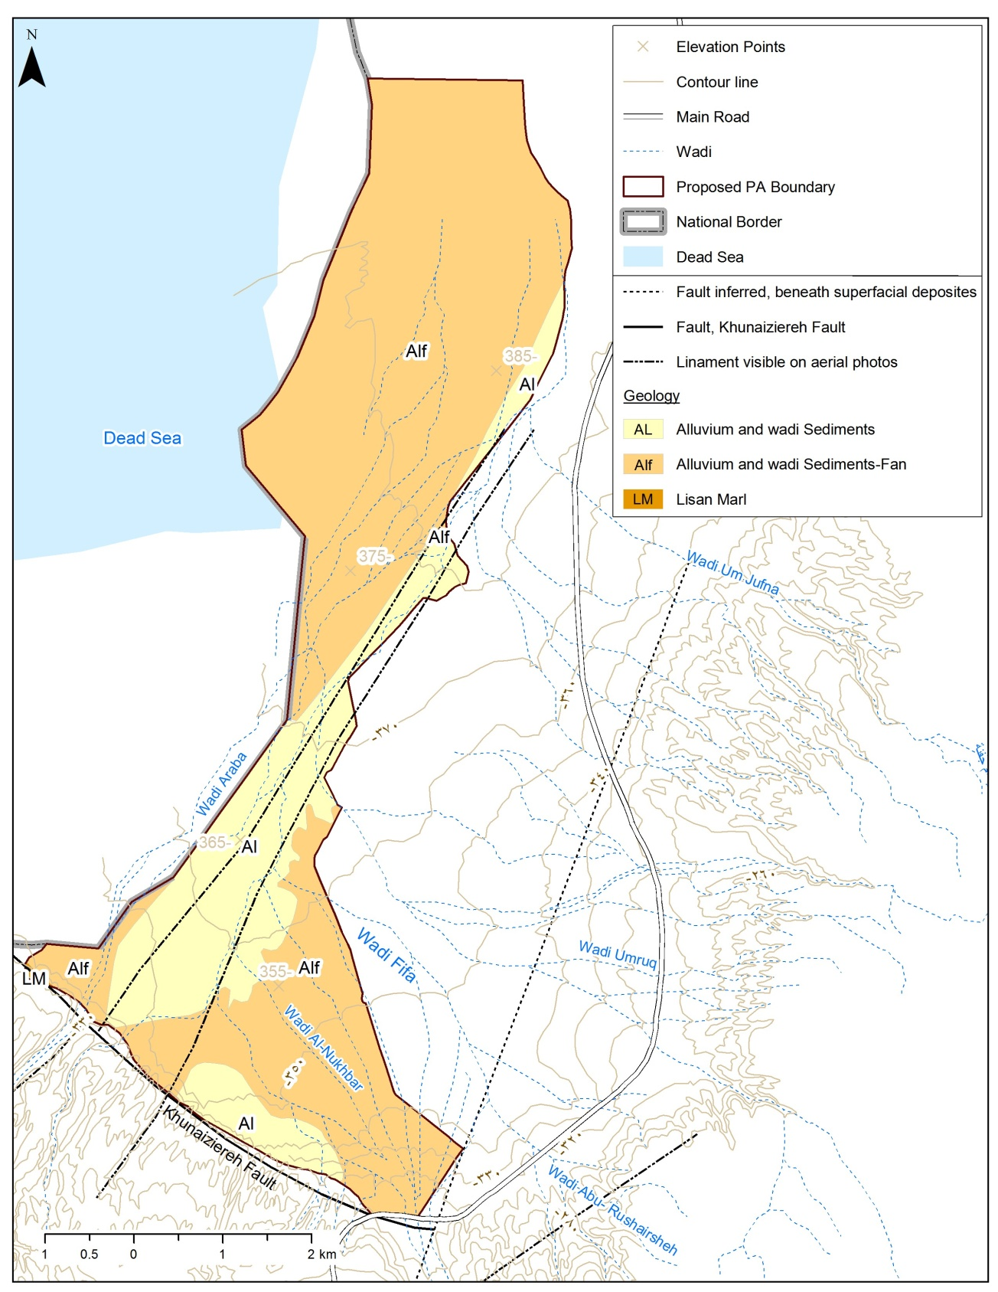
Map 3 Geology of Fifa Protected Area

1.2.1.4- Soil
Fifa Reserve is comprised of several different areas. Each of these areas has its own soil characteristics. The first area is flat and salty. Salts are soluble and with carbonates which could be detected with fizzing when 1M HCl is added. The carbonate content of the salts is variable spatially. There is no vegetation growing in this area at all, indicating the very high salinity. The soil has a small amount of clay, which could be detected by feel after wetting the soil. The color of soil is variable from yellowish brown to dark yellowish brown.
The second area, which is to the south of the first area, is also salty with carbonate. Area is flat with lots of white areas due to the accumulation of salts on the surface. In this area there is more plant cover. Some of the plants are healthy green shrubs, while most of the plants are dead. This indicates that the soil salinity is less than that of the first area, but it is still too high to allow normal plant growth. The color of the soil is mostly light brownish grey. The third area is flat with heavy dense population of tamarix. Soil is mostly very sandy with carbonate content, fairly strong fizzing. As we go south, the vegetation becomes less and less dense until very sparse, probably due to cutting by local population. Soil is still sandy with. Color of soil is mostly dark yellowish brown.

1.2.2- Biological information

1.2.2.1- Flora
A total of 80 plant species were recorded at Fifa protected area in the baseline survey. The species are belonging 30 families including seven threatened species as in the table below.
Arabic Name | Conservation statuts | English name | Scientific name
نخيل | Threatened | Palm | Phoenix dactylifera
ارآك | Threatened | Toothbrush Tree | Salvadora persica
سويدا | Threatened | Seablite | Suaeda monoica
سدر | Threatened | Ziziphus | Ziziphus spina-christi
طلح | Threatened | Acacia | Acacia tortilis
عشير | Threatened | Milkweed | Calotropis procera
قطف | Common, medicinal | Atriplex | Atriplex halimus

The plant species were classified based on the human use and it was found that there are 10 medicinal plants, 5 woody species, 6 eatable (for human), 2 poisonous, and 46 palatable.
Two vegetation types were identified in the protected area; the saline vegetation, and the tropical vegetation (Map 4). These two types are distributed as a result of variation in the soil salinity, soil type, and the quality of water. Thus, the tropical vegetation is more common in the eastern part of the protected area because it is less saline due to the water runoff along the wadies at that site. As for the western part, it is dominated by Tamarisk trees that stand high level of salinity. Al-Eisawi [1996] stated that Fifa is distinguished by its tropical vegetation that is limited to few areas in the Rift Valley, which is a sign of high adaptation of this vegetation types to drought.
Saline vegetation
Saline vegetation represents 78 % of the total protected area with an area of 17.4 Km² Tamarix tetragyna, Arthrocnemum macrostachym.,Nitraria retusa,.and Suaeda monica, Juncus rigidus Alhagi graecorum, Lycium shawii are the leading species of this vegetation.
Tropical vegetation
The Tropical vegetation type represents 22% of the total protected area with an area of 4.9Km². The leading species of this vegetation are Salvadora persica, Calotropis procera, Zizphus spina-christi, Ochradenus baccatus, and Aerva javanica

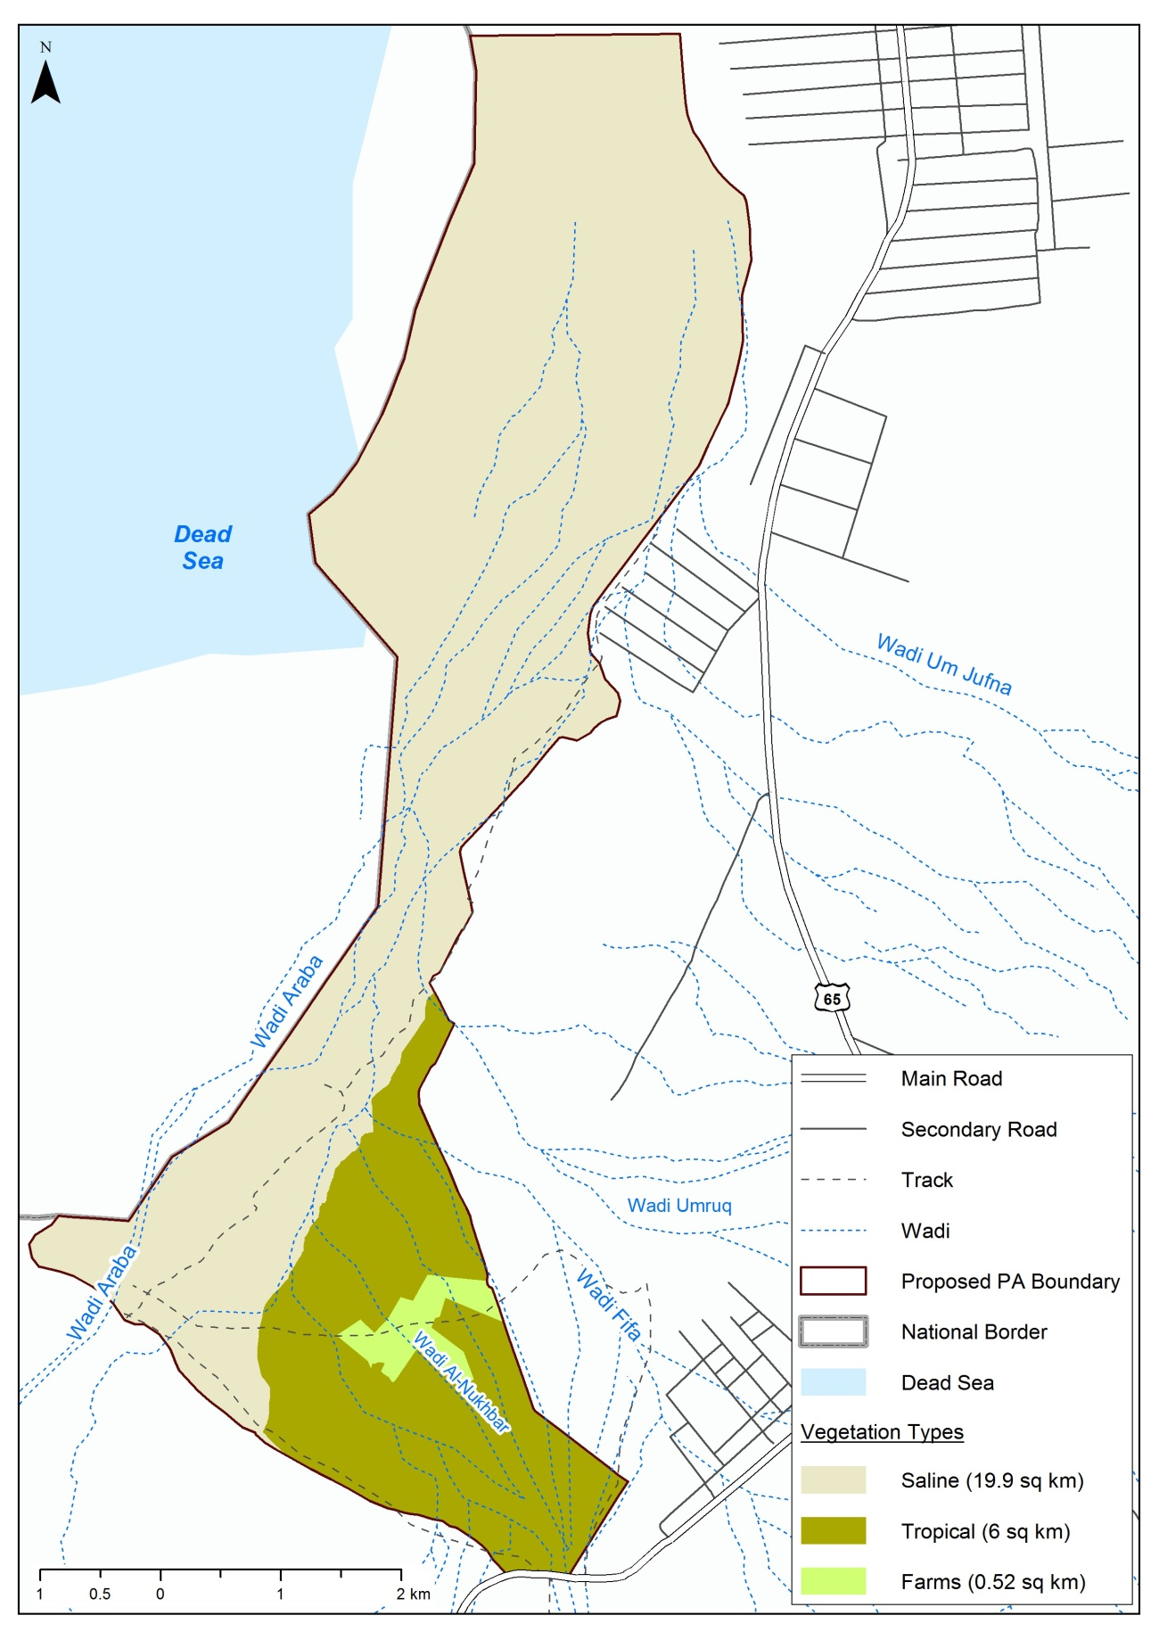
Map 4 Vegetation types of Fifa protected area

1.2.2.2- Vegetation communities
Ten vegetation communities were identified in Fifa protected area (Map 5) as following:
- Tamarix tetragyna is the characteristic species of these stand accompanied with Phragmites australis, it is the largest community in Fifa located mainly in the northern west part, the absence of annuals was remarkable.
- .Mix ( Tamarix tetragyna Lycium shawii) This group comprise by dominance of Tamarix tetragyna , Lycium shawii, Calligonum comosum, Seidlitzia rosmarinus, Suaeda monoica and some annual plant , Filago desertorum, Centaurea aegyptiaca
- Mix Tamarix tetragyna with Arthrocnemum macrostachym, Arthocnmum macrostachym is the characteristic species of these stand accompanied with Tamarix tetragyna, Seidlitzia rosmarinus, Salsola baryosom, Atriplex halimus Suaeda monoica these area slightly saline with high amount of moisture.
- Tamarix tetragyna with Alhagi graecorum, Alhagi graecorum is the characteristics species, a accompanied with, Ziilia spinosa, Atriplex halimus,Aizon canariense , Malva parviflora.
- Mix Tamarix tetragyna with Suaeda monoica, Suaeda monoica is the characteristic species of these stand accompanied with Tamarix tetragyna Arthocnmum macrostachym ,Seidlitzia rosmarinus, Atriplex halimus, Suaeda monoica and annual herbs such as Plantago ovate , Malva parviflora, Trigonella stellata.
- Mix ( Tamarix tetragyna- Nitraria retusa ) This group comprise by dominance of Tamarix tetragyna, Lycium shawii, Calligonum comosum, Seidlitzia rosmarinus, Suaeda monoica and some annual plant such as Filago desertorum and Centaurea aegyptiaca
- Haloxylon salicornicum is the characteristic species of this group its companied with Artimesia sieberi, Salsola vermiculata, faresitia aegyptica , Suaeda monoica, iflago spicata
- Vegetation characterized by the dominance of juncus rigidus , and Tamarix spp. with highest cover favour to juncus rigidus, ,Alhagi graecorum ,Halxylon salicornicum, Phonix dactylifera , Prosopis farcata.
- Phoenix dactylifera is the characteristic species of these stand accompanied with Phragmites australis, juncus rigidus, Tamarix spp., Alhagi graecorum, Halxylon salicornicum, Phonix dactylifera, Prosopis farcata.
- This area is characterized by Acacia tortilis scattered with Tamarix tetragyna, Ochradenus baccatus, Prosopis juliflora Tamarix aphylla, and Dipcadi erythraeum.

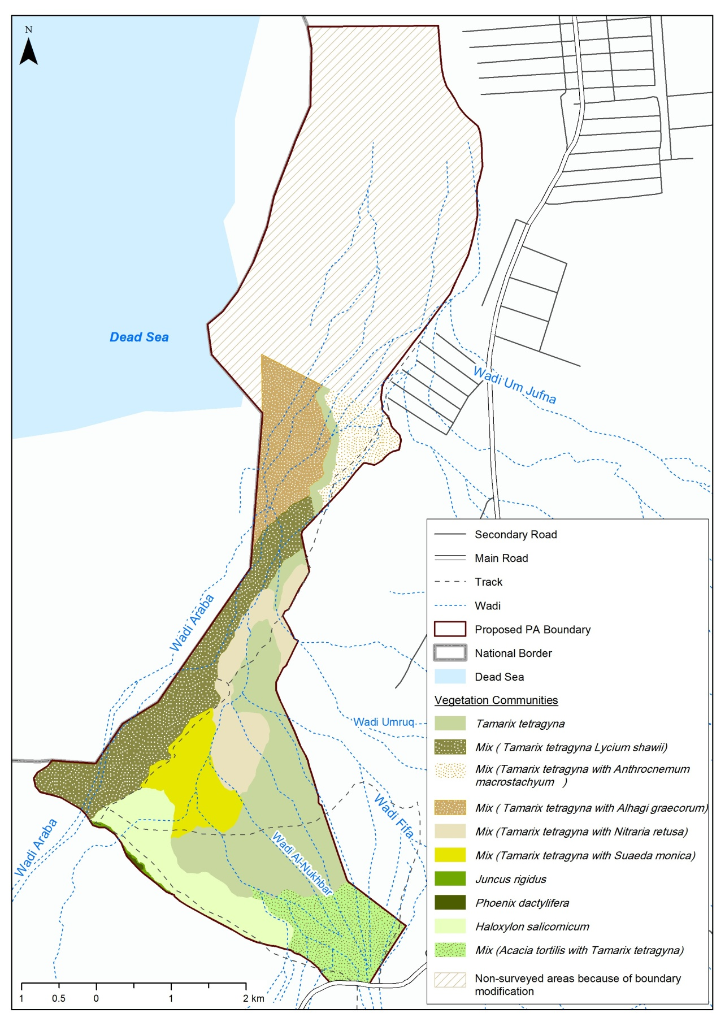
Map 5 vegetation community of Fifa protected area, notice that the area that is not surveyed was due added to the original borders after the flora baseline survey was finished, so that it was not surveyed in the time of writing this plan.

1.2.2.3- Fauna
A number of vertebrates were recorded in the protected area during the base line survey, including:
Freshwater fish
An endemic subspecies known as Arabian Killifish Aphanius dispar richardsoni that is the sister species of another endemic species of Jordan Azraq killifish is known to inhabit the area long time ago. The species is secondary fresh water fish, and it can stand high level of salinity reached up to 13.5 ppt. The species was collected at the time of preparation of this management plan, however, its habitat was modified and changed to receive the exceeded irrigation water; in addition the cichlid fish Oreochromis aureus was introduced. This cichlid fish is well known by its damaging impact on native species in all fresh water bodies where it is introduced.
Amphibians
Two species of amphibians were recorded in the protected area, the common Bufo viridis that is consider basic food source for snakes, birds, and even carnivores. The other species is Rana bedragae that was found around the water spring southern of the protected area, it is easy can be heard during the mating season, and it is also a main food source for snakes, birds, and carnivorous.
Reptiles
Three species of reptiles were found in the protected area including the two largest lizards in Jordan that are considered rare at the local level, they are the Egyptian Dabb Uromastyx aegyptia that is on the appendix II of CITES convention, and it is threatened by hunting because some people thought that eating this species will cure some chronic disease.
The other species is the desert monitor that is the largest lizard in Jordan; local people thought that this species is poisonous, and eating this species helps in developing immunity against snake poison. However, the species is at Appendix I of CITES convention because its leather is being used in industry but there is no trading in this species. The species is still threatened by habitat loss and hunting.
Birds
A total of 36 bird species were recorded in the area, among which Sand Partridge and Dead Sea Sparrow were of most importance since they have a limited distribution in the Middle East and the region. The later is suffering from its habitat loss mainly Tamarisks due to the development activities along the Dead Sea cost that removed major portion of such habitats.
Mammals
Ten species of mammals were recorded in Fifa, they are four carnivores, three rodents, the Cape Hare, and the Wild Boar. Brief description of each category is given below.

- Carnivores
Four species of carnivores were found in Fifa during the baseline survey, they are belonging to three families and all are threatened at the national level. The carnivores were the Arabian Wolf Canis lupus the largest carnivore in Jordan and is listed on Appendix II of CITES convention, the Golden Jackal Canis aureus that is considered endangered nationally because of the competition with the common Red Fox for food and shelter where the last was also recorded in the protected area and is considered highly adaptive species that can survive in wide range of conditions, and finally, the striated Hyena Hyaena Hyaena which is the most unfavourable species to locals due to incorrect believes about its behaviour, or because it is being captured and sold for zoos.
- Rodents
Three species of rodents were spotted at the protected area including the common Cairo Spiny Mouse Acomys cahirinus that is well known along the Dead Sea cost, Gerbillus dasyurus and Gerbillus nanus. These rodents are providing a fundamental food source of other species like carnivores, birds, and reptiles mainly snakes.
- Leporidae
Represented in one species that is the only species of this family in Jordan, the common Cape Hare Lepus capensis. The species is nocturnal but can be seen at the early morning,
- Artiodactyla
This family is presented in Jordan by one species the Wild Boar Sus scrofa that can be seen in large flocks in Fifa due to the strict protection by military against hunting. The large numbers of this species start to be a problematic to farmers since the species is known with its damaging behaviour of agricultural crops.

1.2.3- Cultural information

1.2.3.1- Antiquities and past use
Three ancient sites were identified during the archeological survey by Waheed in 2009. These sites are Fifa graveyard that is the largest and oldest graveyard along the Rift Valley, Umruq site, which is a small building on top hill that may used to be monitoring tower and Khnaizeerah Cairn to the west of the protected area. The survey recommended a programme that is connecting all the sites in one day visit activity.

1.2.3.2- Current use
Most of the protected area is military land were entrance is not allowed except with permission, so the current use is very limited to grazing and wood cutting activities at the southeastern part close to Ein bin Thiker. In addition, a considerable part of the protected area is (no-man's Land) adjacent to the border, where entrance is strictly prohibited, and a group of monitoring towers are distributed along the western border of the protected area.
In addition to the military, RVA owned a total of 3,500 donoms in Fifa that were all used for agriculture through a project at the eastern border of the protected area, which cause RSCN to adjust the border of the protected area to avoid these farmlands from the east. A division under the Ministry of Agriculture is working onsite mainly to control the expansion of farms on the governmental lands.
Parallel with governmental organization, there is nongovernmental organization which is the Jordanian Hashemite Fund for Human Development that is working in the area since 1991 and focusing on:
- Child care, establishing a nursery and class for child of special needs.
- Women empowerment.
- Water use development (more than 82 beneficiary)
- Fighting poverty (Poverty Pockets Project)

1.2.3.3- Past conservation management
By the nature of the area being very sensitive due to its location, the area was fully protected against any encroachment, except of some individual cases of hunting. Communications back to 1985 between the Ministry of Agriculture, RVA, and the prime ministry found to stress on the importance of protection Fifa as arrange land reserve, and explained the negative impact of the previously mentioned agricultural projects on the native flora, it is also figured the land encroachments and asked RVA not to supply those farmers with water.
The main factors that helped in expansion of agriculture on the stat land were the lack of staff that patrol the area and follow up any illegal expansion, in addition to the lack of equipment mainly the vehicles. A formal letter to the prime ministry by the ministry of agriculture explained that there is a total of 40,000 JD need to be collected from expansion farmers as a fine. The letter also recommended:
- Increase the staff number.
- Stop supporting water for encroached agricultural lands.
- To establish forestry monitoring towers.
- Remove the land encroachments immediately.
- Enhance the monitoring and patrolling programme.
- Allow the rangers to drive the forestry department vehicles.
- Prepare a fire breaks plan.
- Hire seasonal fire fighting staff from May to October.
- Coordination with civil defense force in case of fire.
- Increase the number of radios to enhance communities.
In addition to that, communication with the armed force on the border was established to help the department of forestry in controlling wood cutting gin particular.

1.2.3.4- Conservation current Status
The proposed site is not yet designated as a protected area in the time of preparing this management plan; however, the designation process is in progress.

1.2.3.5- Landscape
The landscape of the protected area gave the impression about its dense vegetation that is graduated from dark green to pale green, with white spots of saline soil. In addition to the wet area to the south that is forming a small wetland with high palm trees. However, the integrity of landscape is challenged with the off-road network and agricultural encroachment, and agricultural wastes.

1.2.3.6- The Socio-economic of the site
The protected area is surrounded by two villages Fifa and Ma'moura. Fifa population reaches 1,878 individuals (968 males / 910 females) and Ma'moura population is 811 individuals (437 males / 374 females). The average family size I 10-15 individuals, and maximum of 30-40 individuals.
As for the social structure, there is three tribes in the area, Al-Ghawarneh who lives in Fifa, and Suaideyeen tribe who lives in Ma'moura, then a nomadic tribe known as Azazmeh. The closest village to fifa is Ghor al Safi that is considered as services centre. It hosts male secondary school, and female secondary school, medical center, and nursery. The main social problem the area is facing is the low level of education especially between males because they leave school early to work, lack of teachers, and the low quality of teaching.
As for the economical situation, more than 37% of Ghor al Safi inhabitants are under the poverty line, and they either work in agriculture, labors or in the armed force. The source of income varied, Al-Ghawarneh tribe is depending on agriculture or governmental work, while Suaideyeen depends on livestock mainly camels.
The high level of poverty in Fifa triggers intention of developers and donors, so the area first received a royal fund to build a total of 80 residential units, in addition to several aids by the ministry of social development, national aid fund, and private sectors. Some local cooperatives manage to develop projects that improved the economical situation such as the Ghor al Safi cooperative for social development, and women of Ghor al Safi cooperative.

1.2.3.7- Research use and infrastructure
Fifa protected area is a good environment for research, since it has areas with very strict protection similar to those in category Ia protected areas according to the international union for the conservation of nature categories of protected areas. Although, the research team had conducted a number of baselines both for its fauna and flora, the site is still need management and scientific oriented research especially in the high protected area to be sat as a control point to monitor the effectiveness of management toward the objectives. There is no other use such as education, or recreation because of the sensitive location of the protected real along the national border.

1.3- Factors that affecting management

1.3.1- The military status of the area
The military management of the site is giving security the first priority, which does not look for ecosystem management if conflict with the security. This kind of management is giving the military the right to clean the dense vegetation to control the border, and burn the Palm trees, and any other dense vegetation to clear the visibility. In addition, the network of off-roads is facilitating the movement of armed force when patrol the area. This kind of practices, need to be discussed to reach a win-win situation in balance with ecosystem management approach.

1.3.2- Agricultural land expanding toward the protected area
The agricultural project caused RSCN to modify the border and size of the protected area and get rid of 30 % of the original proposed site from the east. The expansion of agricultural land especially at the narrowest areas is a real challenge because if happened, it will disconnect the ecological integrity of the protected area. On the other hand, a kind of agreement needs to be formulated with land owners to use eco-friendly agricultural techniques and to select crops with less water consumption.

1.3.3- Red – Dead Canal
Because the Dead Sea level is declining rapidly, a large scale project was proposed to bring water from Red Sea to Dead Sea through pipe systems with some open areas to generate electricity and desalinate water. The proposed pathway of the canal will pass through fifa from the western side that could affect the whole site, and facilitate its habitats degradation.

1.3.4- Grazing
Grazing is limited to the southeastern area of the site because of security reason. The primary data of rangeland survey showed that the area is severely overgrazed. It recommended the opportunity of using the crops remain as a fodder, and work on long term grazing plan.

1.4- References

- عبد القادر عابد (2000). جيولوجية الأردن وبيئته ومياهه. نقابة الجيولوجيين الأردنيين. 2587/9/2000.
- غير معرف (2009). الدراسة الاقتصادية الاجتماعية لمناطق عمل مشروع الإدارة المتكاملة للنظم البيئية في وادي الأردن. قسم الأبحاث والدراسات. الجمعية الملكية لحماية الطبيعة.
- Abu Ajamieh, M. Bender, F. and Eicher, R. (1988). Natural Resources in Jordan. Natural Resources Authority, Amman, 224p.
- Al Share, T. Eid, E and Abed, O. (2011). Rodents and Reptiles Baseline Survey in Fifa Proposed Protected Area. Research and Survey Section. The Royal Society for the Conservation of Nature (Unpublished Report).
- Budieri, A. (2005). Hashemite Kingdome of Jordan. In: Directory of Wetlands of the Middle East. www.wetlands.org/inventory&/middleeastdir/jordan.htm
- Clarke, J. E. (1979). A proposal for Wildlife Reserves in Jordan. IUCN/WWF Project Leader for Projects 1591. Development of Wildlife Reserves in Jordan. Royal Society for the Conservation of Nature. Amman, 9 july 1979
- Eid, E. Al Share, T. and Abed, O. (2011). Carnivores Baseline Survey in Fifa Proposed Protected Area. Research and Survey Section. The Royal Society for the Conservation of Nature (Unpublished Report).
- Evans, M. I. (ed.) (1994). Important Birds areas in the Middle East. Birdlife Conservation Series No.2. Birdlife International. Cambridge, UK, 410 pp.
- Khoury, F. Dhesat, M. and Qaneer, T. (2010). Breeding Bird’s Baseline Survey. Research and Survey Section. The Royal Society for the Conservation of Nature (Unpublished Report).
- RSCN (1999). Protected Area Review. Royal Society for the Conservation of Nature
- Sabbarine, A. and Ananbeh, Y. (2011). Flora Baseline Survey in Fifa Proposed Protected Area. Research and Survey Section. The Royal Society for the Conservation of Nature (Unpublished Report).
- Sakkijha, E and Eid, E. (2009). Rapid Assessment Survey in Fifa Proposed Protected Area. Research and Survey Section. The Royal Society for the Conservation of Nature (Unpublished Report).
- Salameh, I. (1986). Curative Water in Jordan. Water Research and Study Center, 7, University of Jordan, Amman.
- Waheeb, M. (2009). Cultural Resources Study. The proposed PAs and SCAs of the Integrated Ecosystem Management in the Jordan Rift Valley Project – IEM JO. The Royal Society for the Conservation of Nature.

Chapter Two: Site Evaluation
The location of the protected area relatively close to the major cities of Amman, Karak, and Tafeeleh will facilitate the communication with different sections at RSCN and other protected areas namely Mujib Nature Reserve and Dana biosphere reserve, in addition to other governmental institutions closed by.
The existing of military at the site was a key factor that conserved its natural landscape, and the site's location close to the two villages will support the communication and outreach with local communities to spread awareness and support the idea of establishing a protected area onsite. The local communities expressed their upset during the socioeconomic survey because of the negative impact and pollution resulted by industrial activities close to the site. However, the locals are yet not aware about the purpose of the protected area, and the reason why it is in Fifa.
On the other hand, the sensitive location of the protected area at the international border will make the progress of management difficult because of the limited access to large portion of the protected area, and the priority given to border security rather than conservation of habitats and ecosystems.
Finally, the location close to agricultural lands will put more administration pressure on the protected area management due to the needs of monitoring of agricultural practices and its leftovers.

2.1- Standard Criteria of Evaluation

2.2.1- Size
The size and shape of the protected area is not optimum to conserve its biodiversity, since the size is smaller than the home range of some large mammals. The small size is a determinant factor that is challenging the site to stand the continuous impact of human use and potentially the climate change. The longitudinal design of the protected area with the narrow in the middle is making the protected area vulnerable to habitat disconnecting.

2.2.2- Diversity
The diversity in the protected area is agree with the general diversity of this type of biogeographical region, the Sudanian Penetration zone, that is known by its saline vegetation. Thus the diversity of the site is considered high if compared with this biogeographical zone, but if compared to the whole types it is considered fair, the total number of plant species is consisting 4% of total plant species of Jordan, while faunal species is consisting 8% of total fauna species of Jordan.

2.2.3- Naturalness
The military status of the area, and the strict controlling of human activities, in addition to the existing of (No man’s land) all together cause the area to be of high level of naturalness. However, all what is mentioned above is managed except of the no man’s land by drifting or burning the vegetation to reach a clear visibility for security purposes. In this given arrangement the no man’s land is the highly natural area having all biological and ecological progresses running without any interfere, while other areas is heavily impacted by the military style of management to the site.
In addition to these factors, the agricultural lands close to the protected area at the eastern side, and the agricultural expansion in the protected area is affecting its level of naturalness due to the agricultural practices including fertilizers, the way of irrigation, and the leftovers.

2.2.4- Rarity
The protected area can be considered rare when looking for two main aspects. It is unique by its location at the lowest point on earth that is reaches -420 m below sea level, and it is unique by hosting an endemic species of killifish, and it is believed now that Fifa is almost the last site in the Dead Sea basin where this species is occurred.

2.2.5- Fragility
In the context of size and shape of the protected area it is considered fragile and weak to stand the increasing negative impact caused either by the military management for security, or due to the agricultural practices in and around the protected area. The narrow in the middle of the protected area is making it vulnerable for habitat disconnecting in case the agricultural expansion occurred to the west.

2.2.6- Typicalness
By its location in the Sudanian penetration biogeographical zone the protected area is typical to present the faunal and floral characteristics of this type. The saline soil was typical for Tamarisks that stands high salinity and provided the typical shelter for the Dead Sea Sparrow.

2.2.7- Position in the ecological unit
Fifa is positioning itself at the lower depression of the Rift Valley being the lowest point on earth; it is also located at the migration fly way for migrant birds especially raptors along the Rift Valley, and is providing a stopover point for these species to rest, feed, and sometimes to for wintering.

2.2.8- Potential for improvement
The opportunity of ecosystem restoration can be achieved through effective partnership with the military and the RVA. The no man's land in particular can represent a model of the strict conserved area like those of Category Ia at the IUCN system. In addition, there is a real opportunity to build up a well trained staff that are aware about the sensitivity of the protected area, and can work together with the main stakeholders to present a module of participatory management approach in the protected areas' management. Finally, the existing of functional protected area at Fifa will play a role in economical development that can be magnified directly or indirectly.

2.2.9- Public use / access
Although the public use and access to the protected area is limited, but the agricultural lands around the area and network of roads that is serving these lands facilitated the expansion of toward the protected area. On the other hand, the eastern side of the protected area is becoming overgrazed due to accessibility.
The need of patrolling and securing the borders push the military to create a network of off-roads that gradually cause habitat disconnecting and continuously degrading.

2.2.10- Other Factors
The military status of the protected area prevents any touristic, educational, or interpretational uses. Even for research, the area was not known to be targeted by ecological research except what RSCN studied recently at the time of preparing this management plan, and 10 years ago when it first investigated the status of the endemic subspecies.
Despite of this status, a low profile activity at the southeastern site can be developed in coordination with the military and RVA.

Chapter Three: Problem Analysis
The protected area –as mentioned earlier- is still suffering from a set of challenges. These challenges formed the problem statement which is: “Fragmentation of the native ecosystem due to human induced factors”. The immediate causes of this problem are identified according to their impact as following:
- Remove / manage the vegetation cover in the context of security purposes.
- Replacement of the original vegetation by the introduced Prosopis farcata trees.
- Modification of hydrology regime in the protected area.
- The expansion of agricultural lands toward the protected area, including the non ecological friendly agricultural practices.
- Hunting of wildlife species (Individual’s practices by military).
- Overgrazing that is almost removing significant part of native vegetation southeastern of the protected area.
For each cause, a set of root causes were analysed as following:
Immediate cause | Root causes | Impact
- Remove / manage the vegetation cover in the context of security purposes. | - The priority is given for security rather than conservation.  - The lack of coordination with military, and ministry of agriculture.  - Lack of awareness in regard to the importance | Disconnecting of the ecosystem integrity, and un-intestinally managed the wood vegetation to be at the same age, which limited it’s used by native fauna mainly birds.
- Replacement of the original vegetation by the introduced Prosopis farcata trees. | - Lack of awareness in regard to the invasive species.  - Lack of coordination with relevant institutions.  - The fast growing rate of this species. | Replacement of the native flora especially the tooth brush trees.
- The expansion of agricultural lands toward the protected area, including the non ecological friendly agricultural practices. | - Lack of awareness in the importance of the protected area and its need for conservation.  - Lack of knowledge about the existence of an endemic subspecies in this area.  - Lack of coordination with the relevant stakeholders.  - Management for security purposes as military decided.  - Lack of legal monitoring for the introduction of invasive species activities. | Disconnecting of the water system integrity and the expected negative impact cause by cichlid species on the endemic sub species that gradually will lead to extinction of the endemic subspecies.
- The expansion of agricultural lands toward the protected area, including the non ecological friendly agricultural practices. | - The lack of coordination between the relevant authorities  - The lack of agricultural plan that organise the type of crops and regulate the agricultural practices.  - Weak economical resources at the area.  - Lack of legal monitoring for the land encroachments. | Narrow corridors in the middle of the area making it vulnerable for habitat disconnecting, which will affect all the ecosystem components mainly faunal species.
- Hunting of wildlife species (Individual’s practices by military). | - Lack of awareness in the importance of the protected area and its need for conservation.  - Lack of legal monitoring for hunting (RSCN rangers, and Ministry of Agriculture).  - Lack of awareness in the hunting law.  - Individual attitudes.  - The miss use of position, and the nature of work in the area. | More impact on these already impacted species that will minimize the opportunity of its survival.
- Overgrazing that is almost removing significant part of native vegetation southeastern of the protected area. | - Free source of livestock fodder.  - The low income for most of livestock owners.  - It is an accumulated effort since long.  - Habitat drifting which is not allowing the rangeland to be renewed. | Most of the vegetation cover at the southeastern part was eradicated.
From the table above, the level of management interfere could be limited, and this what is going to be discussed in the following chapter.

Chapter Four: General objective, operational objectives, and outputs.
The management plan in the coming five years will try to “Reach a connected and viable ecosystem, participatory managed in balance between the security needs and the conservation needs, while securing in this context the sustainable use of the protected area’s resources”.
Ten operational objectives are driven for the general objective. These objectives are created as a response of the previously mentioned causes in chapter 3. The following table is presenting the operational objectives with brief explanation for each objective.
Operational objectives | Brief
- Replace the Prosopis farcata trees by a native trees mainly the Tooth brush tree (Siwak). | In the coming five years, the Prosopis trees are planned to be removed, and it could be used later as a fodder or timber.
- Manage the water regime in regards of conserving the endemic subspecies and get rid of the introduced species. | By restoration processes of the habitats trying to reach the original status before the major change or at least close to the original status, the introduced fish will be removed as possible.
- Buildup a conservation plan to protected the area against the agricultural expansion, especially in the narrow area. | To secure the ecological connectivity, especially in the critical narrow area.
- To manage grazing in the southeastern part of the protected area. | Based on the rangeland survey results and recommendations.
- Build up a research programme that will monitor the habitat expansion and movement. | Especially in the narrow area, the programme will work to guide the site management towards the best scenarios of management to agree with the general objective.
- To build up an effective communication with all stakeholders in the area. | Especially the military, RVA, farmers, and department of forestry.
- Hire the protected area staff and build up their capacity. | Based on the operational needs, will be discussed later in outputs.
- Study the financial sustainability options of the protected area. | In order to develop a proposed business plan that deal with incomes and outcomes.
- To develop an educational programme targeting different age student groups. | To support the idea of establishing a protected area in Fifa that may reduce the threats in the coming future.
- To develop a low profile tourism programme that is agree with the security status of the area same as the conservation status. | This may include low profile programmes such as one day visit, educational programmes, bird watching, etc . . .
It should be notice that these objectives are notable to be achieved especially in this type of sensitivity without the close cooperation with the military who are the main partners in this management. The following table is presenting the objectives, output of each objective, and brief explanation.
Operational objective | Output | Brief
- Replace the Prosopis farcata trees by a native trees mainly the Tooth brush tree (Siwak). | - The targeted sites of restoration are identified, and agreed between partners.  - Pilot site for restoration is selected.  - Monitoring plan is in place to monitor the success of restoration activities. | This part includes a lot of communication with the relevant agencies.
- Manage the water regime in regards of conserving the endemic subspecies and get rid of the introduced species. | - The status of the endemic subspecies is identified.  - The original status of water regime is identified.  - Scientific based programme to illuminate the alien species.  - Management oriented monitoring programme is functioning.  - Ein-bin Thikr is ecologically restored. | To achieve these outputs, a baseline study for the endemic subspecies should take place to identify the exact threats, then the water regime will restored with minimum impact trying to reach part of the original regime. As for Ein bin Thiker, work will include cleaning of draining canals, and removing of the burning signs.
- Buildup a patrolling plan to protected the area against the agricultural expansion, especially in the narrow area. | - The protected area is free of any new land encroachments  - A comprehensive patrolling plan targeting the sensitive habitats and land encroachments. | This will include the limitation of the current encroachments, and preventing any new encroachments by all means including law, outreach, and coordination with relevant authorities. The patrolling plan should be linked to the enclosed zoning plan.
- To manage grazing in the southeastern part of the protected area. | - Grazing plan is prepared based on the rangeland survey results | To be prepared jointly with the livestock owners and local cooperatives.
- Build up a research programme that will monitor the habitat expansion and movement. | - Ecological monitoring plan depends on indicators.  - Research programme in the no man’s land to be used as a control point. | The programme will be focusing on indicators of change, and will guide the management to the best scenario to achieve the objectives.
- To build up an effective communication with all stakeholders in the area. | - Outreach programme targeted to the military is prepared and functioning.  - Steering committee is established and functioning.  - Outreach programme targeting all other stakeholders is active. | The military will be the core of this programme since they are the most related stakeholder in the protected area management. The steering community should include all related stakeholders from deferent institutions. As for the outreach with the local communities’ institutions, the protected area management can build up their capacity and facilitate their communications with donors.
- Hire the protected area staff and build up their capacity. | - The protected area staffing is completed and functioning.  - Capacity building programme in implemented. | Six staff is proposed to be hired including site manager, two rangers, two local communities’ liaison officers, and educational officer. Their training needs will be analysed, and the training programme will be developed.
- Study the financial sustainability options of the protected area. | - The opportunities of financial sustainability are identified. | To develop a business plan at later stage that will look for inputs and outputs and will guide the management to the best scenarios of financial sustainability.
- To develop an educational programme targeting different age student groups. | - Educational programme targeting all the identified age class is implemented. | The educational needs will be analysed, and the knowledge gaps will be identified. Based on that, the educational programme will be developed.
- To develop a low profile tourism programme that is agree with the security status of the area same as the conservation status. | - A group of agreed low profile ecotourism programmes is developed. | In coordination with military, a group of low profile ecotourism programmes can be developed, based on short staying in the site, and low profile activities, such as Birdwatching . . .

Chapter Five: Zoning Plan
The zoning plan (Map 6) was developed in the frame of two aspects, the level of impact, and the possibility to interfere taking the sensitivity of the area into consideration. Thus, the zoning plan divided the area into three main zones surrounded from the eastern side by a buffer zone that is the area of agriculture, in which; the protected area management will try to guide the agricultural practices to be eco-friendly with less impact on the protected area. The three zones are:

5.1- Rehabilitation zone
Located in the northern side of the protected area where the opportunity of rehabilitation is possible. Because of security, the use of this area is strictly limited to military, so the proposed work will be jointly achieved in coordination with military, and the forestry department. The rehabilitation progress will be oriented to a gradual replacement of the introduced Prosopis trees with native flora of the site mainly the Salvadora persica (Tooth Brush Tree).

5.2- Conservation and biological connectivity zone
This is the most threatened zone because of agricultural expansion toward the protected area from the east, which makes it the narrowest corridor in the protected area. The management intervention here will be limited to research activities and protection against any new agricultural expansion, supported by the outreach programme that will try to promote the sustainable agricultural practices. No other activities are planned to take place in this area, except in case of security purposes by military.

5.3- Management intervention zone
This will be the zone where most of management interventions will take place including the rangeland management, education, and probably the low profile ecotourism activities. The management of the protected area will work here to regulate the human activities such as woodcutting and the previously mentioned grazing. The agricultural land encroachments will be freeze not to expand, and the area will undergo rehabilitation plan especially in the water spring Ein bin Thiker.

5.4- Buffer zone
This zone is not under the properties of protected area but surround it. The agricultural practices in the buffer zone are affecting the ecological integrity in the protected area, so the management will try to promote the sustainable practices, and participatory reached to a win-win situation with all farmers around the protected area through a comprehensive outreach programme having all the relevant stakeholders involved.
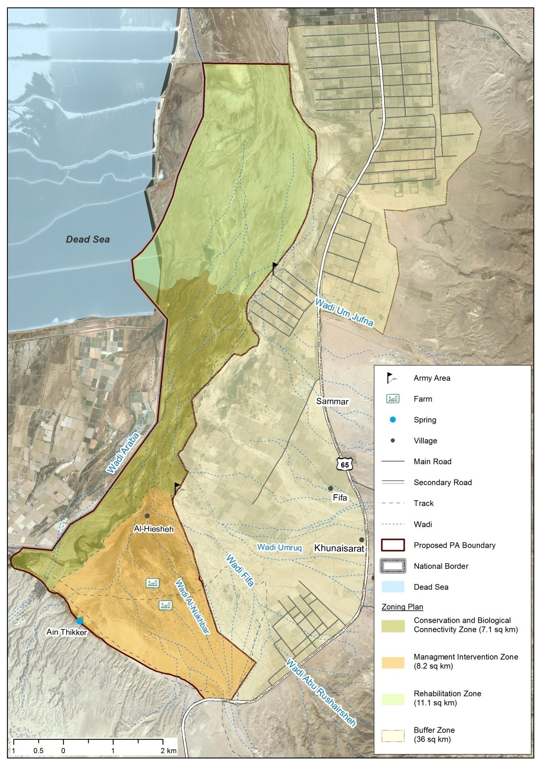
Map 6 Zoning Plan of Fifa protected area

CITES (the Convention on International Trade in Endangered Species of Wild Fauna and Flora) is an international agreement between governments. Its aim is to ensure that international trade in specimens of wild animals and plants does not threaten their survival
A measure of land, 1 donoms is 1000 sq meter

