A Preliminary Checklist of Birds of Kamlang Tiger Reserve.
Sl.no | Family | Genus | Species | Common name
 | Galliformes | Francolinus | francolinus | Black Francolin
 | Galliformes | Lophura | leucomelanos | Kalij pheasant
 | Galliformes | Polyplectron | bicalcaratum | Grey peacock pheasant
 | Ardeidae | Ardea | insignis | White bellied Heron
 | Phalacrocoracidae | Phalacrocorax | carbo | Great Cormorant
 | Accipitridae | Pandion | haliaetus | Osprey
 | Accipitridae | Icthyophaga | humilis | Lesser Fish Eagle
 | Accipitridae | Accipitrridae | trivirgatus | Crested Goshawk
 | Columbidae | Ducula | badia | Mountain Imperial Pigeon
 | Columbidae | Macropygia | unchall | Barred Cuckoo Dove
 | Columbidae | Stigmatopelia | chinensis | Spotted Dove
 | Columbidae | Chalcophaps | indica | Emerald dove
 | Strigidae | Glaucidium | cuculoides | Asian Barred Owlet
 | Upupidae | Upupa | epops | Common Hoopoe
 | Trogonidae | Harpactes | erythrocephalus | Red headed trogon
 | Alcedinidae | Alcedo | atthis | Common Kingfisher
 | Bucerotidae | Buceros | bicornis | Great Hornbill
 | Bucerotidae | Aceros | nipalensis | Rufous-necked Hornbill
 | Bucerotidae | Rhyticeros | undulatus | Wreathed Hornbill
 | Ramphastidae | Megalaima | asiatica | Blue-throated Barbet
 | Picidae | Micropternus | brachyurus | Rufous Woodpecker
 | Picidae | Blythipicus | pyrrhotis | Bay Woodpecker
 | Picidae | Dendrocopos | macei | Fulvous-breasted Woodpecker
 | Campephagidae | Pericrocotus | brevirostris | Short-billed Minivet

Sl.no | Family | Genus | Species | Common name
 | Dicruridae | Dicrurus | remifer | Lesser Racket-tailed Drongo
 | Dicruridae | Dicrurus | hottentottus | Spangled Drongo
 | Dicruridae | Dicrurus | macrocerus | Black Drongo
 | Dicruridae | Dicrurus | aenus | Bronzed Drongo
 | Rhipiduridae | Chelidorhynx | hypoxantha | Yellow-bellied fantail
 | Rhipiduridae | Rhipidura | albicollis | White-throated Fantail
 | Corvidae | Dendrocitta | formosae | Grey Treepie
 | Pycnonotidae | Pycnonotus | flaviventris | Black-crested Bulbul
 | Pycnonotidae | Pycnonotus | cafer | Red-vented bulbul
 | Pycnonotidae | Hemixos | flavala | Ashy Bulbul
 | Pycnonotidae | Hypsipetes | leucocephalus | Black Bulbul
 | Cisticolidae | Orthotomus | sutorius | Common Tailorbird
 | Leiothrichidae | Garrulax | leucolophus | White-crested Laughingthrush
 | Leiothrichidae | Pterorhinus | pectoralis | Greater Necklaced Laughingthrush
 | Leiothrichidae | Garrulax | rufogularis | Rufous-chinned Laughingthrush
 | Leiothrichidae | Actinodura | egertoni | Rusty fronted Barwing
 | Pellorneidae | Alcippe | nipalensis | Nepal Fulvetta
 | Troglodytidae | Troglodytes | troglodytes | Eurasian wren
 | Cinclidae | Cinclus | pallasii | Brown Dipper
 | Sittidae | Sitta | cinnamoventris | Chestnut-bellied Nuthatch
 | Certhiidae | Certhia | discolor | Brown-throated Treecreeper
 | Sturnidae | Acridotheres | grandis | Great Myna
 | Sturnidae | Acridotheres | tristis | Common Myna
 | Sturnidae | Sturnia | malabarica | Chestnut-tailed Starling
 | Turdidae | Myophonus | caeruleus | Blue-Whistling Thrush
 | Turdidae | Zoothera | dauma | Scaly Thrush
 | Muscicapidae | Rhyacornis | fuliginosa | Plumbeous Water Redstart
 | Muscicapidae | Chaimarrornis | leucocephalus | White-capped Redstart
 | Muscicapidae | Phoenicurus | hodgsoni | Hodgsons’s Redstart
 | Muscicapidae | Enicurus | scouleri | Little Forktail
 | Muscicapidae | Enicurus | schistaceus | Slaty-backed Forktail
 | Muscicapidae | Ficedula | strophiata | Rufous-gorgeted Flycatcher

Sl.no | Family | Genus | Species | Common name
 | Muscicapidae | Culicicapa | ceylonensis | Grey-headed Canary Flycatcher
 | Chloropseidae | Chloropsis | hardwickii | Orange-bellied Leafbird
 | Nectariniidae | Aethopyga | saturata | Black-throated Sunbird
 | Nectariniidae | Arachnothera | magna | Streaked Spiderhunter
 | Motacillidae | Motacilla | citreola | Citrine Wagtail
 | Motacillidae | Motacilla | cinerea | Grey wagtail
 | Motacillidae | Motacilla | alba | White Wagtail
 | Motacillidae | Anthus | hodgsoni | Olive-backed Pipit
 | Emberizidae | Emberiza | pusilla | Little Bunting

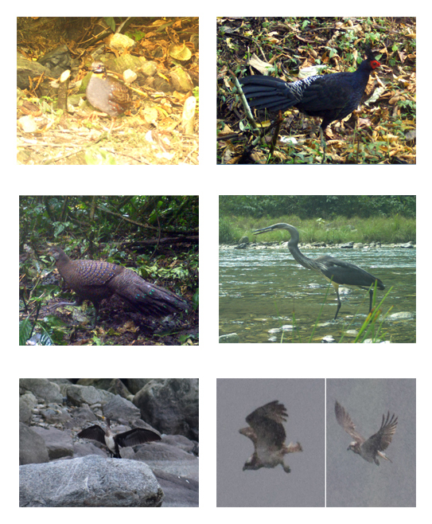
PICTURE PLATES
6
7
4
3
2
1
PLATE I: (1) Black Francolin; (2) Kalij Pheasant; (3) Grey Peacock Pheasant; (4) White-bellied Heron; (5) Great Cormorant ;(6) Osprey
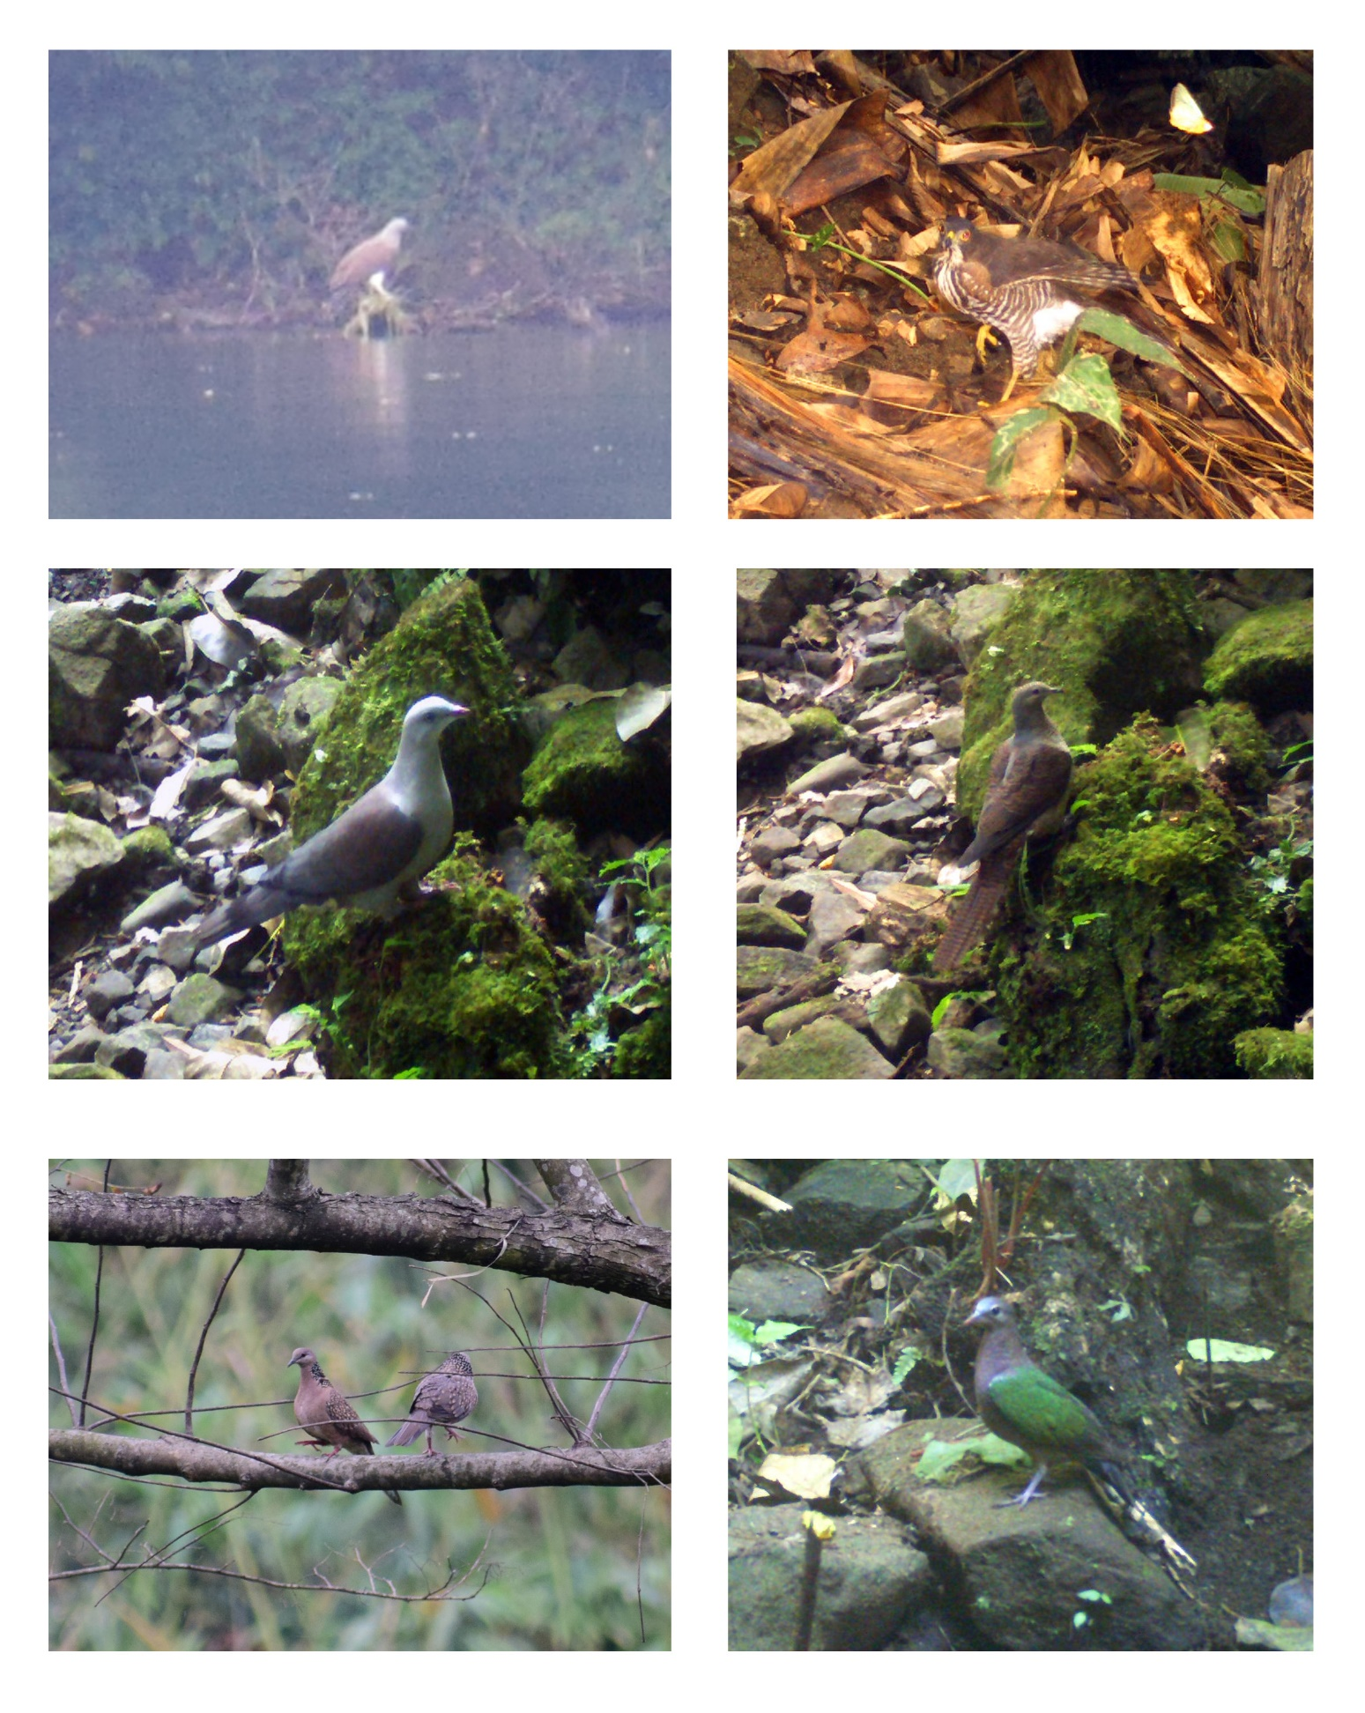
PLATE II: 7) Lesser Fish Eagle; 8) Crested Goshawk; 9) Mountain imperial Pigeon; 10) Barred cuckoo Dove; 11) Spotted Dove; 12) Emerald Pigeon
9
10
11
12
8
7
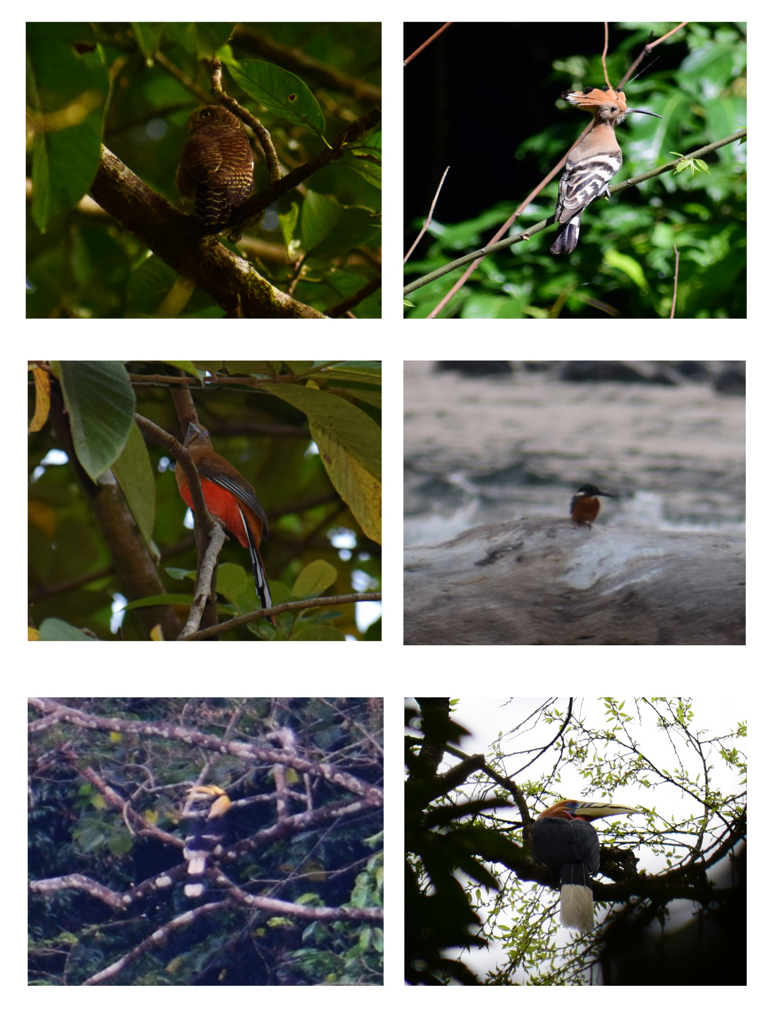
PLATE III: 13) Asian Barred Owlet; 14) Common Hoopoe; 15) Red headed Trogon; 16) Common Kingfisher; 17) Great Hornbill; 18) Rufous necked Hornbill
18
17
16
15
14
13
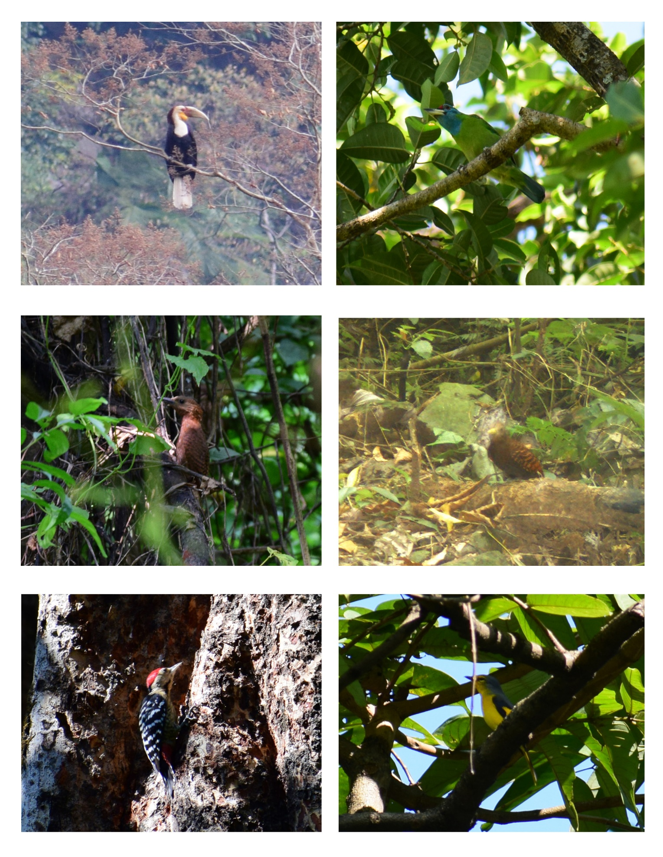
PLATE IV: 19) Wreathed Hornbill; 20) Blue Throated Barbet; 21) Rufous Woodpecker; 22) Bay Woodpecker; 23) Fulvous breasted Woodpecker; 24) Short billed Minivet
24
23
22
21
20
19
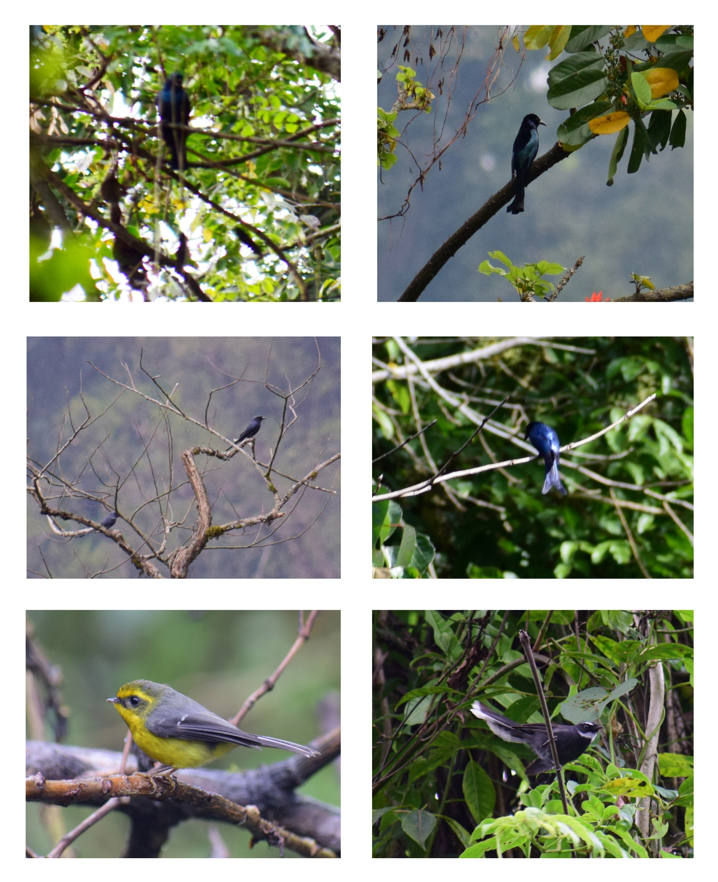
PLATE V: 25) Lesser racket Tailed Drongo; 26) Spangled Drongo; 27) Black Drongo; 28) Bronzed Drongo; 29) Yellow bellied fantail; 30) White throated fantail
30
29
28
27
26
25
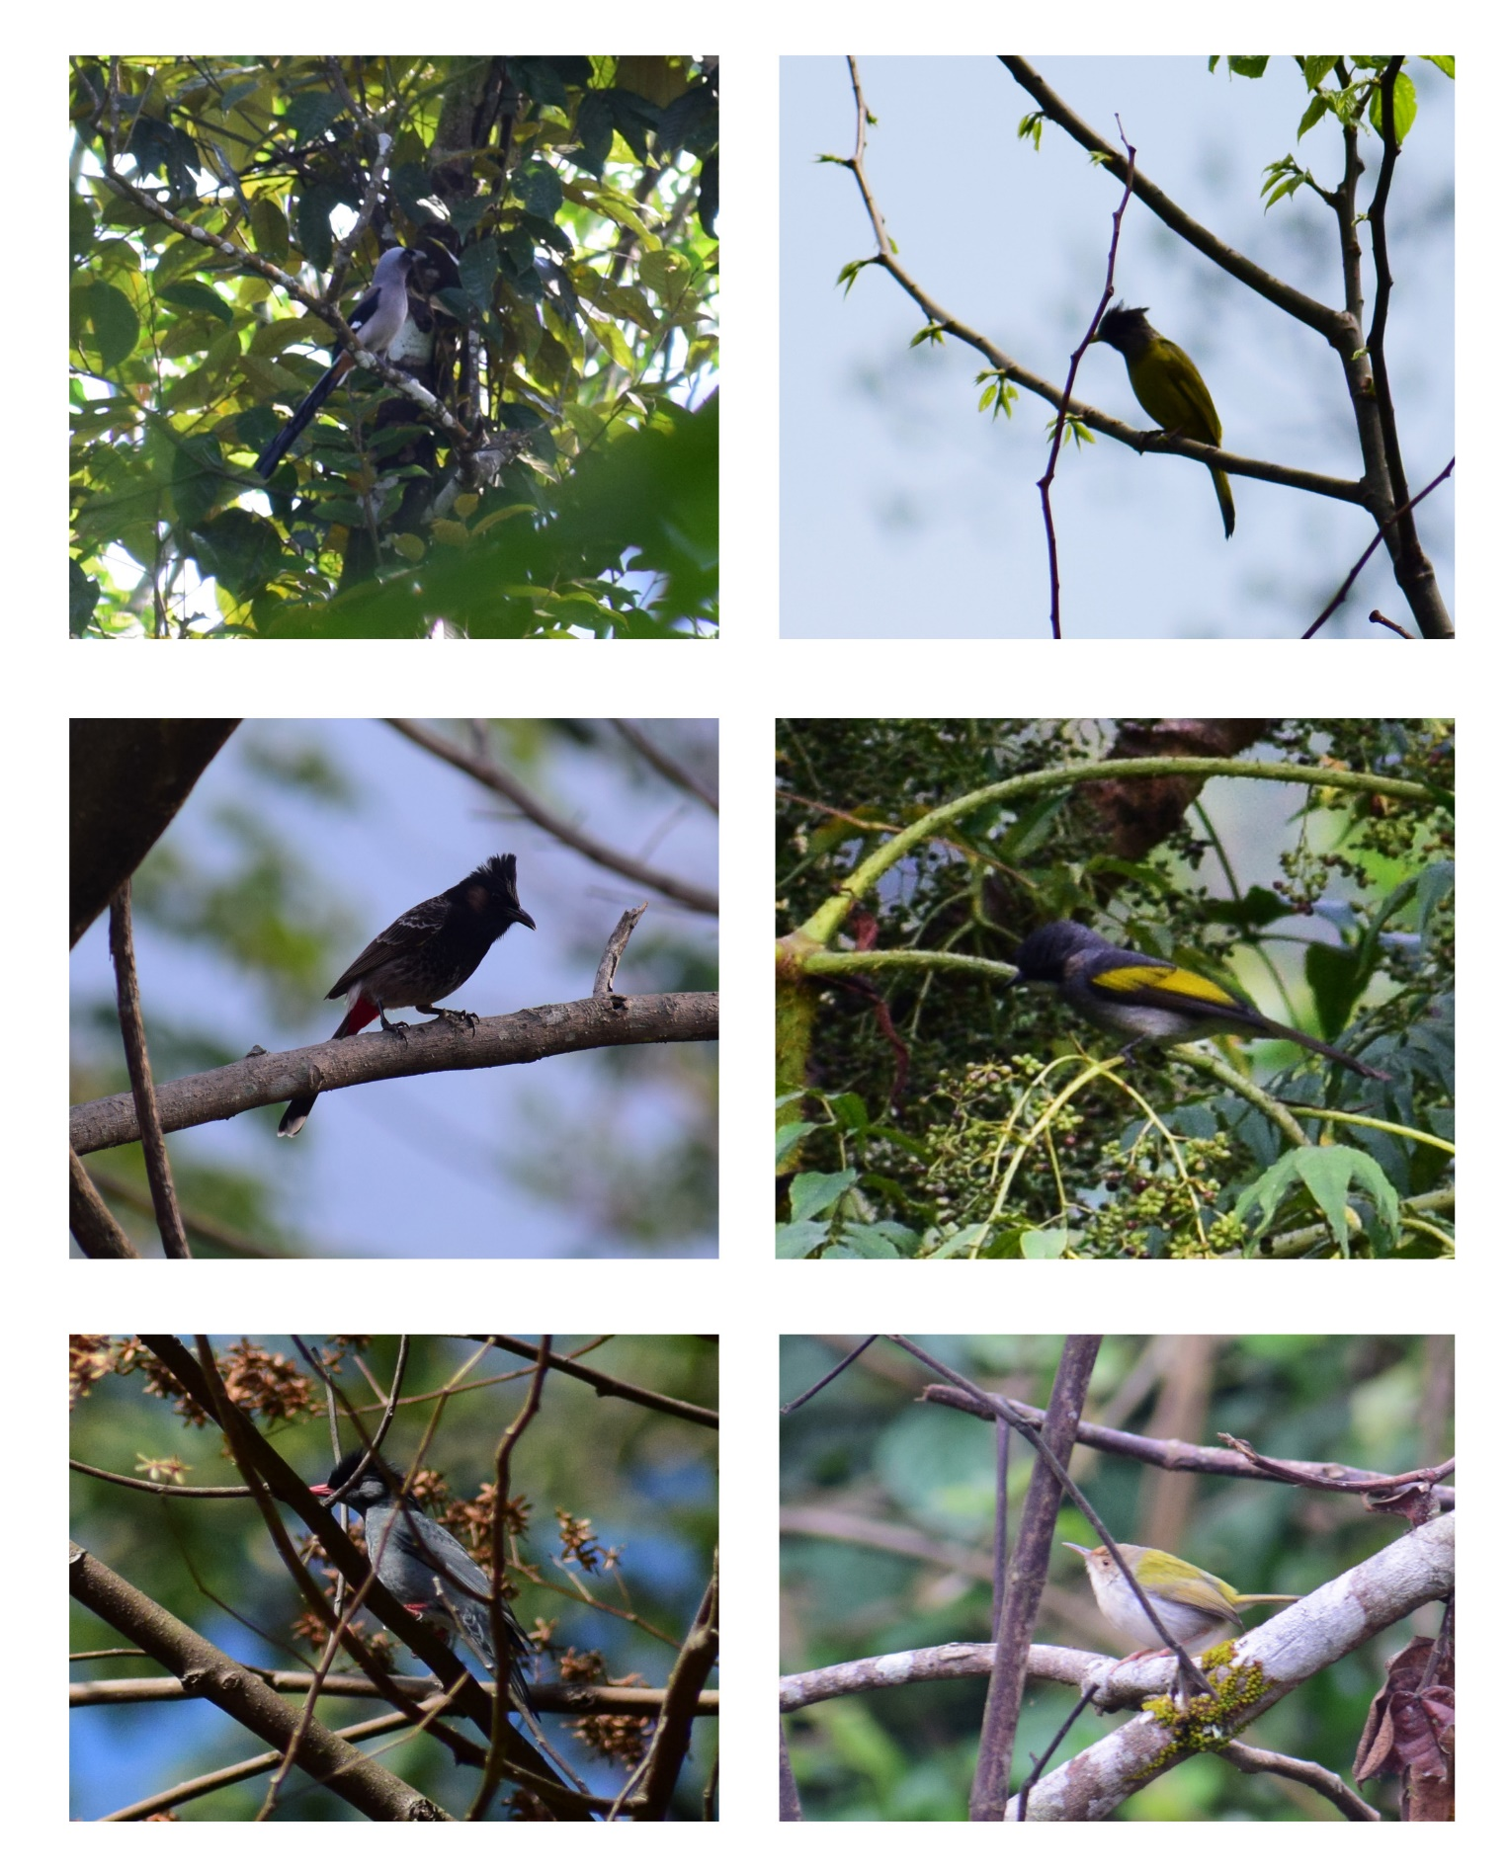
PLATE VI: 31) Grey Treepie; 32) Black crested Bulbul; 33) Red vented Bulbul; 34) Ashy Bulbul; 35) Black Bulbul; 36) Common Tailorbird
33
34
36
35
32
31
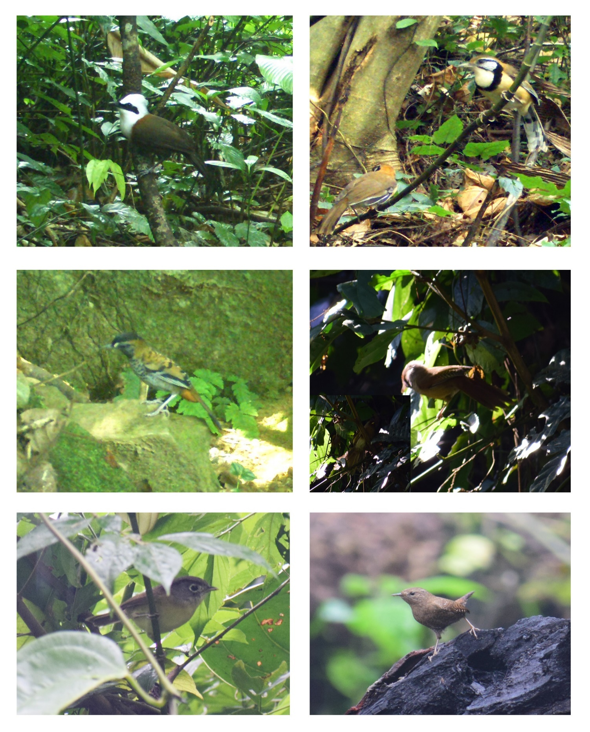
PLATE VII: 37) White crested Laughingthrush; 38) Greater necklaced Laughingthrush; 39) Rufous Chinned Laughingthrush; 40) Rusty fronted Barwing; 41) Nepal Fulvetta; 42) Winter Wren
42
41
40
39
38
37
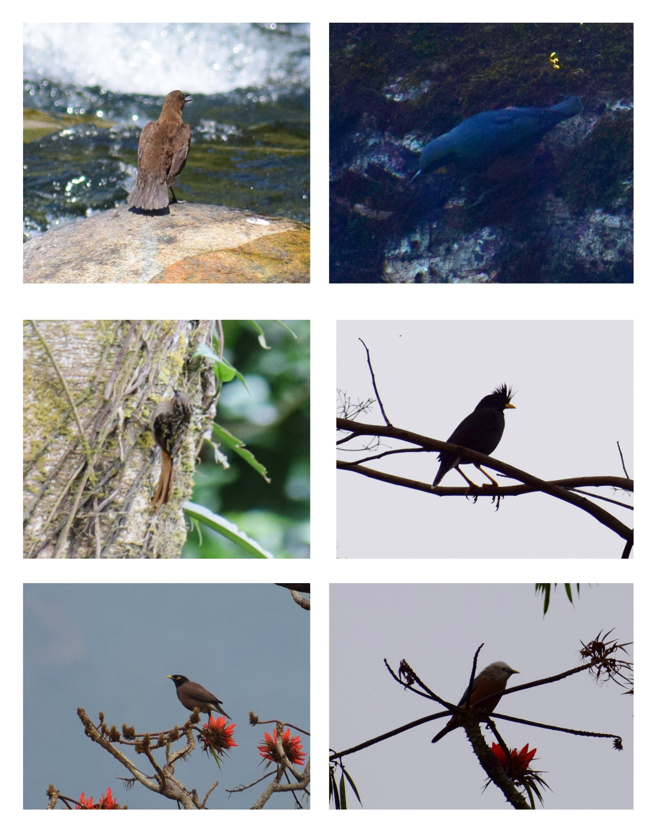
PLATE VIII: 43) Brown Dipper; 44) Chestnut Bellied Nuthatch; 45) Brown throated Treecreeper; 46) Great Myna; 47) Common Myna; 48) Chesttailed Starling
43
44
47
48
46
45
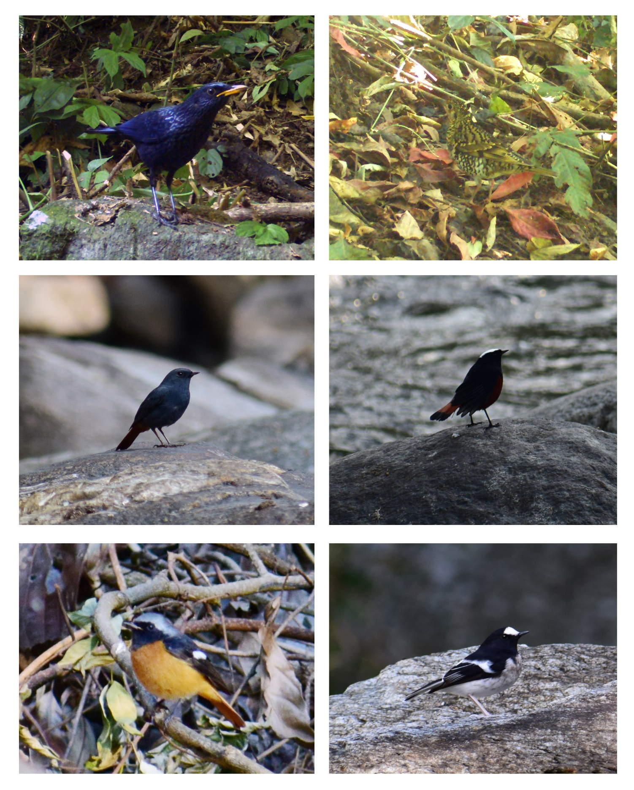
PLATE IX: 49) Blue Whistling Thrush; 50) Scaly Thrush; 51) Plumbeous water Redstart; 52) White capped Redstart; 53) Hodgson’s Redstart; 54) Little Forktail
54
53
52
51
50
49
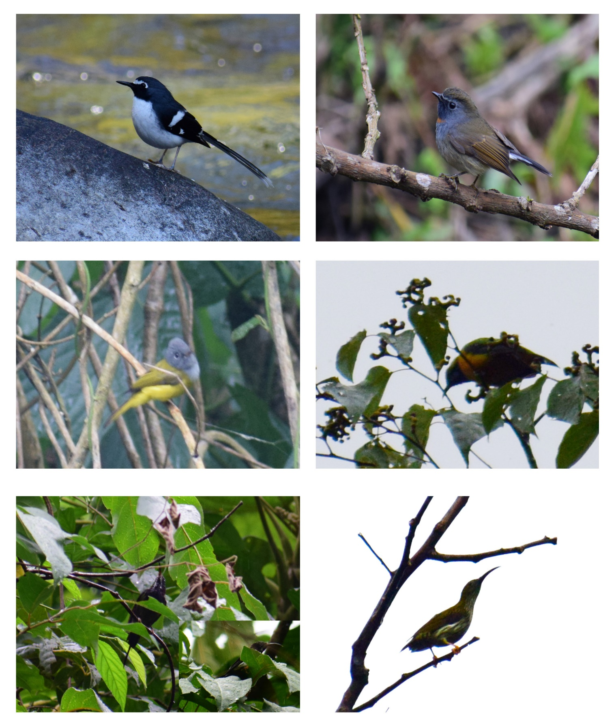
PLATE X: 55) Slaty backed Forktail; 56) Rufous gorgeted Flycatcher; 57) Grey headed canary Flycatcher; 58) Orange Bellied Leafbird; 59) Black throated Sunbird; 60) Streaked Spider Hunter
60
59
58
57
56
55

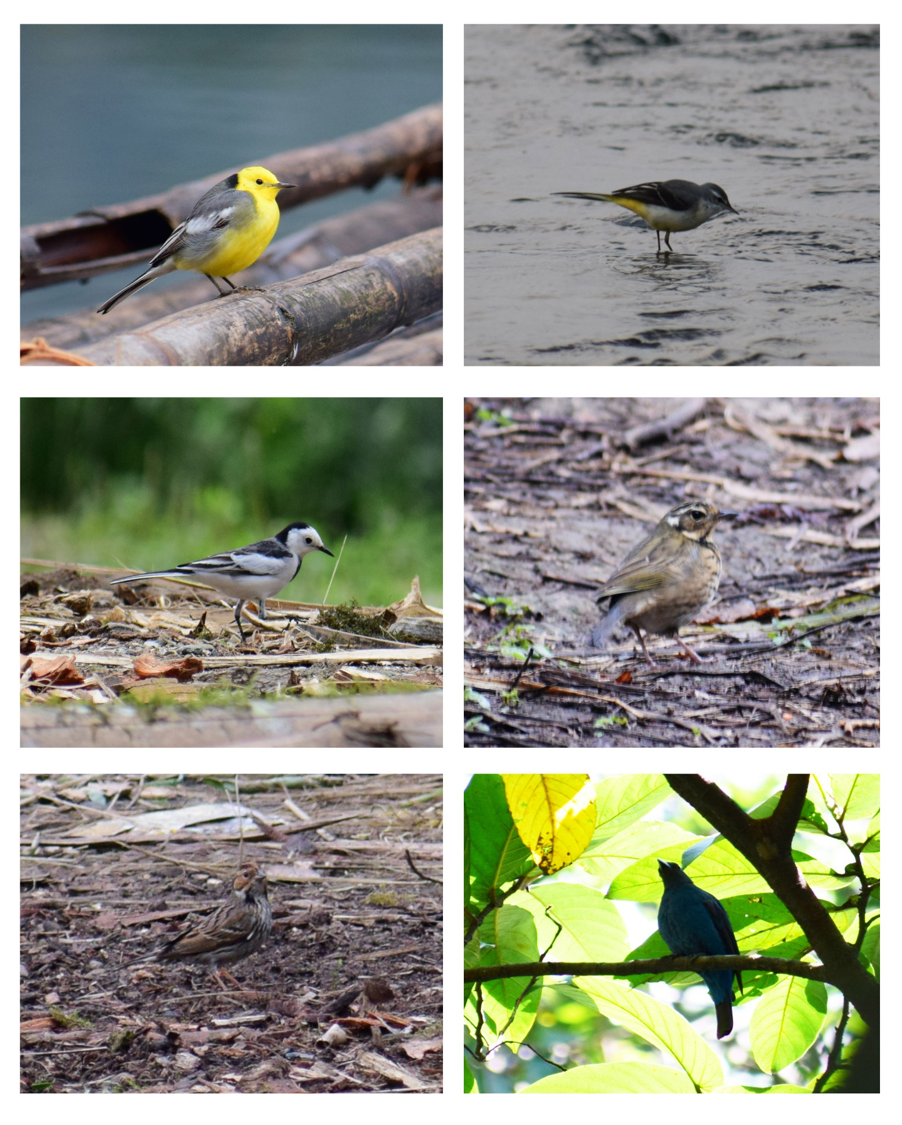
PLATE XI: 61) Citrine Wagtail; 62) Grey Wagtail; 63) White Wagtail; 64) Olive backed Pipit; 65) Little Bunting; 66) Unidentified
66
65
64
63
62
61

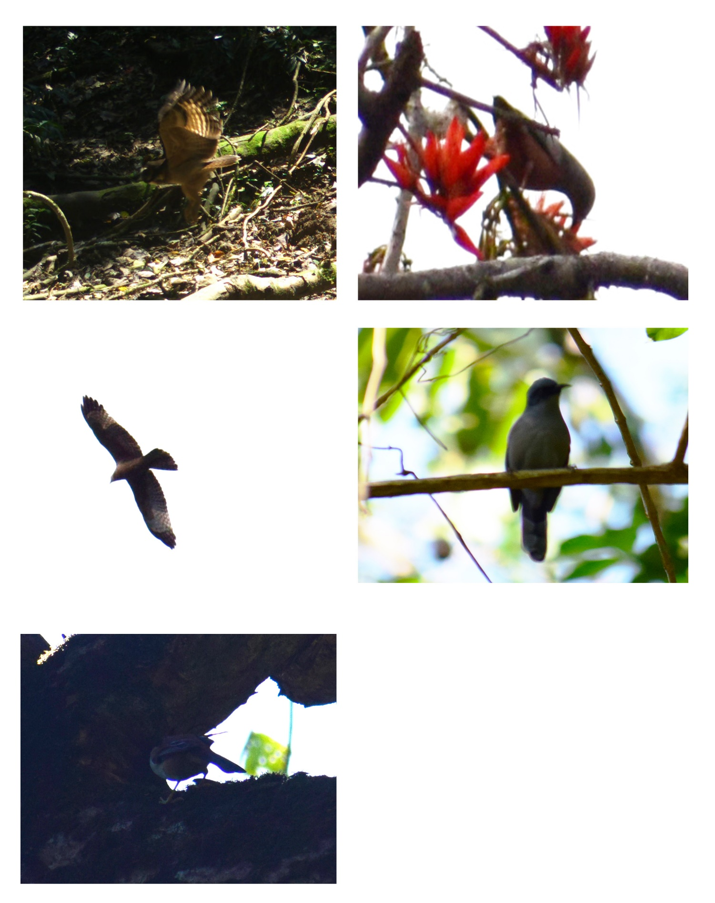
PLATE XII: 67) Unidentified; 68) Unidentified; 69) Unidentified; 70) Unidentified; 71) Unidentified;
71
70
69
68
67

